Chapter 4
Discussion

In what follows, we discuss the characteristics of the proposed system and the problems we met during the experiments.

4.1 Feature Extraction

Generally speaking, poor thinning will cause the stroke extraction fail and thus lead to bad recognition result. Fortunately, it does not have significant effects in our system. The features used in our proposed system are a kind of statistical feature. They also have the properties of the local and structural features. The feature extraction is to count the numbers of the 8 categories (see Fig. 2.5) and the numbers of the continuous pixels in each row and column. It is easy to achieve and just spend a little time.

4.2 Fault Tolerance

The variations, distortions and noises will affect the stability of features. Favorably, the features used in our proposed system are stable and insensitive to the conditions mentioned above. Because we use the global concept to extract the second primitive features in the large dividing block, it has better tolerance ability than the general local features do. Since the neural networks have the fault tolerance and generalization ability [Hammerstrom 93], we use the SEART neural network model to handle imperfect or incomplete data, providing the tolerance for variations and distortions.

4.3 Performance Measure

The number of preclassification classes should be large and the class size should be small. These two factors are the performance measure of the preclassification system [Cheng et al. 95]. In our system, the number of preclassification classes is equal to the total size of all preclassification groups. When we control the preclassification class size below 25 character categories, the preclassification rate is acceptable. Our proposed system will produce a good preclassification result in terms of the above two factors.

4.4 The Reasons for Preclassification Errors

From the experiments, we observe that there are two major reasons to cause the preclassification errors. In what follows, we discuss these two reasons, respectively.

4.4.1 Character displacement

Although we adopt the dividing blocks and SEART mechanisms to avoid the influence of writing habit, the primitive features we employed are still sensitive in character displacement. For example, all the Chinese characters
"午" (noon) in the training set look like the Fig. 4.1. The vertical stroke of the training character "午" is in the three central blocks. However, the vertical stroke of the Chinese character "午" in the sample 20 of testing set shown as Fig. 4.2 is in the three right blocks. When we extract the stroke direction features from the dividing blocks mentioned in Fig. 2.2, the features extracted from the character "午" of sample 20 are quite different from the features extracted from the character "午" of the other samples. Thus, the preclassification error occurs in testing character "午" of sample 20.

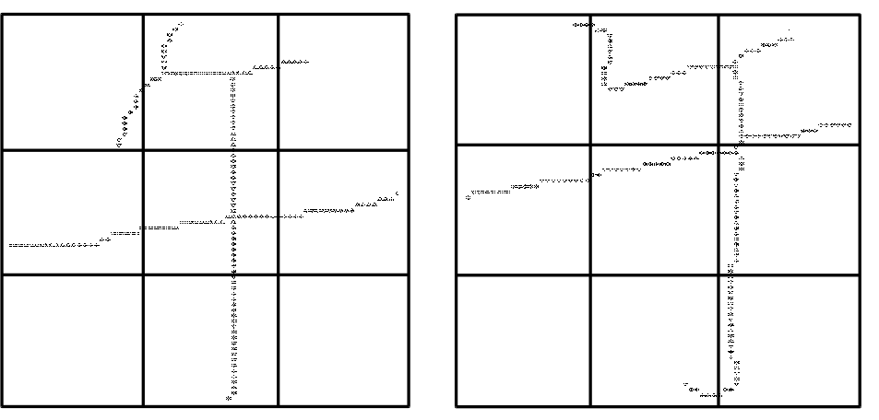
Fig. 4.1. The preprocessing result Fig. 4.2. The preprocessing result
of Chinese character "午" of Chinese character "午"
(noon) in the sample 1 of (noon) in the sample 20 of
database CCL/HCCR3. database CCL/HCCR3.
4.4.2 Serious damage of the stroke shape

Normalization and thinning processes may lead to damage of the stroke shape. If the damage is serious, the preclassification error may take place. Fig. 4.3 shows the preprocessing result of Chinese character "多" (much) of sample 1 in training set. Most of the characters "多" in the training set look like the Fig. 4.3. However, the Chinese character image "多" in sample 30 of database CCL/HCCR3 is quite long and narrow. The normalization process damages the stroke shape seriously and causes the character displacement. The preprocessing result of this character sample is shown in Fig. 4.4. The damage of stroke shape causes the changes of the stroke directions of many pixels. Thus, we can not extract the correct stroke direction features. In addition, since the character displacement, the influence mentioned in Section 4.4.1 will take place. These make the preclassification error.

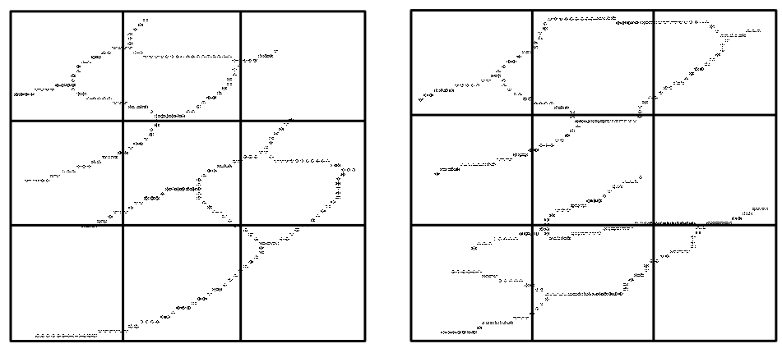
Fig. 4.3. The preprocessing result Fig. 4.4. The preprocessing result
of Chinese character "多" of Chinese character "多"
(much) in the sample 1 of (much) in the sample 30 of
database CCL/HCCR3. database CCL/HCCR3.
4.5 Other Issues

During the research process, we have tried to use other methods to accomplish the preclassification, but the results are not good enough. In the following subsections, we will discuss these methods.

4.5.1 Dividing blocks

Before deciding to adopt the 9 dividing blocks mentioned in Section 2.2, we have tried to use other dividing method. We have divided the character image into four blocks, and then extract the stroke direction features from each dividing block. The method of four-dividing-blocks is very simple. At first, we horizontally scan the character image for each row until we find a row without any black pixel. We then separate the character image horizontally in that position. If we can not find any row only with white pixels, we separate the character image horizontally in half size of the character image. Similarly, we can separate the character image vertically in the proper position. After separating the character image horizontally and vertically, we have the four-dividing-blocks.

According to the radical composing structure, Chinese characters can be divided into four main categories: indivisible, left-right divisible, top-down divisible, and special characters [Cheng & Hsu 88]. The purpose of the four-dividing-blocks method is to recognize whether the character is indivisible, left-right divisible or up-down divisible roughly. Then we can extract the stroke direction features from each portion of dividing character. Since the writing habit, this method is not stable enough. Fig. 4.5 to Fig. 4.7 show the four-dividing-blocks of Chinese character "千" (thousand) of samples 3, 20 and

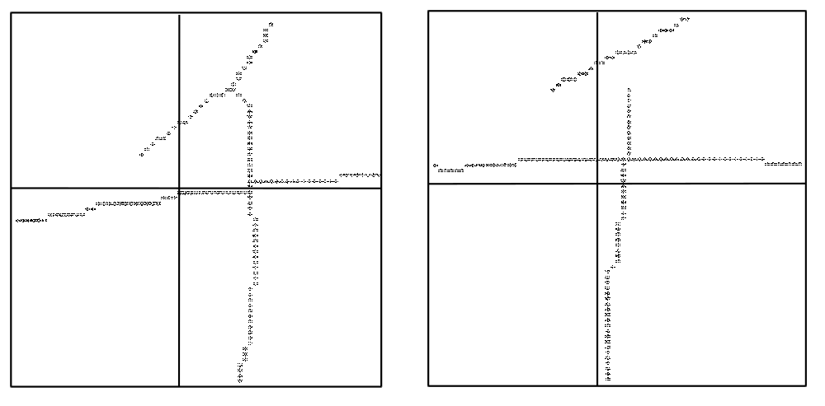
Fig. 4.5. The four dividing blocks of Fig. 4.6. The four dividing blocks of
Chinese character "千" Chinese character "千"
(thousand) of sample 3 in (thousand) of sample 20 in
CCL/HCCR3. CCL/HCCR3.

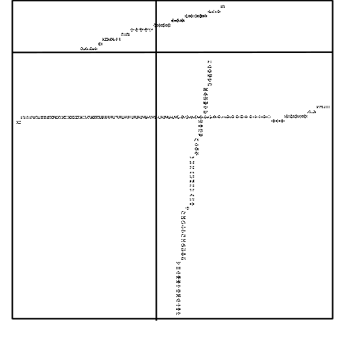
Fig. 4.7. The four dividing blocks of
Chinese character "千"
(thousand) of sample 10 in
CCL/HCCR3.
10 in CCL/HCCR3, respectively. In fact, "千" is an indivisible character. According to the writing habit, it may be written as a divisible character shown as Fig. 4.7. That will lead to distinct four-dividing-blocks. Even if "千" is written as an indivisible character correctly, the four-dividing-blocks are not uniform. For example, Fig. 4.5 and Fig. 4.6 are two indivisible characters "千". We can find that if we extract the stroke direction features from each dividing block, respectively, the extracted features of Fig. 4.5 and Fig. 4.6 are quite different. A character category may have many different four-dividing-blocks. Although we adopt SEART neural net to avoid the influence of writing habit, the results still do not satisfy our needs.

4.5.2 Membership functions and fuzzy rules

In addition to the membership functions of fuzzy set Low and High, we have tried to create the membership functions of fuzzy set Middle for horizontal density H and vertical density V in stage I. Fig. 4.8 illustrates the shape of these functions. In order to deal with these additional membership functions, we have to define some other fuzzy rules. Therefore, we have 9 preclassification groups according to the combination of the three different types (High, Middle, and Low) for horizontal density H and vertical density V, respectively. The results are not good enough since the overlap degree of the preclassification groups is high. Too many areas of the membership function of fuzzy set Middle overlap with the membership functions of fuzzy set Low and High. This causes the high overlap degree of the preclassification groups.

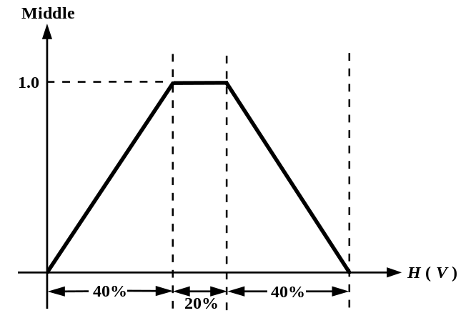
Fig. 4.8. The membership function of fuzzy set Middle for horizontal density H
(vertical density V ).

