A Multiclass Neural Network Classifier with
Disjunctive Fuzzy Information

Kuo-Hsiu Chen, I-Feng Jiang and Hahn-Ming Lee*

Department of Electronic Engineering
National Taiwan Institute of Technology
43, Keelung RD., Sec. 4, Taipei, Taiwan
Tel: +886-2-7376410
Fax: +886-2-7376424
E-mail: hmlee@et.ntit.edu.tw

Extended Summary

The objective of this paper is to describe a neural network classifier to learn disjunctive fuzzy information in the feature space. Even though unusual complex regions or extremely small data clusters occur in the feature space, this proposed classifier will trade off memory requirements, training complexity and classification computation requirements to fit the needs of the problem. This network consists of two types of nodes in the hidden layer. The prototype nodes [1,2] and the exemplar nodes [3,4] represent prototypes and exemplars in the feature space, respectively. The classifier generates and refines prototypes for distinct clusters in the feature space. The number and growth parameter of these prototypes are not restricted, so the prototypes will form near-optimal decision regions to meet the distribution of input patterns. These clusters are then learned the mapping to the responding classes. It is obviously that the decision regions may be complex or even overlap so that the prototypes could not classify all patterns correctly. To solve this problem, the proposed classifier places and adjusts exemplars to learn the patterns that cannot be classified by the prototypes. The number of the exemplars generated depends on the shapes of decision regions. The more complex the decision regions are, the more exemplars will be generated. This strategy reduces the memory requirement while minimizes the amount of misclassification. The exemplars may be nested inside one another. It provides this classifier the ability to handle the exceptions inside exemplars. Each time when the new information is received, on-line learning [5] is realized with the aid of the generating, refining and nesting of exemplars. The inputs and weights of the proposed network are fuzzy numbers [6,7] so that numerical information and fuzzy information can be learned. The operations used in this classifier are simple, so that the computation load of the network is not heavy. The experimental results manifest that the appropriate number of prototype nodes used to represent patterns clusters can be determined by this model, and the recognition rate for disjunctive fuzzy information evaluated by this model is encouraging.
All the nodes of hidden layer represent fuzzy prototypes and exemplars. The classifier creates classes by aggregating many fuzzy set prototypes and several fuzzy set exemplars into a single fuzzy set class. The input is represented as an LR-type fuzzy set [6,7]. Also the prototypes and exemplars are represented as LR-type fuzzy sets. This is because the LR-representation of fuzzy sets can increases computational efficiency without limiting the generality beyond acceptable limits, and the fuzzy interval can represent various types of information [7].
This neural net classifier is a three-layer neural network. Fig. 1 illustrates the complete structure of this classifier. The input layer contains one node for each input feature. Each input feature is represented as an LR-type fuzzy set. These nodes are used only to hold input values and distribute these values to all nodes in the hidden layer.
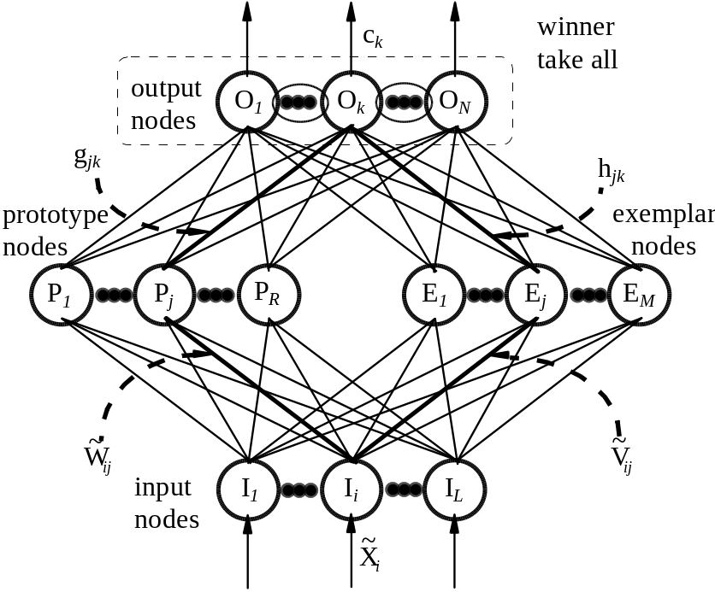
Fig. 1: The complete structure of proposed neural network.
The hidden layer consists of two sets of nodes: prototype nodes and exemplar nodes. Each of these nodes represents a fuzzy vector. Each class may have several prototype nodes and these prototype nodes will classify as many input instances as possible. The exemplar nodes are generated for classifying those training instances that cannot be correctly classified by the prototypes. Therefore, the number of exemplar nodes generated depends on the complication of classes.
The output layer contains a node for each class. The weight vectors g and h are adjusted such that when an input vector is presented to the classifier, this classifier's behavior will be like to check whether the input vector can be classified correctly by some exemplar. If so, the winner exemplar (i.e. the closest or the innermost exemplar) will send a correct classification output to the output node. Otherwise, it will be classified by the prototype nodes.
The training of this classifier is a two-phase learning procedure. In the first phase, this training algorithm combines the unsupervised learning Self-Organizing Map (SOM) network [8] and the supervised learning Grossberg's outstart network [9]. It consists of two separate training subpasses. The first subpass extends the standard SOM algorithm to a fuzzy version. Each prototype node in the hidden layer is represented as a trapezoidal fuzzy number [7] in an LR-type fuzzy interval [6]. The similarity degree between the input pattern and prototype nodes is measured by a similarity function. The prototype node with the highest value will be declared to be the winner. The fuzzy weights between the input node and winner prototype node are updated by the winner-take-all learning rule [8].
The goal of such training strategy is to cluster similar training patterns by a prototype node. During a few training epochs, the first subpass will automatically generate the appropriate number of prototype nodes according to the distribution of fuzzy input instances in the disjunctive pattern space. After the first subpass ends, the second subpass is used to determine which class the prototype node belongs to.
In phase 2, the learning process extended from the nested generalized exemplars (NGE) theory [10,11] begins if any training instance 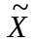 cannot be correctly classified by prototypes and existing exemplars. If any winner exemplar node is found, the hyperbox of the winner will be expanded to include the instance . If no winner exemplar can be found, a new exemplar node will be added for this instance. Because the prototypes learned in phase 1 can recognize most instances, the iterations needed in phase 2 are also few. In addition, the nesting exemplars may be generated.
In order to illustrate the workings of our methods, two databases, IRIS data [12], and Knowledge Base Evaluator (KBE) [13] are modified to include disjunctive fuzzy information for evaluating this model. The experimental results show that the proposed model can handle the disjunctive fuzzy information efficiently. This model can be able to automatically determine the appropriate number of the prototype nodes with little information about the inputs distribution after few training epochs. The main advantage is that it can efficiently reduce the number of fuzzy hyperboxes needed, because these generated prototypes can be used to classify as many disjunctive fuzzy input instances as possible. The exemplar nodes will be generated and expanded to classify those fuzzy input instances that cannot be correctly classified by the prototype nodes. Also nonlinear separate and overlapping classes can be easily classified. These exemplar nodes also provide the on-line adaptation to learn new information without destroying old memory. The operations used in this classifier are simple, so that the computation load of the network is not heavy.
References

[1] M. A. Abounasr and M. A. Sidahmed, Fast learning and efficient memory utilization with a prototype based neural classifier, Pattern Recognition 28 (1995) 581-594.
[2] C. L. Chang, Finding prototypes for nearest neighbor classifiers, IEEE Transactions on Computers C-23 (1974) 1179-1184.
[3] H. A. Guvenir and I. Sirin, Classification by feature paritioning, Machine Learning 23 (1996) 47-67.
[4] R. P. Lippmann, Pattern classification using neural networks, IEEE Communication Magazine 40 (1989) 185-234.
[5] P. K. Simpson, Fuzzy min-max neural networks－part 1: Classification, IEEE Transactions on Neural Networks 3 (1992) 776-786.
[6] D. Dubois, and H. Prade, Fuzzy real algebra: some results, Fuzzy Sets and Systems 2 (1979) 327-348.
[7] H. -J. Zimmermann, Fuzzy Set Theory and Its Applications (Kluwer-Academic Publisher, Boston, 1991).
[8] T. Kohonen, Self-Organization and Associative Memory, 3rd edition, (Berlin, Springer-Verlag, 1984).
[9] S. Grossberg, Studues of Mind and Brain (D. Reidel Publishing Company, Boston, 1982).
[10] S. Salzberg, A nearest hyperrectangle learning method, Machine Learning 6 (1991) 251-276.
[11] D. Wettschereck, An Experimental Comparison of the Nearest-Neighbor and Nearest-Hyperrectangle Algorithms, Machine Learning 19 (1995) 5-27.
[12] The UCI repository of machine learning database, ftp://ics.uci.edu/pub/machine-learning-database.
[13] R. Keller, Expert System-Development & Approaches (Prentice-Hall, Englewood Cliffs, NJ, 1987).

* Correspondence to this author.

