Chapter 5

Experiments

We illustrate the workings of our method by real examples, IRIS and KBE. The IRIS data (Fisher, 1936) and the Knowledge Base Evaluator (KBE) (Keller, 1987) are modified to include disjunctive fuzzy information for evaluating this model. The inputs of the KBE are linguistic terms. The experiments in the KBE illustrate the fundamental application of the proposed classifier with fuzzy inputs. The LR-representation of fuzzy sets can represent various types of information, so crisp inputs can be processed well in the proposed model. The application of crisp inputs is shown in the experiments: the IRIS data and the modified IRIS data. The performances on these databases are compared with results of our previous works FUNLVQ and FENCE (Chen et al., 1995, in press), and GFENCE and DYNPRO (Chen et al., 1996). All the experiments were programmed in C under the software environment of PDP programs (McClelland & Rumelhart, 1988).

5.1 The IRIS Database

The IRIS database created by Fisher (1936) includes three classes: Virginica, Setosa, and Versicolor. The database has four continuous features: sepal length, sepal width, petal length, and petal width. The data set consists of 150 instances, 50 for each class. The Setosa class is linearly separable from the other two, but the other two are overlapped each other.

In this subsection, the performance of the proposed classifier is evaluated by original IRIS database with the non-disjunctive property. One half of the 150 instances are randomly selected to train this model. The remaining patterns are used as the testing set. The distance parameter for the proposed classifier is set to 0.08. After training, 12 to 21 nodes (average 15.4) are generated by the proposed classifier. There is an average 2.7 misclassifications in the testing set from twenty trials. Although the average number of hidden nodes is larger than those produced by the other strategies, the proposed model just needs a single epoch to operate. Therefore, the speed of this model is faster. Table 5-1 shows the comparison results with the FMMC (Simpson, 1992) classifier and our previous works. Table 5-2 exhibits the comparison with the various traditional, fuzzy, and neural classifiers.

TABLE 5-1
The classification results on IRIS

Number of Hidden Nodes
Testing Errors
Testing Recognition Rate

FMMC (Simpson, 1992)
48
2
97.3%

FUNLVQ+FENCE (Chen et al., 1995)
4~8 (avg. 5.7)
1~5 (avg. 3.2)
95.7%

FUNLVQ+GFENCE (Chen et al., 1996)
8~13 (avg.10.9 )
0~6 (avg. 2.75)
96.3%

The proposed classifier
12~21 (avg.15.4)
0~5 (avg. 2.7)
96.4%

TABLE 5-2
The comparison with various classifiers
Model name
No. of errors

NGE (D. Wettschereck, 19
95)
3.75 ~ 4.65

BNGE (D. Wettschereck, 1995)
2.85 ~ 3.45

KBNGE (D. Wettschereck, 1994)
3~3.6

Bayes classifier *
2

k-nearest neighbor *
4

Fuzzy k-NN *
4

Fisher rations *
3

Fuzzy min-max network *
2

Perceptron *
3  Fuzzy perceptron *  2  FUNLVQ+FENCE (Chen et al., 1995, in press)  3.2 |  | FUNLVQ+GFENCE (Chen et al., 1996)  2.75
DYNPRO+GFENCE (Chen et al., 1996)
3.8

The proposed classifier
2.7

*: The data of these models are from (P. K. Simpson, 1992).

Figure 5-1 shows that the incorrect number of the testing set does not alter significantly for various distance parameters. This means that the sensitive degree of the distance parameter is low. However, since the distance parameter limits the expansion of exemplar nodes, it will affect the number of hidden nodes. The smaller the distance parameter is, the larger the number

of hidden nodes is.

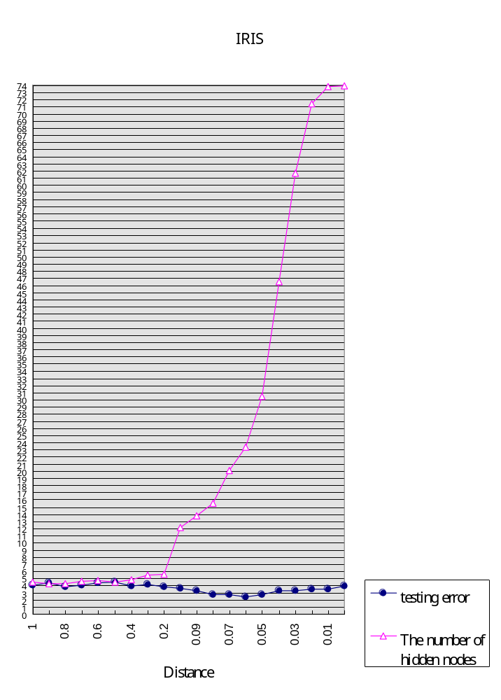Figure 5-1. The numbers of testing errors and of hidden nodes for various distance parameters in the IRIS.

5.2 The Modified IRIS Database

This original IRIS database is modified in Chen et al., 1996 to have disjunctive information. These instances belonging to the Setosa class are changed to belong to the Virginica class. Therefore, the modified IRIS database has the disjunctive property, and it is suitable for evaluating the performance of the proposed algorithm. The modified database includes two classes Virginica and Versicolor in these clusters.

The distance parameter for the proposed classifier is set to 0.1. We randomly select 75 patterns as training patterns, and the remaining patterns are used to test. For comparison, the DYNPRO + GFENCE, the DYNPRO + FENCE, and the FUNLVQ + FENCE are re-implemented. Table 5-3 shows the average results in twenty trials.
TABLE 5-3
The classification results on Modified IRIS

DYNPRO
+pGFENCE *
DYNPRO
+FENCE *
FUNLVQ
+FENCE *
The proposed classifier

Pass 1 Training Error
1~12 (avg. 4.6)
1~12 (avg. 4.5)
22~30 (avg. 24.8)
-

Training Error
0~1
0
0
0~3 (avg. 0.55)

Testing Error
0~9 (avg. 4.25)
2~10 (avg. 6.1)
8~22 (avg. 12.2)
0~6 (avg. 3.55)

Number of Prototypes
3~5 (avg. 3.6)
3~5 (avg. 3.65)
2
-

Number of Exemplars
6~14 (avg. 8.15)
2~6 (avg. 2.75)
6~15 (avg. 8.5)
8~5 (avg. 10.25)

Number of Hidden Nodes
9~19 (avg. 11.75)
5~11 (avg. 6.4)
8~17 (avg. 10.5)
8~5 (avg. 10.25)

Testing Recognition Rate
94.3%
91.8%
85.1%
95.27%
*: (Chen et al., 1996)

The proposed classifier has no prototypes and not the pass-1 to train prototypes, so they are indicated as ‘-‘ in Table 5-3. From Table 5-3, it is obvious that the testing recognition rate of the proposed learning strategy is superior than those of the other strategies. The number of the hidden nodes generated in our proposed classifier is less than those generated by DYNPRO + GFENCE and FUNLVQ + FENCE.

Figure 5-2 shows that the incorrect number of the testing set converges quickly when the distance parameter decrease from 1. Then this incorrect number does not change significantly when the distance parameter decreases. This means that the sensitive degree of the distance parameter is low while the distance parameter is under 0.6. For the same reason in Figure 5-1, the distance parameter affects the number of hidden nodes. The smaller the distance parameter is, the larger the number of hidden nodes is.
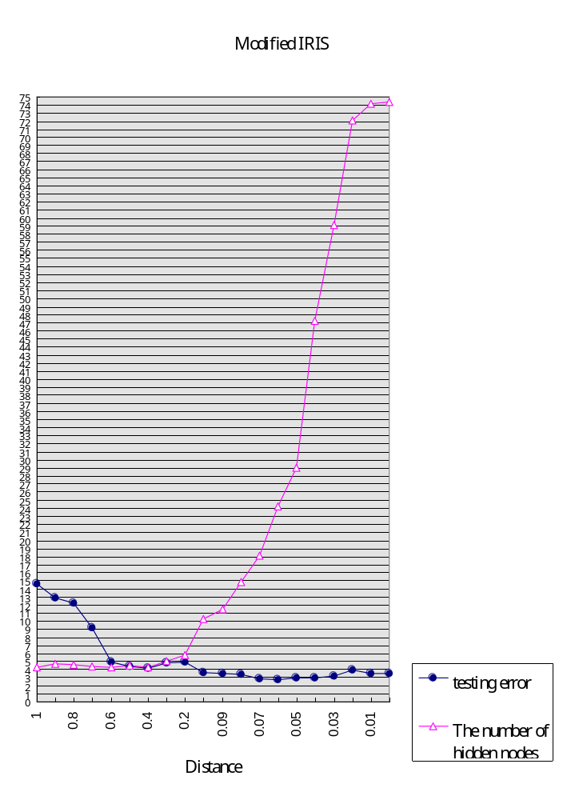Figure 5-2. The numbers of testing errors and of hidden nodes for various distance parameters in the modified IRIS.

5.3 The Knowledge-Based Evaluator Database

The 18 instances of the Knowledge-Based evaluator (KBE) (Keller, 1987) were used as training instances. Inputs of each feature are linguistic terms. The output of the KBE is Suitability, which takes the terms: good, fair, or poor, indicating that the application of the expert system on a domain is good, fair or poor. These training instances and the membership functions used for each attribute are illustrated in Table 5-4 and Figure 5-3, respectively. For instances 2 and 3, we generate all possible terms for the don't-care condition. Thus, total 340 training instances are generated from the original 18 training instances.

TABLE 5-4
18 Instances of KBE
µ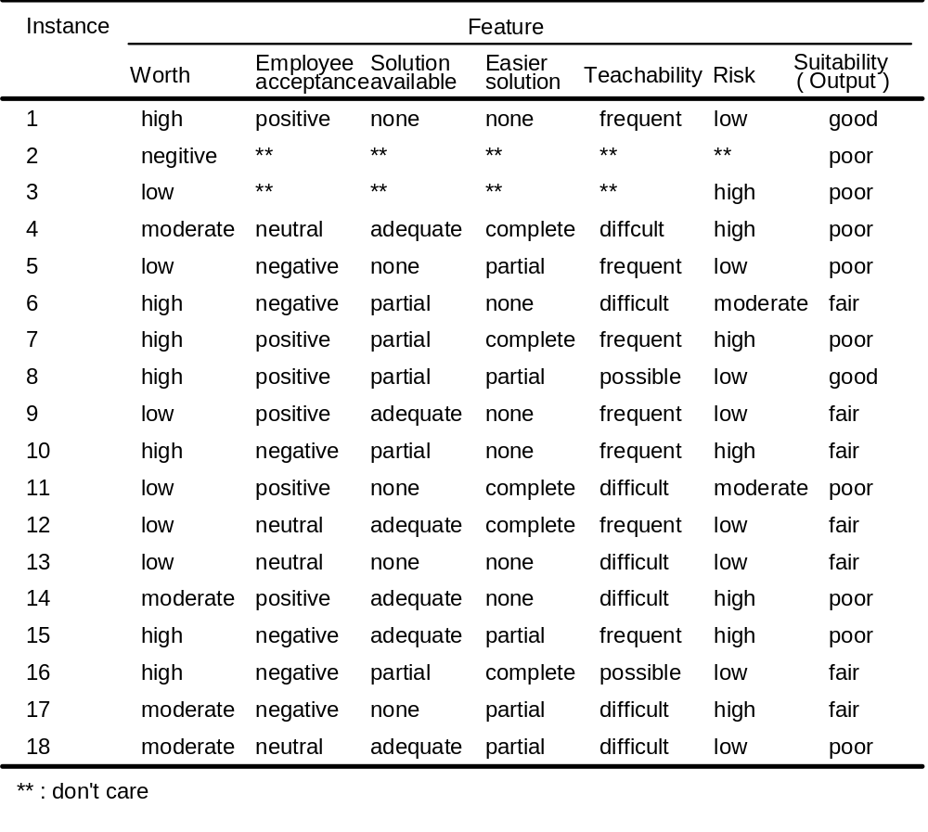

Figure 5-3. The membership functions used for KBE.
Table 5-5 exhibits the average results of three different training strategies in twenty trials. The learning rate for DYNPRO and FUNLVQ is set to 0.015, and hyperbox size is set to 0.85. The distance parameter for the proposed classifier is set to 0.5. The values of these parameters are selected according to one better average result of each model. Two thirds of the 340 instances are randomly selected to train this model and the remaining instances are used as testing set.
TABLE 5-5
The classification Results on KBE

DYNPRO + GFENCE
FUNLVQ + FENCE
The proposed classifier

Training Error
0~2
0~2
0

Testing Error
1~5 (avg. 3.9)
0~9 (avg. 4.15)
0~5 (avg. 2.9)

Number of Prototypes
3
3
-

Number of Exemplars
6~14 (avg. 8.6)
7~14 (avg. 9.4)
7~19 (avg. 10.85)

Number of Hidden Nodes
7~19 (avg. 12.5)
7~23 (avg. 13.6)
7~19 (avg. 10.85)

Testing Recognition Rate
96.55%
96.33%
97.43%

The testing recognition rate of the proposed classifier is superior than those of DYNPRO + GFENCE and FUNLVQ + FENCE shown in Table 5-5. In addition, the average number of hidden nodes in the proposed classifier is less than those of other strategies.

5.4 The Modified Knowledge-Based Evaluator Database

The original Knowledge-Based evaluator (KBE) is modified to be a disjunctive database. The output (poor) of the 3rd instance is replaced with the term-fair by Jiang (Chen et al., 1996). In this experiment, the average results of four different training strategies in twenty trials are shown in Table 5-6. The distance parameter for the proposed classifier is set to 1 according to one better average result. We randomly select two thirds of the 340 instances as training patterns, and the remaining patterns are used as testing set.
TAB^{LE 5}-6
The classification Results on Modified KBE

DYNPRO
+GFENCE *
DYNPRO
+ FENCE *
FUNLVQ
+FENCE *
The proposed classifier

Training Error
0~2
0
0~2
3~9
Testing Error
0~9 (avg. 5.8)
2~9(avg. 7.2)
4~ 21(avg. 11.2)
0~5 (avg. 3)

Number of Prototypes
3~5 (avg. 3.45)
3~5 (avg. 3.35)
3
-

Number of Exemplars
7~18 (avg. 12.6)
4~9 (avg. 5.6)
4~25 (avg. 14.1)
2~5 (avg.3.65)

Number of Hidden Nodes
11~20 (avg. 16.05)
8~14 (avg. 8.95)
11~25 (avg. 17.1)
2~5 (avg.3.65)

Testing Recognition Rate
94.8%
93.6%
90%
97.35%

*: (Chen et al., 1996)

Table 5-6 shows the testing recognition rate of our proposed classifier is superior than those of the other strategies. In addition, the average number 3.00 of hidden nodes in the proposed classifier is less than those in the other strategies. This result demonstrates that our model can handle the fuzzy inputs and the disjunctive data sets well although the training error in the proposed classifier is higher than those in the other models.

