A New Gradient-Based Search Method:

Grey-Gradient Search Method

Chin-Ming Hong¹, Chih-Ming Chen², and Heng-Kang Fan³

¹ Department of Industrial Education
National Taiwan Normal University

² Department of Electronic Engineering
National Taiwan University of Science and Technology

³ Department of Electrical Engineering
Kuang-Ku Institute of Technology and Commerce

Abstract. Optimization theory and methods play very important role for engineering design and applications. In many domains of engineering applications, it is usually the most important process to find near optimal solution. The gradient-descent method is widely used to solve many engineering optimization problems. But the gradient-descent method has some disadvantages for searching optimal solution. Firstly, its convergent speed is very slowly and is easy to trap into local minimum in the applications of many actual problems. Secondly, the learning rate of gradient-descent method must been determined adequately for different engineering problem. If the learning rate set very small, the convergent speed will be very slowly. If the learning rate is set very large, the searching of solution is very easy to generate trashing or divergence. The main goal of this research is to propose a new method that is based on grey prediction theory to improve the gradient-descent method. We use the idea of grey prediction to speed up effectively the searching speed of gradient-descent method, and improve the drawback that gradient-descent method is very easy trap into local minimum. From the experimental results, we can show the workings of the proposed method that can speed up effectively the searching speed of gradient-descent method, and improve the drawback that gradient-descent method is easy to trapped into local minimum.
Keywords: Gradient-descent Method, Grey Prediction, Grey-Gradient Method, Optimization Method

1 Introduction
The optimization methods can be classified into three categories based on the type of information that must be supplied by the user : (1) Direct search methods, which use function values only. (2) Gradient methods, which require accurate values of the first derivative of function. (3) Second-order methods, which, in addition to the above, also use the second derivative of function [9]. None of the above methods can uniformly solve all problems with equal efficiency. The direct search method will take much calculating time for performance index during solution search, so we will not focus on direct search method. Optimization theory finds application in all branches of engineering in four primary areas [9]: (1) Design of components or retire systems. (2) Planning and analysis of existing operations. (3) Engineering analysis and data reduction. (4) Control of dynamic systems. The gradient-descent method is an optimization method that is used widely in many different engineering domains. For example on optimization control, the designer can use gradient-descent method to adjust and design the parameters of controller [8]. Furthermore, in machine learning, the Back Propagation learning algorithm for multiple-layer perceptrons also is based on gradient-descent method [7]. But the gradient-descent method has two main disadvantages: (1) the need to make an appropriate choice for learning rate, and the convergent speed of gradient-descent method is very slowly in the most real applications [9]. (2) It is very easy to trap into local minimum. So how to improve it is an interesting problem. In here, we joint the concept of short-term memory into our algorithm to record the prediction data during solution search, and use grey prediction to predict the direction and tendency of solution space. Because the grey prediction method has the following properties: (1) It is a precise prediction method and prediction does not need a large number of sample data [1][2][3][4]. (2) The calculation is simple [1][2][3][4]. Although the grey prediction us based on the high order analysis of mathematics, the process of calculation is simple and easy.
Prediction is to analyze the developing tendency in the future according to the past facts. Most of the prediction methods need a large number of history data, and use the statistic method to analyzes the characteristics of the system. Thus, this method is limited by the used data and its accuracy is low [2][4]. The grey theory do not requires lots of history data to make gery prediction. So the paper attempts to use grey prediction theory to predict the direction and tendency of optimization solution, and speeds up the performance of gradient-descent method.

2 Grey Prediction
The Grey System theory was first proposed in the paper, ‘‘Control Problems of Grey Systems’’ [1], proposed in the Journal of Systems and Control Letters by Dr. J. L. Deng in 1982. The Grey Prediction was an important section in the Grey System. The Grey Prediction can describe and analyze the future development according to the past and nowadays result. Because the Grey Prediction does not need a large number of sample data, the calculation is simple, it has been successfully used in the industrial, agriculture, commercial, military, economical, meteorological and civil engineering fields. The Grey Prediction has the following properties [1][2][3[4]:

- The Grey Prediction does not need a large number of sample data, it needs generally four sample datas.
- The calculation is simple. Although The Grey Prediction is based on the high order mathematics, the process of calculation is simple and easy.
- Generally, the Grey Prediction does not need a large number of relationship between each samples, so the sample data is easily got.
- The Grey Prediction can be used in near, middle and far prediction.
- The outcome of the Grey Prediction is more accurate than the other prediction methods.

According to the definition of Dr. Deng, the Grey Prediction is based on the GM(1,1) mathematics model [2]. The basic block diagram of the Grey Prediction is shown as Figure 1.
Grey Predictor
AGO
GM (1,1)
IAGO

Figure.1. The basic block diagram of the Grey Prediction

The steps of the Grey Prediction are described as follow:
- Gather the original sample data

x⁽⁰⁾(t)={x⁽⁰⁾(1), x⁽⁰⁾(2), x⁽⁰⁾(3),...,x⁽⁰⁾(n)}
where 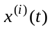 represents the number sample data of times Accumulated Generating Operation.

- Apply Accumulated Generating Operation(AGO) by equation (1) below

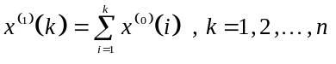 (1)
where x⁽¹⁾(t)={ x⁽¹⁾(1), x⁽¹⁾(2), x⁽¹⁾(3),..., x⁽¹⁾(n)}, x⁽¹⁾(1)= x⁽⁰⁾(1), x⁽¹⁾(2)= x⁽⁰⁾(1)+ x⁽⁰⁾(2), x⁽¹⁾(3)= x⁽⁰⁾(1) + x⁽⁰⁾(2)+x⁽⁰⁾(3),..., and x⁽¹⁾(n)= x⁽⁰⁾(1)+ x⁽⁰⁾(2)+ x⁽⁰⁾(3)+...+ x⁽⁰⁾(n)

- Create the Grey Differential Equation as show in equation (2)

Use the result of AGO to create the GM(1,1) grey differential equation.
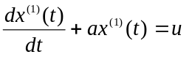 (2)
where the a and u are undecided coefficients of one order differentiable equation, we can get them that use mathematical method as shown below.
The equation (2) could be written as:
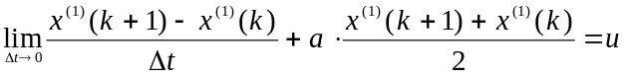 (3)
Let Δt=1 and x⁽¹⁾(k+1)－x⁽¹⁾(k) = x⁽⁰⁾(k+1), equation (3) will be
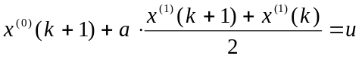 (4)

- Use the method of least squares estimation to get the parameters a and u

The equation (4) could be written as
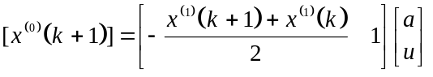 (5)
Let k = 1,2,…,n-1, and equation (5) will be:
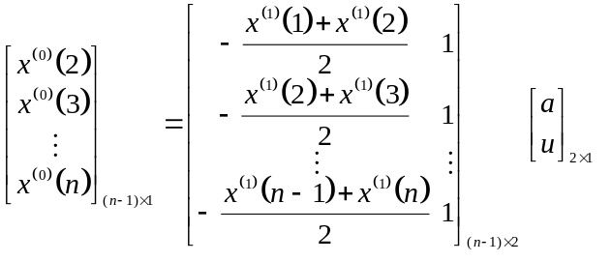 (6)
Equation (6) can be written as:
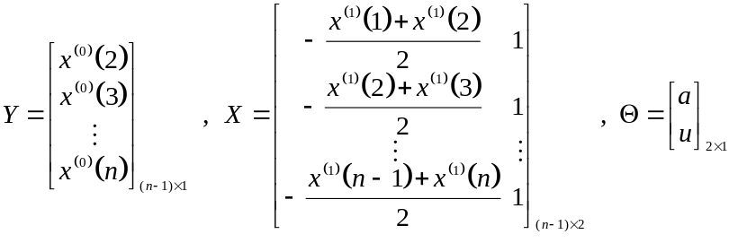
Use the method of least square estimation to get the estimated parameter,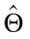:
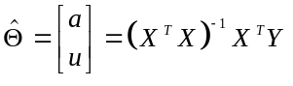 (7)

- Solve the Grey Equation

Use equation (7) and equation (2), we can have:
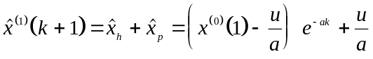 (8)
where 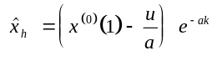 is the homogeneous solution, 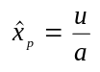 is the particular solution.

- Apply Inverse Accumulated Generating Operation(IAGO)

Because the Grey model is based on the AGO operation, we shall take the inverse accumulated generating operation to get the predict number.
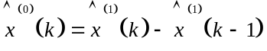 (9)

3 The Grey-Gradient Search Method
The proposed grey gradient search method is a new search algorithm based on gradient-descent method. The algorithm records five history data that generated by original gradient-descent method, then applies one time Accumulated Generating Operation that detailed in section 2 to regularize the five history data. The main goal is to find the searching regular of gradient-descent method. Next, we use GM (1,1) model to create grey differential equation according to the result of one time Accumulated Generating Operation. The grey differential equation can build a prediction model to predict further searching direction of gradient-descent method. When we select different grey prediction step, we can get different prediction point. If we have already decided grey prediction step, we use Inverse Accumulated Generating Operation to get new prediction point, and using the new prediction point serves as the new searching point. The algorithm must detect stop criterion during the searching solution to decide if the algorithm continues searching or stops searching. In this algorithm, we define that 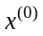 is the initial searching point, the is learning rate of gradient-descent method, is the grey prediction step, the is stop criterion and GM(1,1) represents the grey prediction model of one time Accumulated Generating Operation and one order differential equation. About detailed procedure of the new algorithm is shown as follow:

Step 1. Execute the searching of gradient-descent method
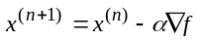(gradient-descent method)
Store all searching points of gradient-descent method
Is accumulating five searching points?
Yes: Go to Step 2 (make grey prediction)
No: Go to Step 1

Step 2. Use GM(1,1) model to construct grey prediction model
Use five searching points that step 2 stored to make Accumulated Generating Operation(AGO)
Use GM(1,1) model to create grey prediction model
Predict next searching point according to the prediction step (Solving the grey differential equation)
Inverse Accumulated Generating Operation for new prediction point, and the result serve as the new searching point

Step 3. Detect stop criterion
Is 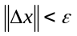?
Yes: Go to Step 4
No: Go to Step 1

Step 4. Print results and stop

4 Experimental Results
To show the workings of proposed grey-gradient method, we use multiple variable functions as experimental target functions. In this experiment, we test and compare the properties between gradient-descent method and grey-gradient method. On the multiple variable experiment, we use Himmelblaus and Rosenbrock function. Figure 2 is the contour figure of Himmelblaus function. From this figure, we can see that the function has four local minimal values. The initial point is set as 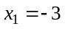 and 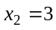, and learning rate is set 0.001. Figure 3 and Figure 4 are the searching locus figure and function convergent figure for searching near local minimum by gradient-descent method. From the two figures, we can see that the near local minimum value is found after executing 37 epochs. The near local optimal solution is 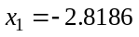 and 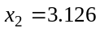. The function value of this point is 0.0072. Figure 5 and Figure 6 are the experimental results of grey-gradient method under the same initial condition and convergence criterion. The grey prediction step is set as 15. From the two figures, we can see that the grey-gradient just requires 15 epochs to find a near local minimum. The near local minimum value is 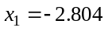 and 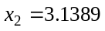. The function value of this point is 0.0024. The grey-gradient method accelerates the searching speed of solution, and finds a better solution than gradient-descent method.

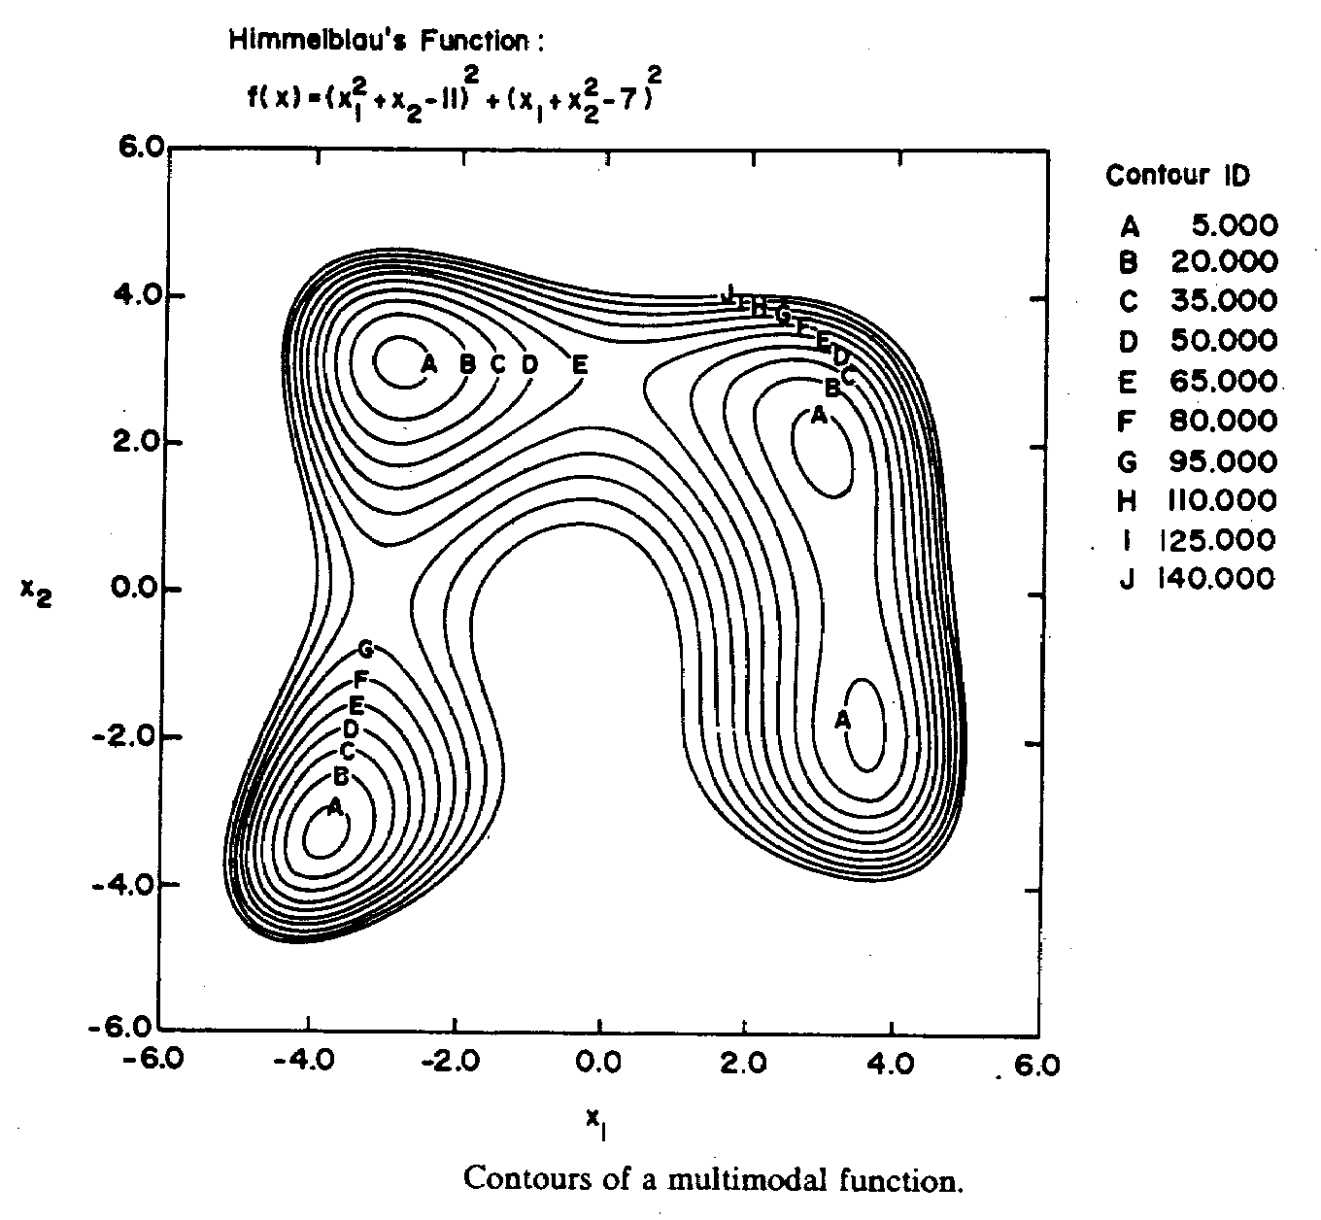
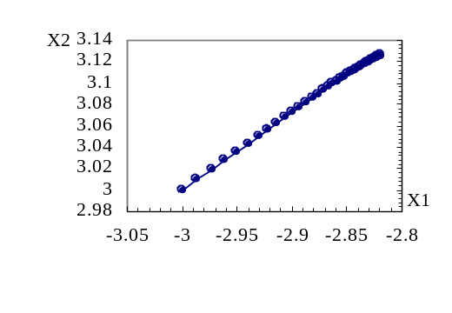
Figure.2. The contour figure of Himmelblaus function
Figure.3. The searching locus figure of Himmelblaus function using gradient-descent method

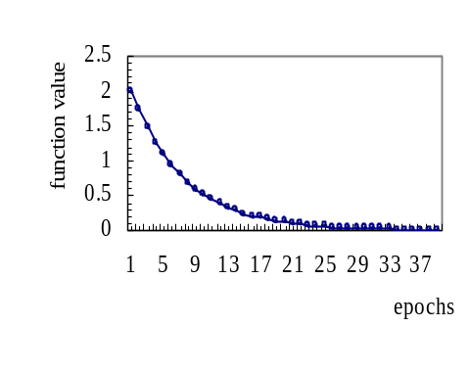
Figure.4. The convergent figure of Himmelblaus function using gradient-descent method
Figure.5. The searching locus figure of Himmelblaus function using grey-gradient method

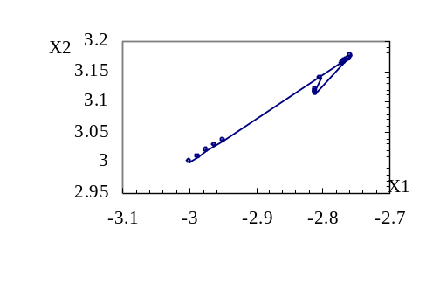
Figure.6. The convergent figure of Himmelblaus function using grey-gradient method
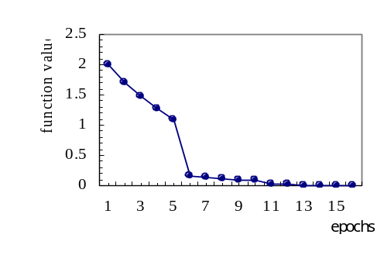

In the next, we will use a more complex Rosenbrock function of two variables to explain the properties of grey-gradient method. Figure 7 is contour figure of two variable Rosenbrock function. If the initial point is set as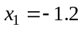 and 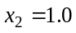, learning rate is set 0.001. Figure 8 and Figure 9 are the searching locus figure and function convergent figure of gradient-descent method for searching local minimum. From the two figures, we can see that the gradient-descent method trap into a local minimum value, and the convergent error can not continue to reduce when epochs increase. The final convergent error is very large. The convergent point is 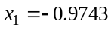 and 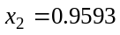. The function value of this point is 3.908. Under the same initial condition and stop criterion, Figure 10 and Figure 11 are the experimental results of grey-gradient method when the grey prediction step is set as 15. From the two figures, we can see that the grey-gradient method can escape the local minimum. It just needs 91 epochs to find a near global minimum. The near global minimum is 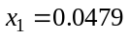 and 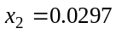. The function value of this point is 0.9816. The grey-gradient method speeds up the searching speed and finds a better solution than gradient-descent method.
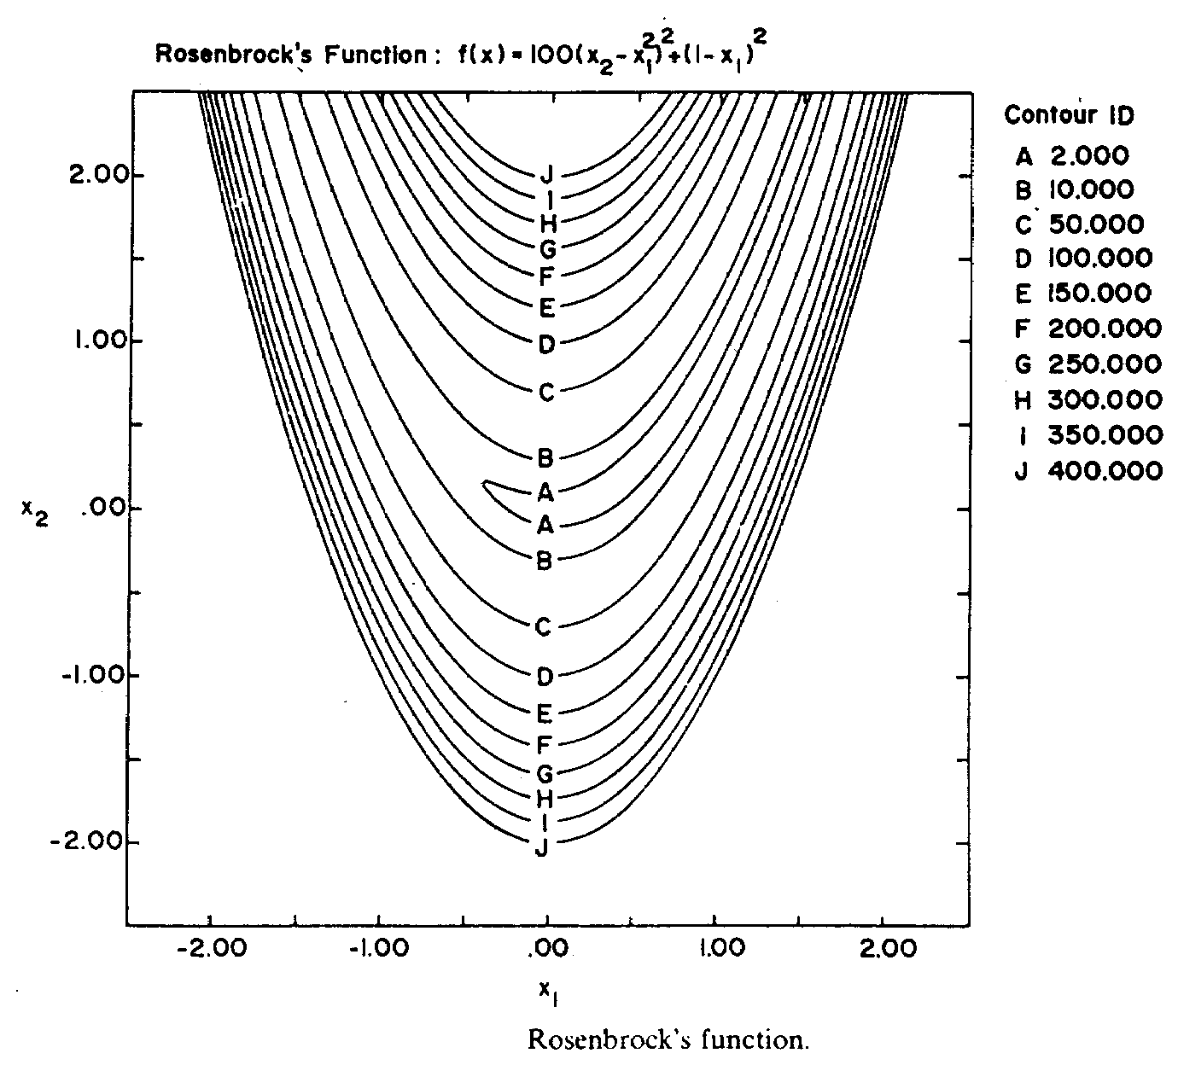

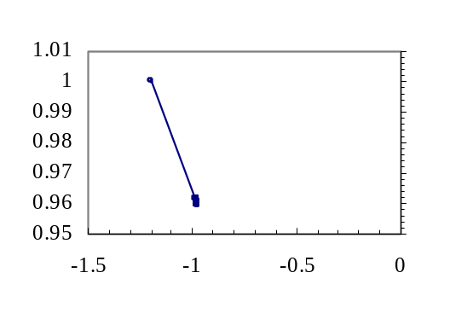
Figure.7. The contour figure of Rosenbrock function

Figure.8. The searching locus figure of Rosenbrock function using gradient-descent method

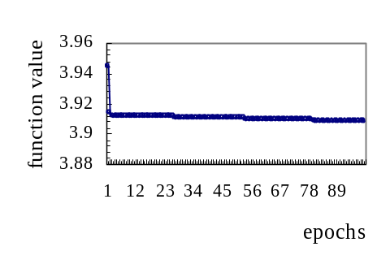
Figure.9. The function convergent figure of Rosenbrock function using gradient-descent method

Figure.10. The searching locus figure of Rosenbrock function using grey-gradient method

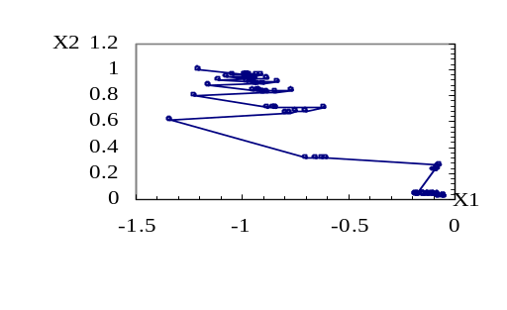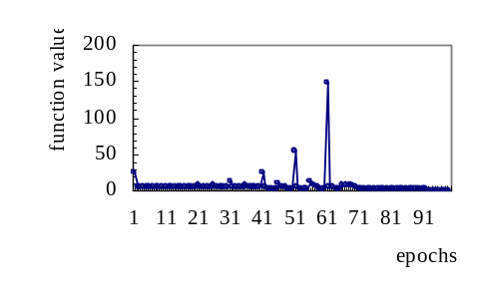
Figure.11. The searching locus figure of Rosenbrock function using grey-gradient method

5 Conclusions and Discussions
From the experimental results, we can conclude some properties about the grey-gradient method that shows as follow:
(1) The grey-gradient method can find the direction and developing tendency of solution according to the searching direction of gradient-descent method. It can predict the possible direction of solution with appropriate prediction step. The grey-gradient method has faster convergent speed than gradient-descent method, and it can speed up the searching speed of gradient-descent method.
(2) When we use appropriately grey prediction step, the grey-gradient method can escape effectively from the local minimal.
(3) For most engineering problems, the grey-gradient method will have more high probability to get global minimum solution than gradient-descent method does.
(4) Because the GM(1,1) model can be calculated at constant time, the grey-gradient method does not increase the time complexity too much.

Although the grey gradient search method can effectively improve the gradient-descent method, there are some issues that need to be discussed. They are:
- More mathematics analysis to prove the properties of grey gradient search method.
- More applications of grey gradient search method.

Acknowledgement
In acknowledgement of being funded by the National Science Council (title: Design of Genetic-Based Cerebellar Model Articulation Controller for DC Servo Motor Control project # NSC 87-2213-E-003-004)

References
[1]J. L. Deng ,“ Control problems of Grey System,” Systems & Control Letters, Vol. 1, pp.288-294, 1982.
[2]J. L. Deng ,“ The Essential Methods of Grey System,” Huazhong University of Science and Technology Press, pp. 1-137, 1987.
[3]J. L. Deng ,“ Grey System Control,” Huazhong University of Science and Technology Press, pp. 25-134, 1985.
[4]J. L. Deng ,“ Introduction to Grey System Theory,” The Journal of Grey System, Vol. 1, pp. 1-24, 1989.
[5]Chih-Ming Chen, Hong-Cen Lin and Chin-Ming Hong ,“ The Design and Application of a Genetic-Based Fuzzy Grey Prediction Controller,” Journal of The Chinese Grey System Association, Vol.1, pp. 33-46, 1998.
[6]Chin-Ming Hong, Chin-Tang Chiang, Sinn-Cheng Lin ,“ Control of Dynamic Systems by Fuzzy-based Grey Prediction Controller,” The Journal of Grey System, Vol. 7, No. 1, pp. 23- 44, 1995.
[7]Jacobs, R. A. ,“ Increased Rates of Convergence Through Learning Rate Adaptation,” Neural Networks, Vol. 1, pp. 295-307, 1988.
[8]Min-Shin Chen ,“ Control of Linear Time-Varying Systems by The Gradient Algorithm,” IEEE Conference on Decision & Control, pp. 4549-4553, 1997.
[9]G. V. Reklaitis, A. Ravindran & K. M. Ragsdell ,“ Engineering Optimization Methods and Applications,” A Wiley-Interscience Publication, 1983.

