Nicholas J. Tustison
480 Ray C Hunt Drive
Charlottesville, VA 22903
ntustison@virginia.edu

Michael Yassa
1400 Biological Sciences 3
Irvine, CA 92697
myassa@uci.edu

March 4, 2019

Dear Professors Peter T. Fox, Jack L. Lancaster, Gary Egan, and Simon B. Eickhoff,
I am pleased to submit an original research article entitled “Longitudinal mapping of cortical thickness measurements: an ADNI-based evaluation study” for consideration for publication in the journal Human Brain Mapping. Cortical morphology has been widely used to investigate both pathological and developmental processes. Members of our team previously published a large-scale evaluation of two well-known frameworks for extracting localized cortical thickness measurements in a cross-sectional human cohort (Tustison, et al., “Large-scale evaluation of ANTs and FreeSurfer cortical thickness measurements,” NeuroImage 2014) which has been well-cited. This work presents a longitudinal specific framework which is also available as open source through the Advanced Normalization Tools software library. Using the well-known ADNI data set, we evaluate the derived thickness measurements in the context of a linear mixed effects modeling which permits a straightforward comparison with other processing streams, including the established FreeSurfer processing stream.

We believe that this manuscript is appropriate for Human Brain Mapping because it presents “results of neuroimaging research, …particularly those which utilize novel ... analytic methods.” A cursory topical search yields similar type articles that have been recently published in Human Brain Mapping:

- C. Jockwitz, et al., Generalizing age effects on brain structure and cognition: A two‐study comparison approach, 2019.
- R. Haast, et al., The impact of correction on MP2RAGE cortical T1 and apparent cortical thickness at 7T, 2018.

This manuscript has not been published and is not under consideration for publication elsewhere. We have no conflicts of interest to disclose

Thank you for your consideration,
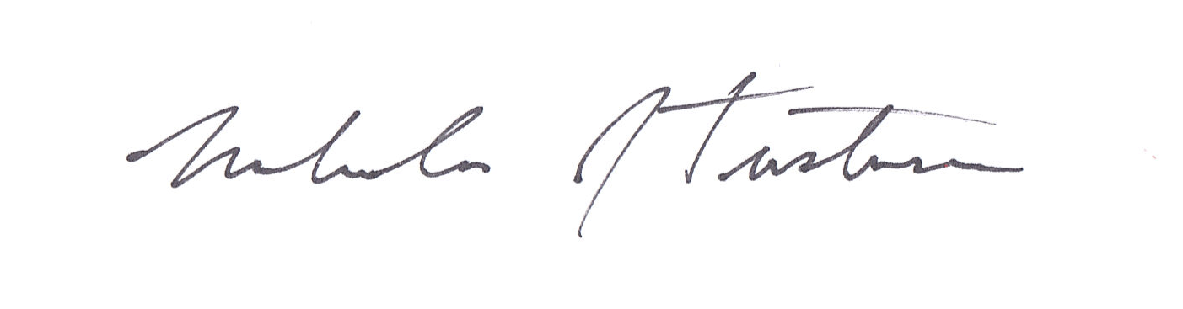
Nicholas J. Tustison, D.Sc.
Associate Professor
Department of Radiology and Medical Imaging
University of Virginia

