Sep. 29, 2018

Dear Dr. Michael Breakspear,
On behalf of all the co-authors, I submit our revised manuscript entitled “The ANTs Longitudinal Cortical Thickness Pipeline” constituting a large-scale longitudinal analysis of the well-known ADNI data set using our proposed processing protocol based on the Advanced Normalization Tools.

We appreciate the opportunity to address the issues raised by the reviewers and have significantly modified our work based on the presented critiques.

We sincerely hope that you consider our revised manuscript for re-review.

Sincerely,
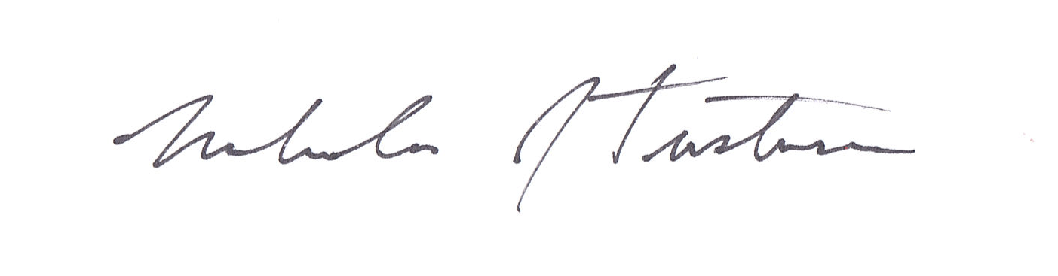
Nicholas J. Tustison

