May 20, 2018

Dear Professor N. Reed Dunnick, MD,
On behalf of all the co-authors, it is with great pleasure that I submit our manuscript entitled Convolutional Neural Networks with Template-Based Data Augmentation for Functional Lung Image Quantification. We are submitting it (class Pulm Funct Imaging) at the invitation of Dr. Rahim Rizi of the University of Pennsylvania who is guest editing a special issue for Academic Radiology.

In this manuscript, we detail three main contributions: structural/functional lung segmentation using convolution neural networks, the introduction of a novel template-based data augmentation strategy for training deep learning architectures, and ANTsRNet---a growing open-source repository for well-known deep learning architectures for image classification, segmentation, and object detection. Given the content and the open science nature of our work in terms of both software and data, we strongly believe strongly that this is a very important contribution to be considered by Academic Radiology.

We sincerely hope that you consider our manuscript for review.

Sincerely,
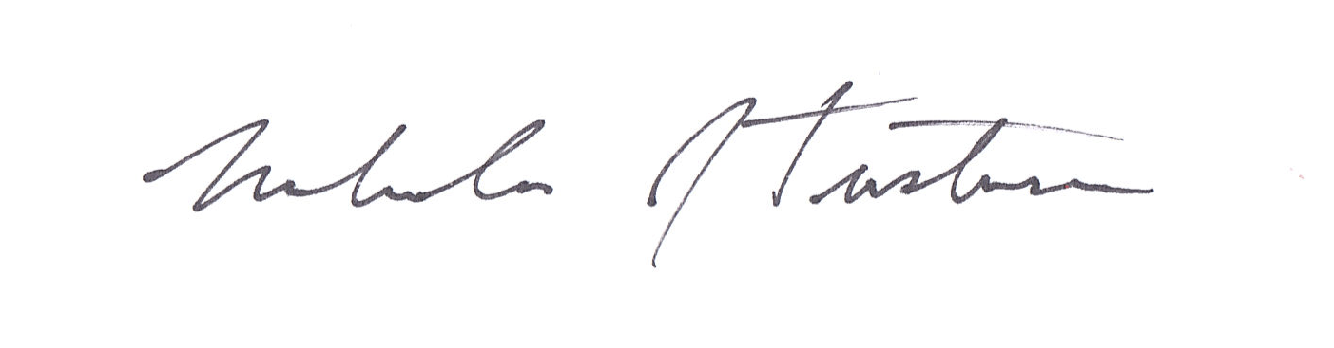
Nicholas J. Tustison

