Nicholas J. Tustison
480 Ray C Hunt Drive
Charlottesville, VA 22903
540-383-2719
ntustison@virginia.edu

March 20, 2021

Dear Dr. Peter Jezzard,
I am pleased to submit an original article concerning widely used image analysis practices in the field of functional hyperpolarized gas lung imaging. Not only do we compare the current state-of-the-art tools in the field which rely heavily on lossy image transformations, but we suggest a focused future research direction that optimizes directly in the image space, i.e., deep learning. This new functionality is publicly available through the well-known Advanced Normalization Tools software ecosystem. In addition, we provide all processing, evaluation, and training scripts as open-source in a dedicated GitHub repository.

All authors have contributed to the work and agree with the presented findings. We have no conflicts of interest to disclose. This manuscript has not been published and is not under consideration for publication elsewhere although it has been posted on medrxiv (https://www.medrxiv.org/content/10.1101/2021.03.04.21252588v3).

Thank you for your consideration,
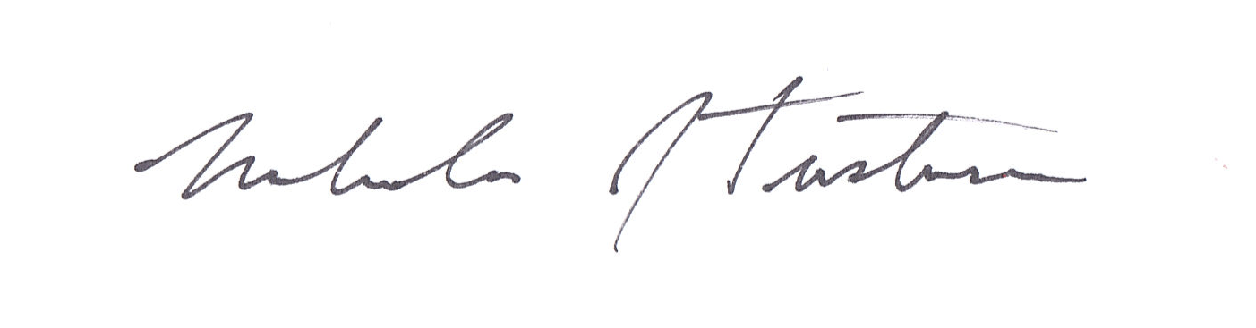
Nicholas J. Tustison, D.Sc.
Associate Professor
Department of Radiology and Medical Imaging
University of Virginia

