April 2, 2026
Nik WEY
nik.wey@stud.hslu.CH

Expert Interview & Reflection
Table of Contents
Introduction 2
Professional Insights 2
Cultural Analysis 3
Self-Evaluation 4
Appendix 5
Bullet list of the 5 prepared questions 7

Introduction
I chose Melissa Phillips, an Offensive Security Engineer. In her position, she does a bit of everything, from security tests to writing reports. When she is off the clock, she gives presentations at cybersecurity conventions such as Black Alps in Yverdon-les-Bains. This is where I first saw her and why I chose her for my interview. Because I saw her there, it was quite easy to use that shared experience in my cold outreach strategy. It didn't really help with the value exchange, but I figured that the paper I'm writing on AI Threat Analysis is the best fit to offer her.

Professional Insights
The most valuable insight from my conversation with Melissa Phillips was her strategy for translating complex technical vulnerabilities for a non-technical board. She emphasized that to get a point across, one must steer clear of the weeds. Instead of explaining the mechanics of an exploit, the goal is to provide a top-level narrative that focuses on the "real-world" business impact. By using storytelling to illustrate the risk, the vulnerability stops being an abstract technical bug and becomes a tangible priority that management can actually visualize and fix.
This conversation also fundamentally shifted my perspective on professional development. Hearing how essential industry credentials are for an Offensive Security Engineer provided the necessary "shot in the arm" to commit to my own certification path. It validated that technical curiosity alone isn't enough; you need a standardized foundation to be taken seriously in the field. As a direct result, I’ve decided to stop dragging my feet and will officially begin my CCNA next semester. This interview helped me realize that being a successful engineer isn't just about the "break-fix" cycle—it’s about mastering the Value Exchange through clear communication and proven expertise.

Cultural Analysis
In the realm of international business and professional interaction, cultural nuances often dictate the success of an exchange more than the technical content itself. During my interview with Melisa, these nuances became visible through the lens of Erin Meyer’s Culture Map. By analyzing our interaction through the scales of Communicating and Persuading, I was able to identify shifts in our dynamic that moved the conversation from a formal Q&A to a high-value professional dialogue.
Melisa’s communication style leaned heavily toward High-Context. A defining moment occurred when she used the professional idiom: "Security should be baked in, not spread on." In Meyer’s framework, the use of metaphors and idioms is a hallmark of high-context cultures, where the speaker assumes the listener has the requisite "insider" knowledge to decode the message. I interpreted this cue not just as a technical philosophy, but as an invitation to engage on a more sophisticated, conceptual level. Rather than asking for a literal explanation, I mirrored this high-context approach by nodding to the shared understanding of the DevSecOps lifecycle, which immediately signaled professional alignment.
Furthermore, Melisa demonstrated an Applications-First method of persuasion. She focused consistently on the "how" of offensive security—practical implementation and real-world execution—rather than dwelling on the abstract theories of vulnerability. Coming from a more academic or "Principles-First" mindset, I initially felt the need to establish a theoretical foundation. However, seeing her directness, I adjusted my strategy. I moved away from my scripted, broad questions toward more direct, actionable ones. I "padded" these questions with my own observations, which served to build Relationship-Based trust. By showing more of my own personality and "opening up," I lowered the professional barrier I had initially set with my blurred camera background—a stark contrast to her unfiltered, more personal background.
We found a moment of perfect cultural alignment in our orientation toward Linear-Time. Both of us joined the call early, showing a mutual respect for the schedule and a shared view that "time is money." This established a baseline of professionalism that allowed me to feel more confident when I later decided to deviate from my plan.
This adjustment significantly improved the interaction. As I became more direct and less reliant on my script, Melisa’s answers became more expansive and candid. I learned that my natural tendency is toward a Task-Based, Low-Context style, which can sometimes come across as rigid. By adapting to Melisa’s high-context metaphors and applications-first logic, I transformed a standard interview into a genuine exchange of expertise. This experience highlighted that in the world of security, being "direct" doesn't mean being "simple"—it means being relevant.

Self-Evaluation
Reflecting on my recent outreach and interview performance, the gap between my preparation and the reality of the exchange was significant. Due to my dyslexia, I find reading from a script restrictive, preferring instead to memorize key points. However, because I didn't invest enough time in prep beforehand, I couldn't fully internalize the material. This led to a rehearsal process that felt "odd," resulting in me improvising most of the session. Interestingly, I found that these spontaneous questions felt much more natural than the pre-written ones. While my phrasing shifted constantly, the core intent remained, and my follow-up strategy actually worked well, allowing me to dig deeper into the responses I received.
Regarding the interpersonal flow, my small talk was admittedly weak. My nerves pushed me to jump straight into the questioning, bypassing the rapport-building stage. The first three questions felt particularly generic and anstrengend, creating a strenuous start. Next time, I plan to start my preparation earlier to accommodate my need for memorization and focus on "chilling" out. By overthinking less and refining my opening to be less generic, I can transform the experience from a rigid interrogation into a more authentic, fluid dialogue.

Appendix

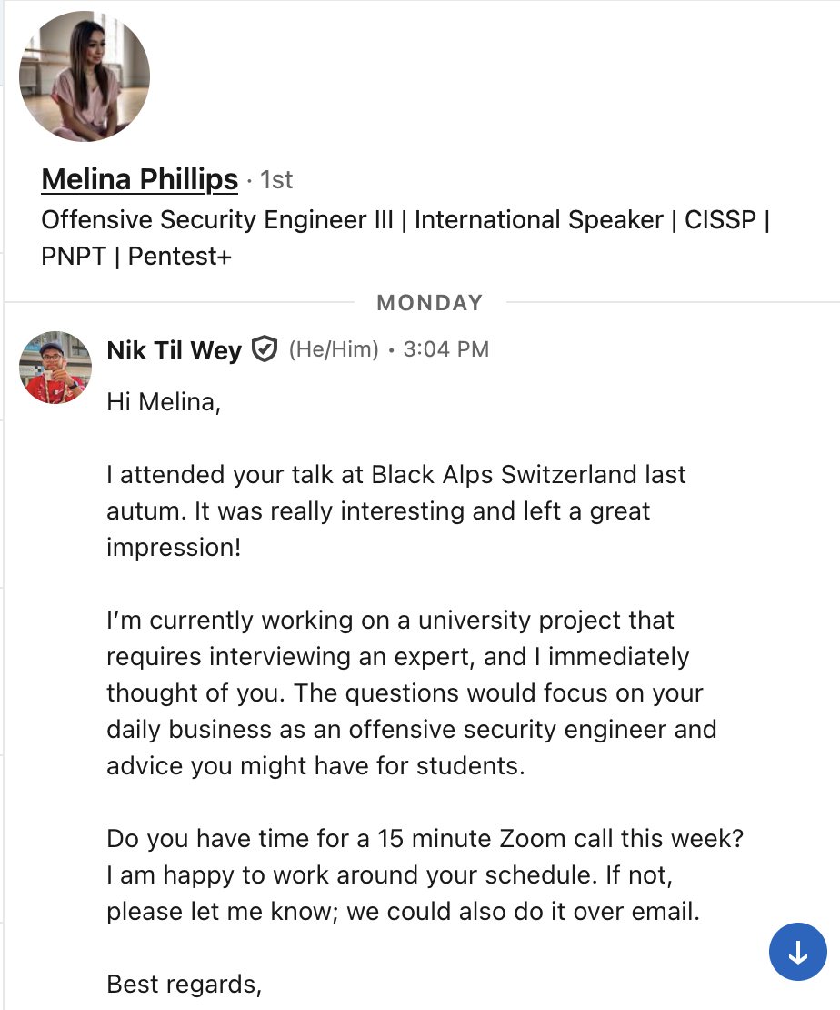
Figure 1 Screenshot of initial outreach

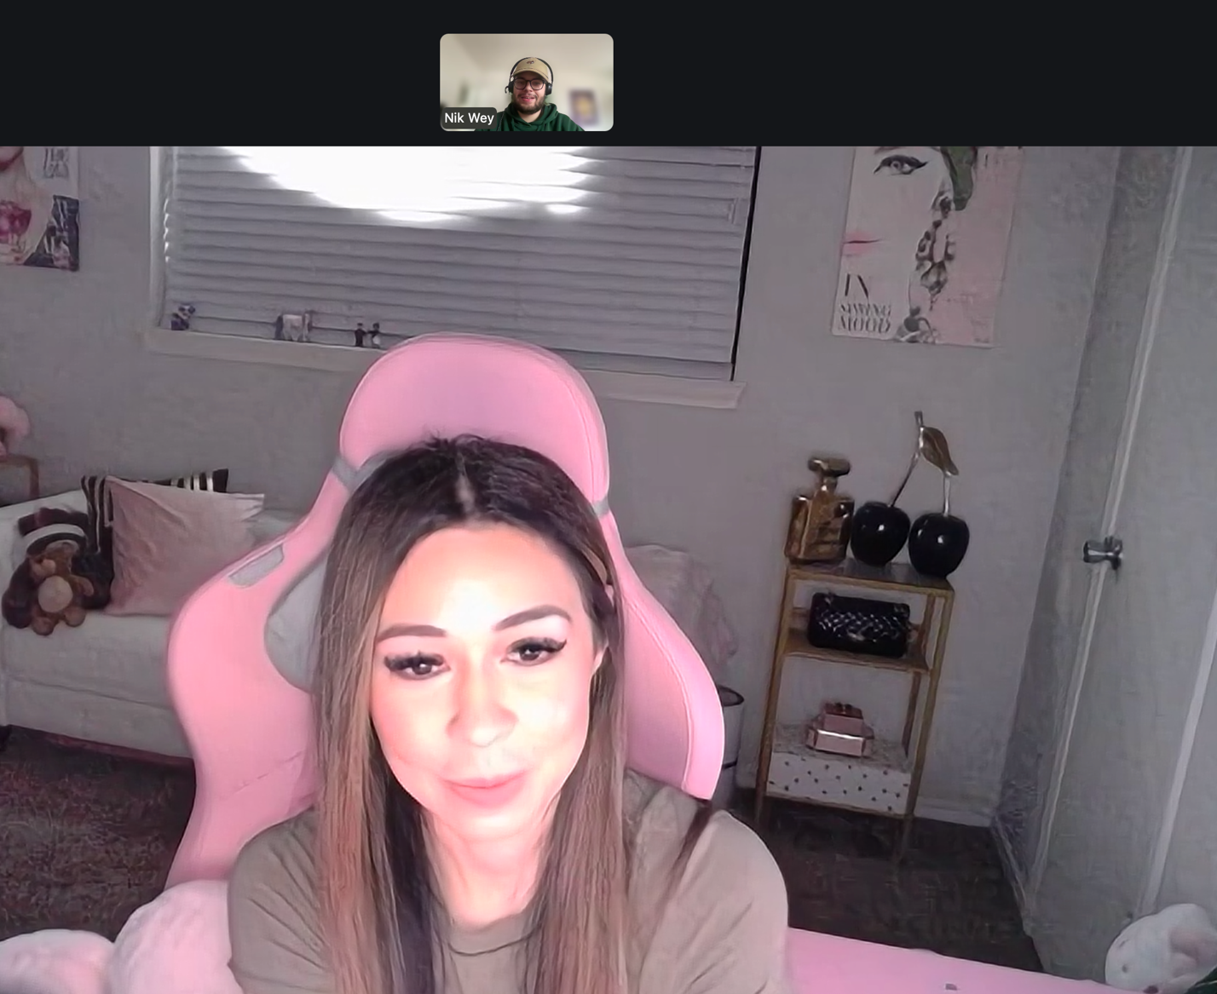
Figure 2 Screenshot of the virtual meeting
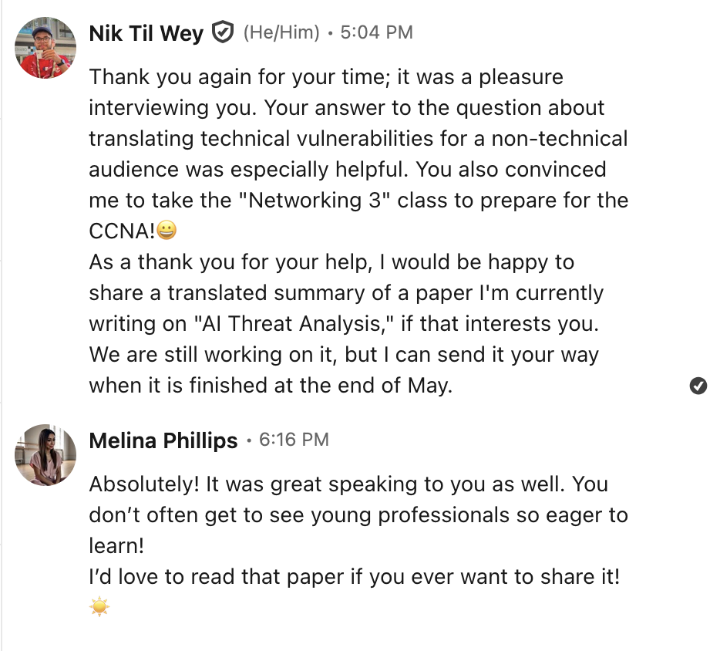
Figure 3 Screenshot of the thank you message

Bullet list of the 5 prepared questions
- What does a 'typical' day look like for you right now?
- How do you see the rise of automated exploitation and AI changing the landscape of offensive security over the next few years?
- When you start an engagement, what is the most common oversight you see defensive teams make?
- How do you translate a technical vulnerability for a non-technical board? Do you find that being extremely direct works best, or do you have to frame it within a larger business story to get them to act?
- For someone like me who works primarily in defense, what is the single most important 'offensive' skill or mindset I should adopt to become a better security professional?

