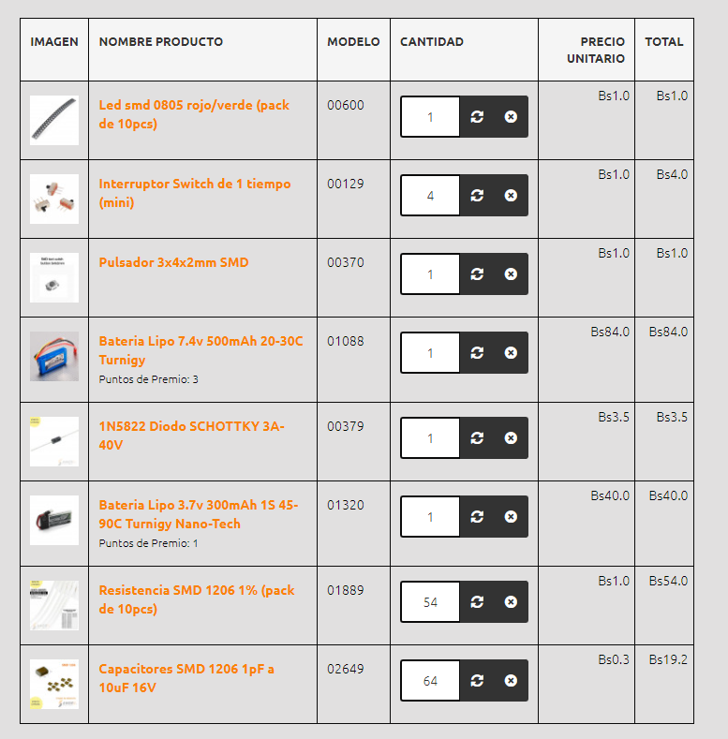

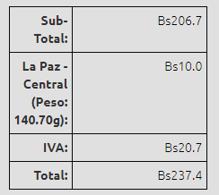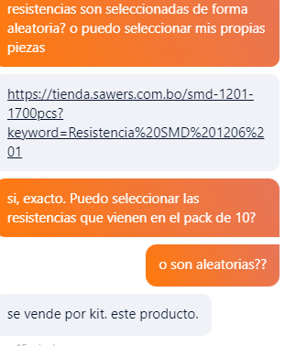

[**Resistencia SMD 1206 1% (pack de 10pcs)**](https://tienda.sawers.com.bo/smd-1201-1700pcs) - Maybe we could buy just 6??? Since its a 10 pcs. pack… But I don’t know if we’ll get the ones we need. Since this is an estimate for us and third parties, maybe we could opt to buy each resistor individually, in order to not buy resistances we won’t use. I think just a resistance was like 0.5 bs.