Quantum Machine Learning

Dataset Description
Fashion-MNIST is a dataset of Zalando's article images—consisting of a training set of 60,000 examples and a test set of 10,000 examples. Each example is a 28x28 grayscale image, associated with a label from 10 classes.

EDA
Choose dataset entries which belong to 5 and 9 classes.
5 class – ankle boots
9 class – sandals
Normalize the dataset images by dividing by 255.0.
Flatten image data by converting it to (1, 4, 1) shape
Encode images with binary function
Convert Cirq Circuits to tensorflow tensors
Encode classes 5 and 9 to be -1 and 1 respectively. This is needed to use Hinge Loss.

Model Architecture
Building the Quantum Neural Network involves two steps
- Build a class that adds gates layer by layer
- Define the QNN using the class from the above step
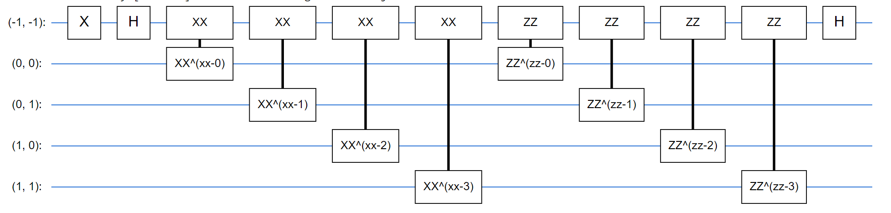

Model Training
The result model is trained with a batch size of 64 and for 10 epochs.
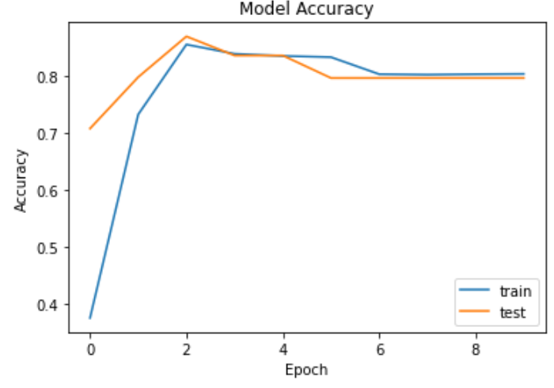
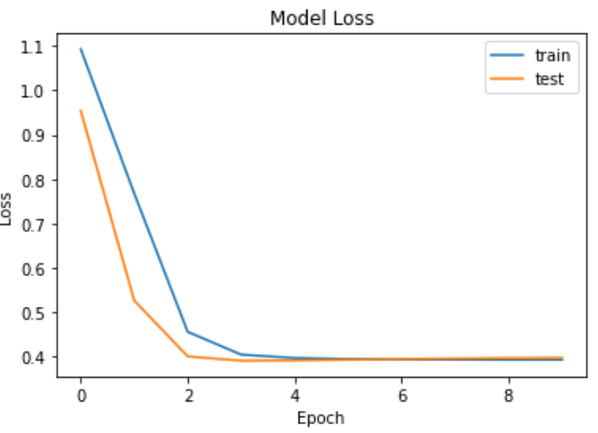
The model performance is represented by the following metrics:
- Loss – 0.37
- Accuracy – 0.82

