CS396 Software Design Principles and Practices
Project: Milestone 2 Report

Project Progress Evaluation
- Revised Class Diagram:
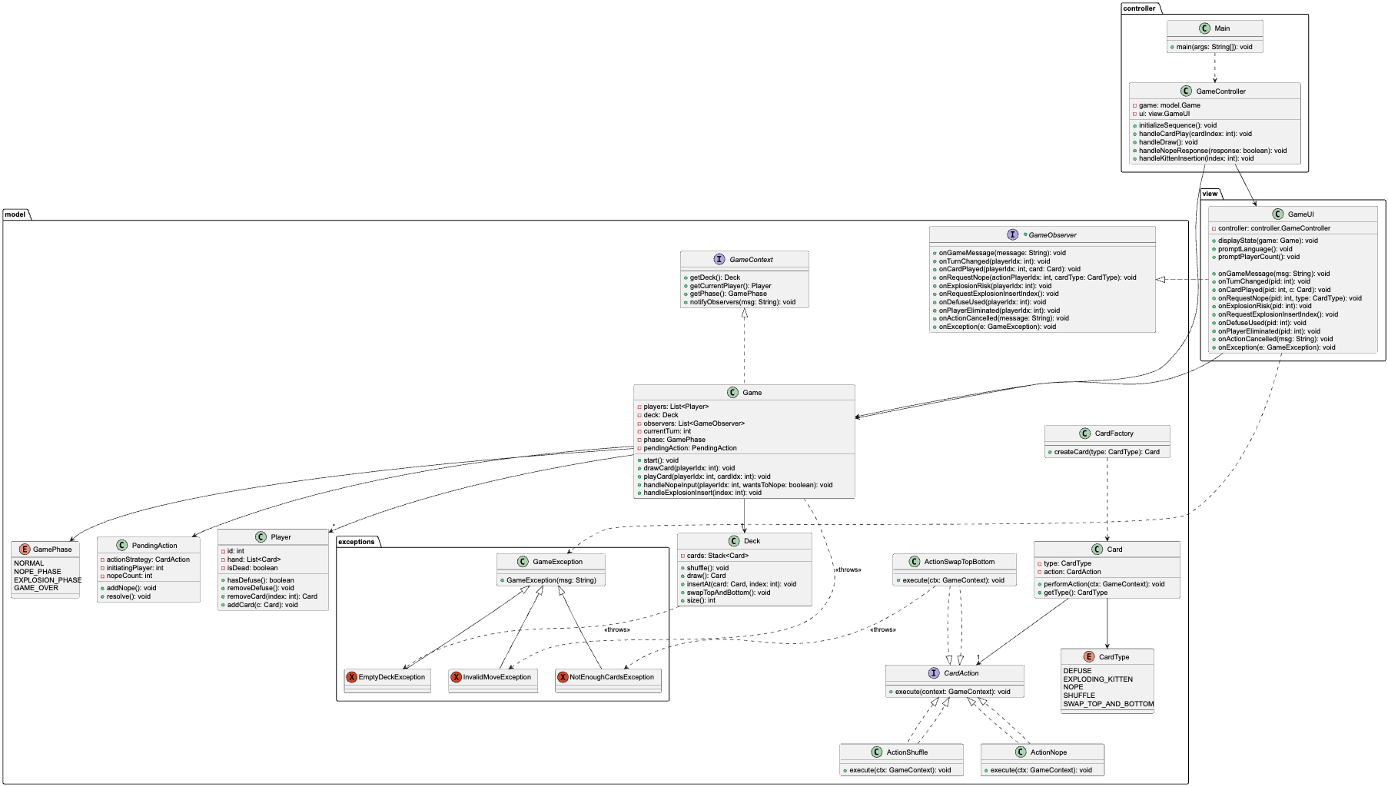
- I have finalized the revised design and am ready to begin implementation next week. Although the project is currently running four days behind schedule due to an overly condensed initial timeline, the planned activities remain valid and necessary. My focus for next week (11/24 – 11/30) will be implementing the logic for the chosen card types, followed by testing and report writing the subsequent week (12/1 – 12/8).

Do You Have Any Questions About the Grading Rubrics?
No.

Do You Have Any Other Questions?
- The recent forum post (screenshot attached below) clarifyed that we only need to produce Use Cases for the 4 specific cards we are refactoring, rather than the entire deck.
Building on that logic, I wanted to ask about the scope of the implementation:
Since we are focusing deeply on refactoring these specific mechanics (Shuffle, Nope, Explosion, Swap), other features like maintaining the legacy support for Multiple Game Modes (Streaking/Imploding Kittens) and different language adds significant complexity to the Domain Layer that isn't relevant to the refactored cards.
My Question is that, to demonstrate a clean design, may I align the implementation with the reduced scope of the Use Cases?
I would like to remove the unused Game Modes and Language logic to produce a polished, "pure" refactored demo of the 4 core cards, rather than a hybrid system that mixes the new design with the old messy code.
Is this acceptable? Thank you!
