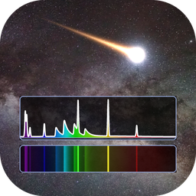
METEORAD
METEOr RADiation spectra
Specification and User Manual
Line-by-line emission/absorption spectra of high-temperature plasmas
Python edition of SPRADIAN-1.8 (JAXA) — GUI version 0.1.0
Original code: SPRADIAN-1.8 — K. Fujita and T. Abe (ISAS/JAXA)
Additional atoms/molecules and GUI: Shinsuke Abe (阿部新助)
Document date: 2026-10-24
Use of METEORAD requires citing Fujita & Abe (1997), Fujita & Abe (2003) and Abe et al. (2026) (Section 1.4).

Contents
1. Overview
1.1 Applications
1.2 Main features
1.3 Verification
1.4 Citation (required)
2. Requirements and installation
3. Start-up and window layout
4. Species panel
4.1 Presets
5. Parameter panel
5.1 Automatic pressure FWHM (Auto)
6. Running and displaying spectra
6.1 Basic procedure
6.2 Plot-panel controls
6.3 Slab intensity
7. Menus
7.1 Spectrum file format
8. Temperature sweep
9. Fitting an observed spectrum
9.1 Settings
9.2 Search method
10. Importing VALD line lists
11. Loading control files (.ctl)
12. Python API
13. Physical model and specifications
13.1 Units and conventions
13.2 Calculation flow
13.3 Line shapes
13.4 Instrument-function convolution
14. Databases
14.1 Approximations for the added molecules
14.2 Adding species
15. Limitations and cautions
16. Credits and references
16.1 Required citations
16.2 Further references
16.3 Terms of use

(If the table of contents is empty, right-click it in Word and choose "Update Field".)

1. Overview
METEORAD (METEOr RADiation spectra) computes line-by-line emission and absorption spectra of high-temperature plasmas. It is a Python port of JAXA's radiation code SPRADIAN-1.8 (Structured Package for Radiation Analysis; K. Fujita and T. Abe, ISAS/JAXA); the physics, the database format and the control-file format follow the original C code.
This software is based on JAXA's SPRADIAN. Shinsuke Abe added further atoms and molecules important for atmospheric entry and meteor emission and built the GUI.
The METEORAD extensions — Python port, additional atoms/molecules, GUI, temperature sweeps, observed-spectrum fitting, Python API, etc. — are described in Abe et al. (2026) (Section 1.4).

1.1 Applications
- Ablation emission of meteors and space debris (metal atoms, ions and metal oxides)
- Radiation of air plasmas around re-entry capsules (N₂, O₂, NO, N, O and their ions)
- Combustion-gas emission (C₂, CN, CH, OH, CO, ...)
- Estimating temperatures, number densities and instrument resolution by fitting observed spectra

1.2 Main features
- Non-equilibrium five-temperature model (translational Ttr / rotational Trot / vibrational Tvib / electronic-excitation Tex / electron Tel)
- Bound-bound radiation (atomic lines and diatomic bands) and continua (bound-free, free-bound, free-free)
- Line shapes: Voigt / rectangular / Lorentzian; automatic estimate of the pressure FWHM (Stark + van der Waals)
- Uniform-slab line-of-sight intensity with self-absorption, and the blackbody at Tel
- Gaussian instrument-function convolution; spectra coloured by dominant species
- Batch temperature sweeps exported to CSV
- Fitting of observed spectra (grid search + linear least squares + Nelder–Mead refinement)
- Import of VALD line lists; reading SPRADIAN-1.8 control files (.ctl)
- Python API (run_spectrum) for calculations without the GUI

1.3 Verification
For sample1.ctl of the C version (10 air species, 10000 K, 3000–3500 Å) the spectra and fluxes agree with SPRADIAN-1.8 to the printed precision (5 significant digits). For all added debris/metal species, the wavelengths of the strongest lines/band heads agree with literature values (tools/test_debris.py).

1.4 Citation (required)
Any publication, presentation or report based on METEORAD must cite all three of the following papers in its acknowledgements/references.
- Fujita K, Abe T (1997) SPRADIAN, structured package for radiation analysis: theory and application. ISAS Report No. 669, pp. 1–47. Institute of Space and Astronautical Science. https://jaxa.repo.nii.ac.jp/records/31438
- Fujita K, Abe T (2003) Development of a radiation analysis code for hypervelocity reentry applications. ISAS Report SP No. 17, pp. 69–82. Institute of Space and Astronautical Science. https://jaxa.repo.nii.ac.jp/records/33242
- Abe S, et al (2026) C₂, CH and CN emission, surface temperature and luminous efficiency of the Hayabusa2 sample-return capsule from ground-based slitless video spectroscopy. Earth, Planets and Space.
Fujita and Abe (1997) is the original SPRADIAN theory paper and Fujita and Abe (2003) describes the development of the radiation analysis code for hypervelocity reentry. Abe et al. (2026) describes the METEORAD extensions of SPRADIAN: the Python port, the additional atoms/molecules for atmospheric entry and meteor emission, the GUI, temperature sweeps, fitting of observed spectra, the Python API, etc.
Example acknowledgement: "Spectra were computed with METEORAD (Fujita and Abe 1997, 2003; Abe et al. 2026)."

2. Requirements and installation
Table 1. Requirements
Item | Requirement
OS | macOS / Linux / Windows (anywhere Python runs)
Python | 3.9 or later
Computational core | numpy
GUI | matplotlib, PySide6 (Qt 6)

pip install numpy matplotlib PySide6
The directory layout is shown below. Both database directories are scanned at start-up.
SPRADIAN/
├── SPRADIAN-1.8/DATAPAC/database/ # original air/combustion .dat files (23 species)
└── meteorad_py/
├── meteorad/ # computational core (port of RADIPAC)
├── meteorad_gui/ # PySide6 GUI
├── database_debris/ # debris/metal .dat files (20 species) / VALD target
├── tools/ # .dat generators and tests
├── notes/ # port notes, data sources, verification
└── run_gui.py # GUI launcher
SPR-* working files and *.org / *.orig* backups are excluded from the species list. If database_debris/ is missing, the Debris/Metal group is simply empty.

3. Start-up and window layout
cd meteorad_py
python run_gui.py # empty form
python run_gui.py ../SPRADIAN-1.8/RADIPAC/samples/sample1.ctl # load a .ctl at start-up
python run_gui.py --version
If a required package is missing, the launcher prints its name and the pip command. The main window has four areas (Figure 1).
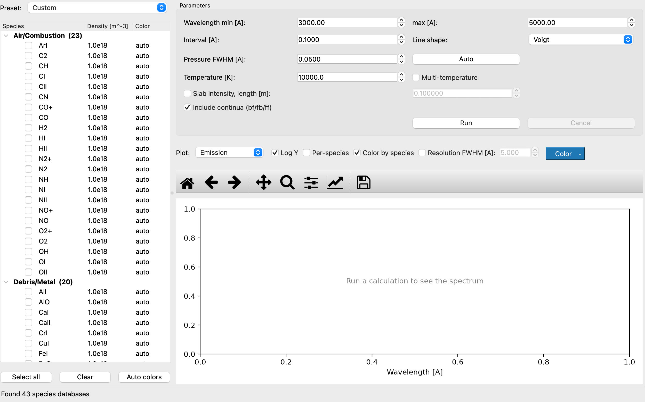
Figure 1. Main window right after start-up
Table 2. Main-window areas
Area | Position | Purpose
Species panel | left | choose species, number densities and plot colours; presets
Parameter panel | top right | wavelength range, interval, line shape, pressure broadening, temperatures, slab length, continua; Run/Cancel
Plot panel | bottom right | result display (quantity, log axis, per-species, resolution, colour)
Status bar | bottom | progress, run time, electron density Ne and total density, value at the clicked point

4. Species panel
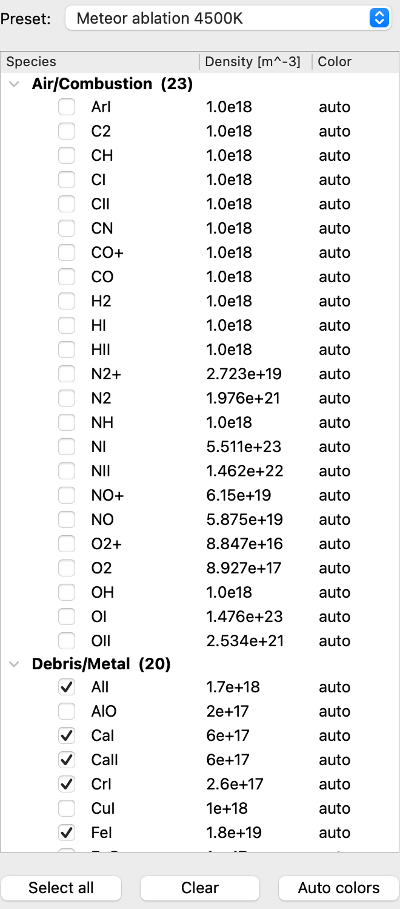
Figure 2. Species panel (after the Meteor ablation 4500K preset)
- Species are grouped as Air/Combustion (original DATAPAC) and Debris/Metal (database_debris).
- Checked species are included in the calculation.
- Double-click the Density [m^-3] column to edit the number density (e.g. 1.5e18).
- Double-click the Color column to choose the species' plot colour. Back to the automatic colour: right-click → "Reset to auto color", the Delete key, or the Auto colors button. Colours are remembered across sessions.
- Select all / Clear check or uncheck every species.
- Editing checks or densities by hand switches the preset box to Custom.

4.1 Presets
The Preset box sets a representative composition and temperature (the same value for all five temperatures) in one step.
Table 3. Presets
Preset | Temperature | Composition [m⁻³]
Air plasma 10000K | 10000 K | equilibrium air of sample1.ctl: NI 5.511e23, OI 1.476e23, NII 1.462e22, OII 2.534e21, N2 1.976e21, NO+ 6.15e19, NO 5.875e19, N2+ 2.723e19, O2 8.927e17, O2+ 8.847e16
Debris ablation 4000K | 4000 K | NaI 1e19, MgI 5e18, FeI 5e18, AlI 2e18, TiI 1e18, NiI 1e18, CuI 1e18, MgO 5e17, AlO 2e17, TiO 1e17, FeO 1e17
Meteor ablation 4500K | 4500 K | CI-chondritic ratios scaled to Si = 2e19: SiI 2e19, MgI 2.1e19, FeI 1.8e19, AlI 1.7e18, NaI 1.1e18, NiI 1e18, CaI 6e17, CaII 6e17, CrI 2.6e17, MnI 1.9e17, KI 7.4e16, TiI 4.8e16
Custom | — | manual settings (no preset applied)

Preset compositions are representative values; set the densities for your own conditions in real analyses.

5. Parameter panel
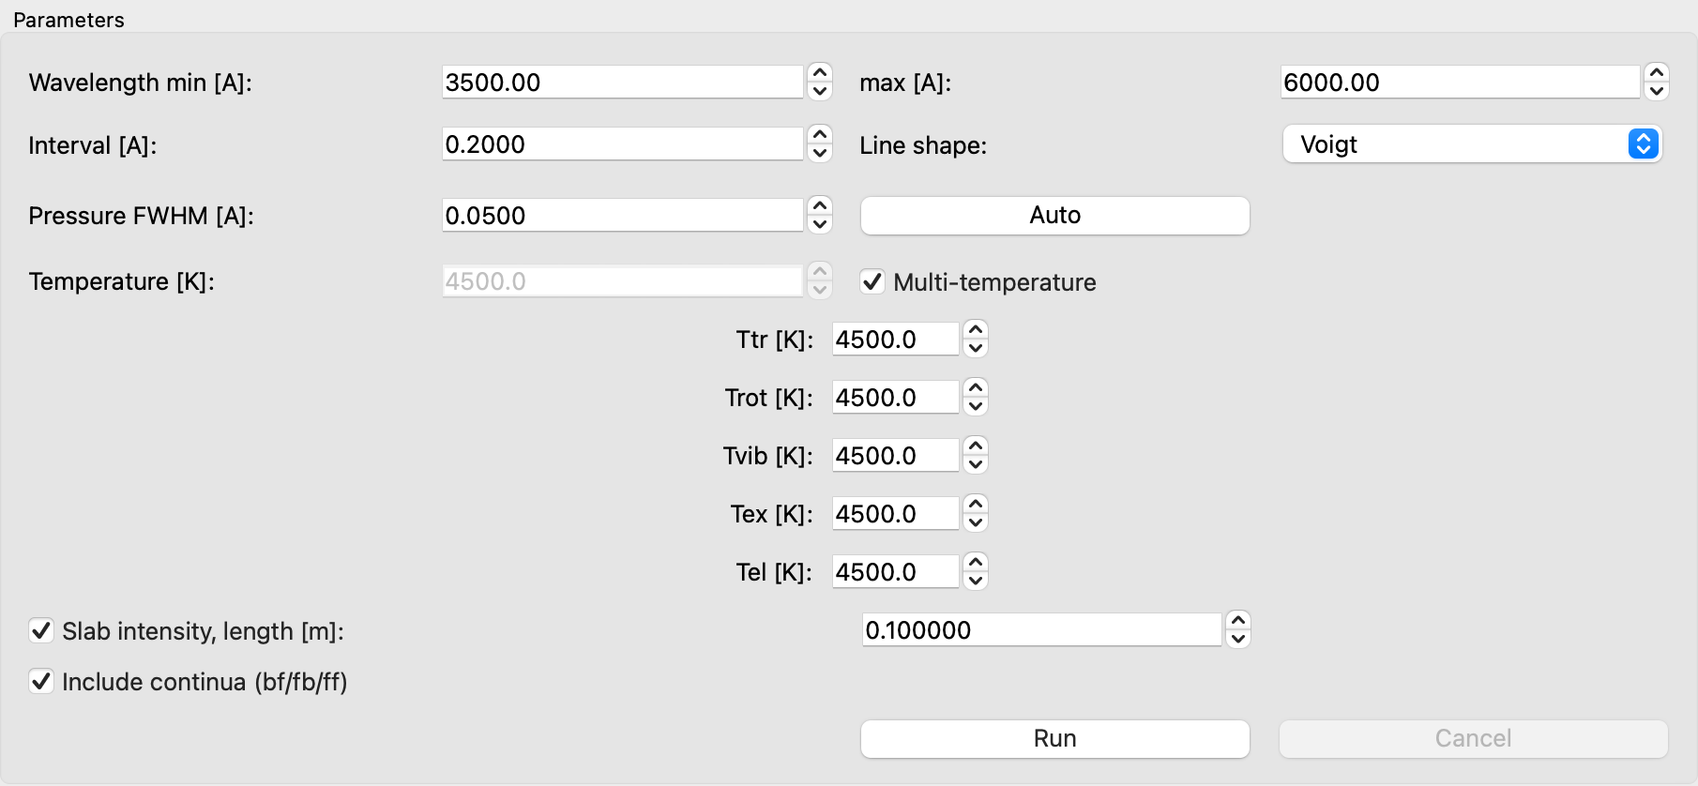
Figure 3. Parameter panel (multi-temperature mode, slab intensity on)
Table 4. Parameters
Field | Unit | Description
Wavelength min / max | Å | Wavelength range. Editing it inside the computed range only zooms the plot; extending it outside triggers an automatic re-run.
Interval | Å | Wavelength grid spacing
Line shape | — | Voigt / Rectangular / Lorentzian
Pressure FWHM | Å | Full width at half maximum of pressure broadening (Lorentzian part). The Doppler width is computed from Ttr.
Auto | — | Estimates the pressure FWHM from the selected densities and temperature (Section 5.1)
Temperature | K | Equilibrium temperature (applied to all five)
Multi-temperature | K | When checked, set Ttr, Trot, Tvib, Tex and Tel individually
Slab intensity, length | m | Compute the uniform-slab line-of-sight intensity (Section 6.3)
Include continua (bf/fb/ff) | — | Include bound-free, free-bound and free-free continua
Run / Cancel | — | Start / stop the calculation (stops at the next species or stage boundary)

Table 5. Five-temperature model
Temperature | Meaning | Mainly controls
Ttr | translational | Doppler width, van der Waals width
Trot | rotational | rotational populations of molecules (band shape)
Tvib | vibrational | vibrational populations (relative band intensities)
Tex | electronic excitation | electronic-state populations (line intensities)
Tel | electron | ionisation, continua, blackbody temperature

5.1 Automatic pressure FWHM (Auto)
The Auto button estimates the sum of the Stark and van der Waals widths at the centre λ of the wavelength range. The electron density Ne follows from the ion densities by charge neutrality; the neutral density N₀ enters the van der Waals term.
FWHM = Stark + vdW
Stark ∝ λ² · Ne, vdW ∝ λ² · (N₀ / N_ref) · (Ttr / 296 K)^0.3
The estimate is an order-of-magnitude value. For precise work, fit it to observations (Chapter 9) or use literature values. Without ion species the Stark term is 0.

6. Running and displaying spectra

6.1 Basic procedure
- Pick a preset in the species panel, or check species and enter number densities.
- Set the wavelength range, interval, temperatures, etc. in the parameter panel.
- Press Run. The calculation runs in a background thread; databases are cached between runs.
- The result appears in the plot panel; the status bar shows run time, Ne, total density and the number of grid points.
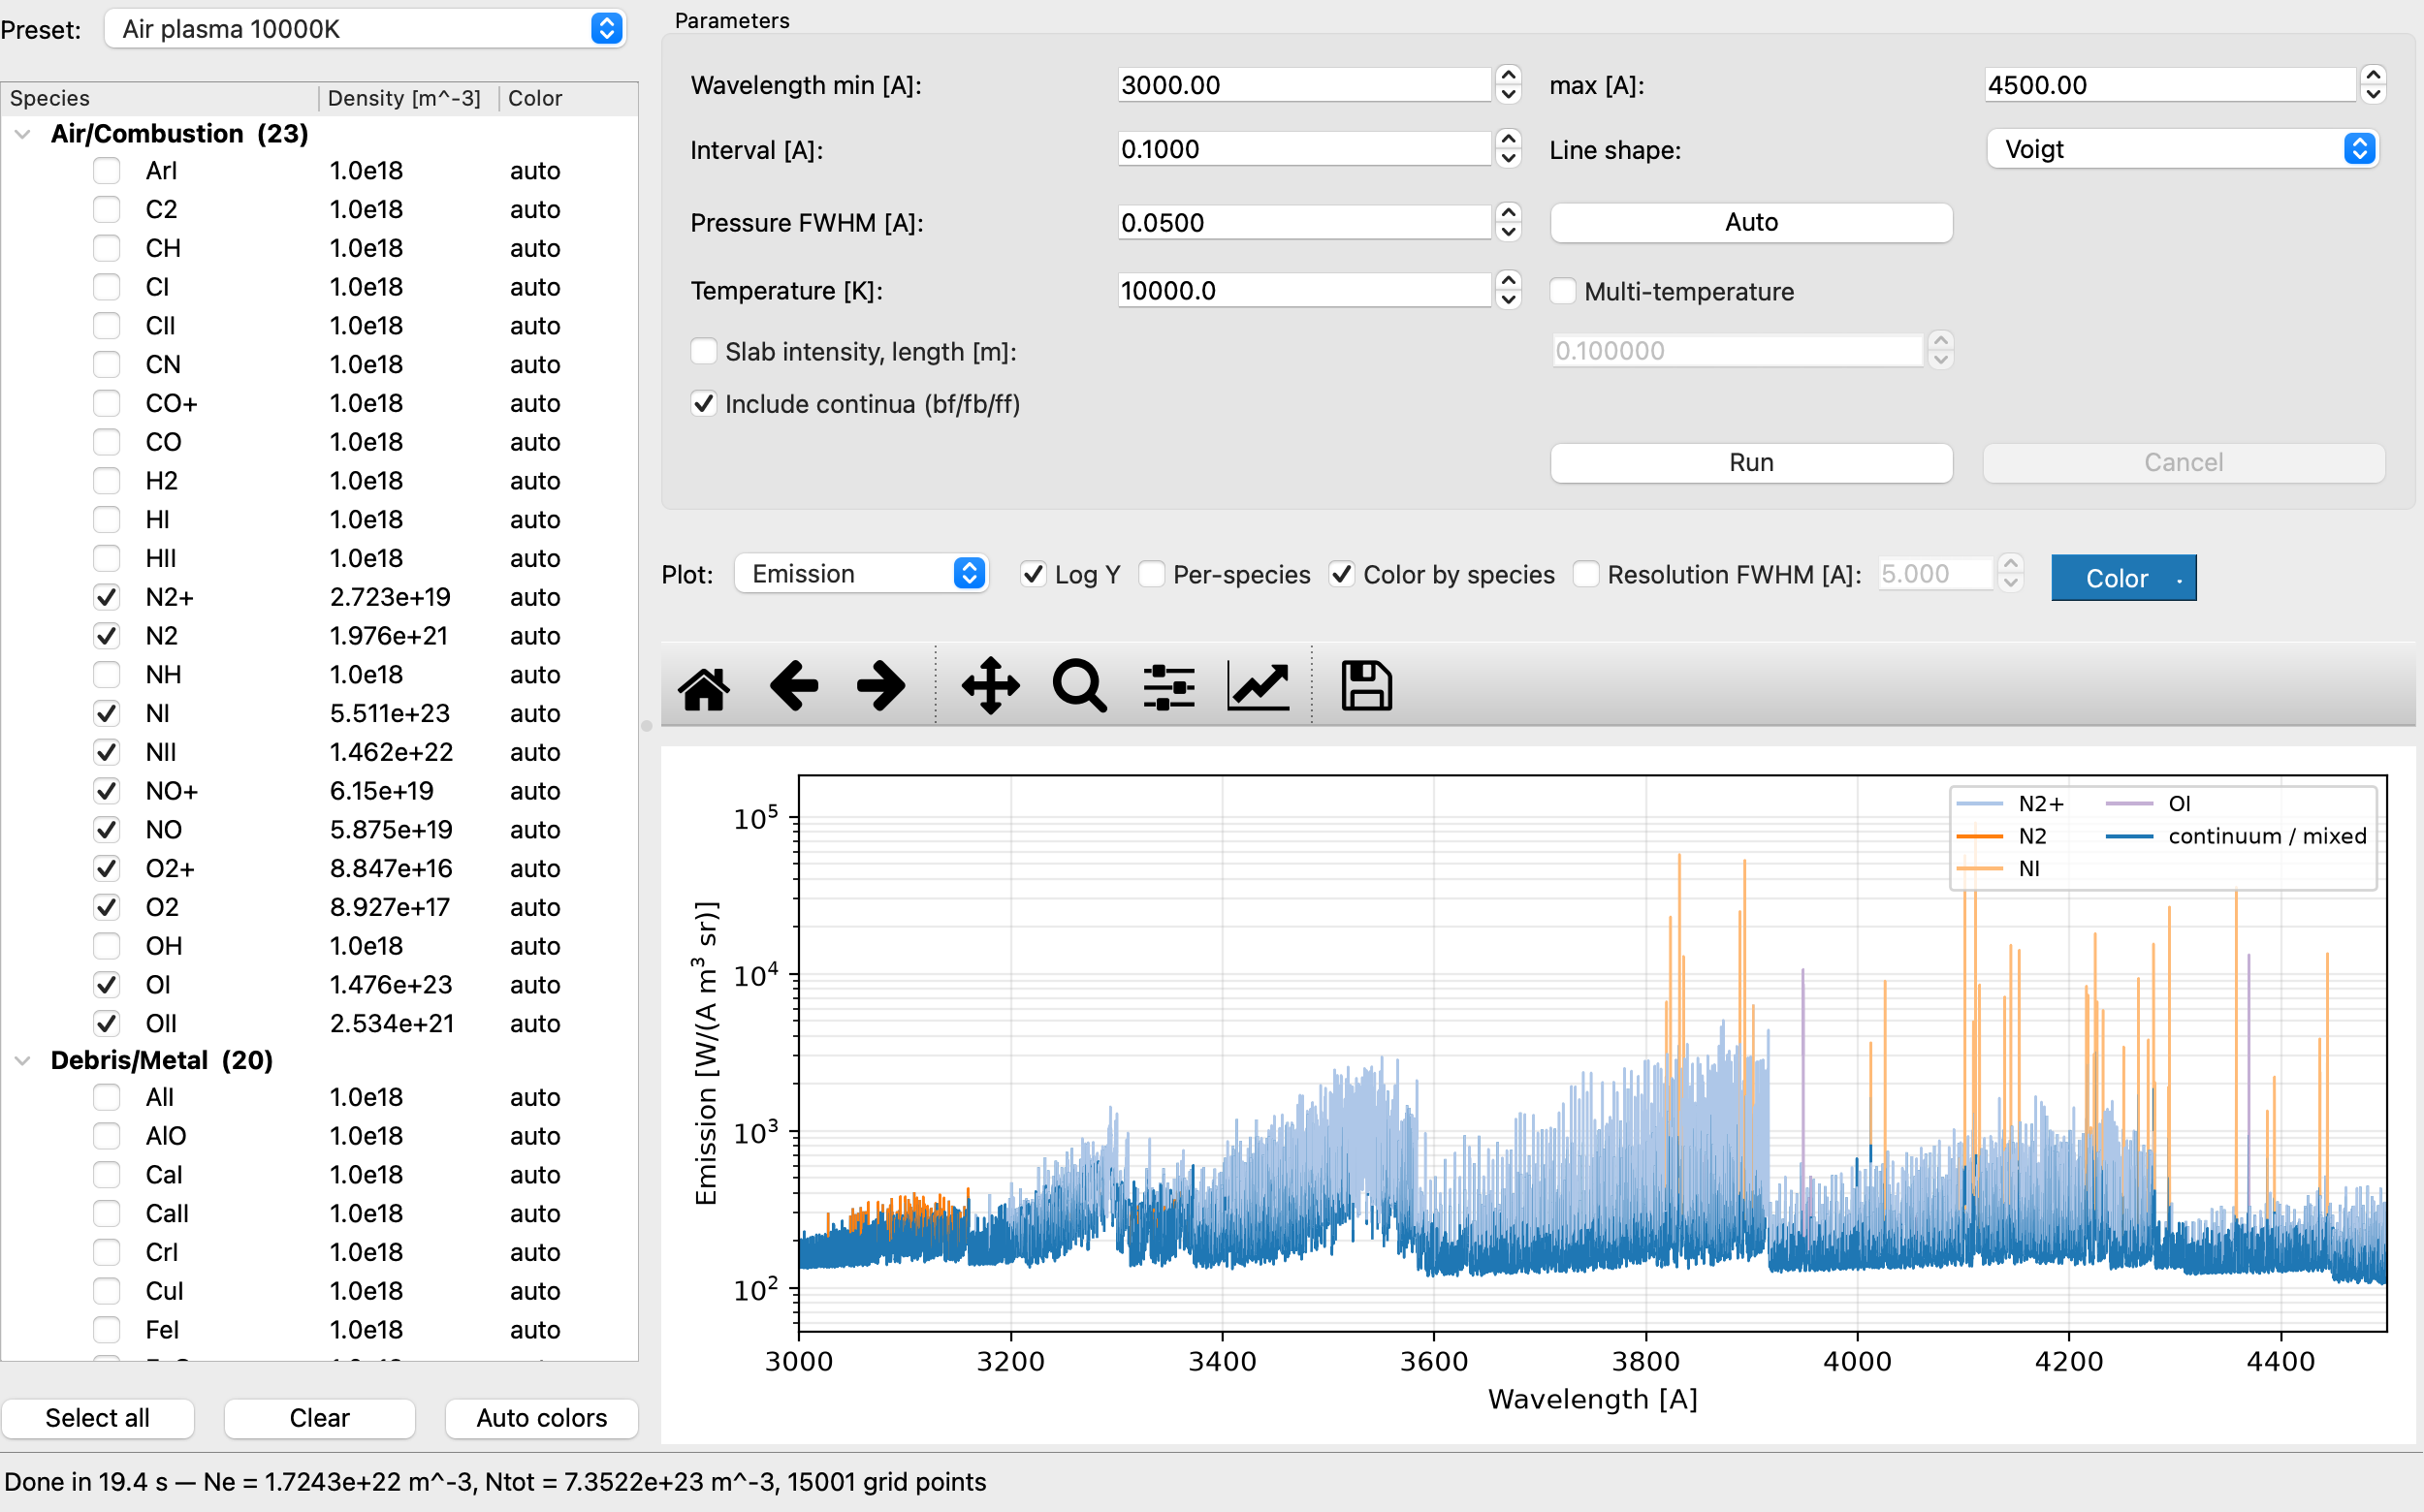
Figure 4. Air plasma at 10000 K (3000–4500 Å, log scale, coloured by dominant species)

6.2 Plot-panel controls
Table 6. Plot-panel controls
Control | Function
Plot | Quantity: Emission / Absorption / Slab intensity / Blackbody (Tel)
Log Y | Logarithmic y axis
Per-species | Overlay each species' emission in its own colour (total drawn faintly)
Color by species | Draw the total spectrum in the colour of the species contributing ≥ 50 % of the line emission at each wavelength; continuum/mixed regions use the Color-button colour.
Resolution FWHM | Convolve the displayed spectrum with an area-conserving Gaussian instrument function; saved CSV files gain convolved columns.
Color | Spectrum line colour; "Reset to default" in its menu restores the default.
Observed | Overlay the observed spectrum after a fit (Chapter 9)
Toolbar | matplotlib standard: home, back/forward, pan, zoom, subplots, axes, save
Click | Shows wavelength, value and dominant species of the nearest grid point in the status bar

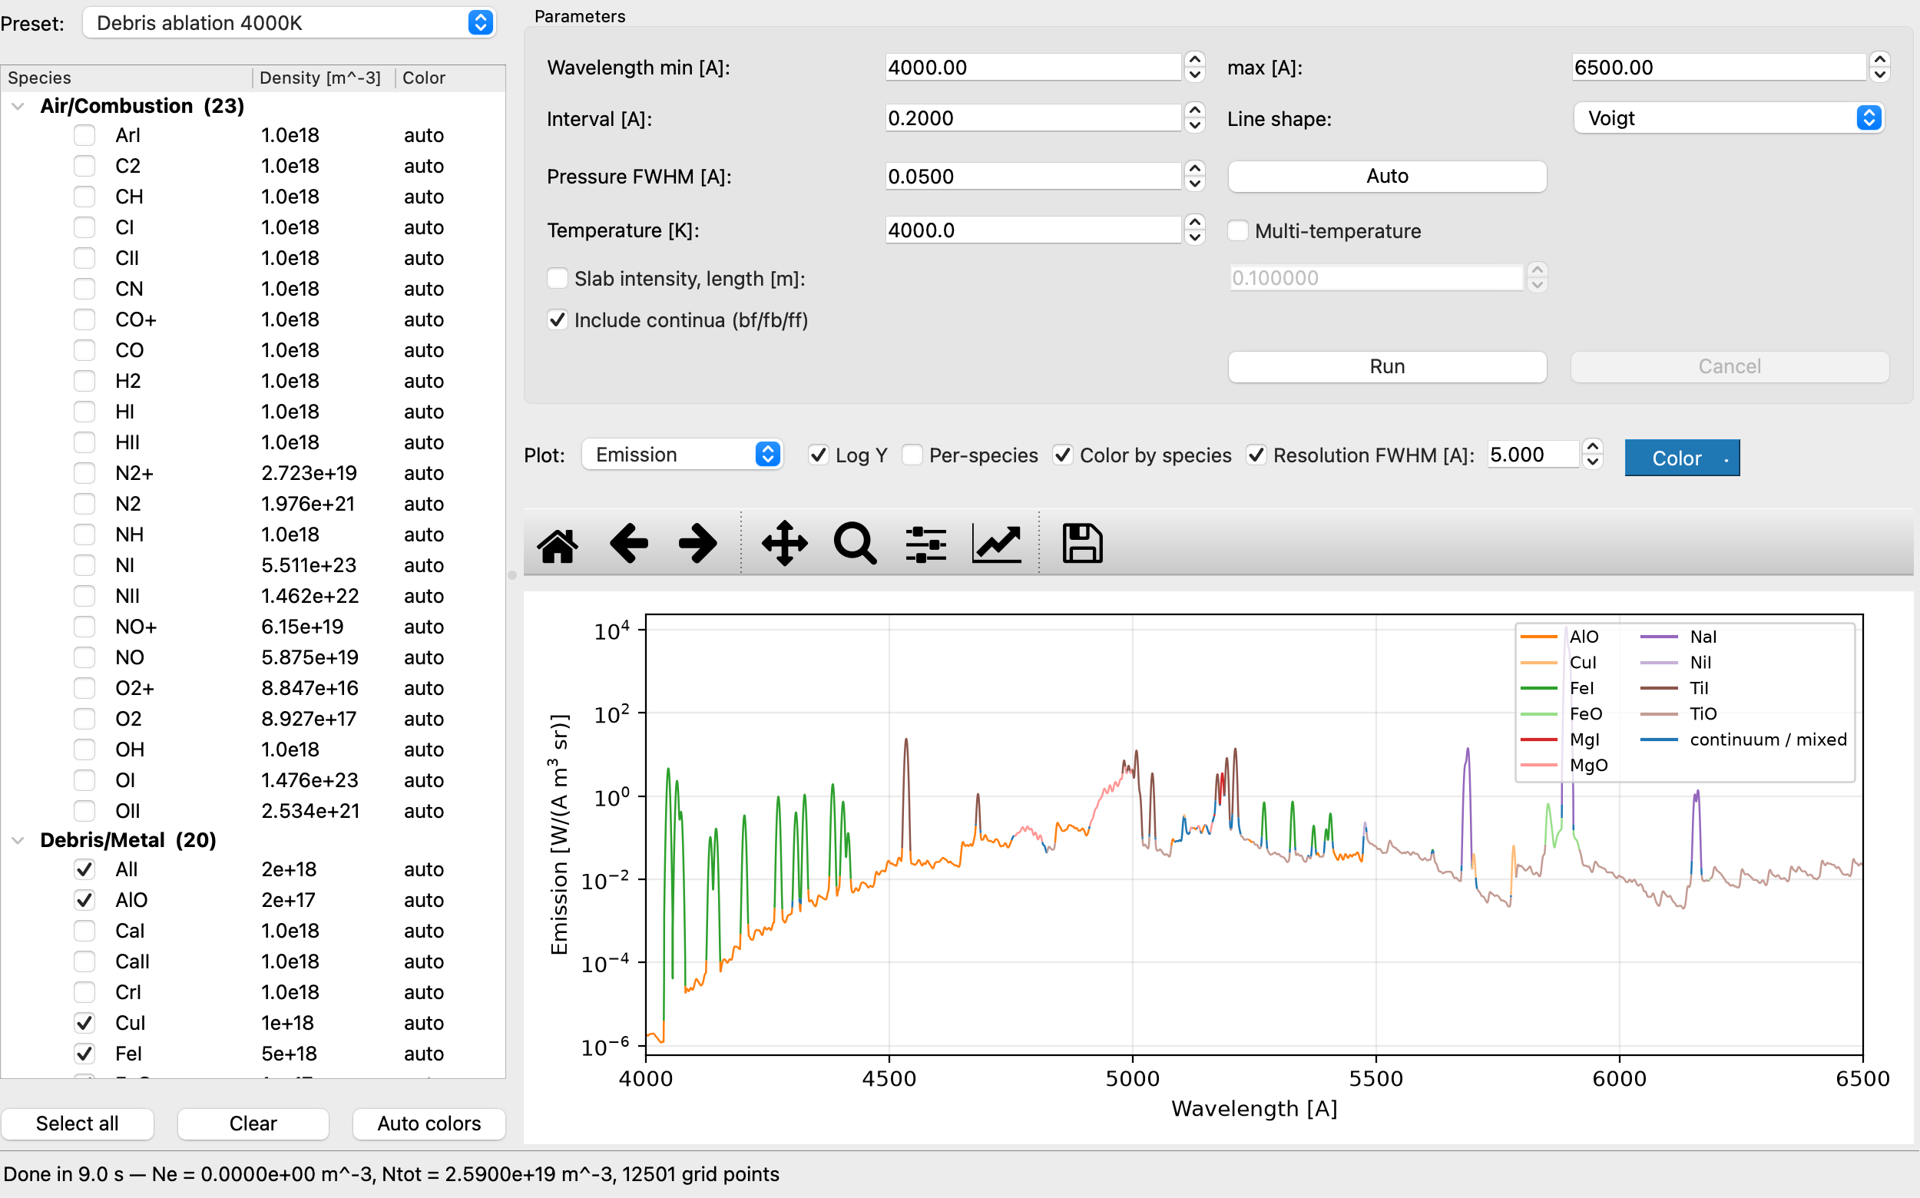
Figure 5. Debris ablation 4000K (4000–6500 Å, 5 Å resolution, coloured by species, log scale)
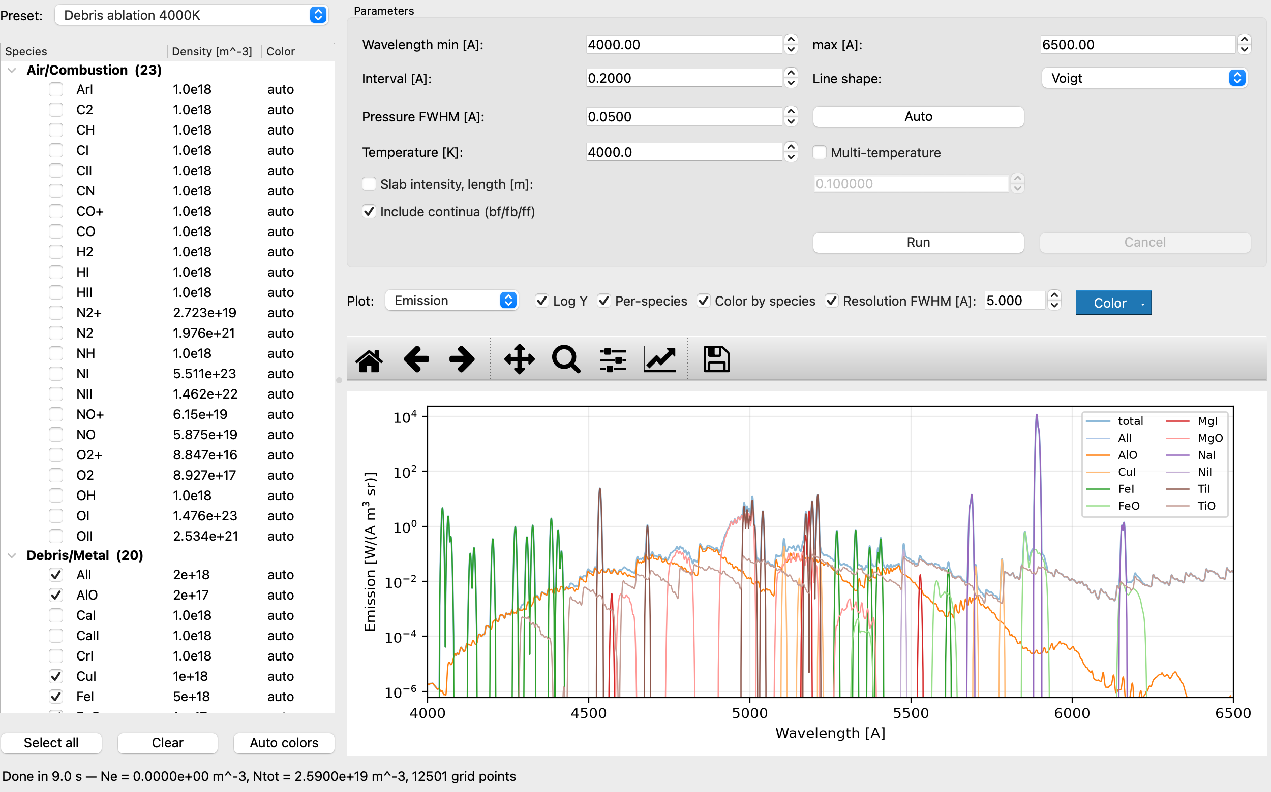
Figure 6. Same run in Per-species mode (each species' emission overlaid)

6.3 Slab intensity
With Slab intensity checked and a slab length L [m], the intensity emerging from a uniform plasma layer of thickness L is computed including self-absorption (same formula as 1D-tool/Self-abs of the C version).
I(λ) = ε(λ) / κ(λ) · [1 − exp(−κ(λ) L)]
optically thin (κL ≪ 1): I → ε L optically thick (κL ≫ 1): I → ε/κ (bounded by the blackbody)
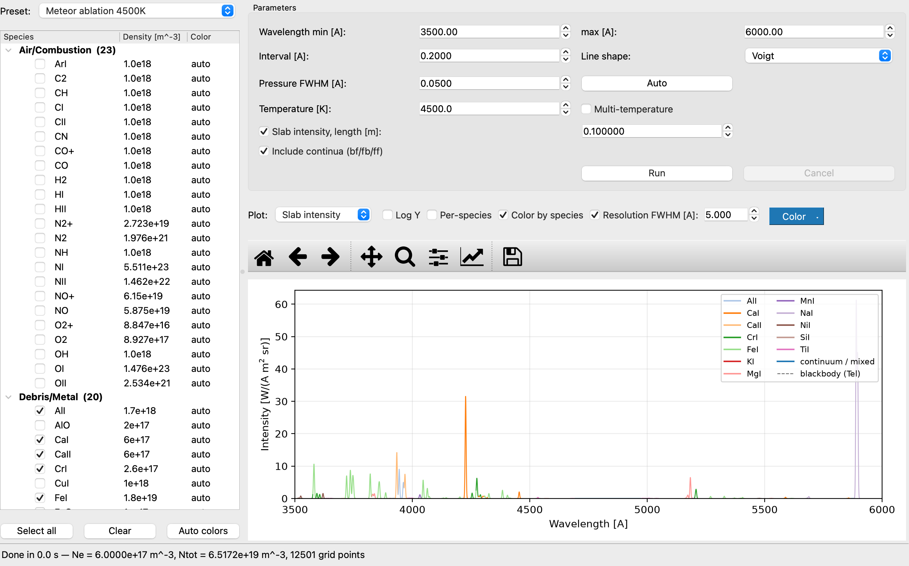
Figure 7. Slab intensity of Meteor ablation 4500K (L = 0.1 m, 5 Å resolution)

7. Menus
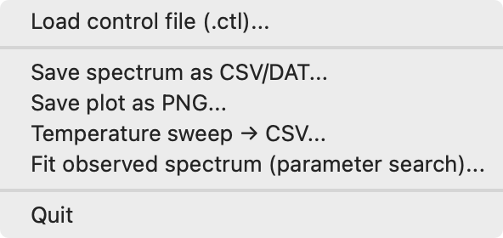
Figure 8. File menu
Table 7. Menu items
Menu | Item | Function
File | Load control file (.ctl)... | Load a SPRADIAN-1.8 job control file into the form (Chapter 11)
File | Save spectrum as CSV/DAT... | Save the spectrum as CSV (comma) or DAT (space-delimited) (Section 7.1)
File | Save plot as PNG... | Save the current plot as PNG
File | Temperature sweep → CSV... | Batch temperature sweep (Chapter 8)
File | Fit observed spectrum (parameter search)... | Fit an observed spectrum (Chapter 9)
Tools | Import VALD line list... | Convert a VALD extract to a .dat file (Chapter 10)
Tools | Rescan databases | Rescan the database directories and refresh the species list
Help | About | Version, credits and units

7.1 Spectrum file format
With a .csv suffix the file is comma-separated with one header line; otherwise it is space-separated with a # header. Numbers use %.6e.
Table 8. Columns of the spectrum CSV/DAT
Column | Unit | Present when
wavelength_A | Å | always
emission_W/(A.m3.sr) | W Å⁻¹ m⁻³ sr⁻¹ | always
absorption_1/m | m⁻¹ | always
intensity_W/(A.m2.sr) | W Å⁻¹ m⁻² sr⁻¹ | slab intensity computed
blackbody_W/(A.m2.sr) | W Å⁻¹ m⁻² sr⁻¹ | always (blackbody at Tel)
emission_conv<F>A / intensity_conv<F>A | as above | Resolution FWHM = F enabled

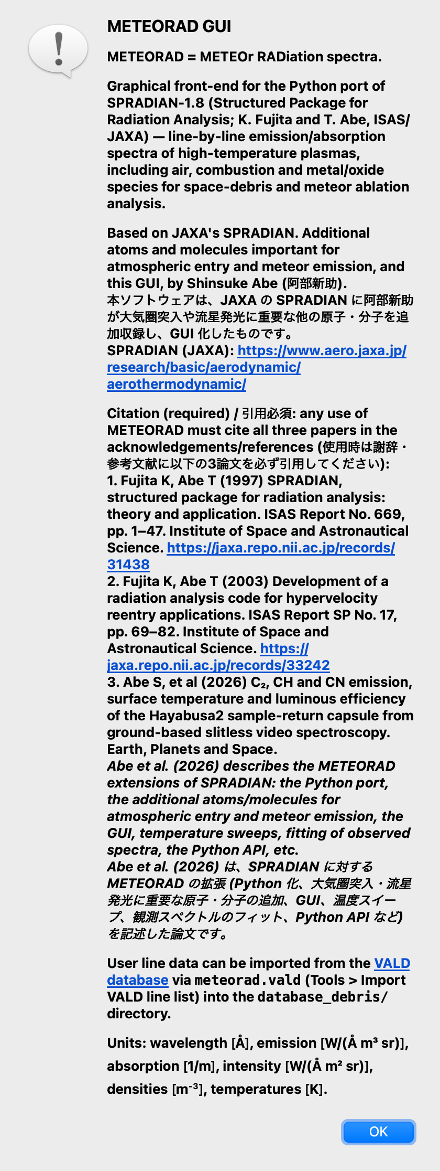
Figure 9. About dialog (credits and units)

8. Temperature sweep
File → Temperature sweep → CSV... keeps every other main-window parameter fixed (wavelength range, grid, line shape, pressure FWHM, slab, continua) and computes spectra of one checked species, or of the checked mixture, over a range of temperatures, saving all of them into one CSV.
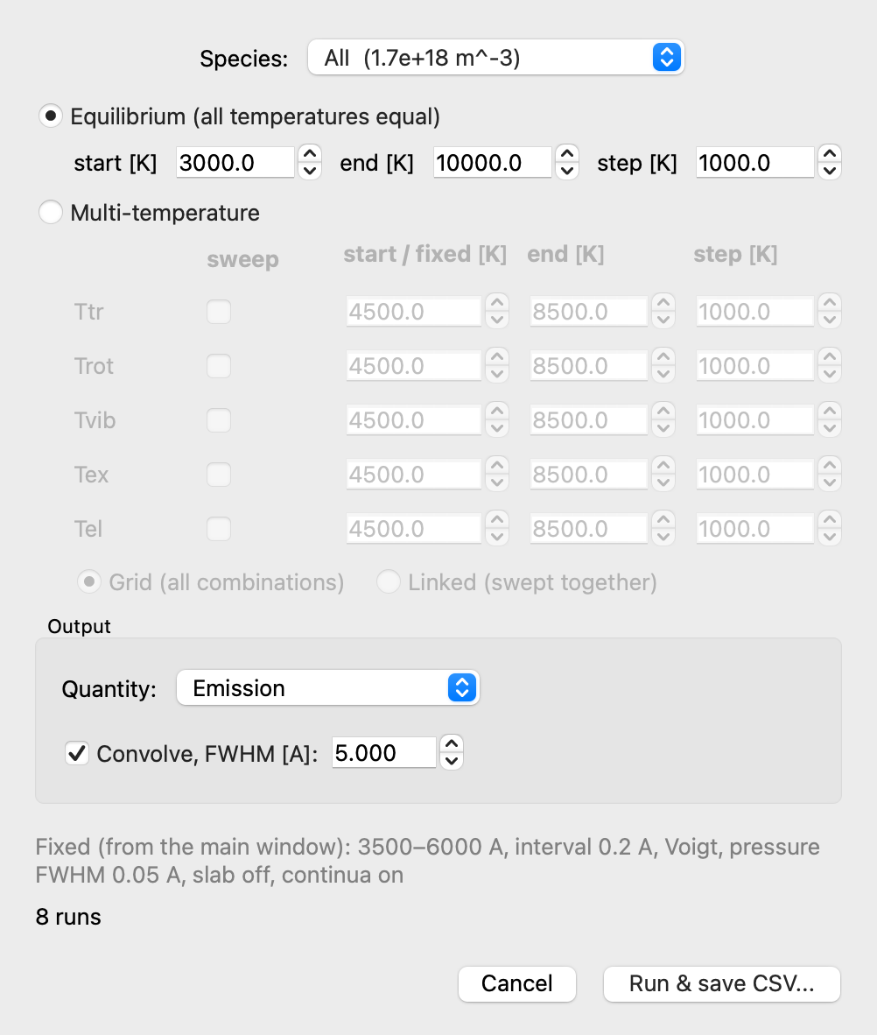
Figure 10. Temperature-sweep dialog (equilibrium mode)
- Equilibrium: one temperature T swept by start / end / step and applied to all five components (default for atoms).
- Multi-temperature: each of Ttr, Trot, Tvib, Tex, Tel is fixed or swept. Swept components are combined as Grid (all combinations) or Linked (advanced together; needs equal numbers of points). Default for molecules: Trot + Tvib linked.
- Quantity: Emission / Absorption coefficient / Slab intensity (slab intensity only when it is enabled in the main window).
- Convolve, FWHM: convolve every spectrum with a Gaussian instrument function before saving.
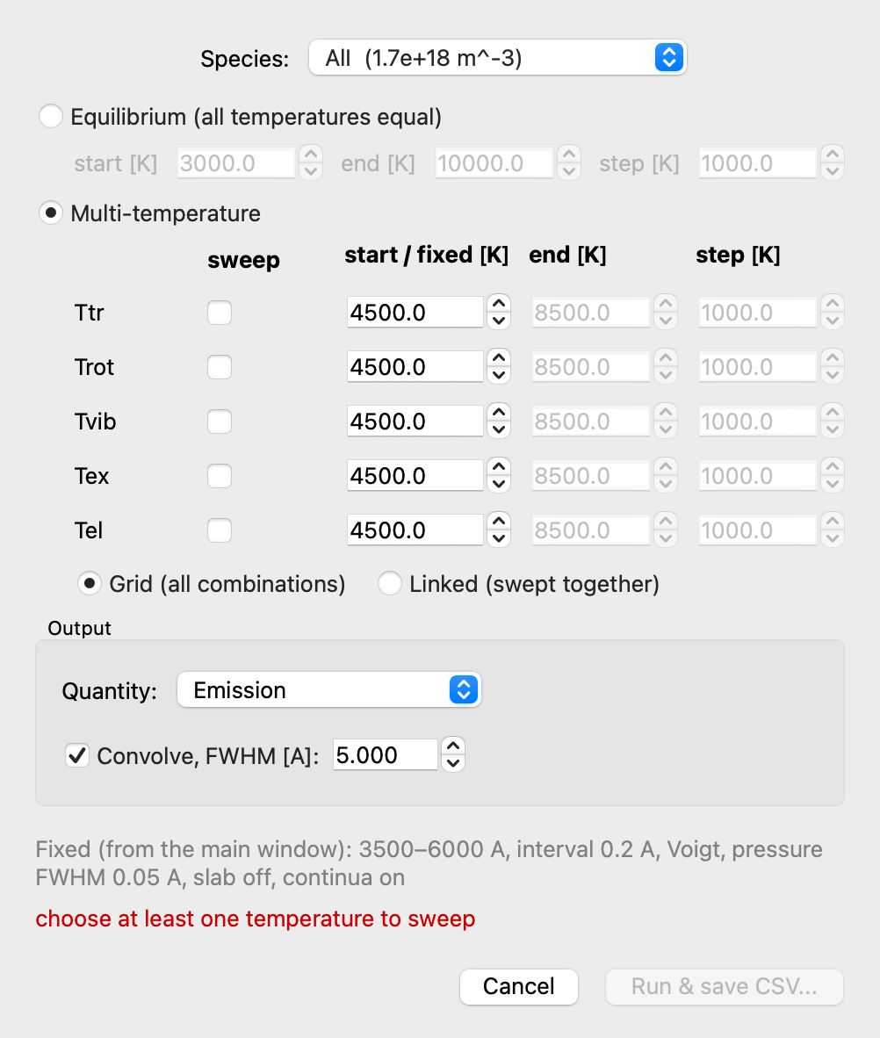
Figure 11. Temperature-sweep dialog (multi-temperature mode)
The CSV starts with # metadata lines, followed by wavelength_A and one column per temperature set (e.g. T=5000K, Trot=3000K Tvib=4000K). Read it with pandas as follows.
import pandas as pd
df = pd.read_csv("sweep.csv", comment="#")

9. Fitting an observed spectrum
File → Fit observed spectrum... opens the fit window. It loads an observed spectrum and searches temperatures, number densities, pressure FWHM and instrument resolution for the species checked in the main window. Wavelength interval, line shape, slab length and continua are taken from the main window when Run search is pressed.
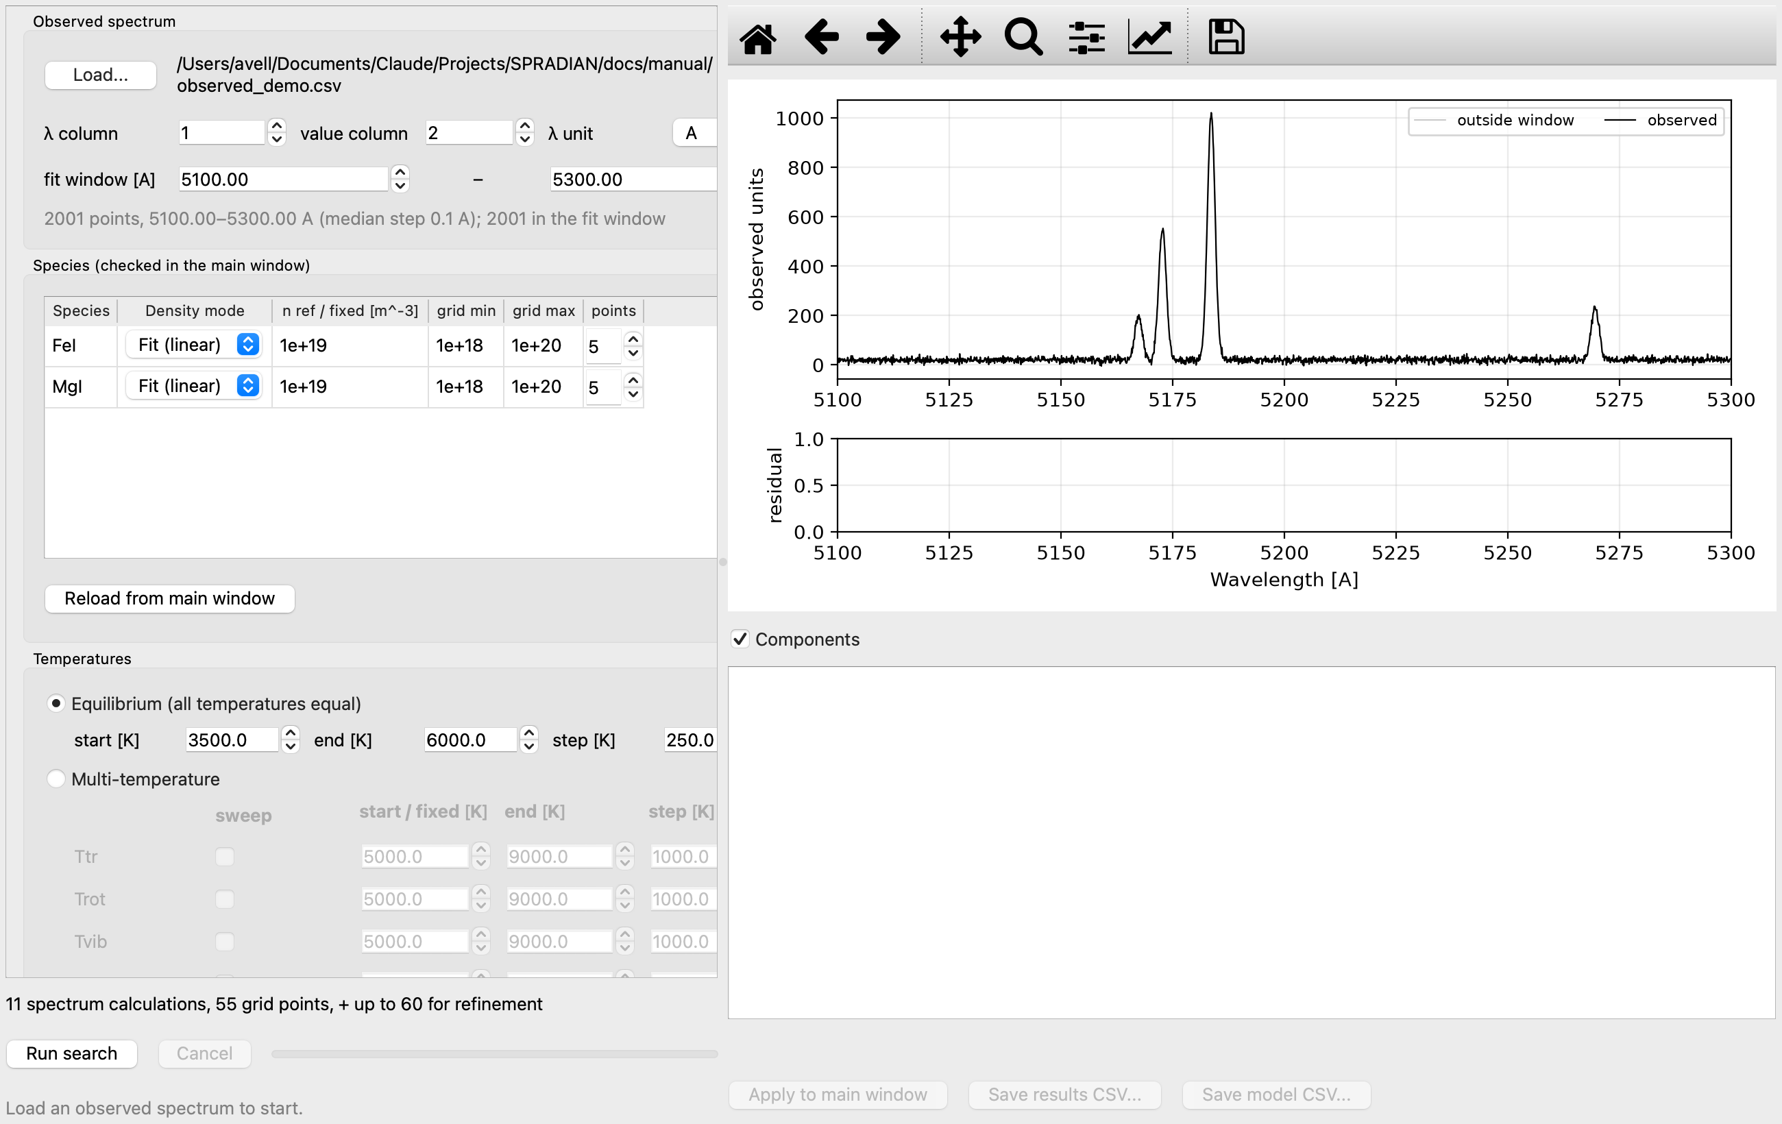
Figure 12. Fit window: loading the observation and setting up the search

9.1 Settings
Table 9. Fit-window settings
Group | Item | Description
Observed spectrum | Load... / λ column / value column / λ unit | Text/CSV observation; column numbers (1-based) and wavelength unit (A, nm, um)
Observed spectrum | fit window [A] | Wavelength range used in the fit
Species | Density mode | Fit (linear): solved by linear least squares (emission model only) / Grid (log): log-spaced min–max / Fixed
Temperatures | Equilibrium / Multi-temperature | Same as the temperature sweep (Chapter 8)
Broadening | Pressure FWHM | Fixed / Range (searched) / Auto (physical estimate at every point)
Broadening | Resolution FWHM | None / Fixed / Range (searched)
Model | Model | Emission (optically thin, fast) / Slab intensity (self-absorption, full run per point)
Model | Observed units | Arbitrary: a scale factor is fitted (only density ratios determined) / Absolute: observation in model units
Model | Baseline | None / Constant / Linear (absorbs stray light / unmodelled continuum)
Model | Refine the best point | Continuous Nelder–Mead refinement from the best grid point

9.2 Search method
- Emission model: one full run per (temperature set, pressure FWHM) at the reference densities; each species' line emission is a basis vector scaled by its density. The continuum (total − lines) is one more basis vector with a non-negative amplitude.
- Slab-intensity model: one full run per (temperature set, pressure FWHM, density-grid combination).
- Figure of merit: sum of squared residuals over the fit window, reported as relative RMS = √(Σr² / Σobs²).
- Limits: 2000 full spectrum runs, 500000 linear solves. The best 50 solutions are kept with their model arrays.
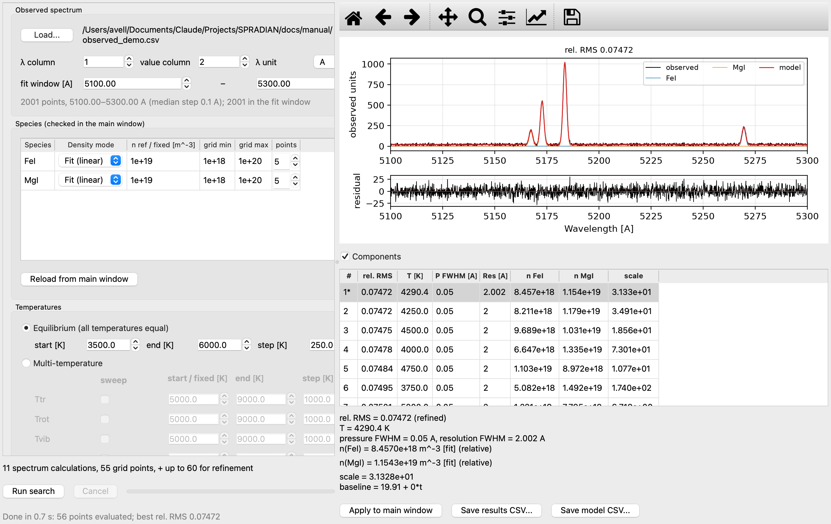
Figure 13. Fit result: observed (black), model (red), components, residuals and the table of evaluated points
The example in Figure 13 fits a synthetic 5100–5300 Å spectrum (MgI + FeI + NaI, 4300 K, Mg/Fe = 1.33, 2 Å resolution, noise added) with MgI and FeI. It recovers T = 4290 K, Mg/Fe = 1.36 and a resolution of 2.00 Å (the relative RMS of 0.075 is the added noise).
Selecting a row shows that solution. Apply to main window copies its temperatures, densities, pressure FWHM and resolution into the main window, re-runs and overlays the observation (Figure 14). Save results CSV stores the parameters and errors of all evaluated points; Save model CSV stores observation, model, residual and components of the selected solution on the observed wavelengths.
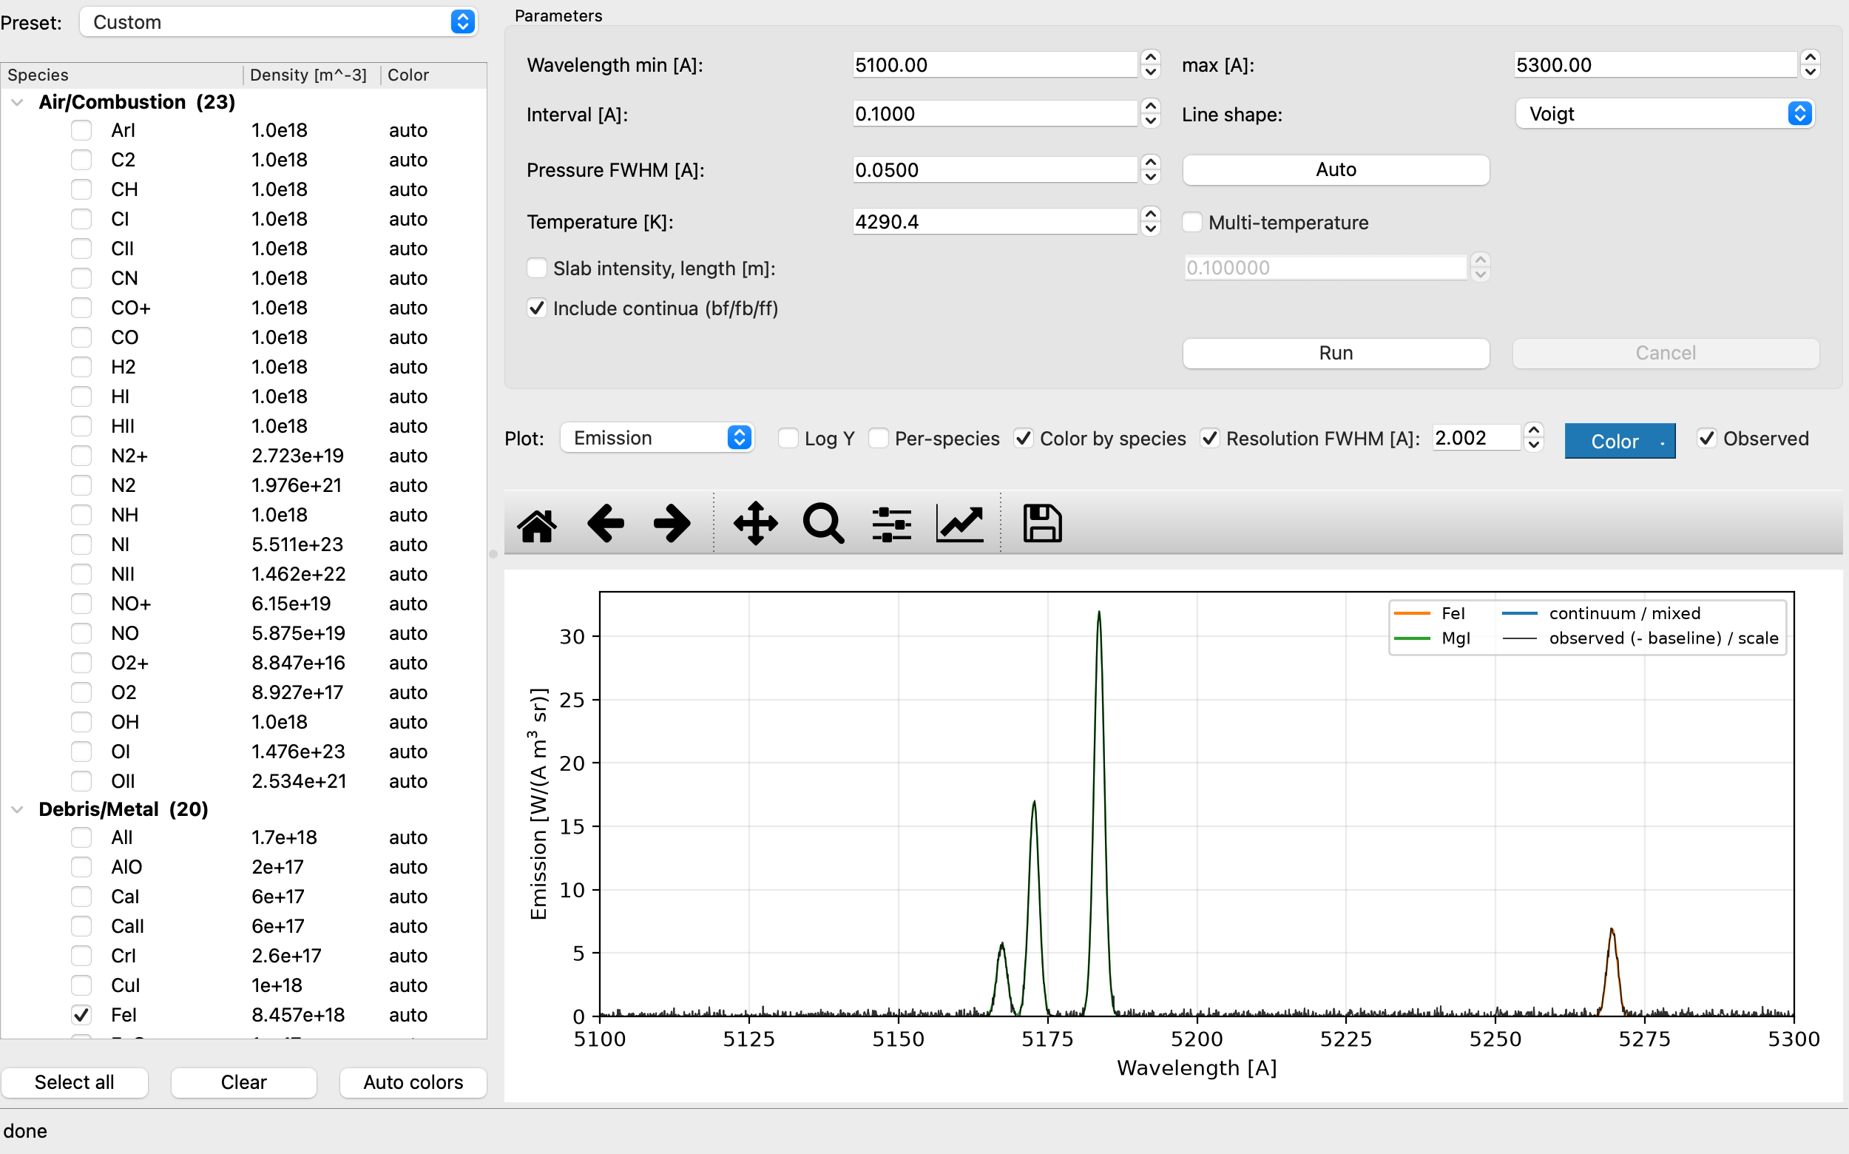
Figure 14. Result of Apply to main window (observed spectrum overlaid)
With Observed units = Arbitrary only density ratios are meaningful (shown values are relative). Use an absolutely calibrated observation with Absolute to obtain absolute densities.

10. Importing VALD line lists
Tools → Import VALD line list... converts a VALD3 long-format extract (https://www.astro.uu.se/valdwiki/) into a SPRADIAN atomic .dat file in database_debris/.
- Register with VALD and request an Extract Element (long format) for the element/ionisation stage.
- Choose the extract (.vald, .txt, .gz) via Import VALD line list....
- Select the species to import from the list found in the file.
- The level table and line list are generated and the species list is rescanned; the status bar shows the numbers of levels and lines.
# conversion (verified)
A_ul [s^-1] = 6.6702e15 · gf / (g_u · λ_Å²)
Ae [W/sr] = 1e10 · h c · A_ul / (4π λ_Å)
Ak [m² Å] = A_ul · λ_Å⁴ · 1e-30 / (8π c g_l)
When publishing results based on VALD data, follow the VALD citation rules.

11. Loading control files (.ctl)
File → Load control file (.ctl)... reads a SPRADIAN-1.8 job file and applies wavelength range, interval, line shape, pressure FWHM, temperatures and species densities to the form. Items the form cannot represent are listed in a dialog after loading.
Table 10. Limitations of .ctl loading
Control-file setting | GUI handling
Densities in an external file | not loaded (enter manually)
Temperatures in an external file | not loaded (enter manually)
Per-species temperature sets (multi-control) | the first set is applied to all species
Wave-file grids | min/max with a default interval
Pressure FWHM 'auto' | replaced by 0.05 Å
Species without a database file | skipped

12. Python API
The computational core meteorad needs only numpy and can be used from scripts without the GUI.
from meteorad.runner import run_spectrum
from meteorad.models import Temperature

res = run_spectrum(
["NI", "OI"], [5.511e23, 1.476e23],
Temperature(tr=1e4, ro=1e4, vi=1e4, ex=1e4, el=1e4),
wl_min=7000.0, wl_max=8000.0, interval=0.5,
db_dir="../SPRADIAN-1.8/DATAPAC/database",
slab_length=0.1, # optional: uniform-slab intensity
)
# res.wavelengths [Å], res.emission [W/(Å m³ sr)], res.absorption [1/m],
# res.intensity [W/(Å m² sr)], res.blackbody, res.per_species_emis, ...

from meteorad.control import read_control_file # legacy job files
Table 11. Core modules
Module | Content (C counterpart)
database.py | load_species(): fixed-column .dat parser (Read_Data)
control.py | read_control_file(): .ctl parser (Read_Parm)
population.py | populations and partition functions (Gene_Popu, InptThrm)
wavegrid.py / lineshape.py | wavelength grid; Voigt (Whiting approx.), rectangular, Lorentzian shapes
bound_bound.py | bound-bound line spectra (BounBoun)
continuum.py | bound-free, free-bound, free-free (BounFree/FreeBoun/FreeFree)
spectrum.py | assembly, blackbody, slab intensity, output (Gene_Spec, Gene_Blck, Self-abs)
runner.py | run_spectrum(): high-level API (CalSpec main)
vald.py | VALD long format → .dat conversion

13. Physical model and specifications

13.1 Units and conventions
Table 12. Units
Quantity | Unit
Wavelength | Å
Emission coefficient ε | W Å⁻¹ m⁻³ sr⁻¹
Absorption coefficient κ | m⁻¹
Intensity, blackbody | W Å⁻¹ m⁻² sr⁻¹
Number density | m⁻³
Temperature | K
Energies inside .dat files | K (= cm⁻¹ × 1.4387687)

Wavelength convention (as in the original): atomic line lists use air wavelengths above 2000 Å, molecular band lines use vacuum wavelengths (λ = K_LAMBDA_CONV / E).

13.2 Calculation flow
run_spectrum() follows the same order as CalSpec main of the C version.
read databases (.dat) → populations (5 temperatures) → bound-bound → bound-free / free-bound / free-free
→ assemble spectrum (ε, κ) → blackbody B(Tel) → [slab intensity] → output

13.3 Line shapes
- Voigt: Doppler width (from Ttr and mass) and the Lorentzian pressure FWHM combined with the Whiting approximation, evaluated at grid points.
- Rectangular / Lorentzian: averaged over grid cells (last element unused). Rectangular suits molecular bands on coarse grids.
- Voigt lines narrower than the grid spacing alias. Use a spacing ≤ half the line width, or combine with the resolution convolution.

13.4 Instrument-function convolution
Resolution FWHM convolves with a unit-area Gaussian, conserving integrated flux. At the grid ends the kernel is renormalised over the part inside the grid, so the edges do not droop.

14. Databases
Table 13. Species in the databases
Group | Species
Air/Combustion (original DATAPAC, 23) | ArI, C2, CH, CI, CII, CN, CO, CO+, H2, HI, HII, N2, N2+, NH, NI, NII, NO, NO+, O2, O2+, OH, OI, OII
Debris/Metal — neutral atoms (13) | NaI, MgI, AlI, SiI, KI, CaI, TiI, CrI, MnI, FeI, NiI, CuI, LiI
Debris/Metal — ions (3) | CaII, MgII, SiII
Debris/Metal — metal oxides (4) | MgO (B–X green), AlO (B–X blue-green), TiO (A–X γ, C–X α), FeO (orange, envelope approx.)

14.1 Approximations for the added molecules
- AlO B²Σ⁺–X²Σ⁺: the ²Σ states are written as S = 0 singlets (spin splitting ~0.007 cm⁻¹ is far below the grid). The common factor cancels in the partition function.
- TiO: X³Δ / A³Φ / C³Δ are approximated as ³Π (coupling case 23). The degeneracy 6 is correct, but the three γ-system heads (7054/7089/7126 Å) merge into one (~7125 Å).
- FeO orange system: a dense multi-state problem represented as one upper state (Te = 17050 cm⁻¹, S = 2, Λ = 0) giving the band envelope only; not for rotational-line work.
- Franck–Condon factors: Morse potentials built from (we, wexe, Be) and the reduced mass; vibrational overlaps computed numerically (revised 2026-10-23).
Table 14. Morse-oscillator Franck–Condon factors (A_total is the v′=0 total rate 1/τ₀)
Band system | rₑ′ / rₑ″ (Å) | q00 | q01 | q10 | A_total (s⁻¹)
MgO B–X | 1.732 / 1.743 | 0.985 | 0.015 | 0.015 | 2.0e7
AlO B–X | 1.667 / 1.618 | 0.730 | 0.238 | 0.225 | 1.0e7
TiO γ (A–X) | 1.665 / 1.620 | 0.721 | 0.236 | 0.235 | 5.0e6
TiO α (C–X) | 1.694 / 1.620 | 0.407 | 0.378 | 0.348 | 1.6e7
FeO orange | 1.630 / 1.620 | 0.984 | 0.016 | 0.015 | 3.0e6

14.2 Adding species
- Atoms: VALD import (Chapter 10) or tools/make_atomic_dat.py (NIST levels and A values).
- Diatomics: add state constants and band systems to tools/make_diatomic_dat.py; FCFs are computed automatically.
- Afterwards check loading and peak positions with tools/test_debris.py. Format details: docs/DATA_FORMATS_ja.md and notes/PORT_NOTES_database.md.

15. Limitations and cautions
- The added debris-atom .dat files have no bound-free / free-bound blocks, so recombination continua of these species are absent (free-free uses the rough effective charge EffC2 = 0.01).
- Some A values come from log gf conversions with ±10–30 % uncertainty; replace them via VALD import for precise work.
- The Qe partition-function tables cover 1500–7000 K; above ~8000 K level truncation makes them incomplete. For Tex ≥ 5000 K the Qe tables are used.
- TiO and FeO carry the approximations of Section 14.1. Morse FCFs are good to a few % at low v; errors can be larger at high v′.
- The triatomic path (CO₂ etc.) is not implemented.
- The Python edition does not include the C version's 1D/2D radiative-transfer tools (Ray-integ, 1D-slab, S-cap, 3D-integ); only the uniform slab is available.

16. Credits and references
This software is based on JAXA's SPRADIAN. Shinsuke Abe added further atoms and molecules important for atmospheric entry and meteor emission (database_debris/) and built the GUI (meteorad_gui/). The original SPRADIAN-1.8 is by K. Fujita and T. Abe (ISAS/JAXA).

16.1 Required citations
Any use of METEORAD must cite all three papers below in the acknowledgements/references.
- Fujita K, Abe T (1997) SPRADIAN, structured package for radiation analysis: theory and application. ISAS Report No. 669, pp. 1–47. Institute of Space and Astronautical Science. https://jaxa.repo.nii.ac.jp/records/31438
- Fujita K, Abe T (2003) Development of a radiation analysis code for hypervelocity reentry applications. ISAS Report SP No. 17, pp. 69–82. Institute of Space and Astronautical Science. https://jaxa.repo.nii.ac.jp/records/33242
- Abe S, et al (2026) C₂, CH and CN emission, surface temperature and luminous efficiency of the Hayabusa2 sample-return capsule from ground-based slitless video spectroscopy. Earth, Planets and Space.
Fujita and Abe (1997) is the original SPRADIAN theory paper and Fujita and Abe (2003) describes the development of the radiation analysis code for hypervelocity reentry. Abe et al. (2026) describes the METEORAD extensions of SPRADIAN: the Python port, the additional atoms/molecules for atmospheric entry and meteor emission, the GUI, temperature sweeps, fitting of observed spectra, the Python API, etc.

16.2 Further references
- JAXA Aeronautical Technology Directorate, Advancement of the thermal-aerodynamic evaluation system for atmospheric entry vehicles (SPRADIAN; in Japanese): https://www.aero.jaxa.jp/research/basic/aerodynamic/aerothermodynamic/
- SPRADIAN-1.5 User's Manual (2.3rd ed., Japanese), ISAS/JAXA
- S. Abe, N. Ebizuka, H. Yano, J. Watanabe and J. Borovička, Detection of the N₂⁺ First Negative System in a Bright Leonid Fireball, ApJ 618, L141 (2005)
- Huber, K. P. and Herzberg, G., Constants of Diatomic Molecules
- NIST Atomic Spectra Database; VALD3 (https://www.astro.uu.se/valdwiki/)

16.3 Terms of use
The SPRADIAN-derived code and DATAPAC are JAXA intellectual property; copying, modification, redistribution, commercial use and other acts requiring the right holder's permission are governed by JAXA's “Guide to the Use of Intellectual Property” (2024.9 ed., Japanese) and require a licence agreement with JAXA: https://www.jaxa.jp/about/ip_policy/data/chizairiyou_tebiki_202409.pdf
See TERMS_en.txt / TERMS_ja.txt in the distribution for details.

