November 2015

Getting the most out of Microsoft Edge

IT Showcase Productivity Guide

Microsoft Edge, the new browser in Windows 10, is designed to deliver a better web experience. It’s fast, interoperable, and built for the modern web—designed to work the way you do and help you get things done through easy sharing, reading, discovery, and more.

## Topics in this guide include:

[Searching with Microsoft Edge](#_Searching_with_Microsoft)

[Using the Hub](#_Using_the_Hub)

[Making Web Notes](#_Making_Web_Notes_1)

[For more information](#_For_more_information)

[Using the PDF reader in Edge](#_Using_the_PDF)

[Using Reading View](#_Using_Reading_View)

[Downloading and uploading](#_Downloading_and_uploading_1)

[Navigating with Edge](#_Navigating_with_Edge_1)

[Opening with Internet Explorer](#_Opening_with_Internet_1)

[Getting around with Cortana](#_Getting_around_with)

[Making a Reading List](#_Making_a_Reading)

[Managing Favorites](#_Managing_Favorites)

# Searching with Microsoft Edge

With Microsoft Edge, when you want to search for something, there’s no need to go to a website. Just enter your search in the handy address bar and you’ll get search suggestions and results from the web, your browsing history, and your favorites—all right on the spot.

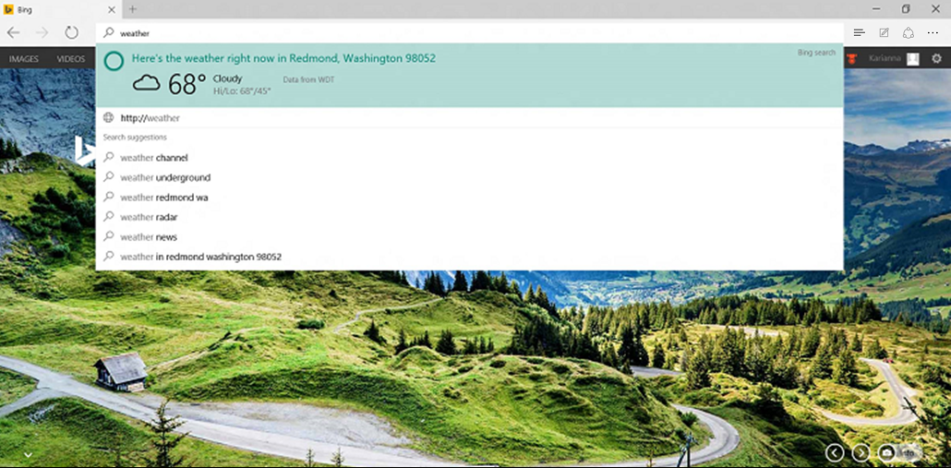

Figure 1. Searching from the address bar.

# Using the Hub

Think of the Hub as the place where Microsoft Edge keeps the things you collect on the web—including your favorites, reading list, browsing history, and current downloads.

* To open the Hub, select **Hub**  .

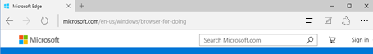

* To change views, select a button at the top of the Hub: **Favorites** , **Reading List** , **Browsing History** , or **Downloads** .

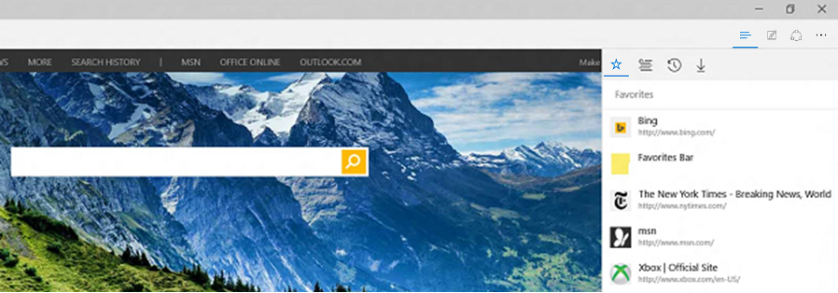

Figure 2. The Hub and its buttons.

# Making Web Notes

Microsoft Edge is the only browser that lets you take notes, write, doodle, and highlight directly on webpages. You can add a few secret ingredients to a recipe to share with your fellow amateur chefs, collaborate on a new project with your coworkers, or have fun with your kids—and then save your Web Note for later or share it with others.

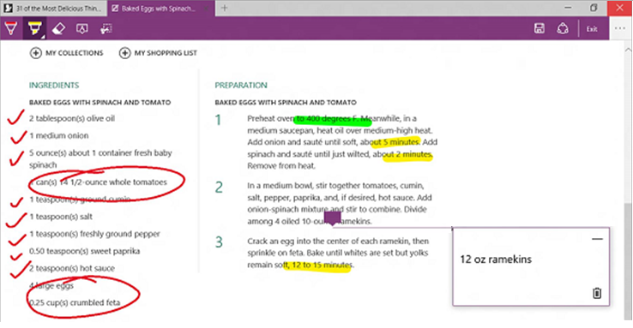

Figure 3. Making Web Notes

Select **Make a Web Note** Image of Web Note icon to display the **Web Note** toolbar, and then you can:

* Select **Draw**   to draw on the page. When the **Draw** tool is active, select it again to adjust color or tool size.
* Select **Highlight**   to highlight content on the page. When the **Highlight** tool is active, select it again to adjust color or tool shape.
* Select **Erase**  to erase everything you’ve added using the **Draw** and **Highlight** tools. When the **Erase** tool is active, select **Erase** again and select **Erase All**.
* Select **Add a typed note** to add a comment, select the place on the page where you want to anchor the comment, and then enter the comment.
* Select **Clip**  to clip part of a page, and then drag to select the region of the webpage you want to clip. Release your finger or mouse, and then to save, share, or copy what you clipped, select the **Save** button that appears next to the clipped region.

When you’re done creating a Web Note, you can:

* Select **Save**  on the **Web Note** toolbar to save the Web Note to your Favorites, Reading List, and OneNote.
* Select **Share**  on the **Web Note** toolbar to share the Web Note via OneNote or to your Reading List.
* Select **Exit** on the **Web Note** toolbar to close it and return to the normal view.

# Getting around with Cortana

Only Microsoft Edge has Cortana, your chatty personal assistant, right in the address bar. She's there to help you do things faster and easier—like make reservations and get at-a-glance directions to the perfect dinner spot.

When Cortana has information that may be useful, you’ll see the Cortana icon D:\Users\Scott\Documents\Case Studies\Active Case Studies\Windows 10 Work Smart\A8 - Microsoft Edge\SS Sandeep\Cortana_AddressBar_Icon.png in the Microsoft Edge address bar—just select it and Cortana will show you the details on the right side of the screen. Click anywhere on the web page to close the details pane.

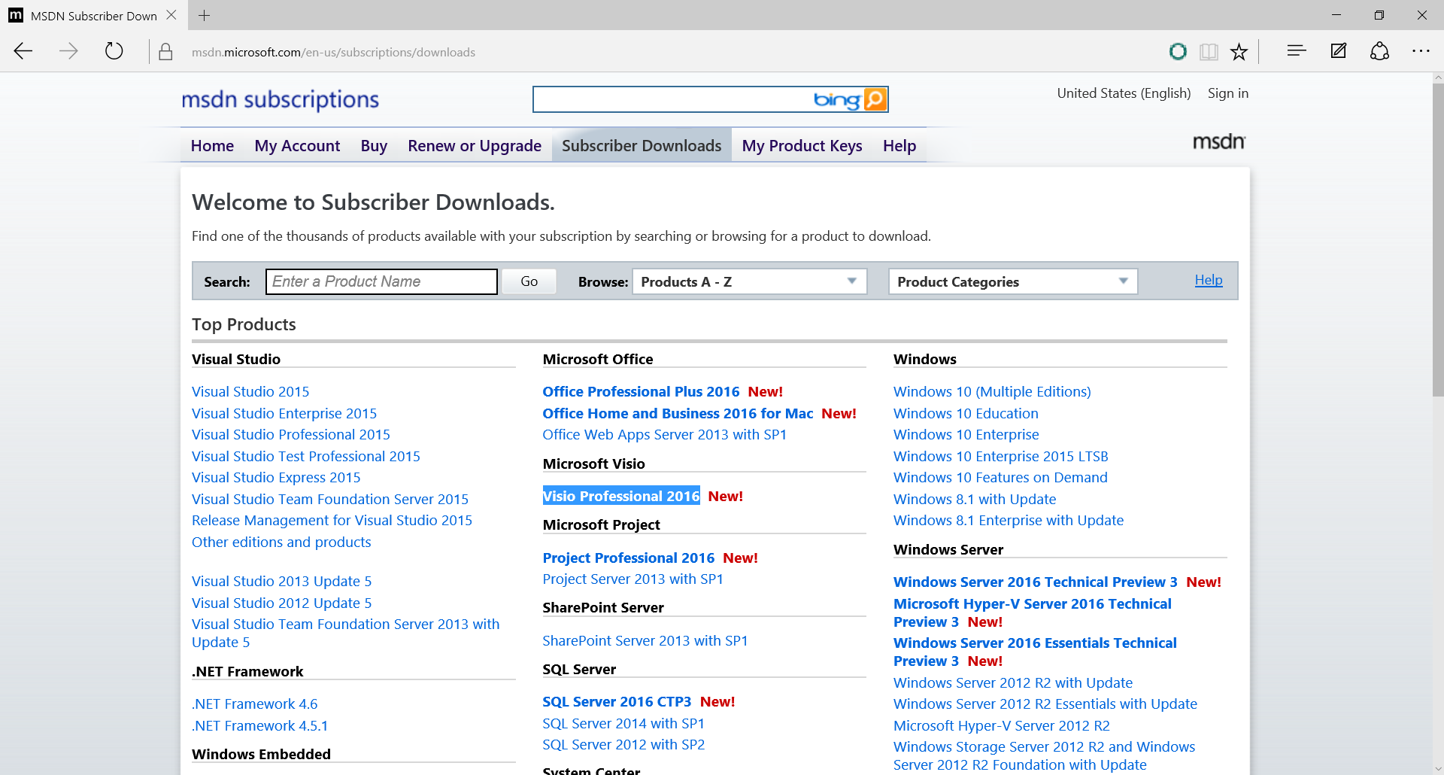

Figure 4. The Cortana icon in the address bar.

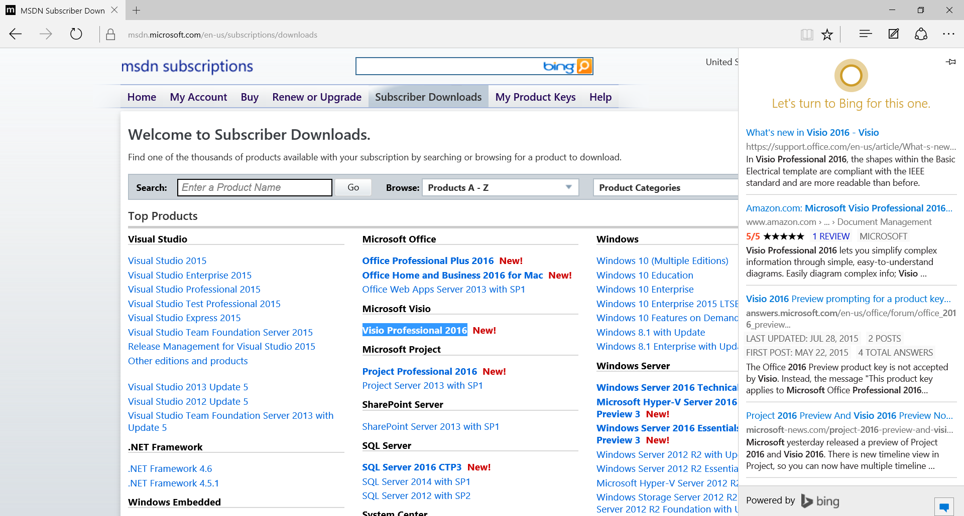

Figure 5. Cortana returns relevant content in a pane on the right.

## Ask Cortana about content on a webpage

1. Use your finger or mouse to select a word or phrase on the webpage.
2. Press and hold (or right-click) the selected content, and then select **Ask Cortana**.

Cortana appears on the right side of the screen with information that may be useful.

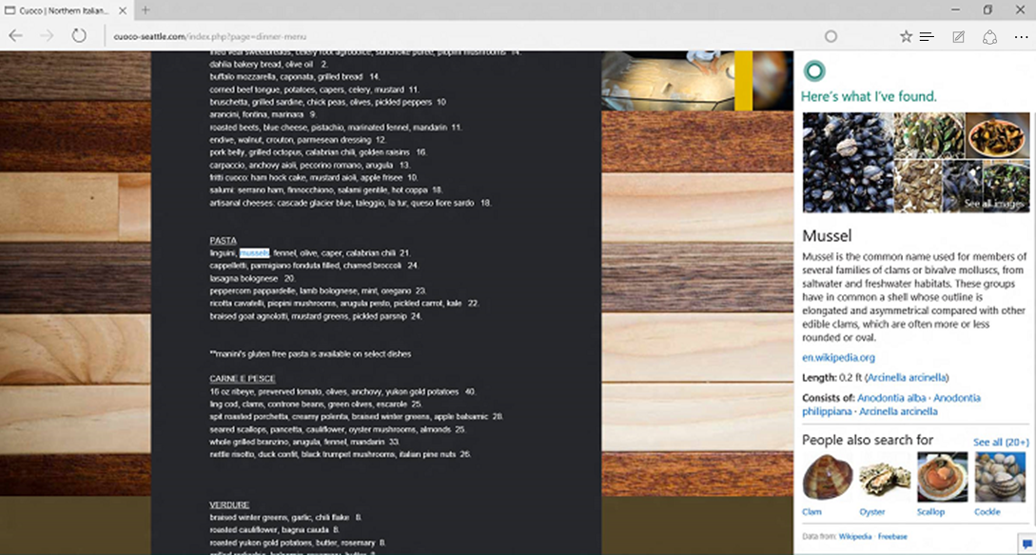

Figure 6. A selected word or phrase, and the results from Cortana on the right.

# Making a Reading List

Reading List gives you a place to save content that you want to read later.

## Create a Reading List

* To save content to a Reading List, select Image of Add to Reading list icon **>** **Reading List** **> Add**.
* When you’re ready to read what you’ve saved, go to the **Hub**  , and then select **Reading List**  Image of Reading list icon.
* Your Reading List will roam across your PC devices and Windows 10 Phone when you are connected using your Microsoft account, also known as MSA (Outlook.com, Live.com, or Hotmail.com).

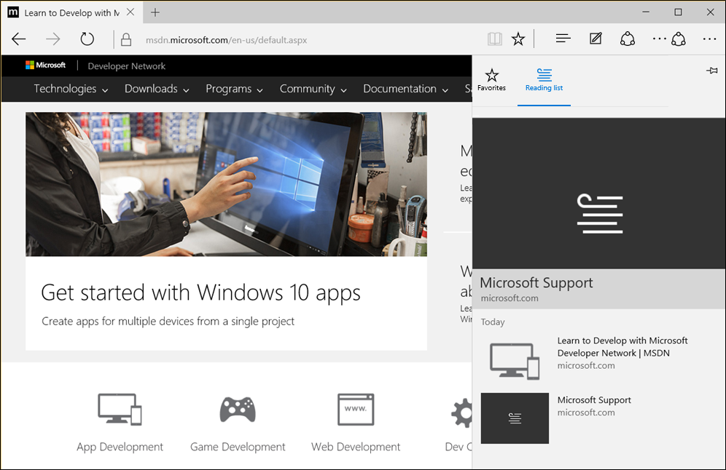

Figure 7. The Reading List, shown under the Hub.

# Managing Favorites

Saving a site as a Favorite is a simple way to remember sites you like and want to visit often.

## Save a Favorite

1. Go to a website you want to add.
2. On the toolbar, select  (**Add to Favorites or Reading List**).



The name of the page appears in the **Name** box, but you can change it to something more friendly.

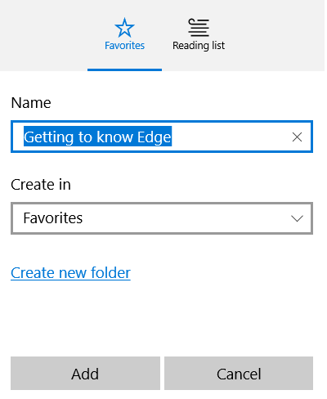

By default, your new Favorite is created in the **Favorites** folder, but you can put it on the **Favorites** bar, in a custom Favorites folder, or select **Create a new folder** and then save it there.

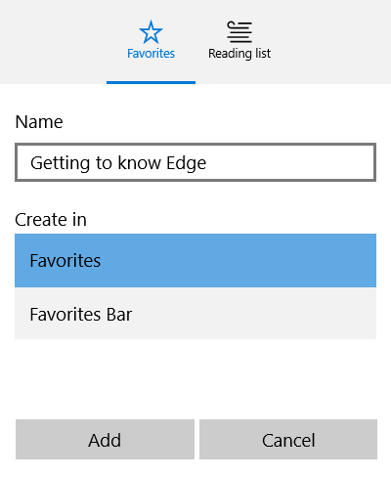

1. Select **Add**.

## Import Favorites

After Edge has been updated, the first time you use it, a welcome page appears that takes you through the steps of importing your Favorites. To import Favorites later, do the following.

1. Select  (**Favorites**).

If **Favorites** is not shown, select  (the **Hub)**, and then select **Favorites**.

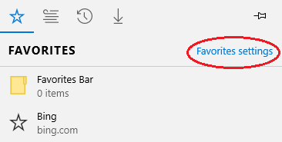

1. Select **Favorite settings**.
2. Choose the browser from which you want to import your Favorites.

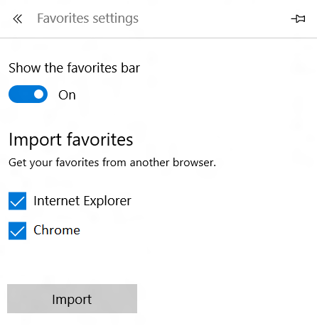

1. Select **Import**.

## Roaming Support for Favorites and Reading List

Microsoft Edge can roam your favorites and reading list across your PC and mobile devices when you are connected using your Microsoft account (Outlook.com, Live.com, or Hotmail.com).

## How to turn on roaming for your Reading List and Favorites

Edge and System sync settings are enabled by default (both sync settings need to be enabled to allow Edge roaming).

How to check the Edge sync settings:

1. Select **More Actions** in the upper right corner.

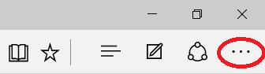

1. Select **Settings**.

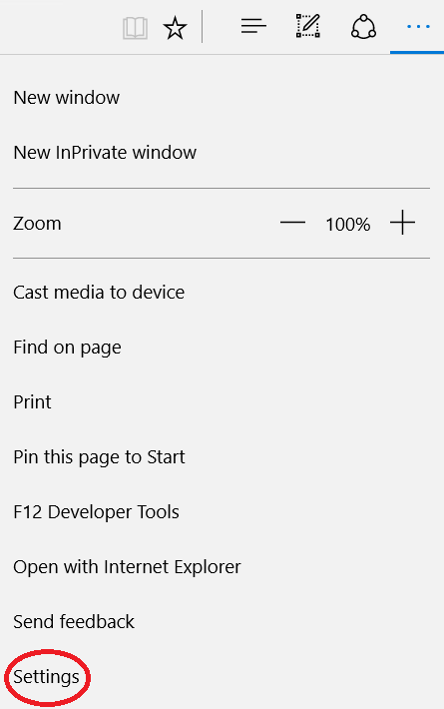

1. Switch the toggle under **Sync** to **On**.

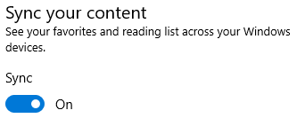

How to check the system sync settings:

1. Go to System settings

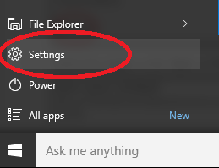

1. Select **Accounts**.

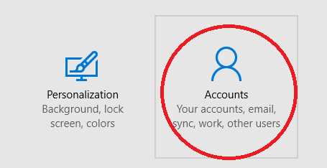

1. Select **Sync your Settings**.

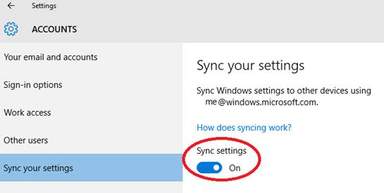

# Downloading and uploading

Edge has some new features and improvements to the download and upload experiences:

* You can drag and drop a file to upload to sites, such as OneDrive for Business or SharePoint.
* You can save a link, image, or other types of items on a page by selecting **Save target as**.

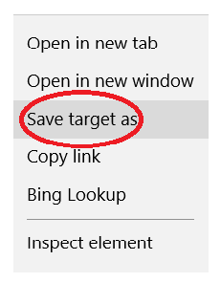

* When you download a file from the web, after the download is complete you can select **Open folder** to see the contents of the download destination folder.



# Navigating with Edge

Improvements to Edge make it easier to see what is on other tabs at a glance, open a new window, and stop annoying loops of new windows and dialog boxes from malicious websites.

## Tab Preview

If you have multiple tabs open in your browser, it can be challenging to keep track of what is on each one. Edge introduces tab preview—when you hover or move your pointer over a tab other than the one that is currently active, Edge shows you a thumbnail preview of the content on that tab.

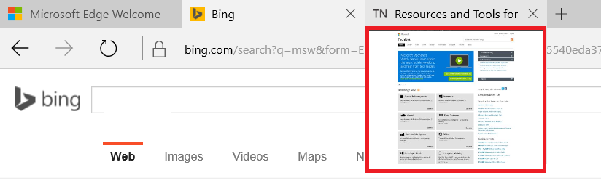

Figure 8. Hover over a tab to see a preview.

## Opening new Edge windows with ease

Need a new Edge window? Just move your pointing device over the Edge icon  on the Windows taskbar, and click the middle button (on a three-button mouse or trackpad) or tap the scroll wheel on your mouse, and a new window opens.

## Virtual Desktop Support

Edge now supports separate Microsoft Edge windows in virtual desktops. Previously, if an existing Microsoft Edge window was open in a virtual desktop, attempting to launch Edge from a different virtual desktop would switch to the existing Edge window on the system hosting the previous virtual desktop. Now, a new Edge window or tab is opened in the active virtual desktop.

# Using Reading View

Microsoft Edge includes an integrated **Reading View**, which provides a clean and simple layout to help you stay focused on the content.

* Select **Reading View** Image of Reading view icon in the address bar to use this feature. If Reading View isn’t available for a particular webpage, the button will be dimmed.
* To adjust Reading View style and font size, select  (**More actions**) **> Settings**.



Figure 9. A web page in Reading View.

# Using the PDF reader in Edge

Edge includes a built-in PDF reader, so you won’t need to download a separate PDF reader app.

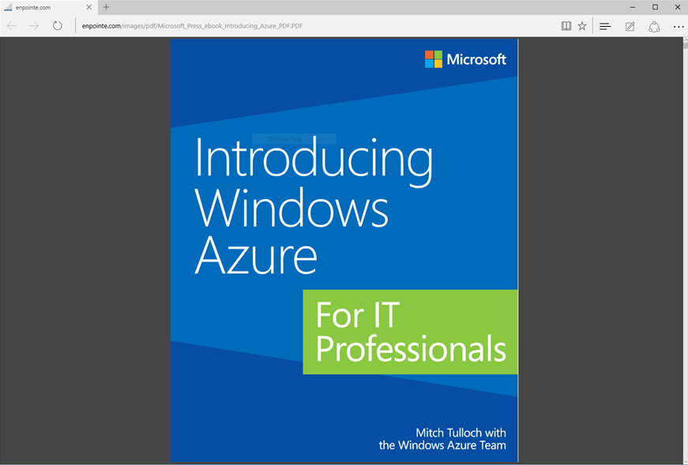

Figure 10. A PDF document in the built-in PDF reader.

## PDF supports Ask Cortana

In addition to being available on a webpage, you can find Cortana when you are reading a PDF document in Edge. Just right-click or press and hold on a word or phrase, and then select **Ask Cortana**.

## The PDF reader toolbar brings commands front and center

Now, common PDF commands like **Zoom**, **Print**, **Save**, and the page controls are easy to find and use on a new toolbar.

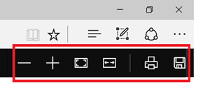

Figure 11. PDF reader toolbar.

# Opening with Internet Explorer

Edge uses a new rendering engine to help you get the most out of modern webpages. If a page doesn’t look quite right in Edge, you can open the same page with Internet Explorer—just select  (**More actions**) **>** **Open with Internet Explorer**.

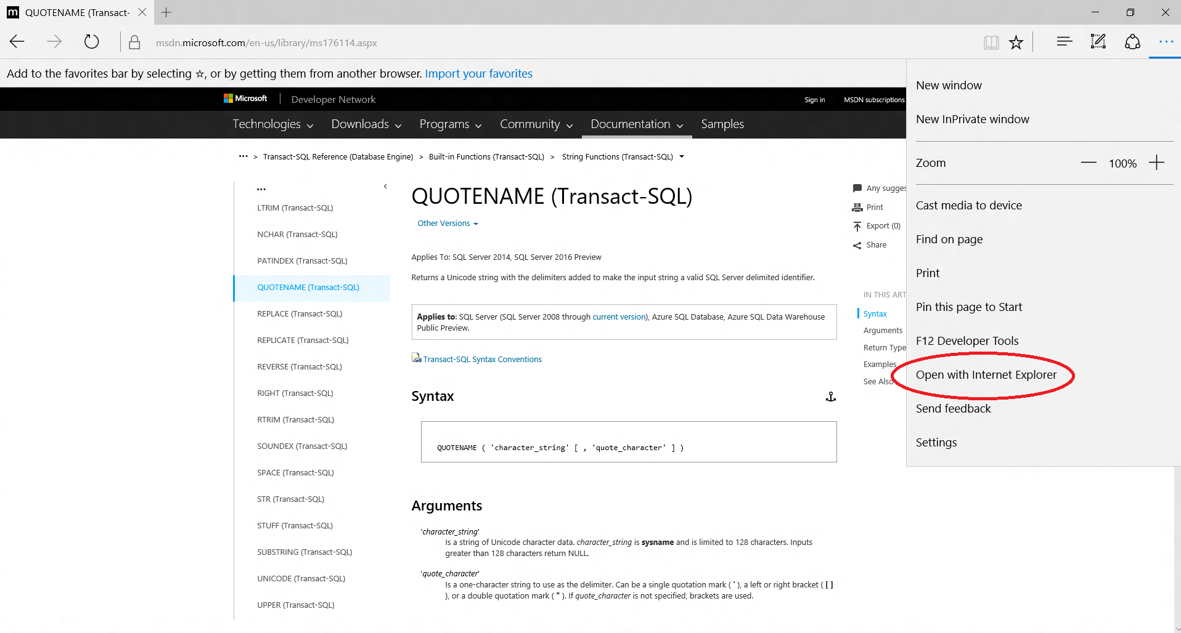

Figure 12. Open with Internet Explorer.

# For more information

For more information about Microsoft products or services, call the Microsoft Sales Information Center at (800) 426-9400. In Canada, call the Microsoft Canada Order Centre at (800) 933-4750. Outside the 50 United States and Canada, please contact your local Microsoft subsidiary. To access information via the web, go to:

<http://www.microsoft.com>

## Microsoft IT

<http://www.microsoft.com/ITShowcase>

## For more great productivity guidance, visit…

<http://microsoft.com/ITShowcase/Productivity>

## Windows

<http://windows.microsoft.com>

## Get to know Microsoft Edge

<http://windows.microsoft.com/en-us/windows-10/getstarted-get-to-know-microsoft-edge>

© 2015 Microsoft Corporation. All rights reserved. Microsoft and Windows are either registered trademarks or trademarks of Microsoft Corporation in the United States and/or other countries. The names of actual companies and products mentioned herein may be the trademarks of their respective owners. This document is for informational purposes only. MICROSOFT MAKES NO WARRANTIES, EXPRESS OR IMPLIED, IN THIS SUMMARY.