SET TASK 2

SUBMITTED BY:

DARSHAN DINESH M P - NNM23MC028
DELBIN GEORGE - NNM23MC036
CHIRASHREE G POOJARY – NNM23MC027
ANUGYA – NNM23MC010

SUBMITTED TO :

Mr. Arhath Kumar
Lecturer in MCA Department

Date of Submission: 04/12/2023

Faculty Signature:

EATABLES

- Abstract

EATABLES is a location-based food discovery platform that allows users to explore and find new dining options. Users can access information about nearby restaurants, including contact details, location, and reviews from other users. They can leave their own reviews, add food items to favorites, and upload food vlog videos through the "drops" feature. The platform offers filtered search results based on price and allows users to submit new restaurant additions for review by the admin. EATABLES aims to provide a comprehensive and engaging experience for users to discover, share, and review food options in their area.

- Objective of the Project

The objective of the EATABLES project is to provide users with a convenient and comprehensive platform to discover new food options based on their location.

The project aims to fulfil the following objectives

- Location-based Food Discovery: Enable users to find nearby restaurants, view their information, and read reviews from other users, helping them make informed dining choices.
- User Reviews and Engagement: Allow users to leave their own reviews, fostering a community-driven approach and facilitating knowledge sharing about dining experiences.
- Favourites List: Provide users with the ability to create a personalized list of favourite food items or restaurants for easy reference and future visits.
- Drops Feature: Allow users to upload and share food vlog videos, enhancing engagement and providing a platform for users to discover and appreciate food-related content.
- Price Filtering: Offer users the option to filter search results based on price, ensuring that they can find dining options that align with their budget or desired price range.
- Restaurant Submission: Enable users to suggest new restaurants to be added to the platform, ensuring the continuous growth and relevance of the database.
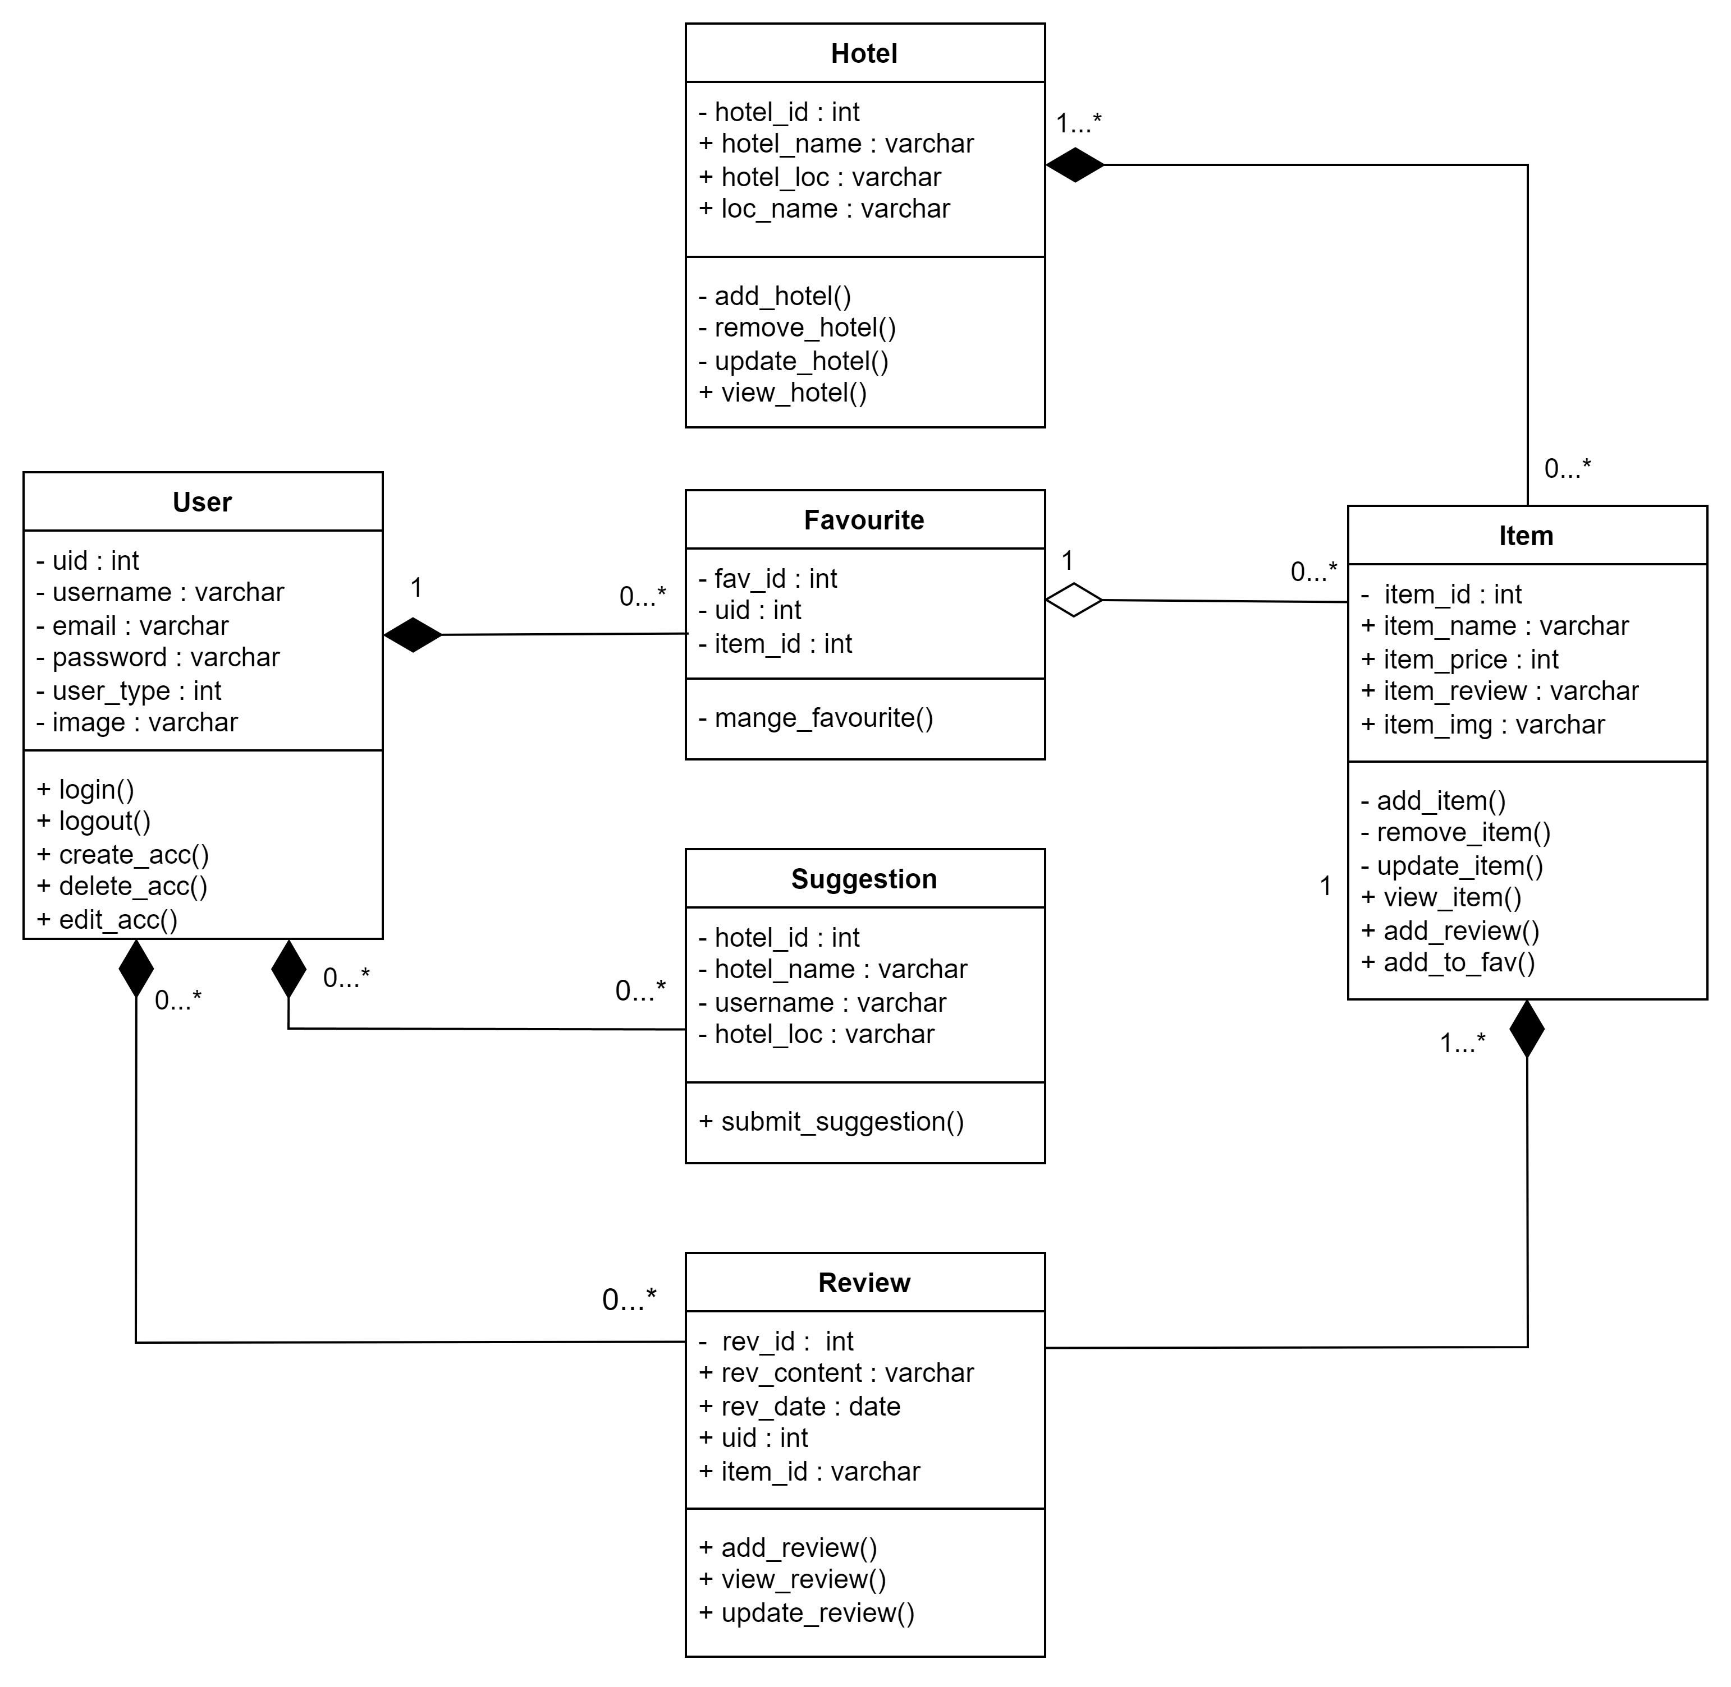
Overall, the objective of the EATABLES project is to enhance the dining experience for users by providing them with a user-friendly platform that leverages location data, user reviews, engagement features, and personalized preferences to facilitate food discovery and decision-making.

- MODELS USED

The development approach was a mix of Agile and iterative methods. The development process involved making continuous improvements in small, incremental steps. Think of it as constructing and refining different components of the project bit by bit. This approach was driven by regular feedback and adjustments, ensuring that the project evolved effectively to meet its goals.

- CLASS DIAGRAM

- USE CASE DIAGRAM

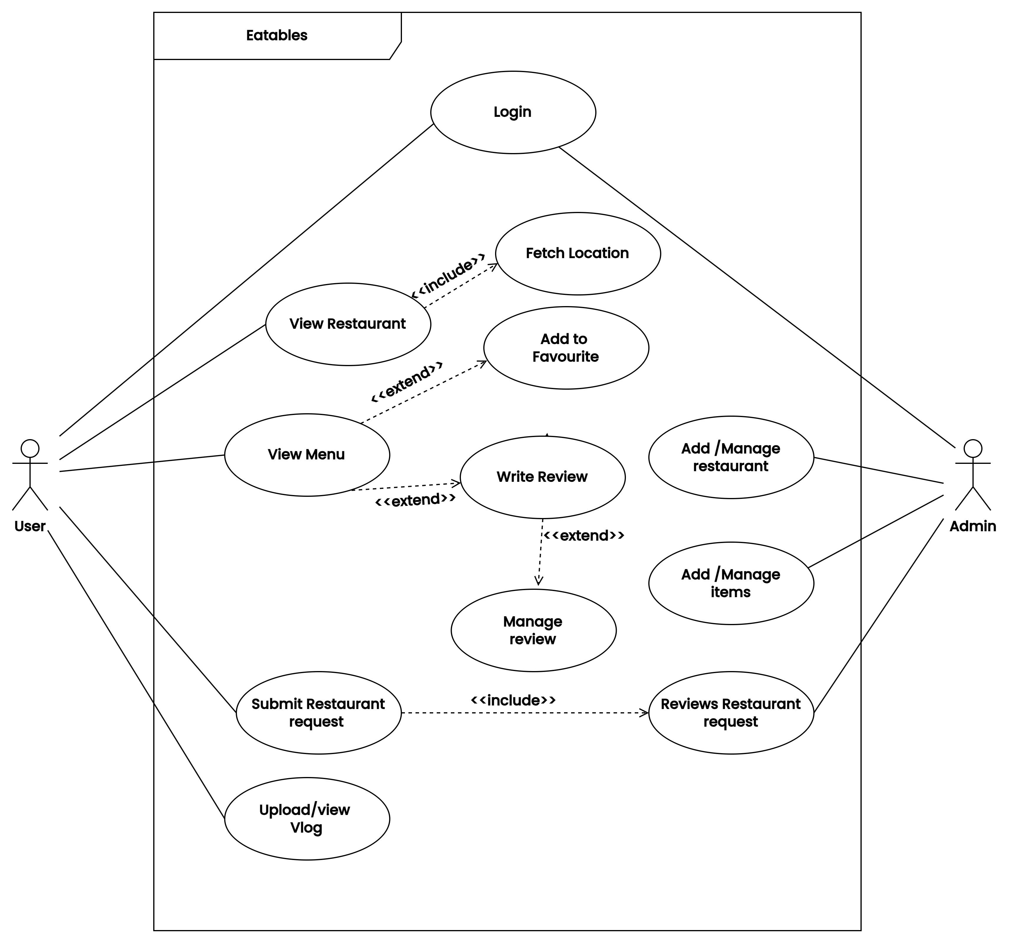

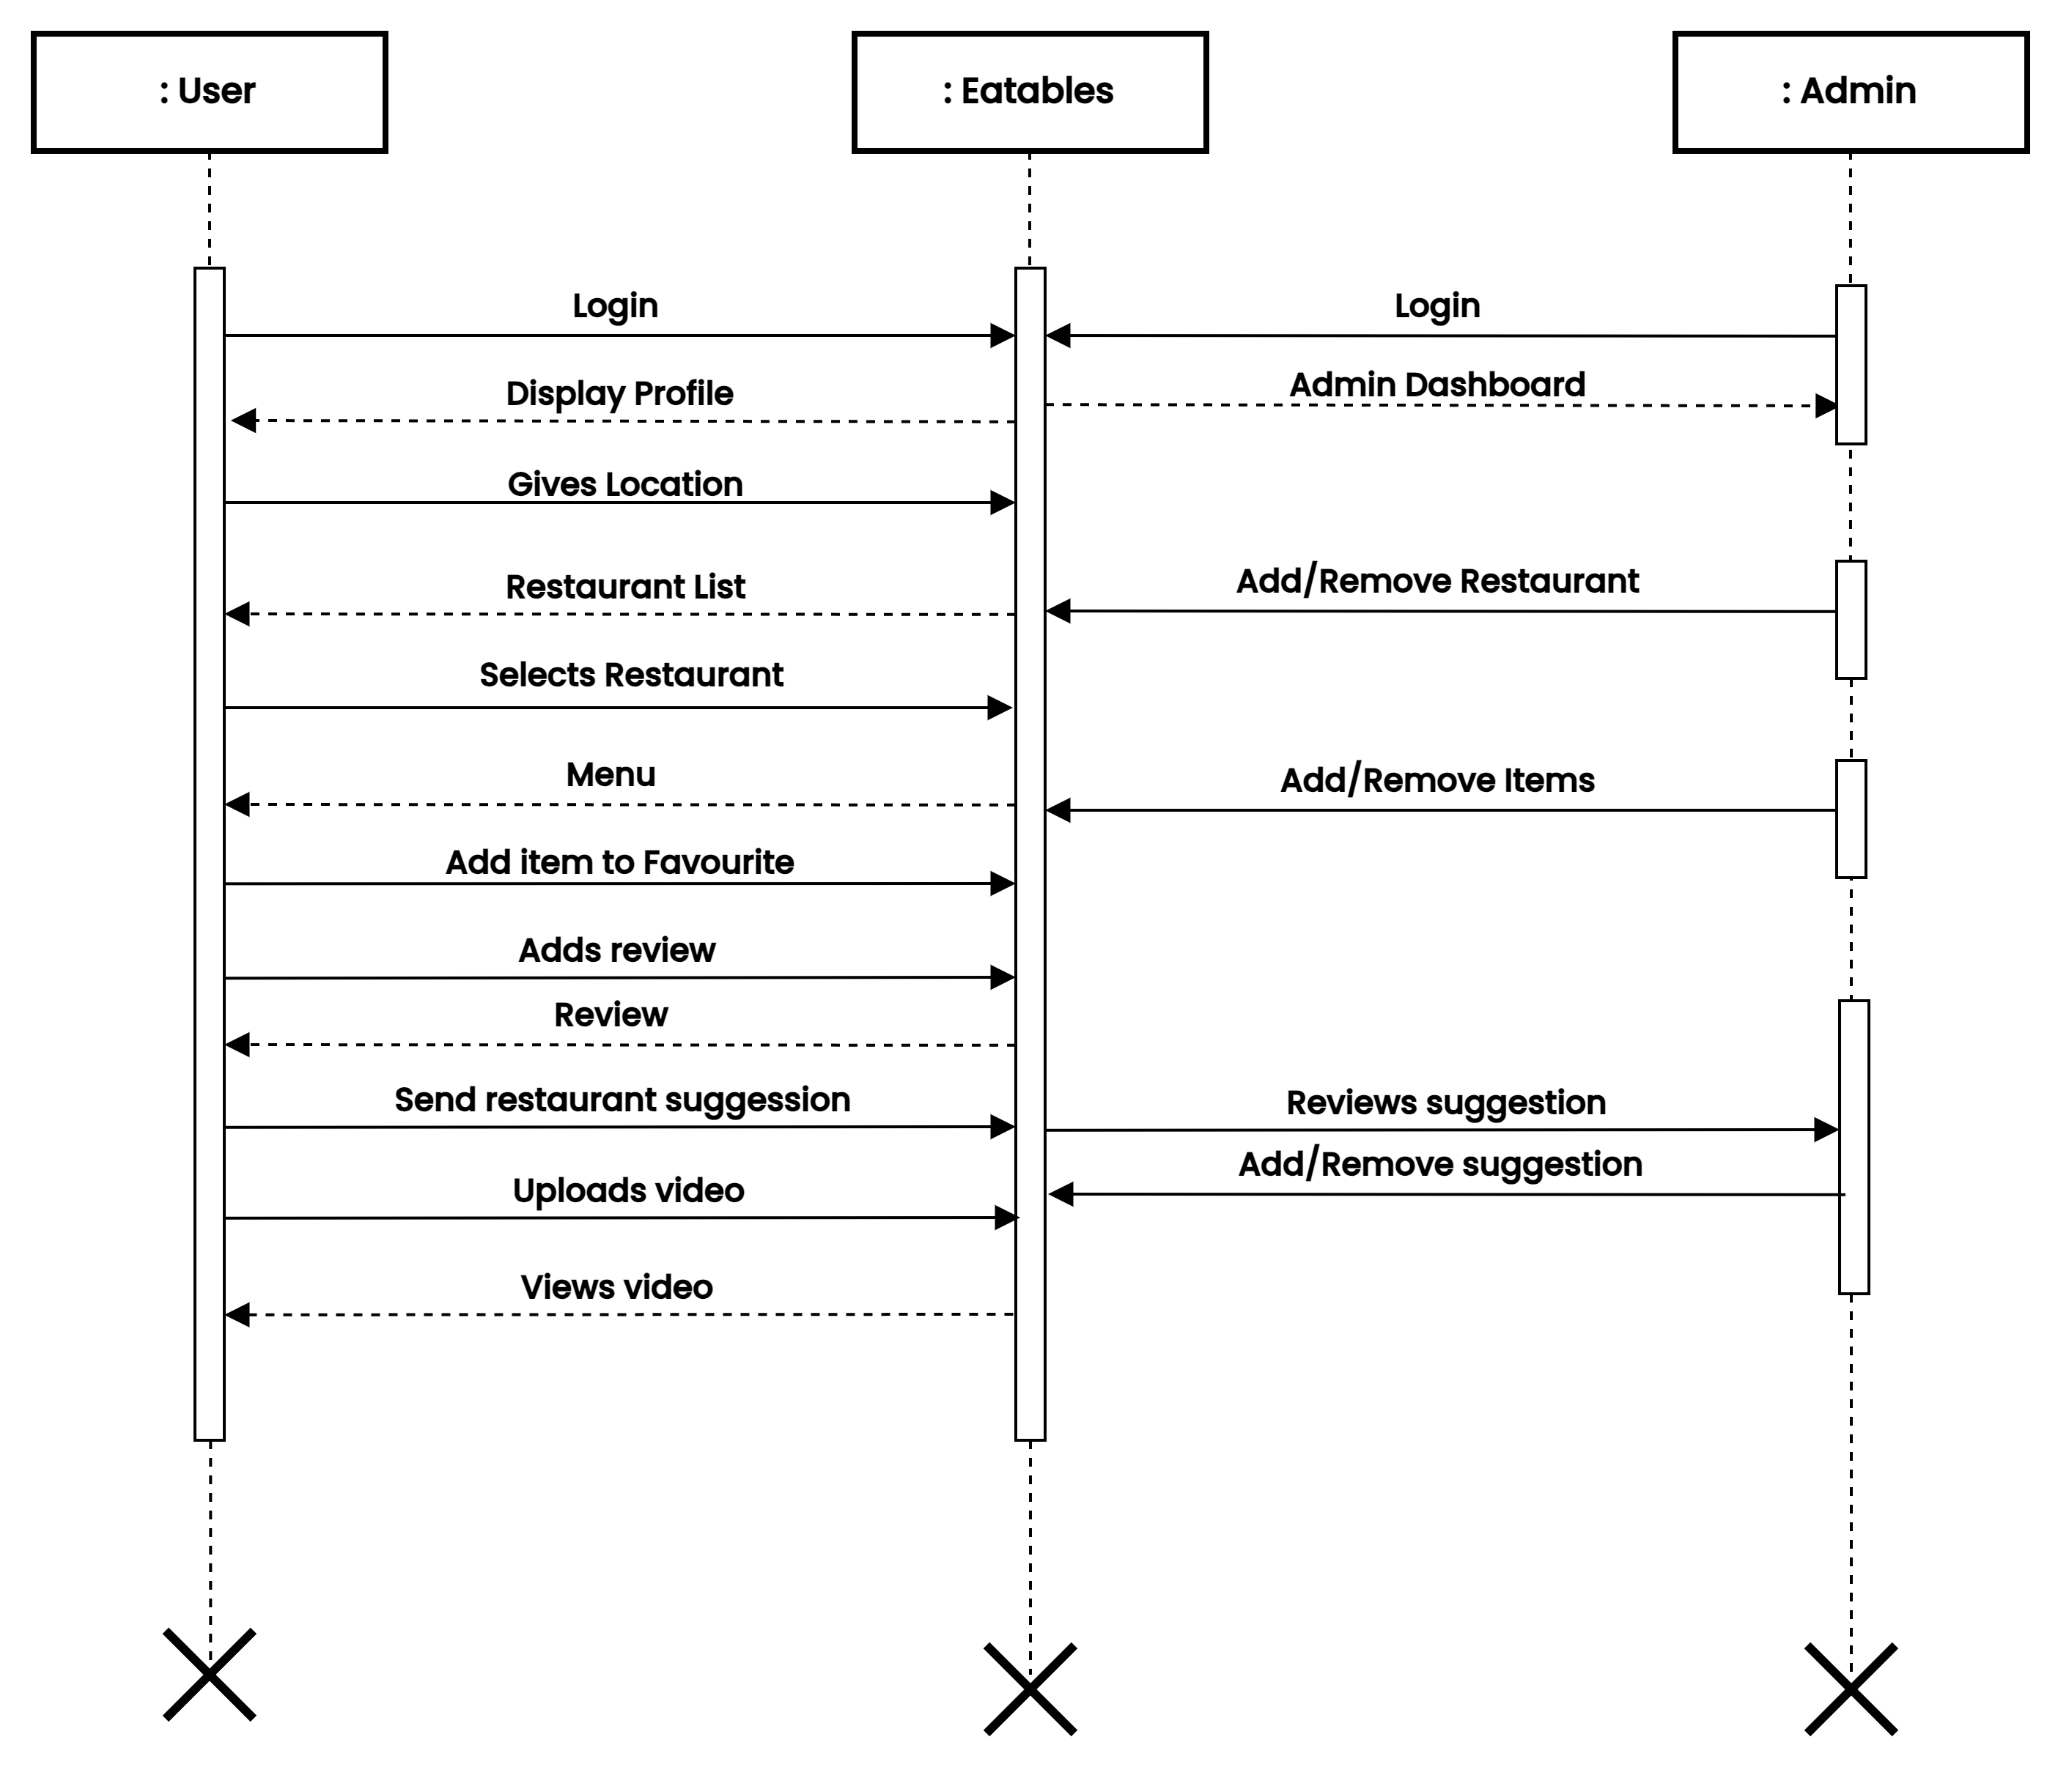

- SEQUENCE DIAGRAM

- TEST CASES

Sign up form:

Test Case ID | Test Condition | Expected Output | Result
1 | If all field empty | Fill all the credentials | Success
2 | If full name field empty | Please enter your full name | Success
3 | If username field empty | Please enter your user name | Success
4 | If email field empty | Please enter your email address | Success
5 | If password field empty | Please enter a password | Success
6 | If password confirm field empty | Please confirm your password | Success
7 | If full name field consist number/special characters | Only alphabets and whitespaces are allowed | Success
8 | If username field consist of less than 4 or greater than 15 characters | Username requires  4 – 15 characters | Success
9 | If user name field consist number/special characters/whitespace/uppercase | Only lowercase letters are allowed | Success
10 | If user name field consist of existing username | Username already taken
11 | If email field consist of invalid email | Invalid email format | Success
12 | If email field consisting of existing email | Account already exist for this email | Success
13 | If password field consist of less than 8 characters | Minimum 8 characters required | Success
14 | If password field does not contain combination of number and letter | Combination of alphabets and numbers required | Success
15 | If confirm password field does not match password field | Password entered does not match | Success
16 | If all credentials are valid | Account created successfully and redirect to login page. | Success

Login form:

Test Case ID | Test Condition | Expected Output | Result
1 | If username field empty | Please fill out this field | Success
2 | If password field empty | Please fill out this field | Success
3 | If inputs wrong username | User not found | Success
4 | If inputs wrong password | Password incorrect | Success
5 | If user clicks on forgot password | Redirect to reset password page | Success
6 | If username and password are valid for user | Redirect to user home page | Success
7 | If username and password are valid for admin | Redirect to admin profile page | Success

Home page:

Test Case ID | Test Condition | Expected Output | Result
1 | If user types restaurant name in search box. | Display similar  restaurant names under search box | Success
2 | If user clicks on eatables logo. | Page refreshes | Success
3 | If user clicks on Drops icon | Redirect to Drops page | Success
4 | If user clicks on profile icon | Redirect to user profile page | Success
5 | If user chooses a restaurant name | Redirect to item details page | Success
6 | If user click on assistant | Open filter window | Success
7 | If user applies price filter | Display items based on the price | Success
8 | If user clicks on Submit restaurant in footer | Redirect to restaurant suggestion page | Success

Submit restaurant:

Test Case ID | Test Condition | Expected Output | Result
1 | If restaurant name field empty | Display please fill out this field | Success
2 | If location field empty | Display please fill out this field | Success
3 | If ratings field empty | Display please fill out this field | Success
4 | If link field empty | Display please fill out this field | Success
5 | If description field empty | Display please fill out this field | Success
6 | If all fields are valid | Display submit message and redirect to user profile page | Success

Hotel page:

Test Case ID | Test Condition | Expected Output | Result
1 | If user clicks on contact number | Dial the contact number | Success
2 | If user clicks on email | Open gmail and compose a new mail | Success
3 | If user clicks/drags on map | Show location of the restaurant | Success
4 | If user clicks on zomato icon | Redirect to zomato page of the restaurant | Success
5 | If user clicks on an item | Redirect to item details page | Success
6 | If user clicks on number in pagination | Redirect to the page | Success
7 | If user clicks on eatables | Redirect to home page | Success

Item page:

Test Case ID | Test Condition | Expected Output | Result
1 | If user clicks on eatables | Redirect to home page | Success
2 | If user clicks on profile icon | Redirect to user profile page | Success
3 | If user clicks on add to favourite/remove favourite | Item is added/removed from favourites accordingly | Success
4 | If clicked on share icon | Website URL is copied to clipboard | Success
5 | If tried to submit empty review | Display please fill out this field | Success
6 | If user submits review | Store review and display it in the same page in the review section. | Success
7 | If user clicks on logout icon | Log out and redirect to login page | Success

Drops page:

Test Case ID | Test Condition | Expected Output | Result
1 | If user clicks on eatables | Redirect to home page | Success
2 | If user clicks on profile icon | Redirect to user profile page | Success
3 | If user clicks in home icon | Redirect to index page | Success
4 | If user clicks on heart icon | Like/dislike the video | Success
5 | If user click/tap in the video | Play/pause the video | Success
6 | If user click on the video icon | Open upload video window | Success

User profile

Test Case ID | Test Condition | Expected Output | Result
1 | If clicked on eatables | Redirect to home page | Success
2 | If clicked on drop icon | Redirect to drops page | Success
3 | If clicked on video icon | Open drop upload window | Success
4 | If clicked on logout icon | Log out and redirect to login page | Success
5 | If clicked on camera icon | Redirect to edit profile page | Success
6 | If clicked on edit profile button | Redirect to edit profile page | Success
7 | If clicked on Favourites | Display items in user’s favourite list | Success
8 | If clicked on the delete icon on the favourite item | Remove from favourite | Success
9 | If clicked on Drops | Display drops uploaded by the user | Success
10 | If clicked on Reviews | Display reviews uploaded by the user | Success
11 | If clicked on delete icon in reviews | Delete the review and redirect to the same page | Success
12 | If clicked on submit restaurant in footer | Redirect to restaurant suggest form page | Success

Admin panel

Test Case ID | Test Condition | Expected Output | Result
1 | If clicked on add new restaurant | Display form to add new restaurant | Success
2 | If clicked on manage restaurant | Display list of all restaurants with edit and delete button | Success
3 | If clicked on add item | Display form to add new item | Success
4 | If clicked on user suggestion | Display all restaurant suggestions submitted by different users | Success
5 | If clicked on admin logo | Redirect to admin profile page | Success

- CONCLUSION:

EATABLES is a user-friendly platform that offers a seamless dining experience, providing users with a one-stop solution for exploring new food options. The platform's innovative features, including geolocation-based restaurant suggestions, community-driven reviews, and personalized favourites lists, make it easy for users to find the perfect dining spot based on their preferences. With its user-centric design and advanced technology, EATABLES is the ultimate tool for anyone looking to discover new culinary delights.

***************

