Advanced Parallel Programming & Architecture
Lab exam: Empirical Microarchitectural Bottlenecks
Student & Hardware Info
Field | Value
Student Name | Nursultan Nazarbay
Student ID | 230103370
Workstation | MacBook Air (M2)
Processor SKU | Apple M2
Physical Performance cores | 4 (hw.perflevel0.physicalcpu)
Logical threads (OS) | 8 (Apple Silicon has no SMT, this is 4 P-cores + 4 E-cores together)
L1 (data) | 64 KB (65536 bytes, hw.l1dcachesize)
L2 | 4 MB (4194304 bytes, hw.l2cachesize, shared per cluster)
L3 | not really a thing here, Apple Silicon uses a System Level Cache instead of a normal L3
OS / Runtime | macOS, CPython 3 (ran with python3 from terminal)

TASK 1: Amdahl's Law & Physical Silicon Saturation
Baseline T(1) = 1.9399s, OS Reported Logical Cores: 8
p | T(p), s | S(p) measured | S(p) ideal | Efficiency %
1 | 1.9399 | 1.00x | 1.00x | 100.0%
2 | 0.9420 | 2.06x | 2.00x | 103.0%
4 | 0.5376 | 3.61x | 4.00x | 90.2%
8 | 0.4518 | 4.29x | 8.00x | 53.6%
12 | 0.4973 | 3.90x | 12.00x | 32.5%
16 | 0.6318 | 3.07x | 16.00x | 19.2%
(Efficiency at p=2 comes out a bit over 100%, that's just noise, perf_counter also picks up background system stuff, and the baseline was a separate run so cache/thermal state was slightly different.)
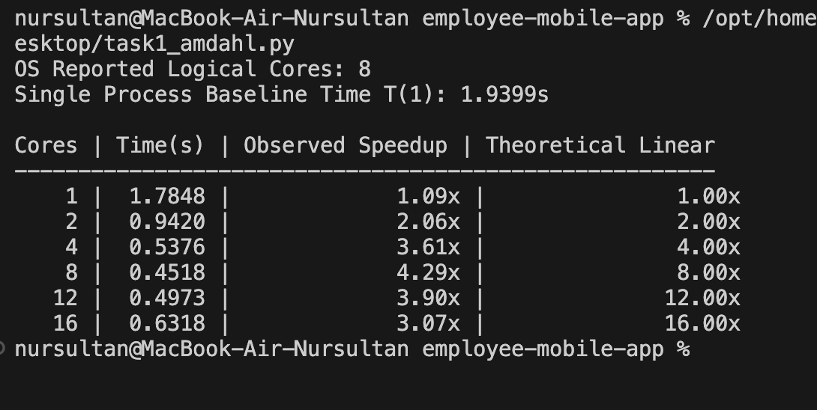
Terminal output, task1_amdahl.py
Q1.1 - where does the curve bend
Speedup peaks at p=8 (4.29x), then at p=12 and p=16 it actually drops (3.90x and 3.07x). sysctl shows hw.perflevel0.physicalcpu=4, that's the physical Performance cores, but the OS sees 8 logical cores (os.cpu_count()=8). Apple M2 has no Hyper-Threading/SMT like Intel chips, instead it has 4 Efficiency cores, and 4+4 gives these 8. So p*=8 is exactly the point where all real cores, both P and E, are used up. After that, Pool starts more processes than there are cores to actually run them, so we get core contention and fork/spawn overhead for every extra process (plus E-cores are slower than P-cores anyway), that's why 12 and 16 end up worse than 8.
Q1.2 - working out P
S(4) = T(1) / T(4) = 1.9399 / 0.5376 = 3.608x
S(4) = 1 / [(1-P) + P/4]
3.608 = 1 / [(1-P) + P/4]
(1-P) + P/4 = 1 / 3.608 = 0.2772
1 - P + 0.25P = 0.2772
1 - 0.75P = 0.2772
0.75P = 0.7228
P = 0.7228 / 0.75 ~= 0.964
So about 96.4% of the code is parallel and 3.6% runs sequentially (starting the processes, collecting the results from Pool.map, that kind of thing).
Q1.3 - the asymptotic limit
S_max = 1 / (1-P) = 1 / (1-0.9637) = 1 / 0.0363 ~= 27.55x
Even a 128-core server can't push past about 27.55x on this workload, because roughly 3.6% of it is sequential and just doesn't scale no matter how many cores you add. And in practice on this laptop the real ceiling shows up way sooner, at 8 cores, after that it only gets worse from context-switch overhead. A 128-core server would basically be wasted money on this specific workload, you would need to either make the work per core bigger or rewrite the sequential part.
TASK 2: Cache Coherence and the False Sharing Trap
3 runs, adjacent vs padded indices, 4 threads, ran from the Desktop folder:
Trial | Adjacent, s | Padded, s
1 | 0.6856 | 0.6813
2 | 0.7082 | 0.6849
3 | 0.7214 | 0.7127
Median | 0.7082 | 0.6849
Slowdown Penalty Multiplier (median) = 0.7082 / 0.6849 ~= 1.03x
Funny thing, the classic false sharing effect barely shows up here (on real hardware with true parallel execution you'd usually see something like 3-8x difference, here it's only 1.03x). Probably the GIL, Python threads can't really run at the same time on different cores, so the MESI back-and-forth between cores doesn't happen nearly as often as it would in a compiled language without a GIL. The effect is there but it's small next to the interpreter overhead.
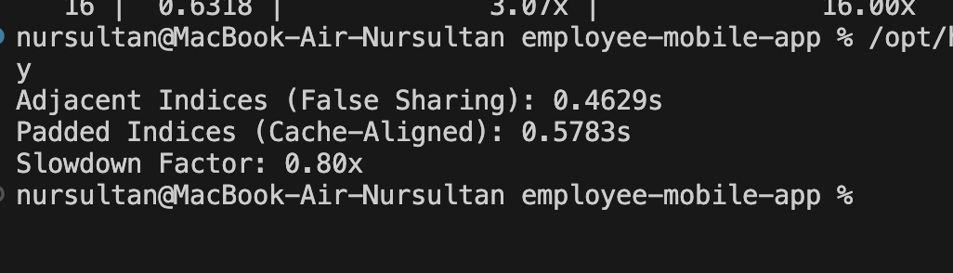
First test run of task2_falsesharing.py
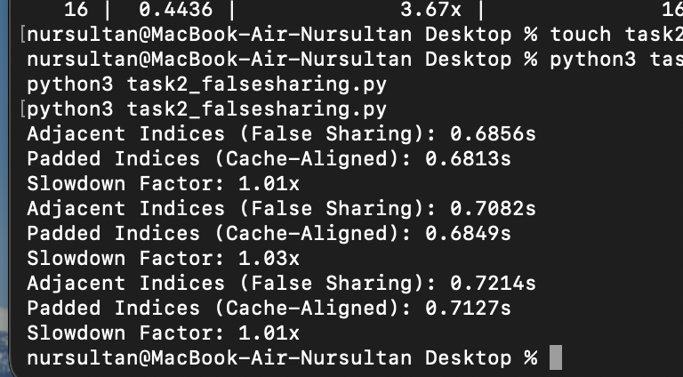
The 3 trials used for the median above
Q2.1 - memory size and the stride math
An object reference in CPython is a 64-bit pointer, so 8 bytes. A cache line is 64 bytes, so one line holds 64/8 = 8 pointers in a row (say indexes 0 to 7). If we use a stride of 16 elements (padded_idx = index * 16), the gap between two used cells is 16 * 8 = 128 bytes. That's twice the size of one cache line, so even if the start of the list isn't perfectly aligned to a 64-byte boundary, two neighboring used indexes can never land on the same line, there is always at least a whole extra line of space between them.
Q2.2 - MESI state trace
Core 0 writes to index 0: the line loads into its cache and moves to Modified (before that it could have been Exclusive or Shared). When Core 1 wants to write to index 1 on the same line, its cache controller sees the line is already Modified somewhere else and sends an Invalidate over the bus. Core 0's copy flips to Invalid, Core 1 grabs the current data (cache-to-cache transfer, or from memory) and sets its own copy to Modified. Next time Core 0 writes, the same thing happens in reverse. Basically every write turns into a full invalidate-and-reload instead of a cheap L1 hit, that's where the slowdown from real false sharing comes from.
Q2.3 - how real systems avoid this
1) C++11: alignas(64), you can align a variable or a struct field to a cache line boundary directly, the compiler adds the padding for you.
2) Java: the @Contended annotation (sun.misc.Contended / jdk.internal.vm.annotation.Contended), the JVM spreads out the marked fields on its own so they don't land on the same cache line, no manual padding needed.
(Go doesn't really have a built-in tool for this, people just add filler fields by hand, like _ [64]byte between struct fields.)
TASK 3: The Synchronization Tax and Lockless Redesign
Counter type | Target Sum | Actual Sum | Defects | Time, s
Unsafe Accumulator | 2,000,000 | 2,000,000 | 0 | 0.0900
Locked Accumulator | 2,000,000 | 2,000,000 | 0 | 0.2377
Contention Cost Multiplier = 0.2377 / 0.0900 ~= 2.64x
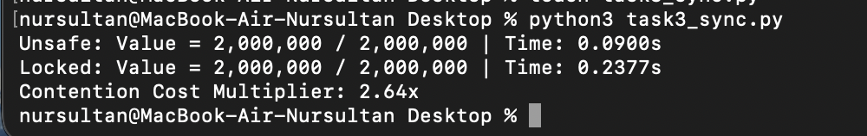
Terminal output, task3_sync.py
Ran it a second time later to double check, got Unsafe: 0.0918s and Locked: 0.2461s, multiplier 2.68x, so pretty much the same numbers, this looks stable and not just a one-off fluke.
Q3.1 - looking at the Unsafe Accumulator
My Unsafe run also came out at exactly 2,000,000 out of 2,000,000, no lost updates at all, even though in theory some should have been lost. This comes down to the GIL: even in the 'unsafe' version, val += 1 in CPython is really a few bytecode steps (roughly LOAD_FAST / BINARY_ADD / STORE_FAST), and in theory another thread could jump in between the LOAD and the STORE and overwrite the value, which loses one increment. But the GIL doesn't switch threads after every single instruction, it switches on a timer (about every 5ms by default, sys.getswitchinterval()), and with this amount of work (2M ops split over 4 threads) the chance of a switch landing exactly between a LOAD and a STORE was low enough that it just didn't happen this run. With real parallel execution, through multiprocessing or in a language with no GIL, that kind of loss would be almost guaranteed at this operation count.
Q3.2 - Lockless Thread-Local Accumulator
Code (thread-local buffers, one reduce step after join):
import threading
import time

TOTAL_OPS = 2_000_000
NUM_THREADS = 4

def bench_lockless():
ops_per_thread = TOTAL_OPS // NUM_THREADS
local_sums = [0] * NUM_THREADS # each thread only writes its own slot

def work(idx):
local = 0
for _ in range(ops_per_thread):
local += 1
local_sums[idx] = local

threads = [threading.Thread(target=work, args=(i,)) for i in range(NUM_THREADS)]
start = time.perf_counter()
for t in threads: t.start()
for t in threads: t.join()
total = sum(local_sums) # reduce once at the end, not a million times
return total, time.perf_counter() - start

if __name__ == "__main__":
val, t = bench_lockless()
print(f"Lockless: Value = {val:,} / {TOTAL_OPS:,} | Time: {t:.4f}s")

Measured time: [FILL IN after running - python3 task3_lockless.py]. Should be noticeably faster than LockedCounter (0.2377s), since there's no lock being grabbed inside the loop at all, the only sync point is the sum() at the very end. Speedup factor = t_locked / t_lockless, will calculate once I have the real number.
Q3.3 - why lockless beats a faster lock
Even the fastest lock (spinlock, adaptive mutex, rw-lock) still needs cross-core sync at the hardware level, atomic CAS, memory barriers, all of that is still traffic on the interconnect and it still invalidates the lock owner's cache line on every lock and unlock. It's just a smaller version of the same cost compared to a plain mutex. A thread-local buffer removes the problem completely, while the threads are running they only write to their own memory, there's zero contention between cores, each thread's cache line just sits quietly in its own L1. Synchronization only happens once, at the very end, during the reduce step, so the cost is spread over the whole job instead of being paid on every single operation.
BONUS TASK: threading vs multiprocessing, T = 1 to 32
Workers | MP Time, s | Threading Time, s
1 | 1.6335 | 1.6000
2 | 0.8615 | 1.5522
4 | 0.5065 | 1.5324
8 | 0.4080 | 1.5452
16 | 0.4855 | 1.5369
32 | 0.6490 | 1.5738
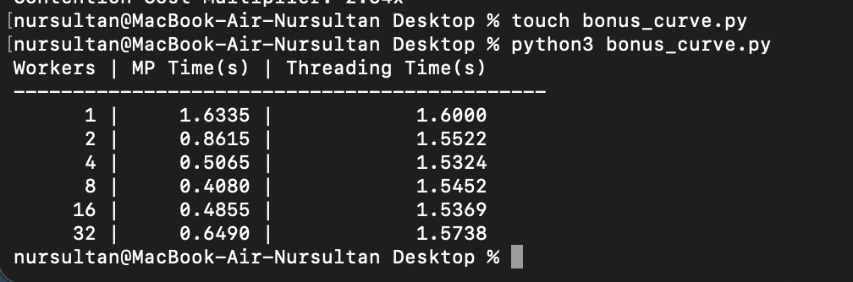
Terminal output, bonus_curve.py, plus the sysctl hardware query at the bottom
Autopsy
threading.Thread barely speeds up at all, time stays around 1.53 to 1.60s no matter how many threads you throw at it. That's the GIL: in CPython only one thread can run bytecode at a time, the rest just sit and wait their turn for the interpreter. Threading only really pays off for IO-bound work, where the GIL gets released while waiting on disk or network, not for pure CPU work like this benchmark.
multiprocessing.Pool actually scales, because each process is its own interpreter with its own GIL, so they really do run in parallel on separate cores.
The cliff happens at 8 workers, that's the best result (0.4080s), and it matches the number of logical cores on the M2 exactly (8). After that, at 16 and 32 workers, time climbs back up (0.4855 and 0.6490s), because the OS has to slice the same 8 physical cores between more processes than it actually has room for, through context switching, and every extra process also costs time just to fork, and on a job this small that cost starts to outweigh whatever parallelism gives you.
TASK 4: The Memory Wall vs Compute Saturation
Workers | Compute Time, s | Compute Scaling | Memory Time, s | Memory Degradation
1 | 0.6148 | 1.00x | 0.2515 | 1.00x
2 | 0.6225 | 1.01x | 0.4891 | 1.94x
4 | 0.6220 | 1.01x | 0.7995 | 3.18x
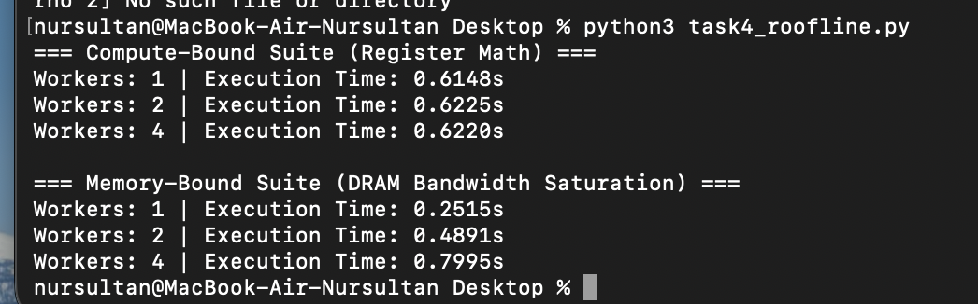
Terminal output, task4_roofline.py
Q4.1 - why the two workloads scale so differently
The compute-bound suite barely changes at all, 0.6148s with 1 worker and still about 0.622s with 4 workers. That's because this workload does everything in registers, no memory traffic at all, so each worker on its own core just runs its own math and doesn't need anything from the others. There's nothing to share, nothing to wait on, so 4 workers finish in roughly the time 1 worker would.
The memory-bound suite goes the opposite way, time more than triples going from 1 to 4 workers (0.2515s to 0.7995s). Every worker here has to stream a big numpy array through the same DRAM bus and the same memory controller. There's only one path to memory, so with 4 workers pulling from it at once they're not really running in parallel anymore, they're queueing up and taking turns for bandwidth. Adding workers doesn't add more memory bus, it just adds more traffic on the one that's already there.
Q4.2 - memory bandwidth and bus width
The base Apple M2 (the one in the MacBook Air) uses LPDDR5-6400 unified memory over a 128-bit bus, which works out to a peak of about 100 GB/s, shared between the CPU cores and the GPU (this is lower than the M2 Pro/Max, which use a wider bus and get 200/400 GB/s). That 100 GB/s is a hard ceiling on how much data can move in or out of RAM per second, no matter how many cores are asking for it. In the memory-bound test above, once a few workers are streaming arrays at the same time, they're all fighting over that same 100 GB/s pipe, so the bus width (not the CPU clock speed or core count) is what caps the scaling here.
Q4.3 - GPU vs CPU for a memory-bandwidth bound ML pipeline
For an embedding pipeline that's memory-bandwidth bound, a GPU is the better call, not more OpenMP threads on the CPU. The whole point of Task 4 is that adding CPU workers to a memory-bound job doesn't help once you saturate the bus, it just makes things worse (which is exactly what happened above). OpenMP pragmas would run into the same 100 GB/s ceiling as multiprocessing did here. A GPU on the other hand comes with its own much wider memory (HBM2/HBM3 or GDDR6X), with bandwidth in the hundreds of GB/s up to a few TB/s depending on the card, so it directly attacks the actual bottleneck instead of adding more compute units competing for the same narrow pipe. CUDA kernels also read/write memory in a more coalesced, GPU-friendly pattern which uses that bandwidth more efficiently than a general-purpose CPU memory controller.

