Altera State Sequencer
Data Sheet
(NOTE: This document is “0000.doc”)

Version 0.1.0
October 10, 2013

by
dlau
cruben

Author: | David Lau, Calvin Ruben
System: | n/a
Subsystem: | n/a
Keywords: | cal microsequencer state sequencer stimulus generator avalon sopc builder

Table of Contents:

1. General Description 3
2. Functional Description 3
2.1 Avalon Interface 4
2.1.1 Avalon Control Slave Port 4
2.1.1.1 status Register 4
2.1.1.2 pc Register 4
2.1.2 Avalon Instruction RAM Slave Port 4
2.2 Sequencer Architecture 5
2.2.1 Instruction Memory Module 6
2.2.2 Address Generation Module 6
2.2.3 Control Module 6
2.2.4 Branch Condition Module 7
2.2.5 Stack Module 7
2.2.6 Counter Register Module 7
2.3 Performance and Clocking 7
2.3.1 Maintaining Overall System Performance by using an External Clock 7
3. MicroCode Development / State Machine Definition 8

General Description
The Altera State Sequencer is a small-footprint QSYS component that provides functionality for fast switching of a large number of signals external to the Avalon system in a completely deterministic manner, with zero-latency response to inputs. It provides a solution in designs where a microprocessor would be too large and require too many clock cycles to perform rapid stimulus generation. Additionally, it provides an alternative to the lengthy design process involved in engineering a custom state machine, and is highly configurable, allowing designers to find a unique fit for a wide range of applications.

Functional Description
The Altera State Sequencer is used to control signals outside the QSYS system while reacting immediately to input signals with 100% predictability. Its states are defined by assembled microcode that is stored in an internal Instruction RAM, and makes use of the following functional registers:
- Program Counter
- Stack
- General Purpose Counter Register
- Branch condition
The Altera State Sequencer architecture is shown in Figure 1. This component is highly configurable, so nearly all the hardware blocks shown can be parameterized or disabled.
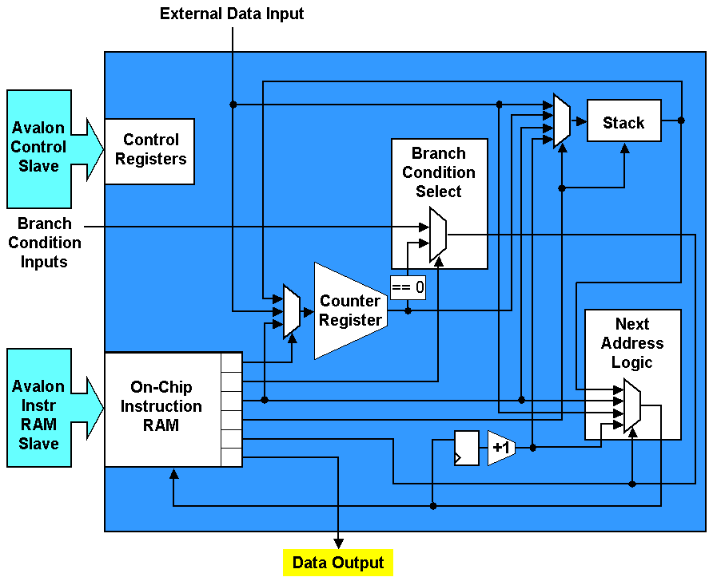
Figure 1. Altera State Sequencer Hardware Block Diagram

Avalon Interface
The Altera State Sequencer is a QSYS Ready Avalon Slave. It has two Avalon slave ports – a control slave port and an instruction RAM slave port. The control slave provides functionality to start, stop, and reset the sequencer. It can also be used to set or read the program counter. The instruction RAM slave is a direct interface to the component’s internal RAM, and can be used to program or reconfigure the sequencer after device programming and system initialization.

Avalon Control Slave Port

Table 1. Avalon Control Slave Register Map
A0 | Register Name | R/W | Description/Register Bits
A0 | Register Name | R/W | 32 | . . . | 5 | 4 | 3 | 2 | 1 | 0
0 | status | RW |  |  |  |  |  | step | rst | run
1 | pc | RW | Program Counter Address

status Register
The Control Slave Port uses a 1-bit address, and 32-bit data bus. As shown in Table 1, the status register at address 0 has only three bits – a run bit, which is an active-high signal that turns the sequencer on and off, a rst bit, which resets all sequencer registers when a 1 is written to it, and a step bit, which pulls the internal sequencer clock enable high for one cycle each time a 1 is written to it. The rst bit does not clear the internal Instruction RAM, but resets the program counter to zero. With the exception of the run bit, reading from any bit in the status register produces undefined results. When writing to the status register, bits 2-31 of the writedata are ignored. The step bit was intended to be used for debug purposes, and has no effect when the run bit is high.
By default, the sequencer boots stopped. That is, after a global system reset signal pulse is received, the sequencer sits at address zero until a write to the status register sets it running. If desired, the component can be configured (in its Wizard) to run immediately after a global system reset pulse is received.

pc Register
The pc register at address 1 stores the value of the sequencer program counter. The width of the program counter register will vary depending on instance configuration. The value returned by a read operation to the pc register is the value of the program counter at the cycle during which the sequencer registers (or synchronizes, if using an external clock) a rising edge of the Avalon read signal. The most significant bits of the pc register are zero-padded if the system width has been configured to be smaller than 32 bits. Setting the program counter while the sequencer is running can produce undefined results.

Avalon Instruction RAM Slave Port ( this will be changing in the next release)
The Instruction RAM Slave Port is a write-only interface to the sequencer’s internal program memory. Its address and data width vary depending on module configuration. The component wizard calculates the Instruction RAM Slave Data Width to be as large as one Instruction Word, which changes size depending on module configuration. The component wizard displays and updates the Instruction Word size and Instruction RAM Slave Data Width as configuration options are changed, as shown in Figure 2. The Altera State Sequencer leverages 64-bit data port width functionality in QSYS version 13.0 to support configurations with large Instruction words.
When writing to the Instruction RAM Slave, one Data word corresponds to one Instruction word. If the Instruction RAM Slave Port is wider than the Instruction word itself, the most significant bits in excess are stored as written, but are ignored by the sequencer during internal read operations. Byteenable signals are used by the Instruction RAM Slave Port to support narrow masters, etc. For more information on Avalon bus transactions, refer to the Avalon Bus Specification Reference Manual.
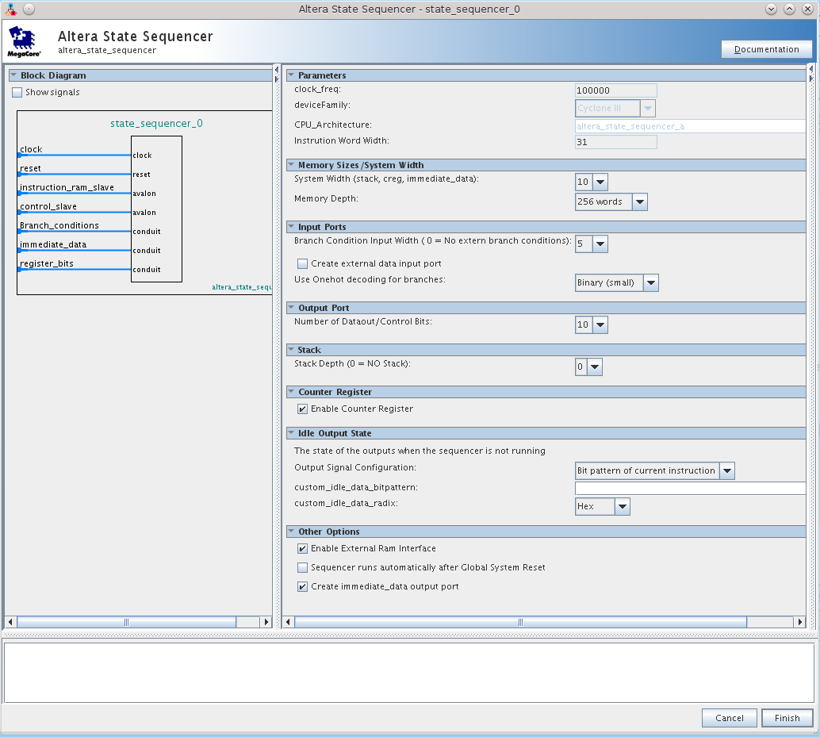
Figure 2. Component Wizard (page 1)
Note:
In Future versions this interface will not use byteenables. The interface will have a 32 bit register which stores the lower 32 of data. Whenever a write to a lower address i.e. 0x0, 0x8 the data will not be written to memory but just stored in the register. Whenever a write to the upper 32 is occurs (0x4, 0xc) a write to the sequencer memory will occur. The data will be the combination of the lower word written previously ( bits 31:0) and stored and the current writedata (bits 63:32) and the memory location address shifted down by 3 bits. So Avalon address 0x and 0x4 map to sequencer instruction memory location 0 and 0x8 and 0xc map to sequencer instruction memory location 1.

Sequencer Parameters

System Width
The system width defines the size of the CREG, width of the immediate data in the opcode, and the stack width. It also defines the upper bound on the instruction memory size. The max size is 15.
If the System Width is 8 bits, only 256 instructions/states are possible. If the system width is changed to 10 bits, then up to 1024 states/instructions can be used.

Memory Depth
The Memory Depth parameter defines the maximum number of states/instructions that the sequencer supports. Because most sequencer code is very compact, not a lot of memory is generally needed. If the instruction word width is 32 or less you may only need one memory block. If the instruction word is larger than 32 words you will need at least 2 memory blocks.
The max memory Depth cannot be greater than 2^systemwidth.

Branch Condition Input Width
This tells the logic generation how many inputs will be needed for branch conditions. These inputs should already be synchronized to the sequencer clock. If they are not metastability issues may occur. Try and keep the number of Branches to a minimum. This will reduce logic and enable the sequencer to run faster.
Setting this to zero disables all external branch conditions.

Use One Hot Decoding for Branches.
This allows you to trade off instruction word size for performance. Turning on one hot increase the size of the instruction word but makes decoding fast and small, while disabling it saves instruction word width.

Create External Data Input Port
This allows data from an external source, to be loaded into the CREG, and stack. It is the width of the System Width. This must be synchronized to the sequencer’s clock.

Number of Dataout / Control bits
The real reason for a sequencer is to control other things. These are the bits that do that. This parameter controls the number of control bits used. This directly affects the width of the instruction word but does not impact performance. These bits come directly from the instruction RAM. The state of each bit is controlled by the state/instruction which is being executed.
The current max is 32 bits.

Stack depth
This parameter determines how deep the stack will be. A depth zero will turn off the stack module. These bits are made from registers, if a large stack is needed, changing the instantiation for the memory in the Verilog will enable it to use a memory block.

Enable Counter Register
This enables or disables the CREG block.

Idle output state
When the sequencer is not running ( run bit off) or no software is currently loaded in the instruction RAM. What should the state of the control bits be? These three options let you define that default state.

Enable External Ram Interface
Creates and extra Avalon port which allows the write of the instruction RAM

Sequencer Runs Automatically after Reset
If the code is not loaded as part of the bit stream this bit should not be enabled. If after reset the sequencer should start executing from its internal RAM select this bit.

Create Immediate Data Port
If you want to be able to use the immediate data outside of the sequencer enable this bit and a conduit will be created with the immediate data. The next version of the compile will have special opcodes for force data to the immediate portion of the opcode. Right now just load the CREG and the data will show up in the opcode.

Sequencer Architecture
The Altera State Sequencer, in its minimal configuration, consists of three modules:
- Instruction Memory Module
- Address Generation Module
- Control Module
These modules are necessary for basic sequencer functionality, and cannot be disabled. A sequencer in this minimal configuration is fully capable of generating output signals, but can only step and jump through code. Three additional modules can be can be added to this base configuration and will extend the functionality of the sequencer:
- Branch Condition Module
- Stack Module
- Counter Register Module
When writing microcode to define a custom state machine, the developer can issue commands to individual modules, which interact with each other. These commands perform actions such as: increment the program counter, push (PC + 1) onto the stack, load an immediate value onto the counter register, etc. It is important to understand the sequencer architecture in order to write effective, efficient microcode. Each of the six sequencer modules are described below, as a preface to the microcode language definition that follows.

Instruction Memory Module
The Instruction Memory Module stores the state definitions (microcode) for the sequencer. The details of its implementation are abstracted away from the system designer – it returns the instruction word corresponding to the program address given. The Instruction Memory is implemented in synchronous RAM blocks
For more information on the Instruction RAM Slave Port, the Instruction Memory Module’s interface to the Avalon bus, see 2.1.2 – Avalon Instruction RAM Slave Port.

Address Generation Module
The Address Generation Module maintains the program counter register, and prepares the next address for the Instruction Memory Module. The program counter register can be loaded from any one of the following sources:
- Program Counter
- Program Counter + 1
- Opcode Immediate Value
- Stack
- External Data bus
- Control Module (data from Avalon write)
The Address Generation Module can also make branching decisions based on the opcode, and the value of the condition bit generated by the Branch Condition Module (see 2.3.4), or the value of the Counter Register.

Control Module
See 2.1.1 – Avalon Control Slave Port.

Branch Condition Module
If enabled, the Branch Condition Module selects a bit from the Branch Condition Input Bus based on the current opcode, and exports it to the sequencer as the condition bit. Other modules use this bit to support zero-latency response to input signals. The Branch Condition Module can also select a constant-1, or select a bit that designates whether or not the counter register equals zero, which is particularly useful when timing out loops. If the Branch Condition Module is disabled, opcodes to select between constant-1 and (counter register == 0) are still supported.
In any given clock cycle or instruction, the sequencer can only consider one branch condition input (i.e., it supports only binary conditions). If support for complex branching is required, the developer can create his complex branch logic external to the Avalon system, and create a branch condition input for each complex evaluation necessary.

Stack Module
The Stack is used to support function calls, and other LIFO program data storage. Data can be popped off the stack and used by the Counter Register Module and the Address Generation Module. The Stack can be loaded from any one of the following sources:
- Program Counter + 1
- Counter Register
- Opcode Immediate Value
- External Data Bus
The Stack Module can also use the condition bit (see 2.3.4 – Branch Condition Module) to determine whether or not to push or pop a value.

Counter Register Module
The Counter Reigster Module can be used to time out loops. The Counter Register can store the loop index, and the module outputs a bit (called the “zero” bit) that is high when the Counter Register is equal to zero. This bit can be selected by the Branch Condition Module (2.3.4) as the condition bit, so that the sequencer branches when the desired number of loop iterations have completed. The Counter Register can be decremented, or loaded from any one of the following sources:
- Opcode Immediate Value
- External Data Bus
- Stack

Performance and Clocking
The Altera State Sequencer is a single-cycle implementation. That is, it evaluates one instruction word per clock cycle. This allows it to operate with 100% determinism and predictability, which is crucial in many control applications.

MicroCode Development / State Machine Definition
Each state (or address) of the sequencer is defined by microcode. The micro code has three basic parts; The outputs, condition and the action. The microcode generically looks like.

<outputs>, <if(condition)> <action><else wait <while creg>>;
The microcode is case sensitive. Any symbol must be defined before it is used. A great place to see all the code in action is in the Example1.seq and test_code.txt code

Outputs
The primary function of a sequencer is control. It can be thought of as a giant state machine that can have as many as 64K states. The outputs are simply the signals that need to be asserted at that particular state. This sequencer allows 1~50 outputs.

Defining Outputs
The outputs field of the microcode is a number that describes the output bits that will be set/asserted.
0x5, continue; // example of hex number
In the above example bits 2 and 0 will be asserted.
10, continue; // example of binary number
In this example bits 3 and 1 will asserted. ( 10 = 0xa)
Writing numbers for the outputs is a poor way to code. It is not very readable. A better way is to describe your outputs is to use symbols to describe each bit. This is accomplished by assigning the value for that bit. i.e. for bit 0 that value would be 1 and bit 3 would be 8 etc.
Here is an example:
// this is the "ONES" seven segment
seg1a = 0x0040;
seg1b = 0x0020;
seg1c = 0x0010;
seg1d = 0x0008;
seg1e = 0x0004;
seg1f = 0x0002;
seg1g = 0x0001;
seg1dp = 0x0080;

// This is the "TENS" seven segment
seg2a = 0x4000;
seg2b = 0x2000;
seg2c = 0x1000;
seg2d = 0x0800;
seg2e = 0x0400;
seg2f = 0x0200;
seg2g = 0x0100;
seg2dp = 0x8000;
You can also combine symbols to make new symbols.
// here I combine a few of them together
zero = seg1a | seg1b | seg1c | seg1d | seg1e | seg1f;
one = seg1b | seg1c;
two = seg1a | seg1b | seg1d | seg1e | seg1g;
three = seg1a | seg1b | seg1c | seg1d | seg1g;
four = seg1b | seg1c | seg1d | seg1f | seg1g;

Using Outputs
Now instead of using the number you can use these symbols
seg1a | seg1b, // also turn on segment b
if(creg ==0) load loop3 else wait while creg; // wait to time out loop2 and then load loop3

seg1a | seg1b | seg1c, // turn on segc as well
if(creg ==0) load loop4 else wait while creg; // wait to time out loop3 and then load loop4

seg1a | seg1b | seg1c | seg1d, // turn on segd as well
if(creg ==0) else wait while creg; // time out loop4

two, // display the number "2"
if( switch2 ==0) goto switch2_pushed;

The in the above all the symbols are “or”ed together. Normally you would want to “|” (or) the symbols together that way if accidentally added one symbol more than once it wouldn’t matter. Here is a list of supported operations on symbols or numbers
+ addition
- subtraction
| bit wise OR
& bit wise AND
* multiply
/ divide
The outputs are separated from the action by a coma. They can be on their own line like the example above or combined with the action on the same line. ( They may also cross as many lines as you like. )

Conditions
Conditions determine if the action will take place and they are based on Brach condition inputs or CREG ( counter register) being equal to zero, or not equal to zero. If no condition is specified the condition is assumed true.

Branch Condition inputs
Branch conditions are signals which are supplied by the user system and are used to determine the flow of the code. Another good way to think of it is, a branch condition is any condition which can cause a change of state in a state machine. It could be an event such as a button push or a done signal from a process that is being controlled, or a signal indicating that data has just arrived. These branch conditions are used to control the flow of the code/states. Only one branch condition can be evaluated at a time. If there is a need to have more that this they must be evaluated sequentially in the code or combined externally in logic.

Defining Branch Condition Inputs
Special symbols BR0- BR32 are used to identify branch inputs. Branch inputs can be compared to “0” or “1”;
if(BR0==0) // true if branch condition_0 is low
if(BR0==1) // true if branch condition_0 is high
if(BR0) // true if branch condition_0 is high
Symbols can be used in place of the “BR” nomenclature. If branch condition bit 0 is a switch input you could define it like
Switch0 = BR0;
Then use it like
if(Switch0 ==0) // true if branch condition_0 is low
if(Switch0 ==1) // true if branch condition_0 is high
if(Switch0) // true if branch condition_0 is high

CREG Condition
The CREG is also and important branch condition. It allows the code to take loops of certain lengths, wait for conditions for a limited period of time.

if(CREG ==0) // true if CREG is 0
if(CREG ==1) // true if CREG is not 0
if(CREG) // true if CREG is not 0

Actions
When the condition is true the action will be executed. There are several action types.
- Actions that effect the next address
- Actions that effect the CREG
- Actions that effect the STACK

Address actions

GOTO <value>
Goto allows the code to jump to the immediate address in the data field of the opcode. This immediate data in normally in the form of a label.
code1:
…
,< if(condition) > goto code1; //jump to the code located at code1

- CREG = GREG
- NEXT_ADDRESS = Value
- STACK = unchanged

GOTO STACK
This pops the value off the stack and uses that value as the next address.
,< if(condition) > goto stack; //jump to the address located on the stack

- CREG = GREG
- NEXT_ADDRESS = stack
- STACK = unchanged

GOTO DATA_IN
Gets the value for the next address from the data_input / Edata
,< if(condition) > goto DATA_IN; //jump to the value at the edata port

- CREG = GREG
- NEXT_ADDRESS = edata
- STACK = unchanged

Gosub <value>
Goto allows the code to jump to the immediate address in the data field of the opcode. This immediate data in normally in the form of a label.
code1:
…
,< if(condition) > gosub code1; //jump to the code located at code1

- CREG = GREG
- NEXT_ADDRESS = Value
- STACK = pushed address+1

Gosub STACK
This pops the value off the stack and uses that value as the next address.
,< if(condition) > gosub stack; //jump to the address located on the stack

- CREG = GREG
- NEXT_ADDRESS = stack
- STACK = pushed address+1

Gosub DATA_IN
Gets the value for the next address from the data_input / Edata
,< if(condition) > gosub DATA_IN; //jump to the value at the edata port

- CREG = GREG
- NEXT_ADDRESS = edata
- STACK = pushed address+1

loop <value>
Goto allows the code to jump to the immediate address in the data field of the opcode and decrement the CREG. This immediate data in normally in the form of a label.
code1:
…
,< if(condition) > loop code1; //jump to the code located at code1

- CREG = GREG-1
- NEXT_ADDRESS = Value
- STACK = unchanged

loop STACK
This pops the value off the stack and uses that value as the next address and decrement the CREG.
,< if(condition) > loop stack; //jump to the address located on the stack

- CREG = GREG-1
- NEXT_ADDRESS = stack
- STACK = unchanged

loop DATA_IN
Gets the value for the next address from the data_input / Edata and decrement the CREG.
,< if(condition) > loop DATA_IN; //jump to the value at the edata port

- CREG = GREG-1
- NEXT_ADDRESS = edata
- STACK = unchanged

CREG actions
The CREG is a down counter. It can be loaded, and decremented.

Load <value>
Loads an immediate value into the CREG
, < if(condition) > load 0x30;
, < if(condition) > load my_symbol

- CREG = value
- NEXT_ADDRESS = ADDRESS+1
- STACK = unchanged

Load STACK
Loads last value pushed onto the stack to the creg
, < if(condition) > load stack;

- CREG = value
- NEXT_ADDRESS = ADDRESS+1
- STACK = unchanged

Load data_in
Loads the value at the edata port
, < if(condition) > load DATA_IN;

- CREG = edata
- NEXT_ADDRESS = ADDRESS+1
- STACK = unchanged

DEC
Decrements the value in the counter
,< if(condition) > dec;
- CREG = CREG-1
- NEXT_ADDRESS = ADDRESS+1
- STACK = unchanged

Stack operations

Push <value>
Pushes the immediate value onto the stack
,< if(condition) > push 20;
,< if(condition) > push my_symbol;

- CREG = CREG
- NEXT_ADDRESS = ADDRESS+1
- STACK = my_symbol ( pushed)

Push CREG
Pushes the CREG value onto the stack
,< if(condition) > push CREG;

- CREG = CREG
- NEXT_ADDRESS = ADDRESS+1
- STACK = CREG ( pushed)

Push DATA_IN
Pushes the immediate value onto the stack
,< if(condition) > push DATA_IN;

- CREG = CREG
- NEXT_ADDRESS = ADDRESS+1
- STACK = edata ( pushed)

Push ADDRESS
Pushes the immediate value onto the stack
,< if(condition) > push ADDRESS;

- CREG = CREG
- NEXT_ADDRESS = ADDRESS+1
- STACK = ADDRESS+1 ( pushed)

Pop to CREG
Loads the CREG from the value on the stack and then pops that value off the stack
,< if(condition) > pop to CREG;

- CREG = STACK
- NEXT_ADDRESS = ADDRESS+1
- STACK = pop

return
Pushes the immediate value onto the stack
,< if(condition) > return;

- CREG = CREG
- NEXT_ADDRESS = STACK
- STACK = pop

Complex instructions

Else Wait while CREG
This is a special instruction used to keep the address from advancing until the condition is met. The CREG is automatically decremented each clock cycle.
,if(condition) load 23 else wait while CREG;
The above example this line of code will not advance until either the CREG is zero at which time the address goes to addres+1 or the condition is met and the address will go to address+1.
,if(condition) goto my_label else wait while CREG;
The above example this line of code will not advance until either the CREG is zero at which time the address goes to address+1 or the condition is met which will cause it to jump to address my_label. This is the way to wait for an input with a timeout.

Else wait
This instruction is very similar to else wait while CREG with one exception, the CREG is not decremented. One word of caution. If the condition is never met the code will be stuck here forever. Also the CREG must not be zero when entering this instruction. If the CREG is zero the wait will not be preformed.
.if(condition) load 23 else wait:
Remember that if there is no condition it is assumed to default pass so the code will never wait.

Compiling the code.
The compiler is named SC.exe to invoke simply call the compiler with the files you want to compile. The compiler does not care what file extensions you use.
sc sequencer.shf Example1.seq

When you build the sequencer with QSYS a file is generated that contains all the hardware information that the compiler needs to compile your code. This file is called the seqencer header file or .shf. . Itshould be the first file listed in your compile list.
This file is place at at
<quartus project>/<Qsys name>/synthesis/submodules/software/<sequencer instance name>.shf
In the Example project included with this sequencer, the sequencer instance was called “sequencer”, so we get a file called sequencer.shf with all the hardware information
The compiler outputs intel hex format. Which is used by quartus. You will need to rename the file
<instance name>_instr_ram_packed.hex
And place it in your Quartus project directory so that is will be part of the bits stream.

Short comings

If( condition ) wait
Not implemented yet. As of release 0.6 of the compiler

Multiple actions
You should be able to have something like this
,if(condition) load my_label push my_label;
.if(condition push DATA_IN dec goto my_label
However the compiler does not handle this as of release 0.6 of the compiler.

More than 32 output bits.
The compiler does not handle more than 32 output bits as of release 0.6 of the compiler

