**Programming the NuPRISM MAX10 Using the Quartus Programmer Tool**

**Author(s):** R. Payne

**Release:** 1.0

**Release Date:** 02/06/2020

**Document Type:** Guide/Tutorial

**Project:** NuPRISM

**Keywords:** MAX10, Altera, Programmer, Quartus

**History of Changes**

|  |  |  |  |
| --- | --- | --- | --- |
| **Release No.** | **Date** | **Description** | **Authour(s)** |
| 1.0 | 02/06/2020 | Initial Release | R. Payne |
|  |  |  |  |
|  |  |  |  |
|  |  |  |  |

# Introduction

This document is intended to act as a guide to programming the MAX10 on the NuPRISM. Any step past step **XX** is generic and only requires a JTAG connection to an Altera device.

# Prerequisites

To complete this guide in its entirety, one must have access to the following hardware:

* NuPRISM Mainboard
* Enclustra SoM
* DC Power Supply
* Altera USB Blaster

And the following software:

* Quartus 20XX.X Programmer

Note: The Programmer can be installed independently or with the entire Quartus package

# Instructions

Step 1:Insert the SoM into the mainboard.

Step 2:Connect the Altera USB to the mainboard, make sure the pin 1 indicator matches between the mainboard and programmer.

Step 3:Launch Quartus. Alternatively, launch the programmer and skip step 4.

Step 4: Go to Tools > Programmer

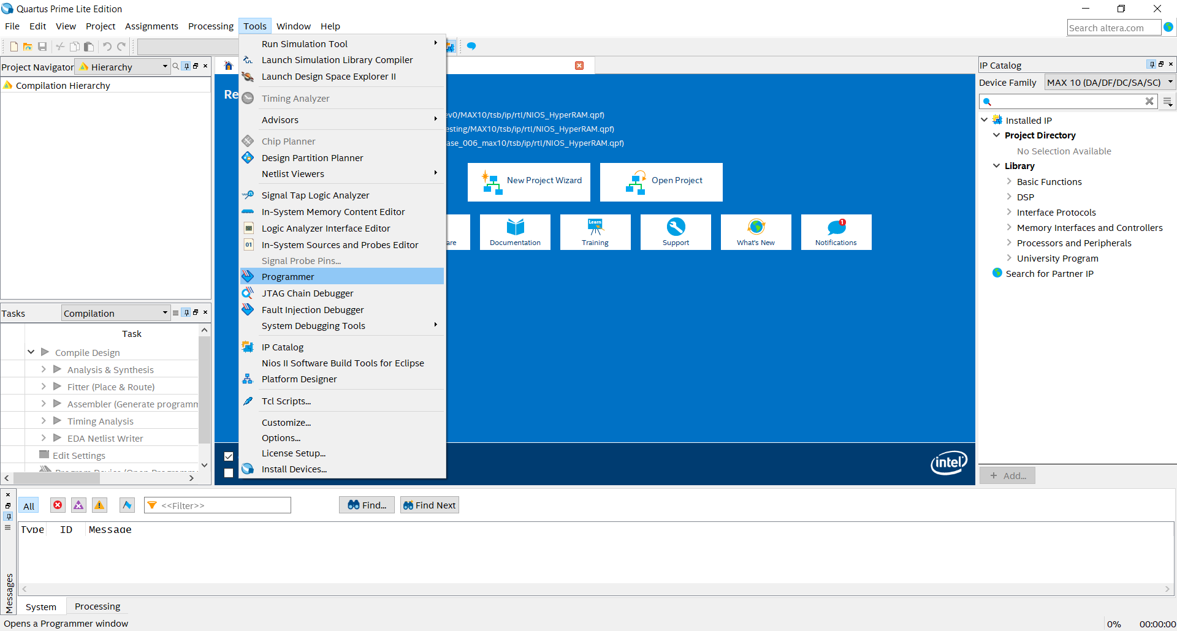

Step 5: Click Hardware Setup…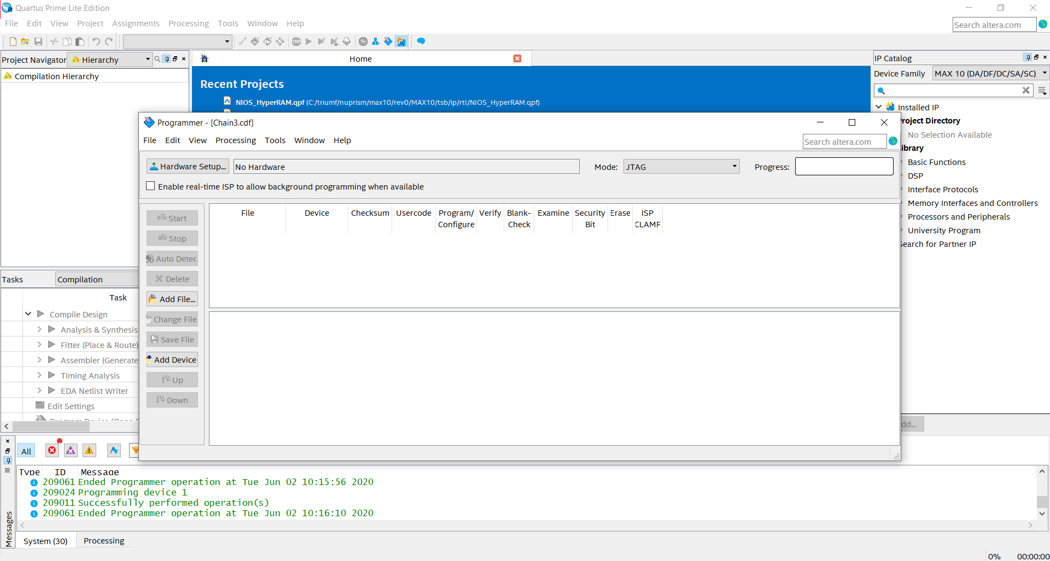

Step 6: In the Hardware Settings tab, click the “Currently selected hardware” dropdown menu and select the Blaster cable. Close the Hardware Setup Menu.

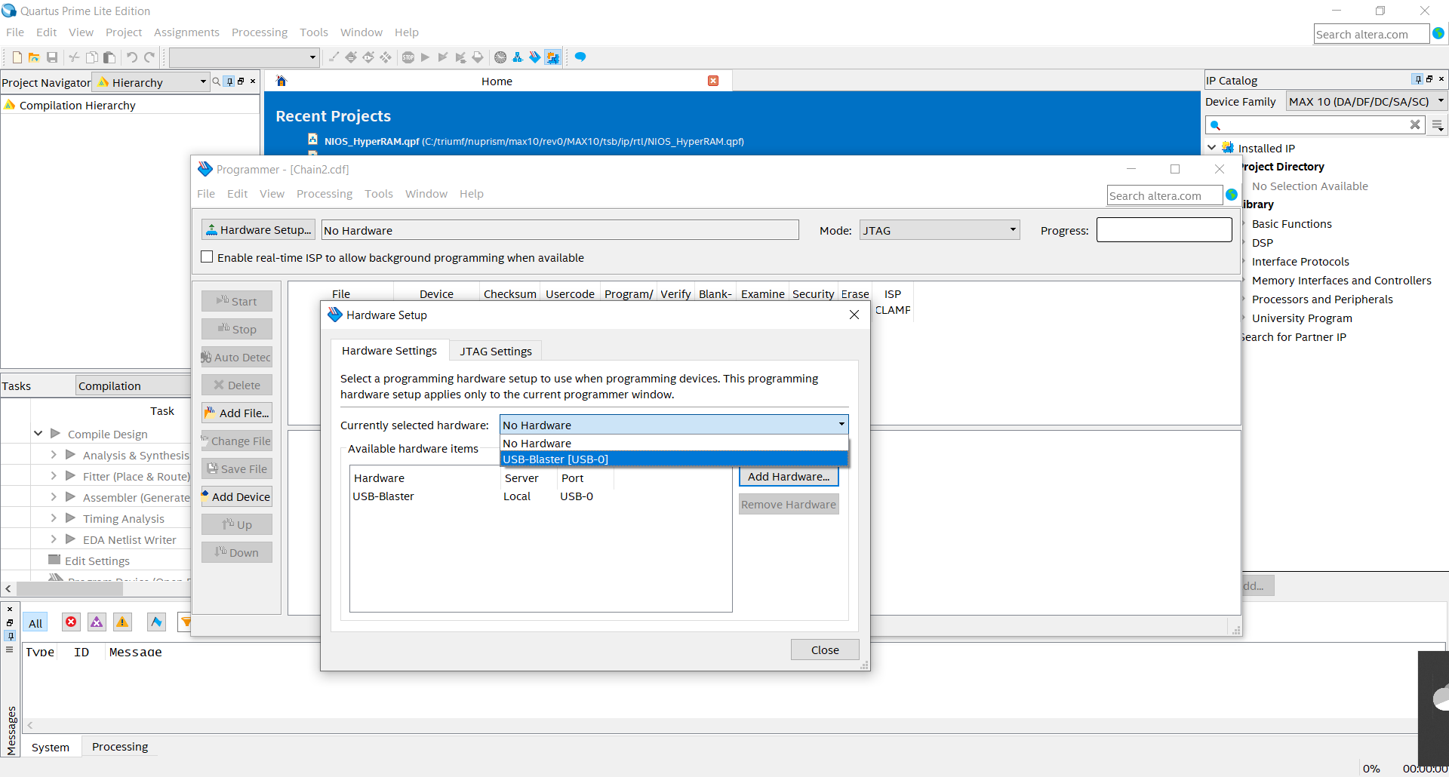

Step 7: Click auto detect. The “Select Device” menu should appear. Select “10M08DAES” and “OK”

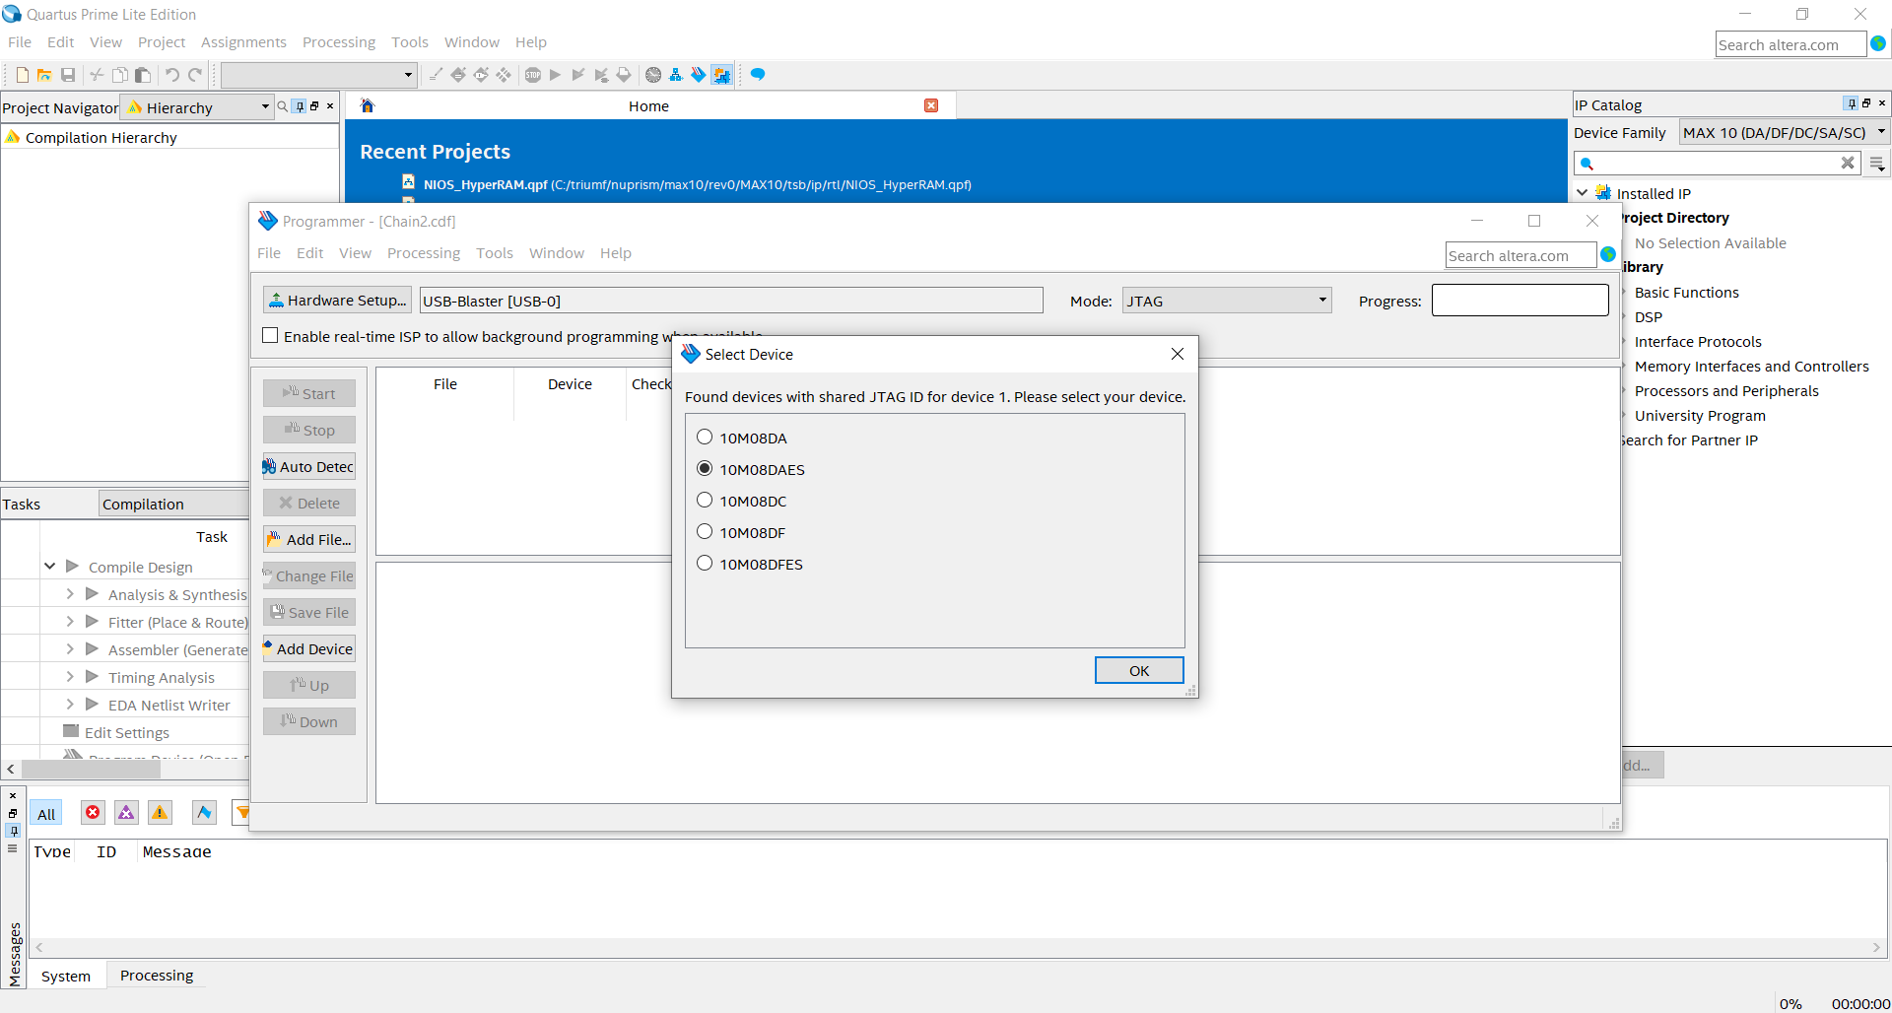

Step 8: Right click on the device and select Edit > Add File…

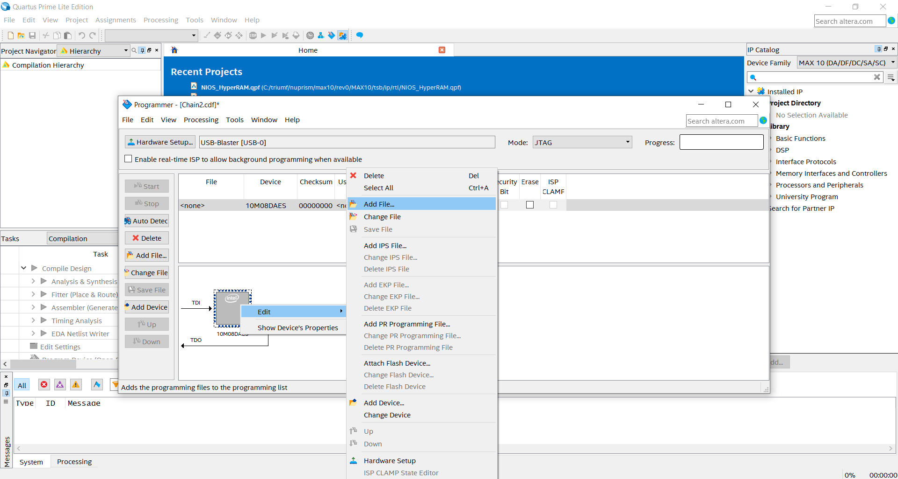

Step 9: Navigate to the sof or pof file and open one. The sof file programs the volatile SRAM, while the pof programs the non-volatile flash memory.

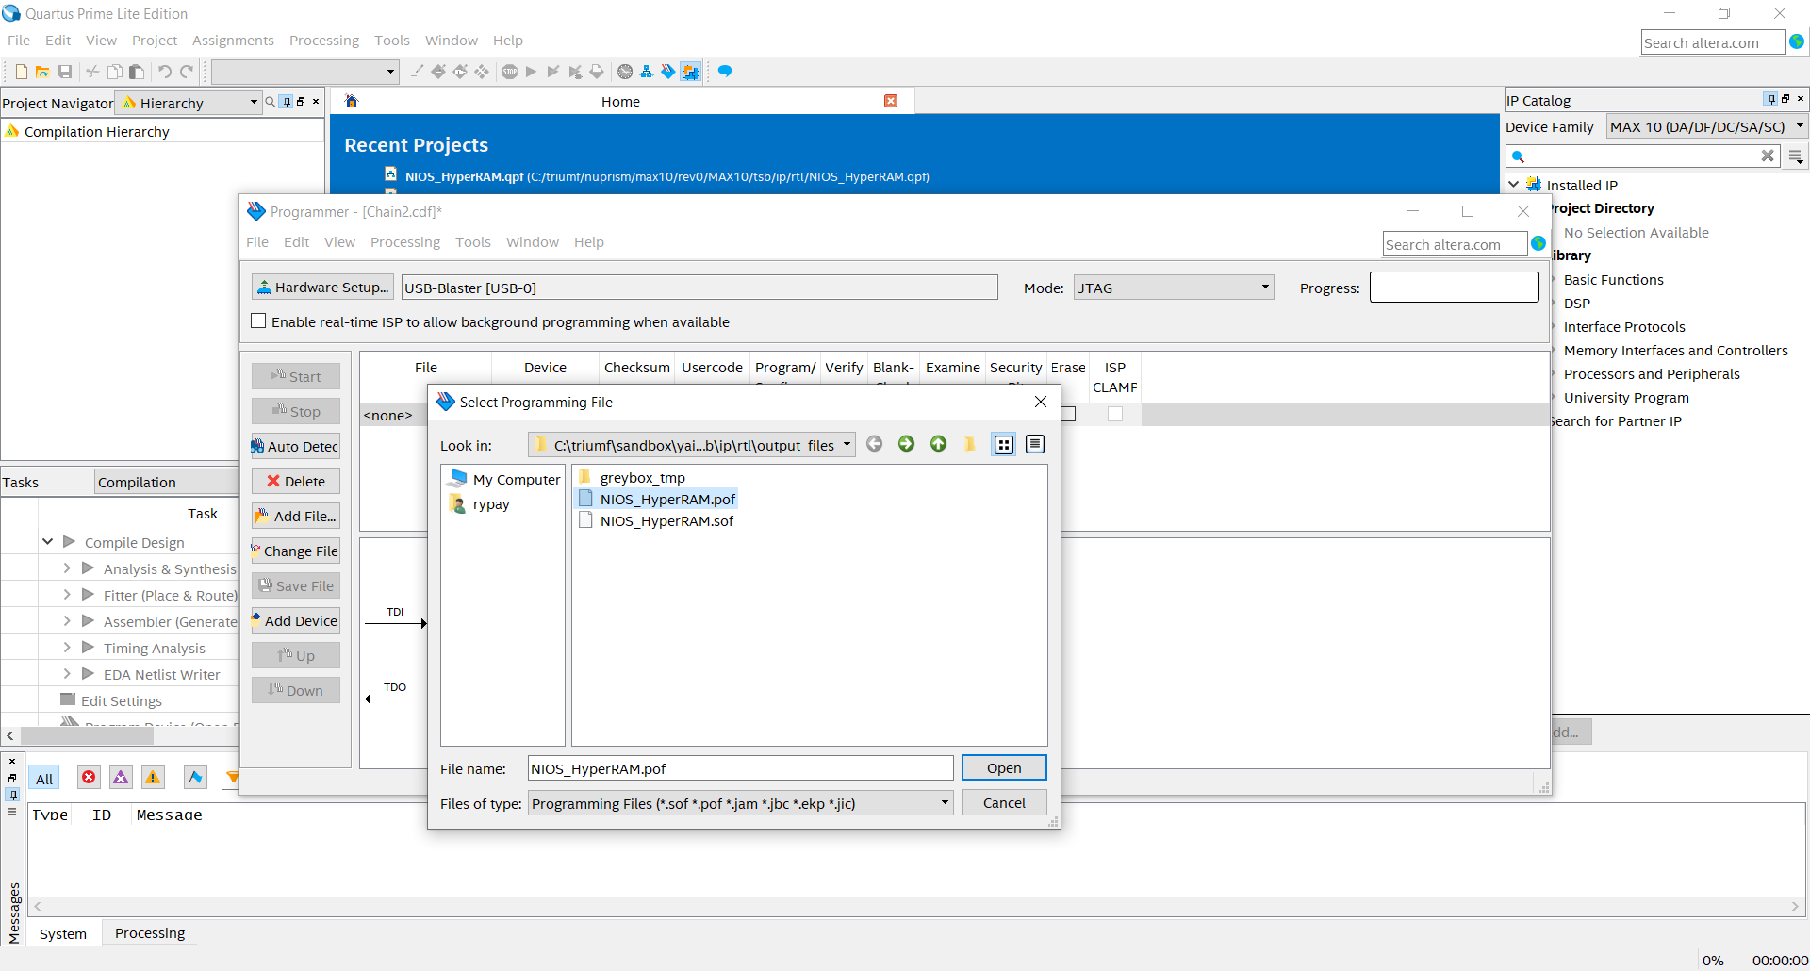

Step 10: Delete the “10M8DAES” device

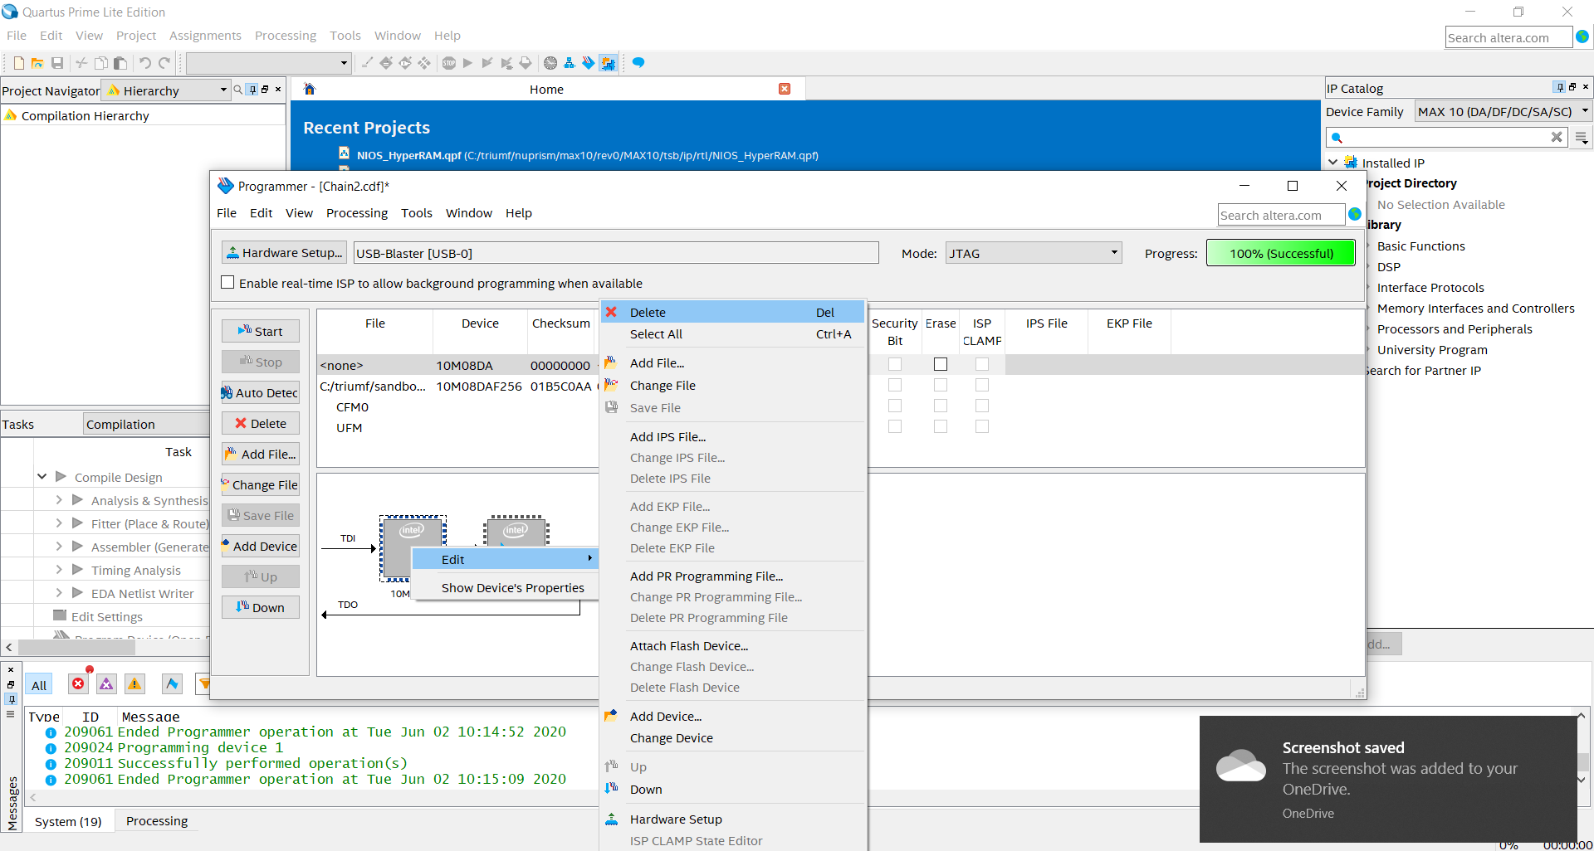

Step 11: Check all boxes in the “Program/Configure” column. Then hit “Start”. When the programming has finished, “Progress” should read “100% (Sucessful)”.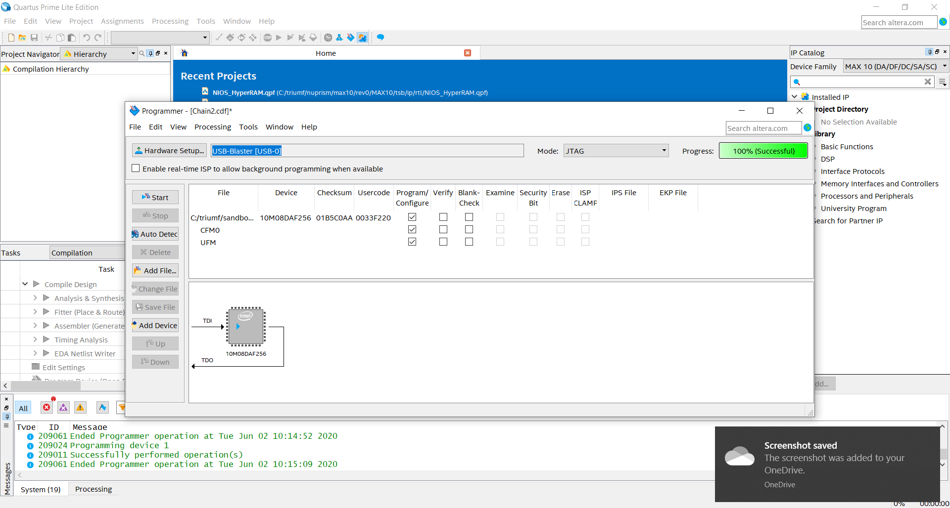

# Troubleshooting

If the device cannot be detected, ensure:

* The SoM is inserted
* The power supply is on
* The Programmer is connected to the mainboard
* The Programmer is connected to your machine

If the device still does not connect. You may need to reinstall the device drivers.