
CCP Report
Rag Based Chatbot
M.Z.AI
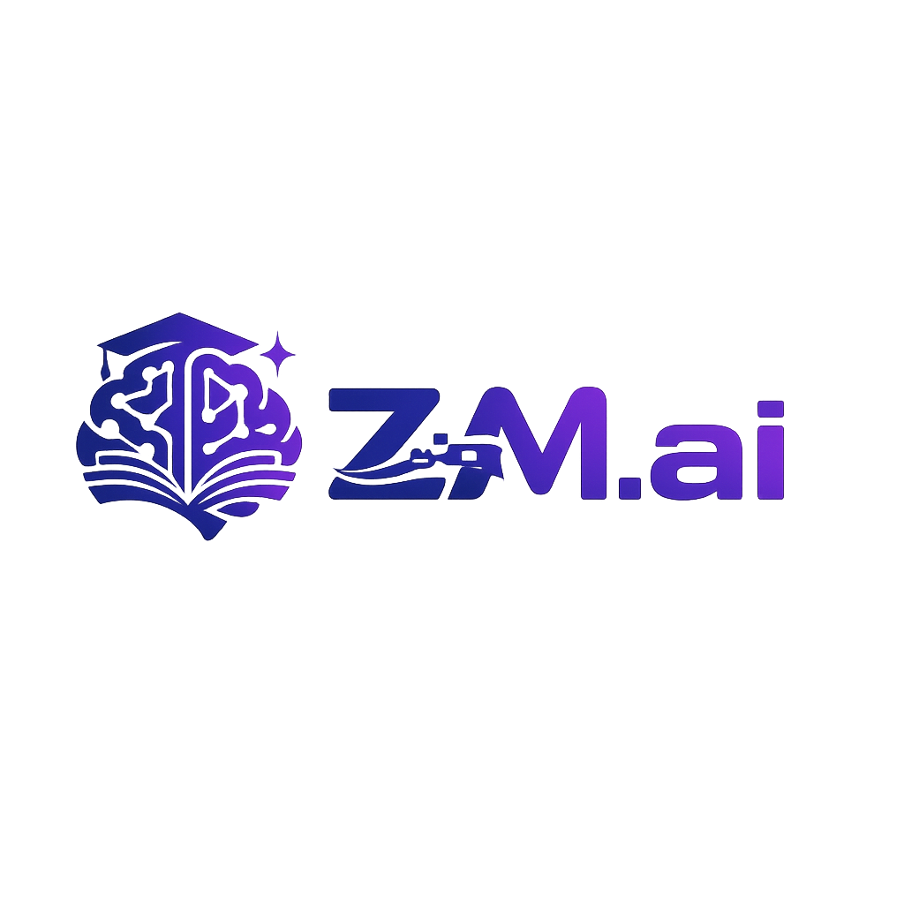
Submitted by:
Zayan Shahid (64740)
Course:
Parallel & Distributed Computing
Submitted to:
Dr Ali Akbar Siddique
Day: Friday/Saturday
Time Slot: 8:30-9:50

1. Introduction
Z.M.ai (ZayMayAi) is an AI-powered academic policy assistant chatbot developed using the Retrieval-Augmented Generation (RAG) approach. Unlike traditional chatbots that rely solely on pre-trained language models, Z.M.ai enhances response accuracy by retrieving relevant information from academic policy documents and web content before generating answers. The system is deployed as an interactive web application using Streamlit, enabling real-time, user-friendly interaction for students seeking information about university policies.
- Key highlights:
- Combines web scraping and PDF content retrieval with natural language generation.
- Provides context-aware and domain-specific responses for academic policies.
- Offers a clean, professional, and interactive web-based chat interface.

2. Background
Recent advancements in Large Language Models (LLMs) have significantly improved conversational AI systems. However, standalone LLMs often suffer from limitations such as hallucinations, lack of domain specificity, and inability to reference updated or external knowledge. Retrieval-Augmented Generation addresses these issues by integrating a retrieval mechanism that fetches relevant documents and supplies them as context to the LLM.
- Benefits of RAG:
- Improved factual accuracy for academic policy queries.
- Reduced hallucinations in domain-specific responses.
- Better performance on policy-related questions.
- Scalable knowledge updates without retraining the model.

3. Problem Statement
Students often face challenges when searching for accurate academic policy information:
- University policies are scattered across multiple documents and web pages.
- Manual searching is time-consuming and error-prone.
- Traditional chatbots provide generic or vague responses to policy queries.
- Lack of a centralized, intelligent system for academic policy information.
Proposed Solution:
To overcome these issues, Z.M.ai implements a RAG-based architecture that retrieves relevant information from academic policy documents and web content, then uses an LLM to generate accurate, context-aware responses for student queries.

4. Objectives
The primary objectives of this project are:
- To design and implement a RAG-based academic policy assistant chatbot.
- To integrate web scraping and PDF processing for comprehensive knowledge base.
- To develop a professional web-based chat interface using Streamlit.
- To demonstrate accurate, context-aware AI responses for academic policy queries.
- To provide a simple, efficient solution without complex dependencies.

5. Scope of the Project
The scope of the Z.M.ai project defines the functional boundaries and capabilities of the system implemented during this project. The chatbot is designed to focus on accuracy, simplicity, and real-time interaction while demonstrating the core concepts of Retrieval-Augmented Generation.
- The scope of Z.M.ai includes:
- Text-based user queries for academic policies in natural language.
- Web scraping from official university policy pages.
- PDF document processing for academic policy manuals.
- Keyword-based retrieval for efficient information matching.
- Real-time response generation using Groq LLM.
- Professional, user-friendly web interface using Streamlit.

6. Tools and Technologies Required
The Z.M.ai project utilizes modern AI and web development tools to ensure efficiency, simplicity, and ease of deployment:
- Programming Language: Python - Backend logic, data processing, and AI integration
- Frontend Framework: Streamlit - Lightweight and interactive web interface
- LLM Provider: Groq API - Fast, cost-effective Llama 3.1 models for natural language responses
- Web Scraping: BeautifulSoup & Requests - HTML parsing and content
- PDF Processing:
- Deployment Platform: Streamlit Cloud - Easy and accessible web deployment

7. Languages and Libraries Used
- Python:
- HTML/CSS:
- Libraries:
- streamlit
- groq
- requests
- beautifulsoup4
- pdfplumber

8. APIs Used and Integration

8.1 Groq LLM API
Purpose: Generate natural language responses using retrieved context.
- Install Groq SDK.
- Configure API key via Streamlit secrets.
- Send user query along with retrieved context.
- Receive and display generated response.

8.2 Web Scraping
Purpose: Extract policy content from university website.
- HTTP requests with proper headers
- HTML parsing with BeautifulSoup
- Content cleaning and formatting

9. Code Implementation (Sample)
# Main application structure
def main():
st.set_page_config(page_title="Z.M.ai | Academic Policy Assistant")
# Load knowledge base (cached locally)
if not st.session_state.knowledge_loaded:
st.session_state.knowledge_base = load_or_create_knowledge_base()
# Chat interface
if prompt := st.chat_input("Ask about academic policies..."):
# Retrieve relevant context
context = retrieve_context(prompt, st.session_state.knowledge_base)
# Generate response
response = get_llm_response(prompt, context, history)
# Display response
st.markdown(response)

10. Results and Outcomes
- Successfully implemented a functional RAG-based academic policy assistant.
- Achieved accurate and context-aware responses for policy queries.
- Deployed working web application accessible via browser.
- Implemented efficient caching system for fast knowledge base loading.
- Created professional, polished user interface.

11. Conclusion
Z.M.ai successfully demonstrates the practical implementation of a Retrieval-Augmented Generation based chatbot tailored for academic policy assistance. By integrating web scraping, PDF processing, and intelligent keyword-based retrieval with a Large Language Model, the system is able to generate accurate, relevant, and context-aware responses for student queries. The simplified architecture eliminates complex dependencies while maintaining high response quality. The use of Groqs fast Llama models ensures quick response times. The Streamlit web interface provides a professional and user-friendly interaction experience. This project highlights how RAG enhances the performance of AI chatbots in domain-specific scenarios. It also showcases the effective integration of modern AI tools within a clean, maintainable architecture. Overall, Z.M.ai fulfills its intended objectives successfully and provides valuable assistance to students seeking academic policy information.

12. References
- Groq API Documentation - https://console.groq.com/docs
- Streamlit Official Documentation.
- GitHub Repository: https://github.com/nubawan/Z.M.ai
- Deployed Web App: https://zaymavai.streamlit.app/

13. Output
The Z.M.ai chatbot is successfully deployed and accessible at:
https://zaymavai.streamlit.app/

