Required Dependencies
Follow the above build.gradle file to download all the required dependencies.
plugins {
id 'org.springframework.boot' version '2.2.4.RELEASE'
id 'io.spring.dependency-management' version '1.0.9.RELEASE'
id 'java'
}
group = 'com.liangwei'
version = '0.0.1-SNAPSHOT'
sourceCompatibility = '1.8'
repositories {
mavenCentral()
maven {
url 'https://repo.spring.io/libs-snapshot'
}
}
dependencies {
implementation 'org.springframework.shell:spring-shell-starter:2.0.1.BUILD-SNAPSHOT'
implementation 'com.google.guava:guava:28.2-jre'
implementation 'org.springframework.boot:spring-boot-starter'
implementation 'org.springframework.boot:spring-boot-starter-data-jpa'
implementation 'com.h2database:h2'
implementation 'org.apache.commons:commons-math3:3.6.1'
testImplementation('org.springframework.boot:spring-boot-starter-test') {
// exclude group: 'org.junit.vintage', module: 'junit-vintage-engine'
}
}
test {
useJUnitPlatform()
}

Build & Run
Run the following commands using command prompt from the project home directory to build and run the project:
- gradlew clean build -x test
- java -jar build\libs\tradingsystem-0.0.1-SNAPSHOT.jar

Runtime
Once the build is running, type `help` to see the list of commands provided using spring shell as shown below.
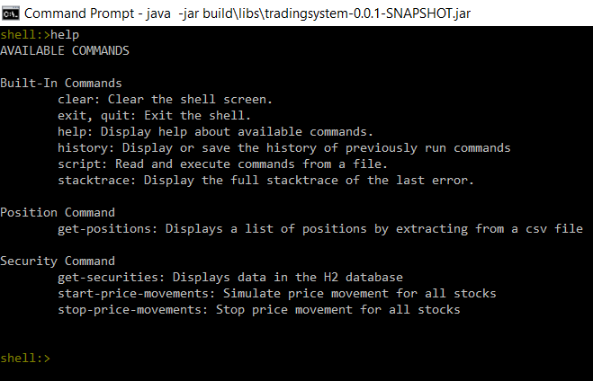

get-positions will display a list of positions extracted from the build\resources\main\positions.csv file as shown below.
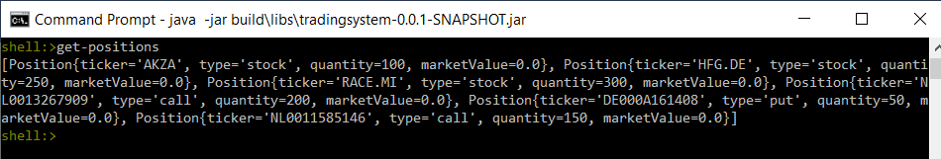

get-securities will display a list of securities which are preloaded into the H2 database upon runtime as shown below.
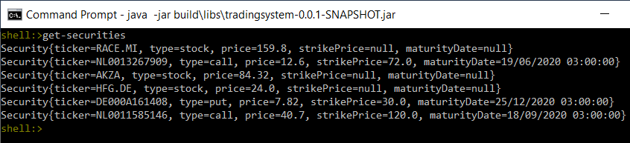

start-price-movements will create a thread for each stock and simulate a price movement based on the geometric brownian motion and publish that to a portfolio aggregator which in turns publishes an updated portfolio to a portfolio subscriber. The subscriber will then output the portfolio on the screen as shown below.
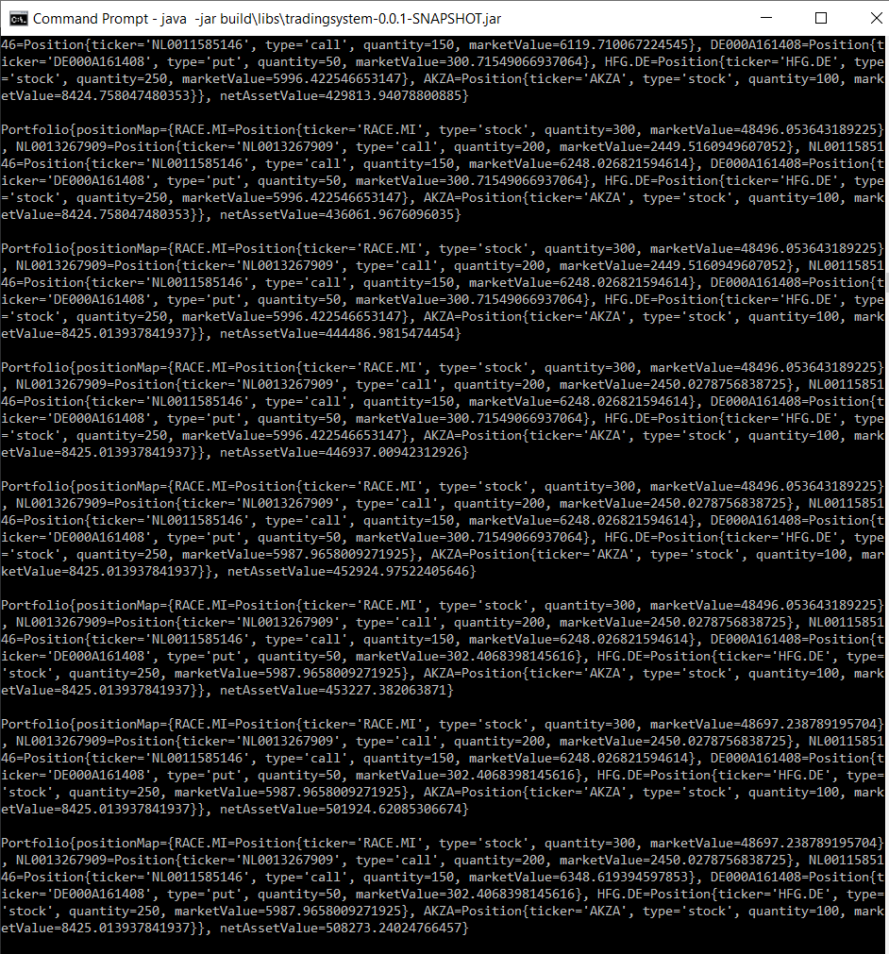

stop-price-movements simply turn a flag off that stops all the price movements.

