PERNOD RICARD WESTERN AFRICA
POS Materials Management System
Stakeholder Reference Document

Prepared | May 7, 2026
System | Pernod Ricard Western Africa — Request Management Platform
Scope | POS Materials Request Lifecycle, Inventory Management & Automated Reminder Engine

1. Overview

The POS Materials Management System allows staff across Nigeria to request Point-of-Sale (POS) items from the company warehouse through a structured, multi-level approval workflow. The system tracks the full lifecycle of each request — from item selection and quantity validation, through approvals, to physical pickup and return — with automated email reminders for pending approvals.

2. POS Item Inventory (Setup)

What it is
The POS List screen (/requests/pos_item_view) is the master catalogue of all POS items held in the warehouse. Only authorised administrators can add, update, or delete records.
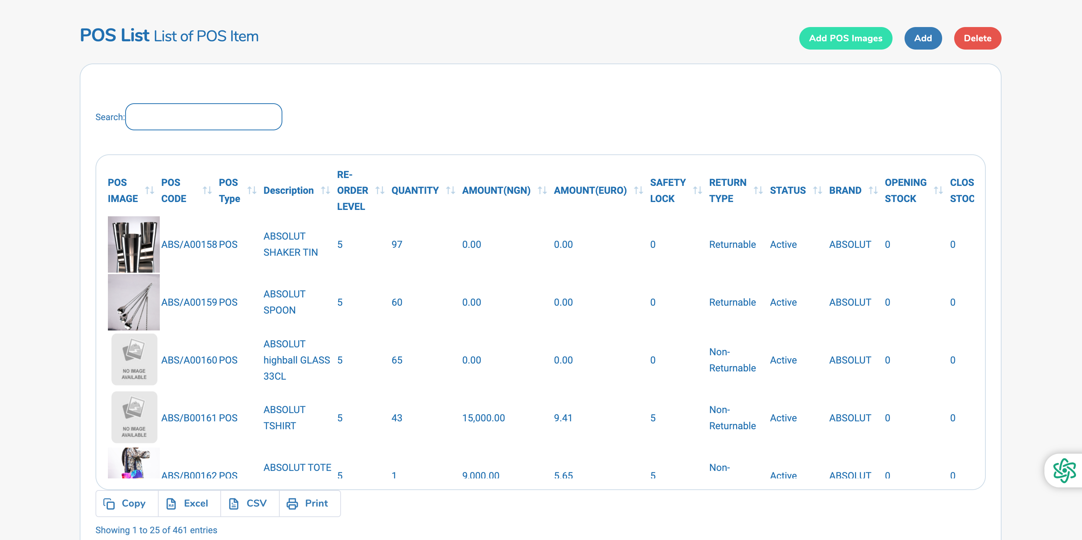
Columns explained
Column | Description
POS Image | Thumbnail photo uploaded via the bulk image import tool
POS Code | Unique item identifier (e.g. AVI/A00296, ABS/S00001)
POS Type | Category of the item (POS)
Description | Human-readable name (e.g. AVION APRON, ABSOLUT SHAKER TIN)
Re-Order Level | Minimum quantity that should trigger a restock alert
Quantity | Current physical stock in the warehouse
Amount (NGN) | Unit price in Nigerian Naira
Amount (EUR) | Unit price in Euros
Safety Lock | Reserved quantity — not available for requests
Return Type | Whether the item is Returnable or Non-Returnable
Status | Active (available for requests) or Inactive
Brand | Brand the item belongs to (e.g. Avion, Absolut)
Opening Stock | Stock at start of reporting period
Closing Stock | Stock at end of reporting period
Location | Nigeria warehouse

Available stock rule
An item is only shown in the request dropdown when all of the following apply:
- Status = Active
- Quantity > 0
- Price (NGN or EUR) > 0
- Nigeria only: Quantity − Safety Lock > 0 (safety-locked units are never requestable)
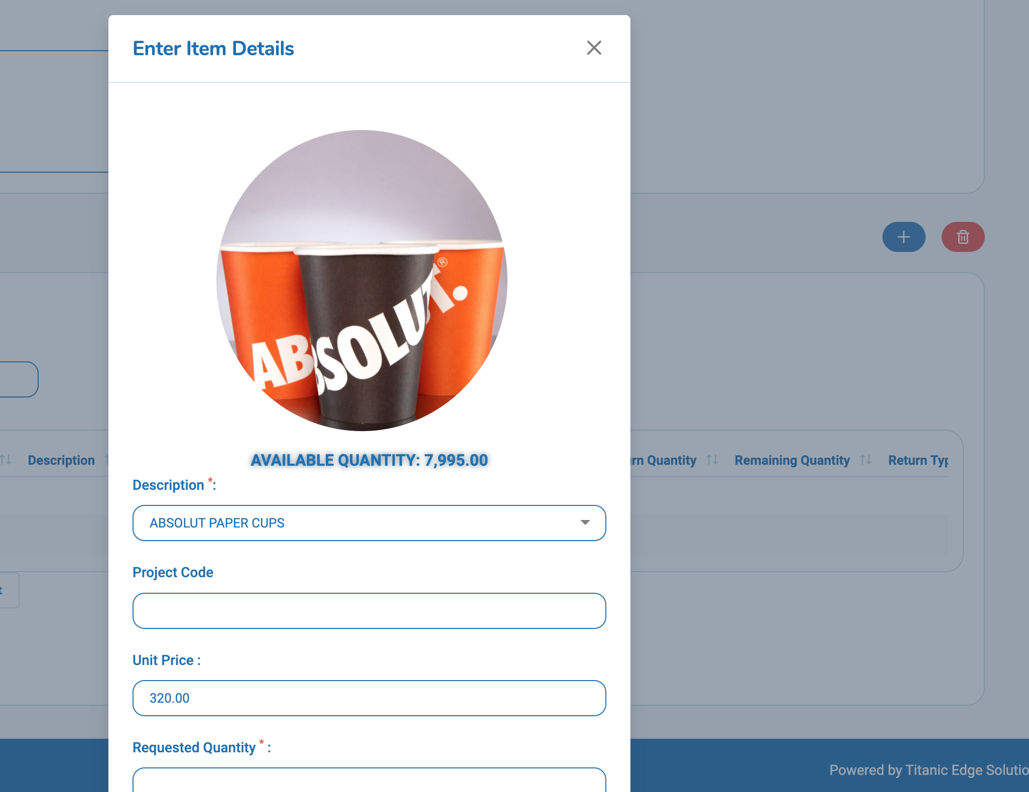
Image management
Images are uploaded in bulk via Add POS Images (supports individual files or a ZIP archive). Each image must be named after the POS description (e.g. ABSOLUT SHAKER TIN.jpg). The system matches filenames to POS descriptions case-insensitively and updates the image link automatically.
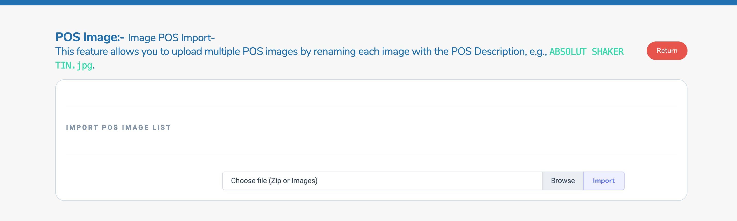

3. POS Materials Request — Form Fields

A new request is created from the Requests menu. The form collects the following information.
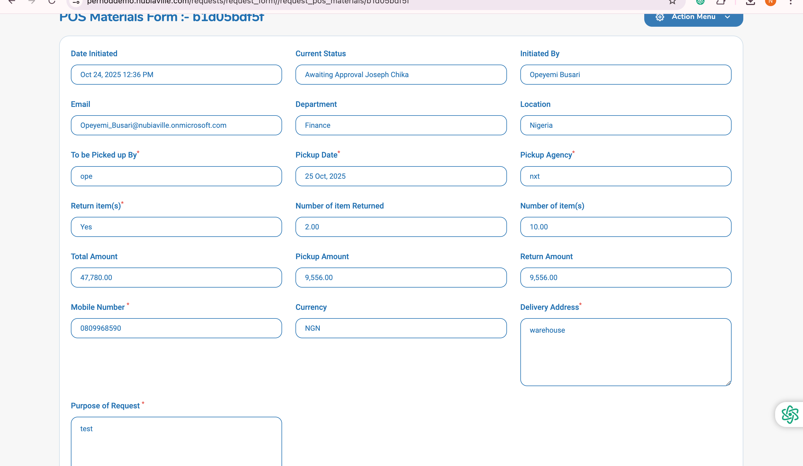
Header section
Field | Required | Description
Date Initiated | Auto | Set automatically on creation
Current Status | Auto | Current approval stage (e.g. Awaiting Approval Joseph Chika)
Initiated By | Auto | Name of the staff member who created the request
Email | Auto | Requester's email address
Department | Yes | Department of the requester (determines workflow path)
Location | Yes | Nigeria or Ghana — determines available items and workflow
To be Picked up By | Yes | Name of the person collecting the items
Pickup Date | Yes | Expected date of collection
Pickup Agency | Yes | Logistics or agency handling the pickup
Return Item(s) | Yes | Yes / No — whether items will be returned after use
Mobile Number | Yes | Contact number for the person picking up
Currency | Auto | Derived from location (NGN for Nigeria, GHS for Ghana)
Delivery Address | Yes | Physical address for delivery/collection
Purpose of Request | Yes | Business justification for the request

Summary totals (calculated automatically)
Field | Description
Number of Item(s) | Total quantity of all POS items requested
Total Amount | Sum of (Unit Price × Qty) across all line items
Number of Item Returned | Total quantity returned so far
Pickup Amount | Total value of items that have been picked up
Return Amount | Total value of items that have been returned

4. POS Details Table

The POS Details section lists every individual POS item added to the request.
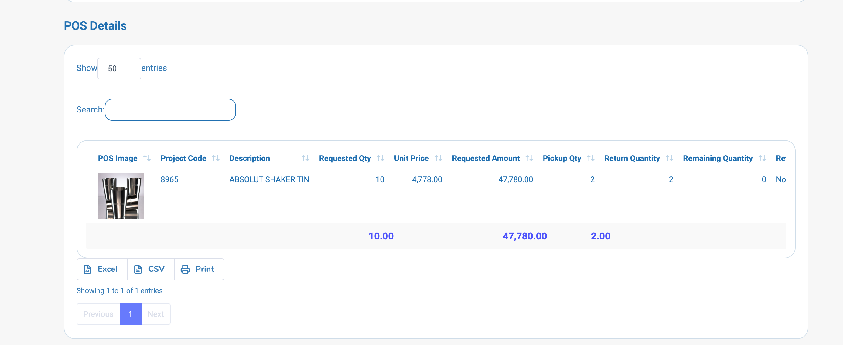
Column | Description
POS Image | Item thumbnail
Project Code | Internal project/cost code for the item
Description | POS item name
Requested Qty | Quantity requested
Unit Price | Price per unit at time of request
Requested Amount | Unit Price × Requested Qty
Pickup Qty | Quantity that has been physically collected
Return Quantity | Quantity that has been returned
Remaining Quantity | Items still out (not yet returned)
Return Type | Returnable / Non-Returnable / No
Comment | Any notes added at line item level

Example from system:
Item: ABSOLUT SHAKER TIN | Qty: 10 | Unit Price: ₦4,778.00 | Total: ₦47,780.00 | Picked up: 2 | Returned: 2 | Remaining: 0

Stock validation on add/update
When a staff member adds or updates a line item, the system checks live warehouse stock:
- If the requested quantity exceeds available stock (qty − safety_lock), the request is blocked with the message: "Maximum value expected is [available qty]"
- If stock is at zero: "The Quantity Of New Item is not available At the Moment — Please Contact The Warehouse Manager"

5. POS Pickup History

Each time a physical pickup is recorded, a new row is added to this table.
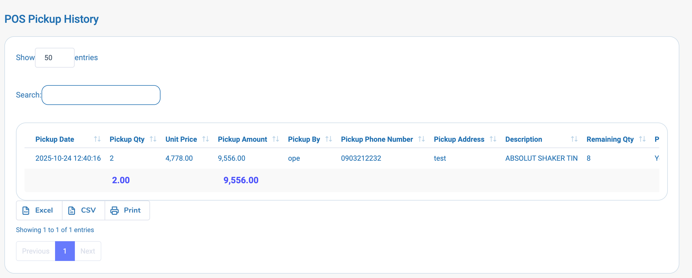
Column | Description
Pickup Date | Date and time of pickup
Pickup Qty | Number of items collected in this pickup
Unit Price | Price per unit at time of pickup
Pickup Amount | Pickup Qty × Unit Price
Pickup By | Name of person who collected
Pickup Phone Number | Contact number used during pickup
Pickup Address | Address where items were delivered
Description | POS item name
Remaining Qty | Items from the request still outstanding
Partial Pickup | Yes / No — whether this was a partial collection
Pickup Reason | Reason recorded for this pickup event

Multiple pickups can be recorded against a single request (partial pickups are fully supported).

6. POS Return History

When items are returned to the warehouse, a return entry is recorded.
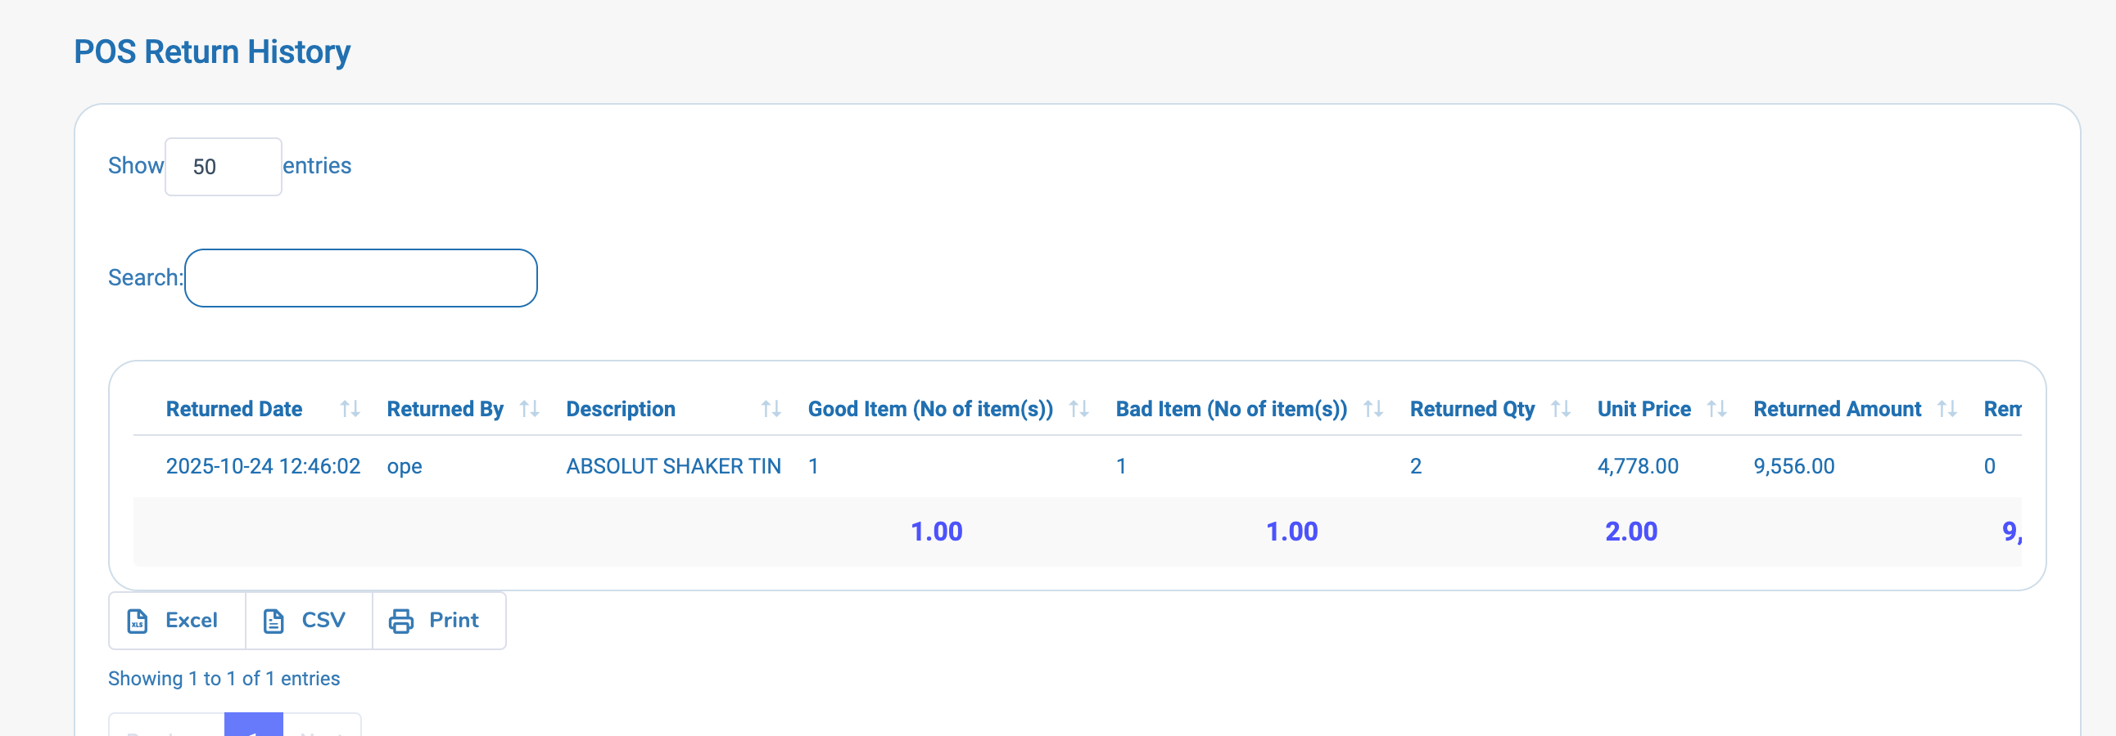

Column | Description
Returned Date | Date and time of the return
Returned By | Name of person returning the items
Description | POS item name
Good Item (No of item(s)) | Count of items returned in good condition
Bad Item (No of item(s)) | Count of items returned damaged
Returned Qty | Total quantity returned (Good + Bad)
Unit Price | Price per unit
Returned Amount | Returned Qty × Unit Price
Remaining Qty | Items still outstanding after this return
Returned Comment | Notes about the condition or reason

Warehouse stock is adjusted upon return processing.

7. Approval Workflow

Every POS Materials request follows a defined multi-step approval chain. The chain is determined by the requester's location and department at the time of submission.

Workflow types
Workflow Key | Applies To
request_pos_materials | Nigeria — non-Marketing departments
request_pos_materials_marketing | Ghana or Nigeria — Marketing / Marketing (incl. Digital)
request_pos_materials_sales | Nigeria — Sales department

Example workflow path — Nigeria, Finance department
Initiator Approver 1 Approver 2 Approver 3
Opeyemi Busari → Joseph Chika → Magdalene Edozie → Johnson Ibikunle
(Requester) (Line Manager) (Line Mgr Manager) (Warehouse Clerk)

Approver 4 Approver 5 Final Approver
Opeyemi Busari → Joseph Chika → Johnson Ibikunle
(Initiator) (Line Manager) (Warehouse Clerk)

Request actions available
Action | Description
Save | Saves the draft without sending for approval
Submit | Sends the request into the approval chain
Resubmit | Re-enters a previously returned request
Reroute | Allows an administrator to change the approval path with a reason

Status indicators
Status | Meaning
Awaiting Approval | In the approval chain, pending an approver's action
Approved | All approvals complete
Denied | Rejected by an approver
Draft | Saved but not yet submitted

8. Automated Reminder Engine (Cron Job)

Purpose
The system includes an automated background process that sends reminder emails to inititor who have not yet acted on a POS return request. This prevents requests from stalling in the approval queue unnoticed.

How it works
Scheduled trigger (server cron)
↓
fetches all pending return requests
↓
For each pending request:
- Check approval_date exists
- Calculate time elapsed since approval_date
- If elapsed > 5 minutes → send reminder email
- If elapsed ≤ 5 minutes → skip (too recent)
↓
Email sent to next approver in chain
↓
Result logged in reminder_log table

Email content
Each reminder email contains:
- The request title and type
- A message stating the request is still awaiting the approver's action
- A direct login link to the request form
- The name of the person who raised the request
- A UAT notice (on the demo/test environment)

Reminder log table
Column | Description
request_id | The request that triggered the reminder
requester_id | ID of the original requestor
Name | Requestor's full name
email | Recipient email address
status | Success (n) or Fail (n) — n = number of times sent
flag_count | How many times a reminder has been sent for this request
request_link | Direct URL to the request
request_date | Date the original request was submitted
date_added | Record creation timestamp
date_updated | Last update timestamp

If a reminder for the same request has been sent before, the existing log record is updated (incrementing flag_count) rather than creating a duplicate row.

9. Key Business Rules

Rule | Detail
Stock reservation | safety_lock units are always held back and cannot be requested
Duplicate item on request | Quantities are accumulated — existing row is updated, not duplicated
Workflow routing | Department + Location at time of submission determines the approval chain
Reminder threshold | Reminders only fire if the request has been sitting with an approver for more than 5 minutes
Image naming | Bulk images must be named exactly as the POS Description (case-insensitive)
Return tracking | Returned items are split into Good and Bad counts for warehouse quality tracking

10. Access Levels

Role | Capabilities
Requester (Staff) | Create, edit, submit, resubmit own POS requests
Line Manager | Approve or deny requests assigned to them in the workflow
Warehouse Clerk | Record pickups, process returns, approve at warehouse stage
Systems Admin | Full access — add/update/delete POS items, manage images, view all requests, reroute workflows

11. Database Tables Referenced

Table | Purpose
pos_item | Master catalogue of all POS items in stock
pos_request | Header record for each POS Materials request
pos_details | Line items (individual POS items) within a request
pos_pickup_trail | Record of each pickup event against a request
pos_return_trail | Record of each return event against a request
workflow_requests | Tracks which workflow process a request is in and its current state
workflow_approvers | Defines the approver sequence for each workflow type
request_approvers | Maps specific users to approval steps for a given request
reminder_log | Audit log of all automated reminder emails sent

12. Stored Procedures Referenced

Procedure | Called By | Purpose
GET_ALL_POS_REQUESTS() | All POS Requests view | Returns all POS requests visible to the current user
CalculateAmountOfPosMaterialsStartup(id) | POS details data endpoint | Calculates item amounts for a request
company_posm_details_new() | Company POSM Details journal | Returns company-wide POSM details (new version)
company_posm_details() | Company POSM Details (legacy) | Returns company-wide POSM details
company_posm() | Company POSM view | Returns all company-wide POS requests
RUN_POS_RETURN_REQUEST() | Cron job | Returns all POS return requests pending approver action — drives automated reminders

