BUKIDNON STATE UNIVERSITY

COLLEGE OF TECHNOLOGIES
INFORMATION TECHNOLOGY DEPARTMENT



ZARVIVAL: Island Quest

A Project Presented to
The Information Technology Department

In Partial Fulfillment of the Requirement for the Course

IT121/CC121 - Data Structure and Algorithm &
IT 123 - Object Oriented Programming

by

Carson, Rusty
Gelacio, Zach Andrie B.
Liman-ay, Aliah Rez G.

December 2024

Louie Jay Labastida
Gil Nicholas T. Cagande
Instructor

Chapter 1
Introduction

1.1 Game Description

In the exciting action-adventure game “ZARVIVAL: Island Quest”, players must make their way across mysterious islands while facing off against strong enemies and overcoming barriers in order to find the legendary power. This project aims to develop an engaging gaming experience that tests players' strategic thinking and survival skills. The Java programming language is used in this project, data structures (arrays, queues, stacks, and linked lists), and object-oriented programming. The IntelliJ, GIMP, and Pixel Art program are among the necessary software. There are two laptops (Acer and Huawei) in the hardware specifications.

1.2 General Objective

The ultimate objective of “ZARVIVAL: Island Quest” is to:
- Create an engaging action-adventure game that demonstrates knowledge of programming concepts and game creation techniques.
- Develop an engaging game experience.
- Ensure smooth gameplay on laptops and computers.

1.3 Scope and Limitations
This study successfully developed “ZARVIVAL: Island Quest”, a Java-based action-adventure game, featuring:
- Efficient gameplay mechanics
- Intuitive user interface
- Engaging graphics and sound effects
- Core gameplay elements (player navigation, enemy encounters, obstacle avoidance, potion collection)

This study's scope was constrained by time limitations, resulting in the following exclusions:
- Expanded enemy diversity
- Additional terrain types and level designs
- Boss battles and advanced enemy mechanics
- Multiplayer functionality
- Enhanced graphics and animations
Future studies can address these limitations to enhance gameplay and overall user experience.

1.4 Target User
The primary users of “ZARVIVAL: Island Quest” are:
1. Gaming enthusiasts: Aged 13+, interested in action-adventure games.
2. Casual gamers: Seeking entertaining, easy-to-play games.

Roles and Needs
1. Gamers: Need an engaging, challenging, and user-friendly gaming experience.
2. Game developers: May utilize the game’s open-source code for educational purposes.
Technical Requirements
1. Basic computer skills
2. Familiarity with keyboard/mouse or gamepad controls
3. Java installation (for development purposes)
4. Minimal technical expertise required for gameplay

Chapter 2
Methodology
2.1 Gameplay and Character

Gameplay Flow

1. Level Selection: Choose from available islands, each with unique terrain, enemies, and challenges.
2. Gameplay: Navigate the island, avoiding obstacles/traps and engaging enemies.
3. Combat: Defeat enemies using keyboard and mouse.
4. Exploration: Discover paths and Potions.
6. Level Completion: Unlocking the next level by defeating all the enemies.

Challenges

1. Enemy Variety: Deal with a range of enemies, each possessing unique powers.
2. Terrain Obstacles: Avoid dangers and traps while navigating difficult terrain.
3. Resource Management: Manage potions, health, and stamina.

Interaction Mechanics

1. Movement: A- to left, D- to right.
2. Attacks/Dash: Mouse click- left click for Attack and right click for Dash.
3. Jumping: Space bar.
4. Potion Usage: Hit the boxes using Attack and move through it.

Level Progression

1. Linear Progression: Complete levels sequentially.
2. Unlockables: Access new islands, enemies, and power-ups.
3. Difficulty Gradation: Increasing enemy strength, terrain complexity.

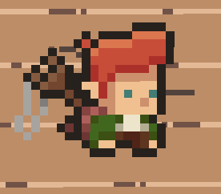
Figure 1. Zee

Zee, a young goblin who lives deep in the forest with his bow and loves hunting, decides to embark on an adventure after hearing the story of the Legendary Power that grants immortality to mortals.


Figure 2. Lia

Lia is a skilled swordmage living near the great wizard's village. When rumors of a legendary power spread, she becomes determined to find it before anyone else.

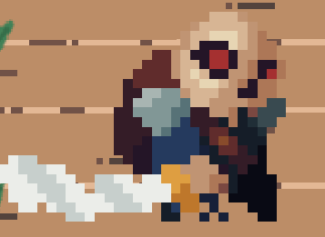

Figure 3. Rex

Rex is a thousand years old skeleton; he believes that the power will take back his life. He is driven by his ambition and dedicates himself fully to uncovering the truth and claiming the power for himself.

In this game, the characters have names and serve as representations of the players and are fully controlled by the user. Each character is equipped with:

Attributes: Different skills and abilities to survive the game.
Role: The character's main task is to survive the Island, taking strategic planning on how to defeat all the enemies, avoid obstacles and find the Legendary Power.

2.2 Conceptualization and Design

The planning and design phase of the game centered on achieving harmony between gameplay mechanics, user engagement, and development simplicity. The goal was to create a game that offered an enjoyable yet challenging experience, ensuring players remained entertained while avoiding unnecessary complexity.

2.2.1 Flowchart
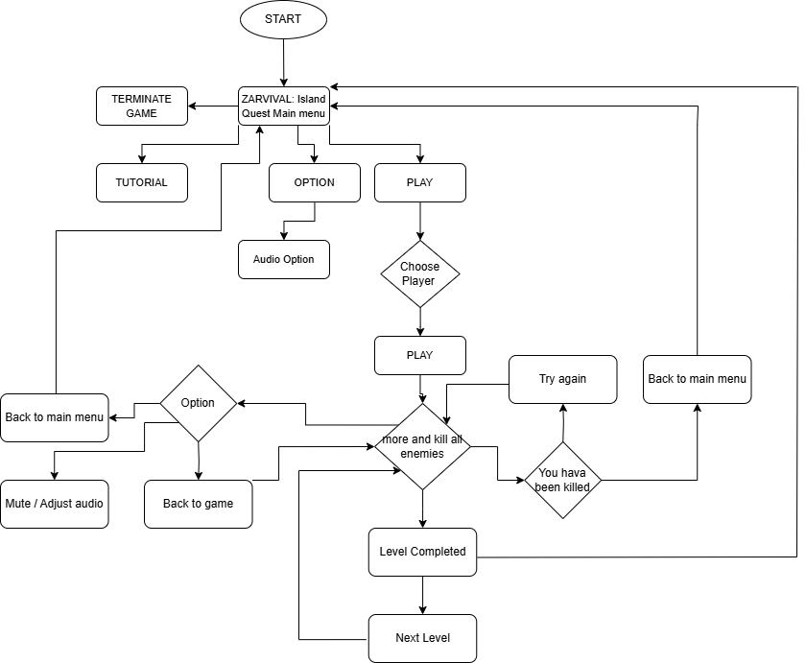

Figure 4. Flowchart of ZARVIVAL: Island Quest

2.2.2 Features
1.User-Friendly Controls: Intuitive keyboards/mouse.
2. 2D Graphics: Vibrant, detailed environments and characters.
3.Challenging Missions: Increasingly difficult levels (Easy, Medium, Hard) with different obstacles.

Power-Ups

1. Health Potions: Restore health.
2. Energy Potions: Restore Energy.

User Interface

1. Health Bar: Displays player health.
2. Energy Bar: Displays player energy.

Innovative Mechanics
1. Environmental Hazards: Traps and Obstacles.
Alignment with Objectives and Theme
1.Survival Mechanics: Resource management, health conservation.
2.Combat: Defeating enemies, bosses.
3.Adventure: Progressing through levels.

These features combine to create an engaging, challenging, and immersive gaming experience, aligning perfectly with the game's survival adventure theme.

2.3 Development

ZARVIVAL: Island Quest was developed using a systematic, modular methodology to guarantee functionality, scalability, and clarity. Because each game feature was created as a stand-alone module, debugging, upgrades, and future expansions will be simple. Readability and reusability were improved by the code's clear naming conventions and comprehensive documentation.

Systematic Approach:
- Modular Code: The code was organized into distinct classes for the Player, enemies, game objects (trees, barrels, boxes, Traps), and game logic. This enabled improved code organization and reusability.
- Iterative Testing: Each part of the game was carefully tested multiple times to make sure it worked properly and fit well with the rest. This testing made sure everything ran smoothly and any problems were fixed before the game was ready to play.
- User Interface: The user interface was carefully designed to be clear and well-organized, making it easy for players to use.
2.4 OOP principle and Data Structure Used
Table 1.
Aspect | Application in Project | How It Ensures Efficiency and Modularity
OOP Principles
Encapsulation | is applied by wrapping ZARVIVAL game objects, such as players, enemies, and objects, within their respective classes. Each class manages its own data (properties) and defines how this data can be accessed or modified through methods. | Ensures that game state and logic are protected and only accessible through well-defined methods, making the game easier to debug and extend.
Inheritance | class extends it allows subclass(mushroom, armadillo, and frog) to Inherit properties and behavior in the superclass(Entity). | Inheritance allows common behaviors and attributes to be written once in a superclass (Enemy), and then reused in subclasses (mushroom, armadillo, frog). This reduces code duplication, ensuring that you don't need to repeatedly define the same methods or variables in every game entity class
Polymorphism | The Entity class has methods overridden by subclasses to define different enemies and player behaviors. | plays a crucial role; it allows different entities to be treated in a uniform way while still executing different behaviors based on their specific types.
Data Structures
Arrays | to store game objects like players, enemies, tiles, and objects (including sprites), which holds all object instances and it allows for efficient management and manipulation of these elements as the game progresses. | ensures efficiency and modularity by providing a simple, structured way to store and access game objects like players, enemies, tiles, and other objects (including their sprites).
ArrayLists | used to efficiently manage dynamic game entities such as enemies and objects(potions, barrel, and box), this allows for fast addition and removals of the elements. For example, when a Mushroom enemy is defeated, it can be quickly removed from the ArrayLists of enemies without shifting other elements, enhancing performance. | ensures efficiency and modularity by optimizing dynamic entity management and allowing for a clean, modular design. Efficiency is achieved through the ArrayList's ability to quickly add and remove elements, which is particularly useful when enemies and objects appear and disappear frequently.

Chapter 3
Results, Discussion and Conclusion
3.1 Results
The game development process revealed significant challenges that includes, Time Constraints: Limited development time, Technical Issues: Blackouts, Slow Internet connection and debugging difficulties, lastly, Design complexities: Difficulty selecting suitable game designs.
3.1 Discussion
The project's timeline and scope were greatly impacted by these difficulties. Due to time restrictions, project goals had to be revised and features had to be simplified. Alternative implementation strategies were required due to technical problems.
Developers find ways and techniques to deal with these challenges. These difficulties required:
1. Alternative approaches (workarounds).
2. Simplified features (reduced complexity).
3. Revised goals (prioritizing core gameplay).
4. Postponing advanced features (stronger enemies,more terrain, inventory, power-ups).
5. Time management adjustments.

3.3 Conclusion
The study identifies key challenges in game production and emphasizes the importance of effective time management, debugging, clear design guidelines, and backup plans. Successful projects prioritize adaptive teamwork, technical expertise, and risk management.
Best practices include setting flexible deadlines, focusing on core features, regularly testing, refining the scope, and fostering collaboration, which enhance game quality, reduce technical issues, and minimize delays.

References

CaledonHawke. (2022, November 16). Unreal engine 5 pixel art shader tutorial [Video].
YouTube. https://youtu.be/BT2jm74lLlg
Game Endeavor. (2021, April 8). How to create a seamless infinite world in Godot
[Video]. YouTube. https://youtu.be/N7zib3qm5Oc
Miziziziz. (2021, May 28). How to make a pixel perfect pixel art camera in Unity
[Video]. YouTube. https://youtu.be/L8mooYbpr7c
HeartBeast. (2021, February 6). Make your first 2D game with Godot [Video]. YouTube.
https://youtu.be/cR9XcF0qIqY
Blackthornprod. (2018, December 17). How to make a game - Unity beginner tutorial
[Video]. YouTube. https://youtu.be/hinuWYaVgNE
Brackeys. (2019, March 3). Making a 2D platformer in Unity [Video]. YouTube.
https://youtu.be/K6xU-WcpOJg
Pixelfrog. (n.d.). Treasure hunters. Pixelfrog Assets.
https://pixelfrog-assets.itch.io/treasure-hunters
Oisougabo. (n.d.). GAP-I. Oisougabo. https://oisougabo.itch.io/gap-i
Monopixelart. (n.d.). Forest monsters pixel art. Monopixelart.
https://monopixelart.itch.io/forest-monsters-pixel-art
Pimen. (n.d.). Fantasy platformer character. Pimen.
https://pimen.itch.io/fantasy-platformer-character
Pixilart. (n.d.). Draw - Online pixel art drawing tool. Pixilart.
https://www.pixilart.com/draw?ref=home-page
Artlist. (n.d.). Search sound effects. Artlist. https://artlist.io/sfx/search
Appendices
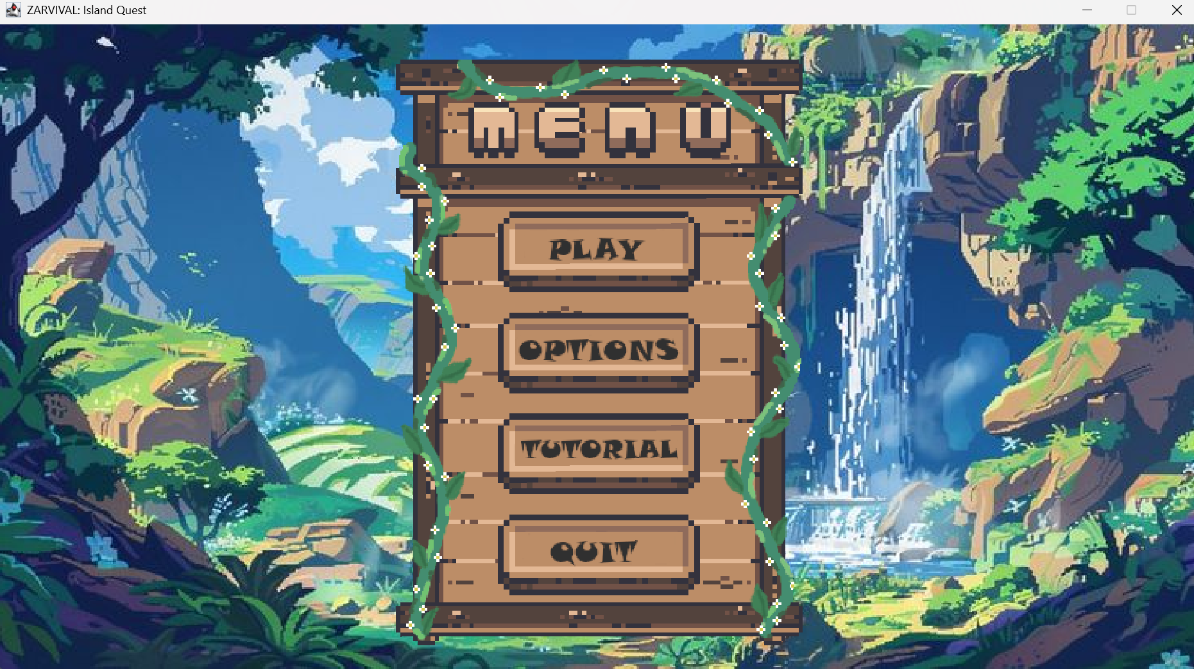
Figure 5. Main Menu
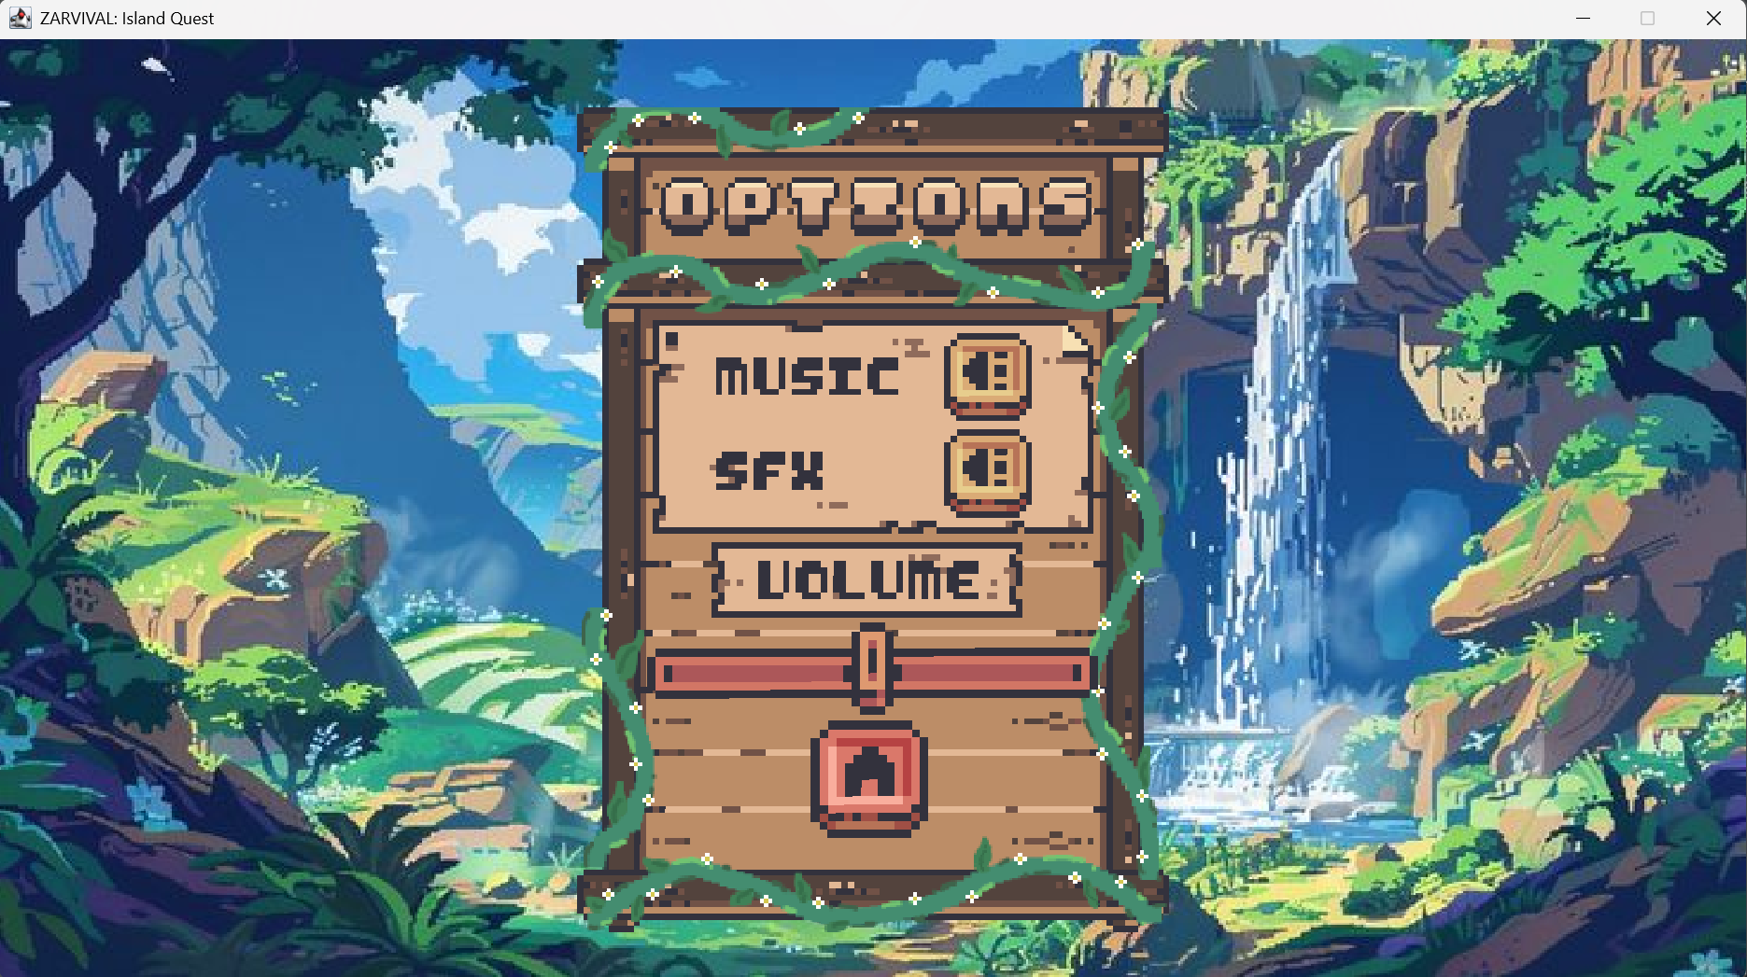
Figure 6. Options
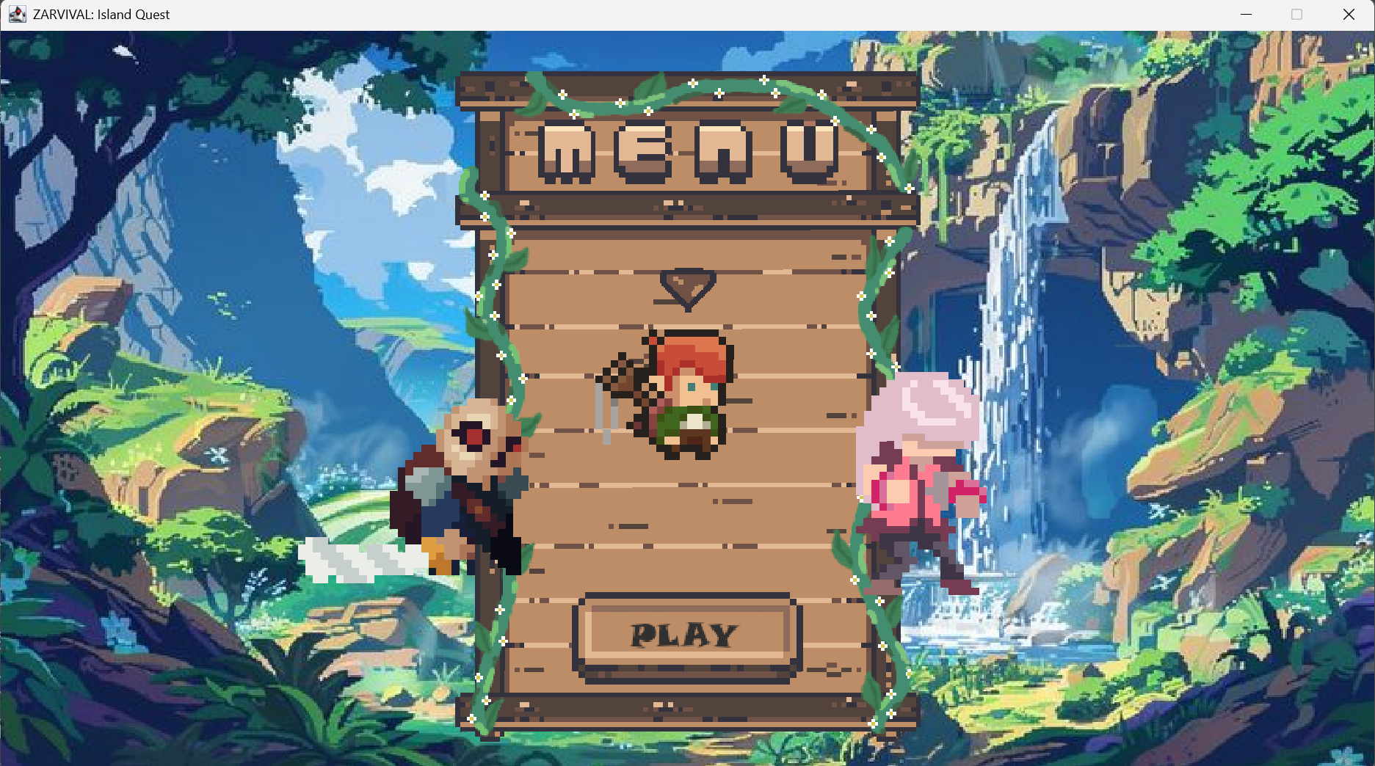
Figure 7. Choose Characters

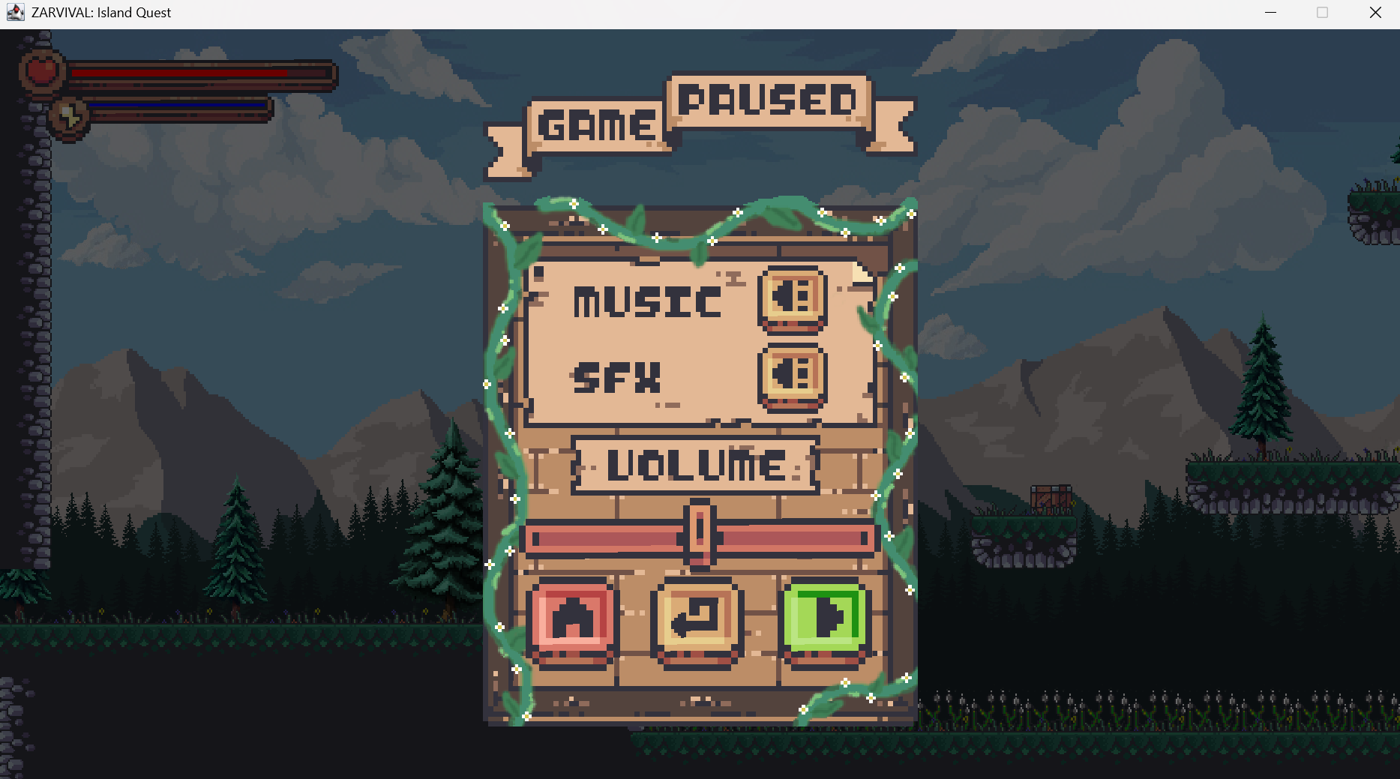
Figure 8. Game Paused
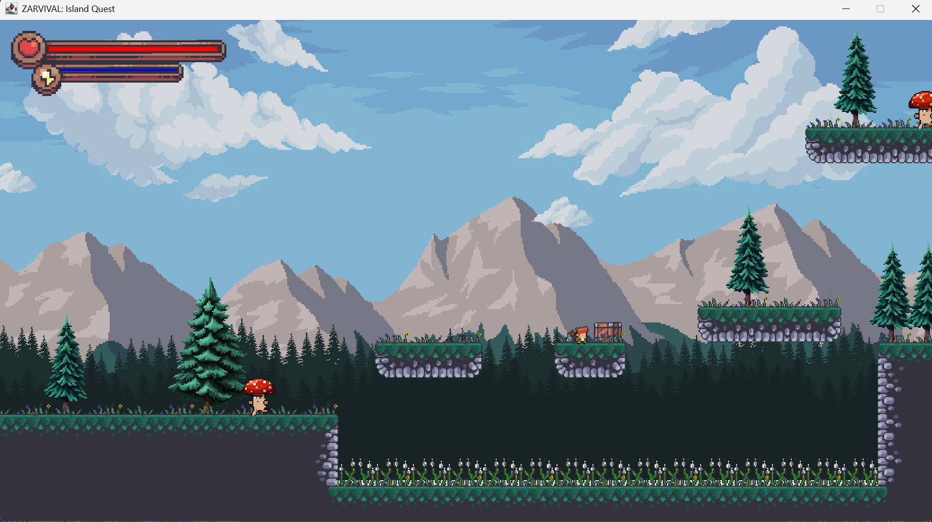
Figure 9. Playing Screen

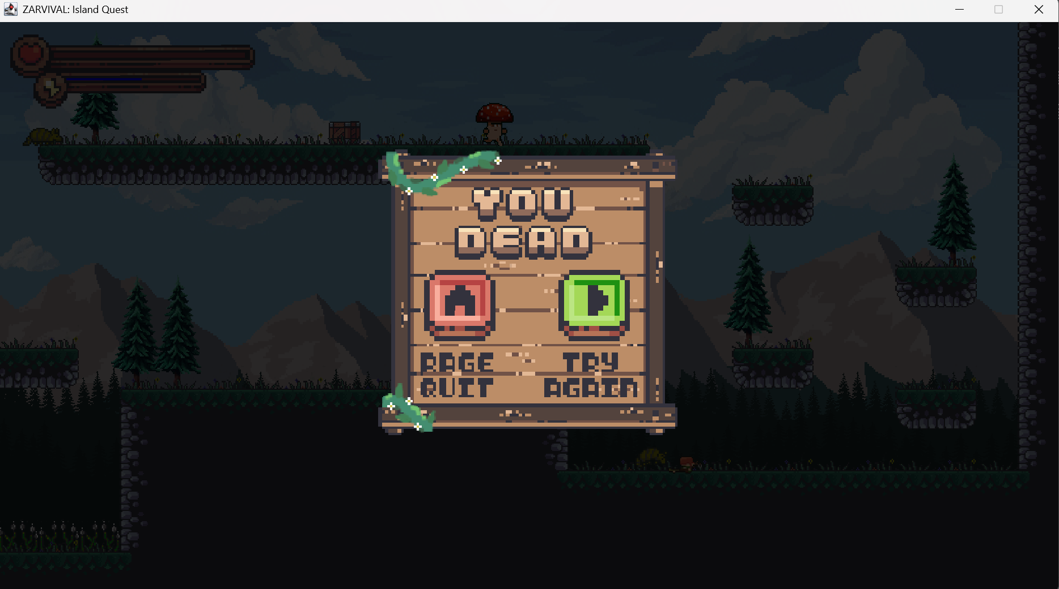
Figure 10. Player Died
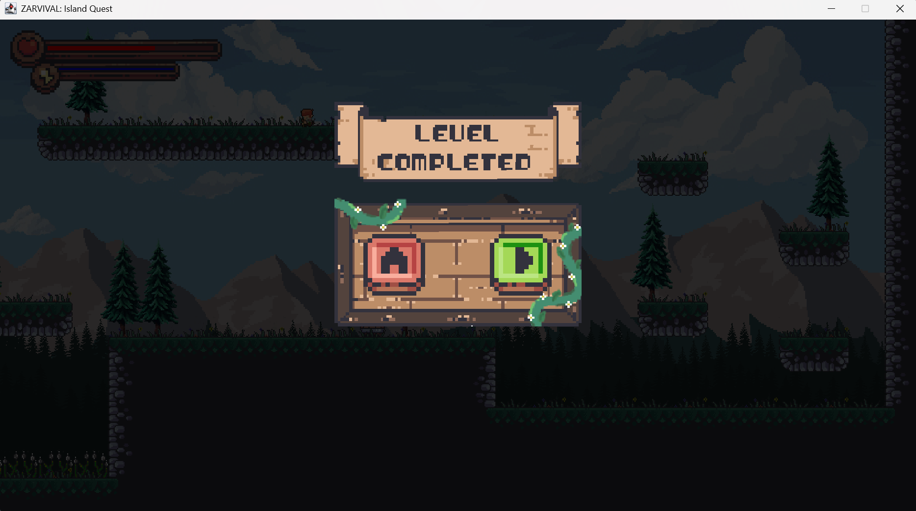
Figure 11. Level Completed

