Análise/resumo inicial, baseada nos links abaixo:
The interactions in Usenet are considered directed, as they are from the message author to the poster of the message they have replied to. No link exists if the message is the start of a new thread (I,e isnot in reply to someone else.)

- Projeto desenvolvido como pesquisa acadêmica (MSc Business Systems Analysis & Design at City University em 2008 por Stephen Thomas Leonard, Project Title: Evaluating sociability in on-line discussion boards);
- Contexto mais acadêmico com projeto open source no Github com pouquíssimo desenvolvimento / colaboração;
- Ferramenta em Java para obter / visualizar dados “mensagens / posts” sobre discussões de grupos da rede UseNet (através protocolo NNTP na porta 119). A visualização é feita nas nos paineis (Graph, Matrix, Pajek File Preview) através projeto java open soruce JUNG (Java Universal Network/Graph Framework). Os dados de rede social são salvos num formato válido “Pajek Network File (.net)” para posterior análise (via algoritmos de métricas sobre grafos) através o programa Pajek.

“The interactions in Usenet are considered directed, as they are from the message author to the poster of the message they have replied to. No link exists if the message is the start of a new thread (I,e isnot in reply to someone else.)”

“Like email, a UseNet message is split into two main sections - a header (where the subject, sender details and date sent are stored) and a body where the text of the message is stored. The header of an NNTP message contains many extra fields, including details of what server the message was posted on, what newsgroups the message is intended for, and a unique message ID. The body is the text of the message – the actual “news”.

System Requirements: JRE 8 and Internet Access to port 119 on external servers

UNISoN (https://github.com/leonarduk/unison) is a Java application that can analyze messages to save to a Pajek-format file for social network analysis. It generates networks using the author of each post. If someone interacts with a post, a unidirectional link is created from the post’s author to the author of the message they are replying to. Also, there is a preview panel that displays the network visually.

(https://www.rankred.com/free-social-network-analysis-tools/)

UNISoN - UseNet Incorporates Social Networks
UNISoN is a Java-based NNTP client that can analyse messages to save to a Pajek-format file for Social Network Analysis. Developed as part of an MSc Business Systems Analysis & Design at City University in 2008, it was made Open Source in 2016, see https://github.com/leonarduk/unison.
Steve Leonard
(http://unison.sleonard.co.uk/index.php)

UNISoN is a Java application that can download Usenet messages from free NNTP servers, show the saved messages, then allow filtering of data to save to a Pajek network file or CSV file. It creates networks using the author of each post. If someone replies to a post, there is a unidirectional link created from the author of the post to the author of the message they are replying to. There is also a preview panel that shows the network visually. It was developed in 2008 as part of an MSc Business Systems Analysis & Design at City University London.[1] and was released as Freeware. In 2016 the code was made Open Source.[2]

Release history

The first version of UNISoN was released in February, 2008. There was an update to the project Website in 2012 which added Java Web Start. In 2016 there was some work to update the code and documentation.
(https://en.wikipedia.org/wiki/UNISoN_(Social_Network_Analysis_Tool))
(https://ipfs.io/ipfs/QmXoypizjW3WknFiJnKLwHCnL72vedxjQkDDP1mXWo6uco/wiki/UNISoN_(Social_Network_Analysis_Tool).html)

The project from my MSc at City University- a java app used to study social networks in Usenet groups. The web page is just HTML, but the app uses various java technologies, including Swing and Hibernate.

(http://sleonard.co.uk/)

UNISoN - A tool to aid evaluation of sociability in on-line discussion boards. After selecting a newsgroup on usenet, messages are downloaded and visualized. They can be saved as Pajek network data for further analyses.

(https://books.google.co.uk/books/about/The_SAGE_Handbook_of_Social_Network_Anal.html?id=mWlsKkIuFNgC&pg=PA599)

UseNet
–
an abbreviation of UNIX Users Network

NNTP (News Network Transfer Protocol)

Pajek (Slovene word for Spider)

Pajek can handle 6 types of data structures: network, partition, cluster, permutation, vector, andhierarchy.

(https://pt.scribd.com/document/100017519/UNISoN-A-tool-to-aid-evaluation-of-sociability-in-on-line-discussion-boards)

Outras Referências:

http://unison.sleonard.co.uk/index.php/4-user-guide/
http://unison.sleonard.co.uk/index.php/4-user-guide/user-guide-sp-226
http://unison.sleonard.co.uk/index.php/4-user-guide/user-guide-sp-226/4-download-message-panel
http://unison.sleonard.co.uk/index.php/4-user-guide/user-guide-sp-226/5-view-saved-data-panel
http://unison.sleonard.co.uk/index.php/4-user-guide/user-guide-sp-226/6-transform-data-for-pajek-panel

=============== ERROS

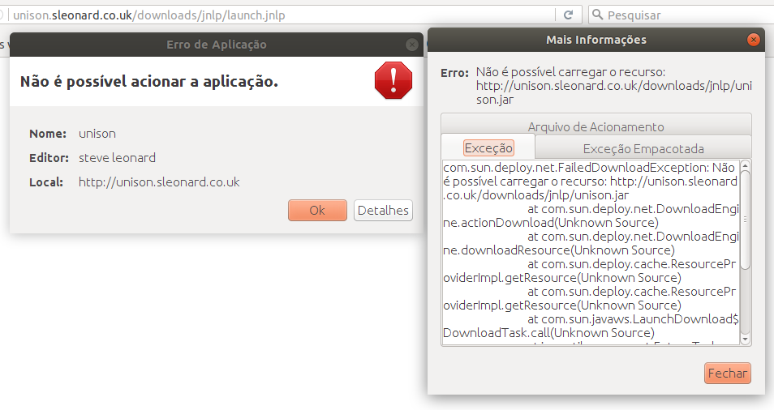

Connection Refused
(https://github.com/leonarduk/unison/wiki/Connection-Refused)

####To avoid problems finding and downloading newsgroups, port 119 needs to be accessible. If this port is not accessible you'll see the follow error message:

####Open port on Unix
sudo iptables -A INPUT -p tcp --dport 119 -j ACCEPT
sudo iptables -A OUTPUT-p tcp --dport 119 -j ACCEPT

####If the issue still remains you can either configure your router to port forward port 119 Or change your internet connection.

Alternatively run maven on command line (Eclipse)
mvn clean install
Then to run it
- Go to src/main/java
- Select uk.co.sleonard.unison.gui.generated.
- Select the class named DownloadNewsPanel.
- Run.

