Lab 1

721030290001

张艺珩

计算机科学

1a)

1b)

2) The 2nd code block is more suitable for multithreading because in every iteration, the calculations are based on the current iteration number, therefore, the iterations can be assigned to different threads and the results wouldn’t be affected. On the other hand, for the Fibonacci code, each iteration is dependent on the results from the previous iteration, multithreading the code will lead to it producing the wrong result.

3) 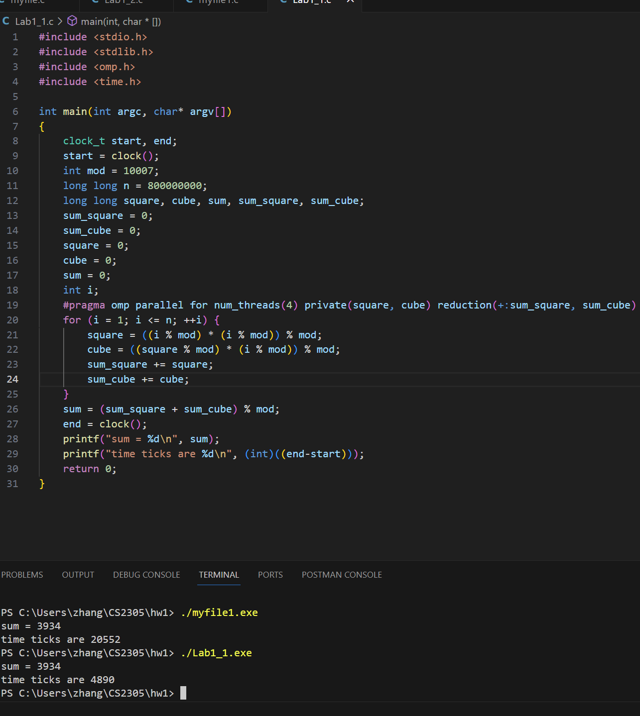 By implementing parallelism with OpenMP and utilizing 4 threads in my code, there is a significant performance improvement. The speedup achieved is approximately 4 times compared to the sequential version of the code. This improvement is evident from the reduced execution time, as indicated by the lower number of time ticks for the parallelized version (Lab1_1.exe) compared to the original version (myfile1.exe). The time ticks represent the CPU clock cycles consumed during code execution. The parallelized code demonstrates a notable reduction in time ticks, indicating that it completes the same amount of work in less time compared to the sequential code. The speedup of around 4 times, which is calculated by dividing the time ticks of the different code, highlights the effectiveness of utilizing multiple threads and parallelism in improving performance. Overall, the introduction of parallelism using OpenMP, with its division of workload among multiple threads, has yielded a significant performance improvement, resulting in faster execution and a noticeable speedup.

4) It will be calculated in t2.

5)

