# MPC-MAP Assignment No. 1- Report

## **Author:** Sukdolak Martin

## **Date:** 23.02.2025

## Task 2

Measurement was made for 1000+ data’s from sensors. Lidar STD is in range 0.0490 +-0.002 which is relatively consistent. GNSS STD is in range 0.4944 +-0.01 which is not that good as Lidar but still based on histogram consistent.

|  |  |  |  |  |  |  |  |  |  |
| --- | --- | --- | --- | --- | --- | --- | --- | --- | --- |
| GNSS | | LIDAR | | | | | | | |
| X | Y | Sen. 1 | Sen. 2 | Sen. 3 | Sen. 4 | Sen. 5 | Sen. 6 | Sen. 7 | Sen. 8 |
| 0,5032 | 0,4856 | 0,0481 | 0,0495 | 0,0490 | 0,0498 | 0,0497 | 0,0486 | 0,0507 | 0,0498 |

Table 1 STD data (sigma)

Figure 1 GNSS histogram Figure 2 Lidar histogram

## Task 3

Main diagonal of both covariance matrix are equal std^2.

Table 2 GNSS covariance matrix

Table Lidar covariance matrix

|  |  |  |  |  |  |  |  |  |  |
| --- | --- | --- | --- | --- | --- | --- | --- | --- | --- |
| GNSS | | LIDAR | | | | | | | |
| X | Y | Sen. 1 | Sen. 2 | Sen. 3 | Sen. 4 | Sen. 5 | Sen. 6 | Sen. 7 | Sen. 8 |
| 0,2532 | 0,2358 | 0,0023 | 0,0025 | 0,0024 | 0,0025 | 0,0025 | 0,0024 | 0,0026 | 0,0025 |

Table 4 STD^2 data (sigma)

## Task 4

Lidar have more accurent PDF than GNSS.

Figure 3 Lidar and GNSS PDF

## Task 5

Time and commands optimized trajectory to reduce effect of source uncertainty.

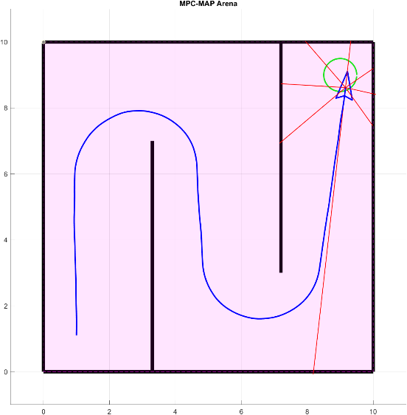

Figure 4 Successful run

Sources of uncertainty

* unevenness of the surface
* wheel slipping
* skipping engine steps
* communication losses