https://packages.chef.io/files/stable/chef/16.6.14/el/7/chef-16.6.14-1.el7.x86_64.rpm

https://www.youtube.com/watch?v=8AAcpUBtOG4&list=PL5nViEmyYI0bmfcM_s4P-dfzKrOpcFWWK

https://www.youtube.com/watch?v=8AAcpUBtOG4&list=PL5nViEmyYI0bmfcM_s4P-dfzKrOpcFWWK

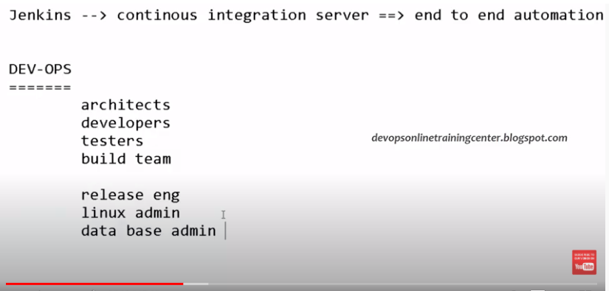

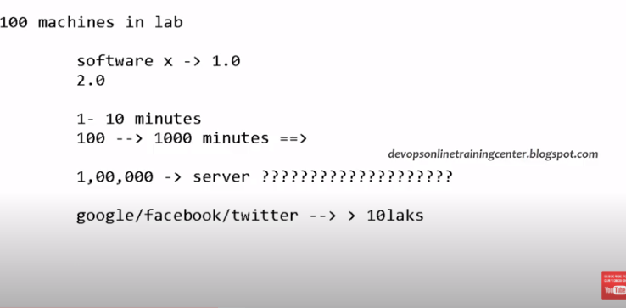

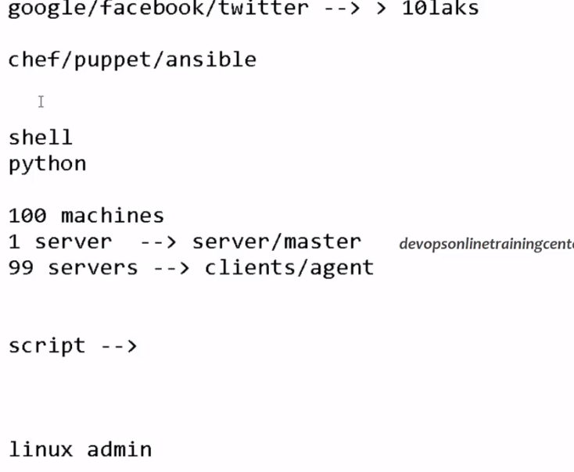

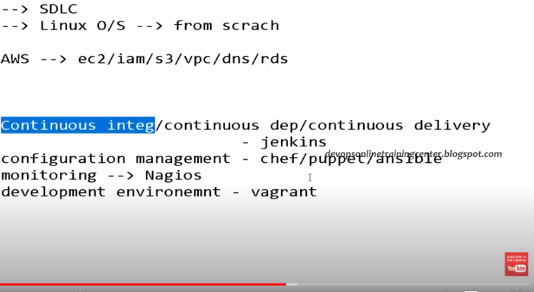

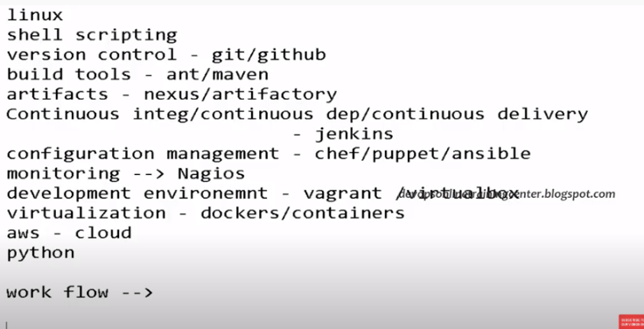

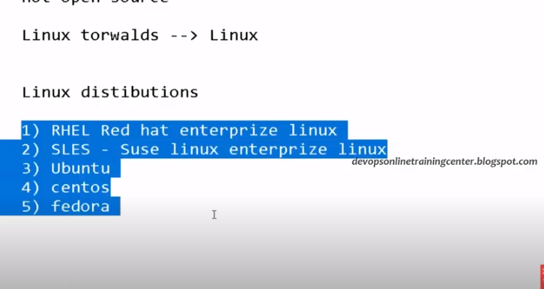

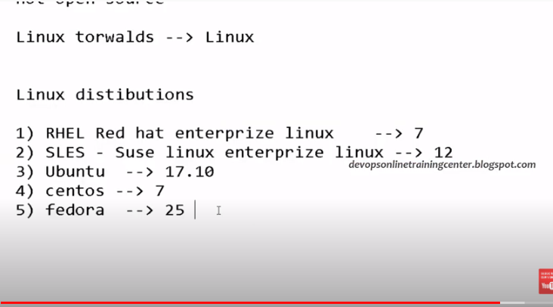

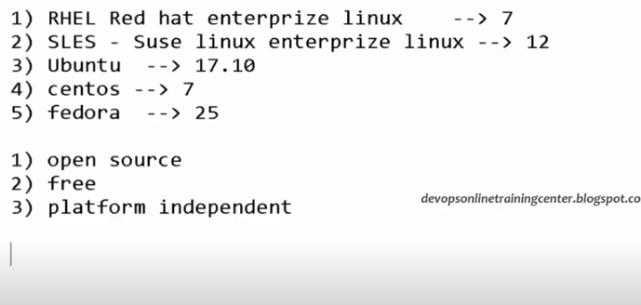

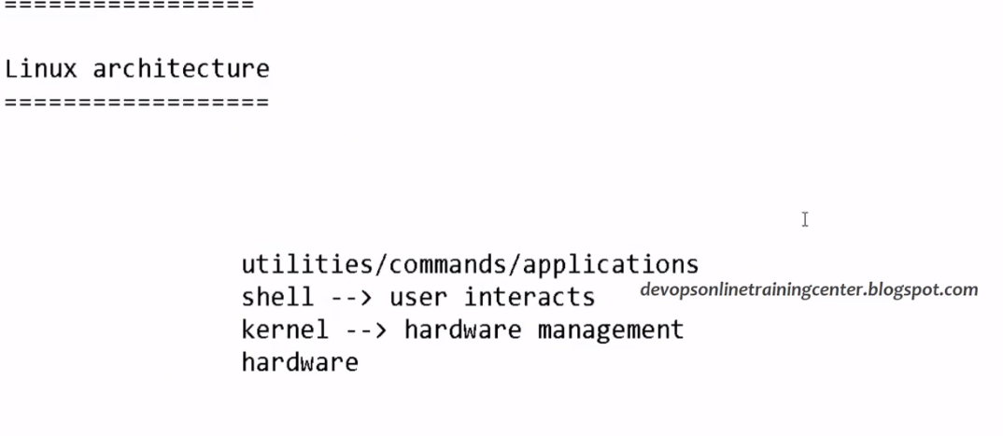

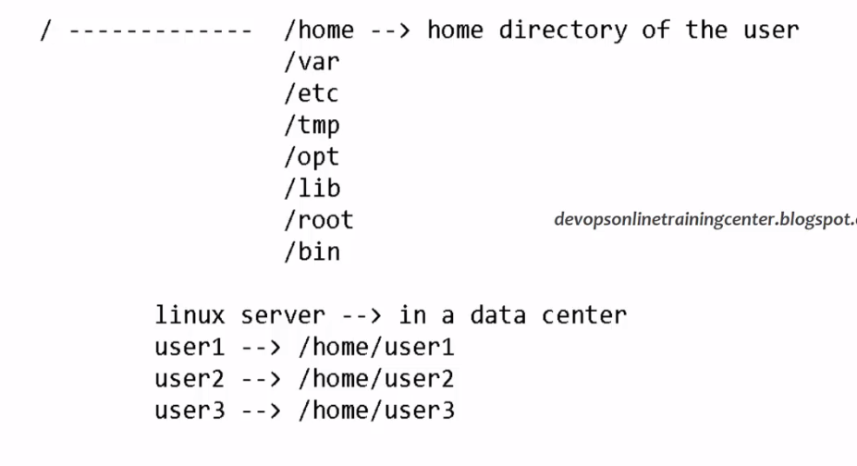

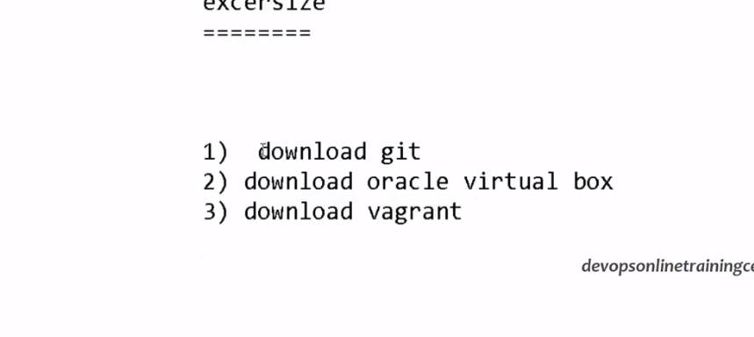

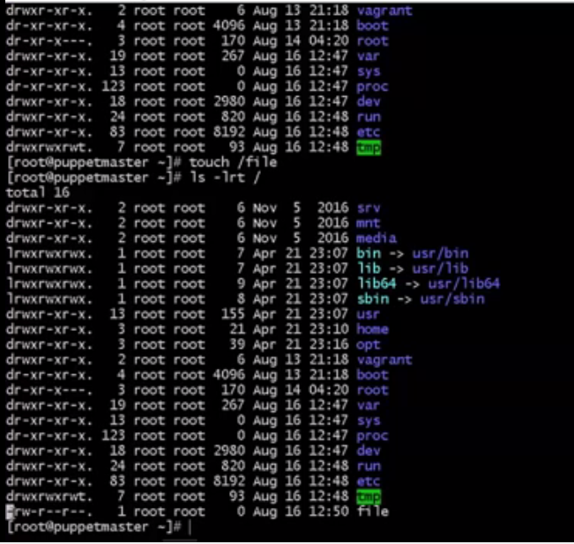

D=>directory

-=> File