[Jenkins Tutorials for Beginners | Continuous Integration Tutorials - YouTube](https://www.youtube.com/watch?v=e8tEF_1jx84&list=PL5nViEmyYI0bmfcM_s4P-dfzKrOpcFWWK&index=21):  
<https://www.youtube.com/watch?v=e8tEF_1jx84&list=PL5nViEmyYI0bmfcM_s4P-dfzKrOpcFWWK&index=21>

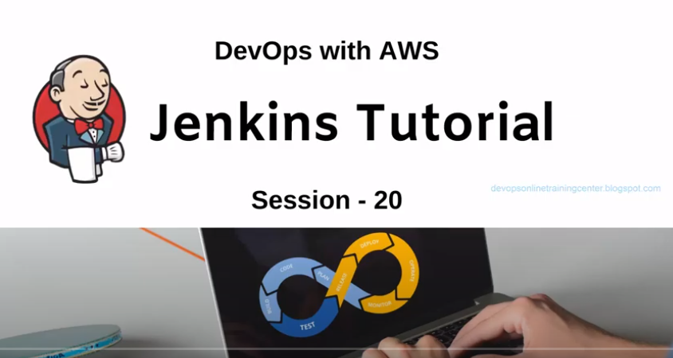

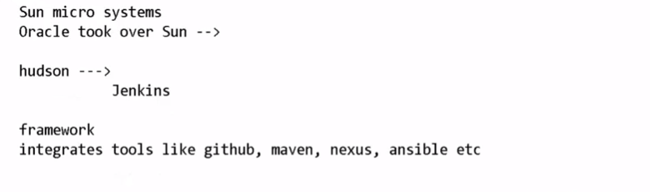

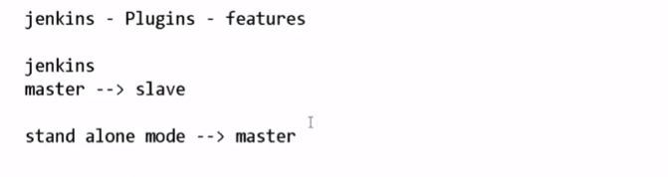

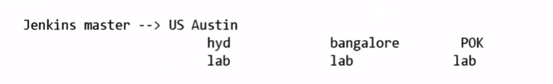

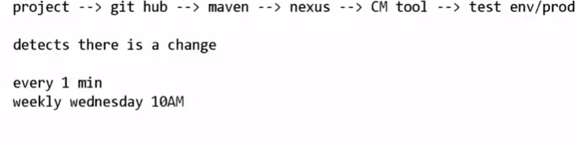

How To Install Jenkins on Ubuntu 18.04 | DigitalOcean:

<https://www.jenkins.io/doc/book/installing/linux/#debianubuntu>

Step 1 — Installing Jenkins

The version of Jenkins included with the default Ubuntu packages is often behind the latest available version from the project itself. To take advantage of the latest fixes and features, you can use the project-maintained packages to install Jenkins.

wget -q -O - https://pkg.jenkins.io/debian/jenkins.io.key | sudo apt-key add -

sudo sh -c 'echo deb https://pkg.jenkins.io/debian binary/ > \

/etc/apt/sources.list.d/jenkins.list'

sudo apt-get update

sudo apt-get install jenkins

### **Start Jenkins**

You can start the Jenkins service with the command:

sudo systemctl start jenkins

You can check the status of the Jenkins service using the command:

sudo systemctl status jenkins

If everything has been set up correctly, you should see an output like this:

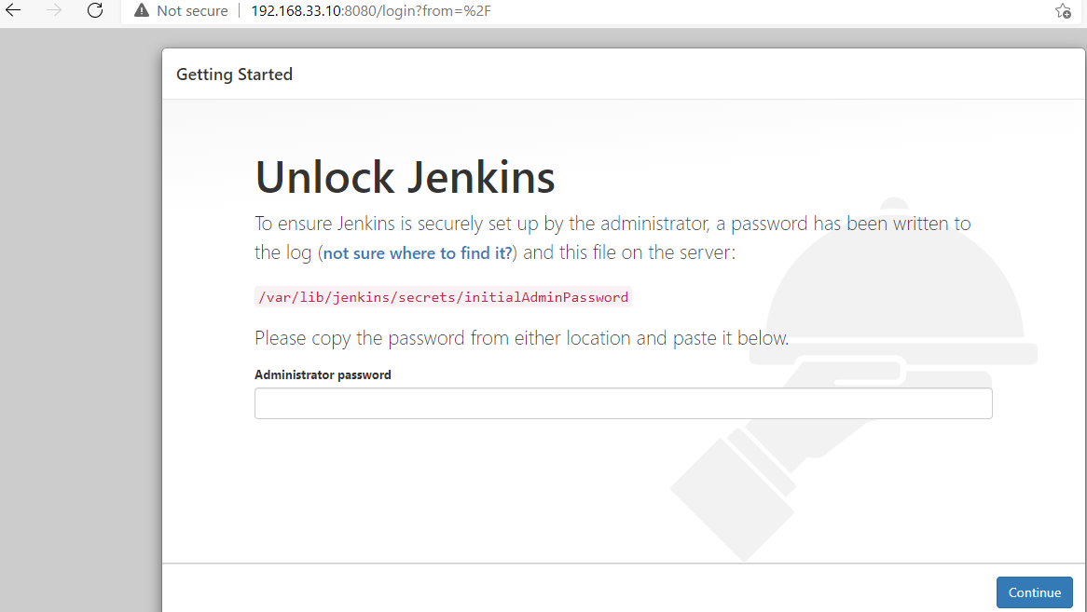

CHANGE THE SETTING IN CLI SO THAT WITHOUT USING ANY CREDENTIALS, WE CAN LOGIN INTO THE JENKINS:

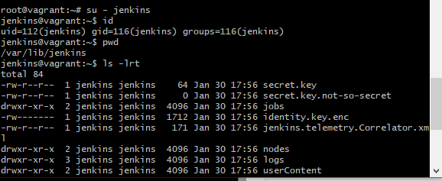



CHANGE THE useSecurity value to false. /var/lib/Jenkins/config.xml

And restart the Jenkins server: Restart the Jenkins server.

service jenkins restart

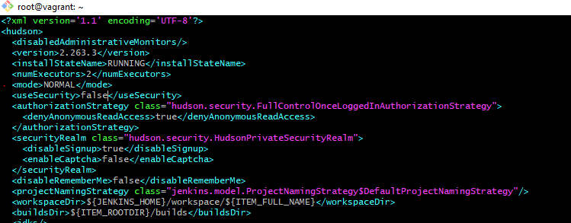

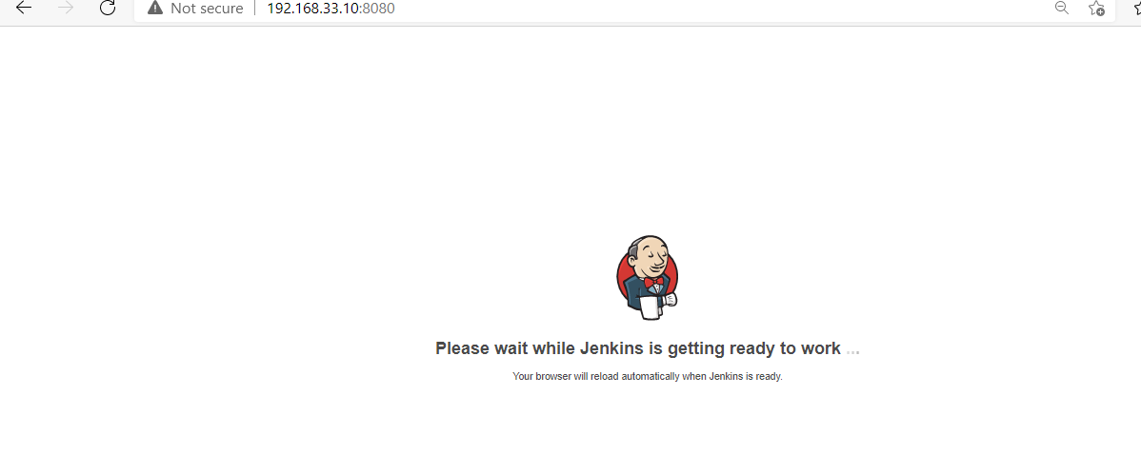

Add admin user:

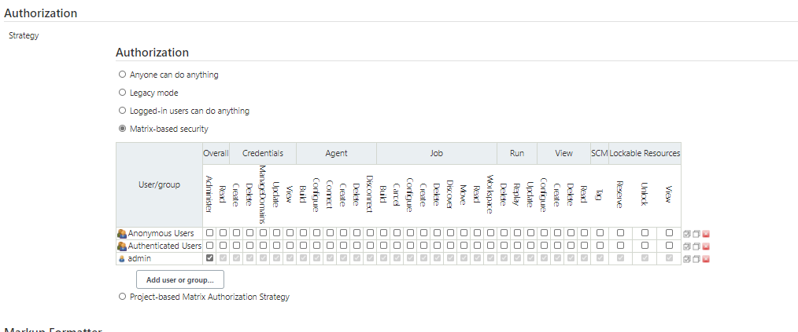

Password will be same as initial password