<https://www.youtube.com/watch?v=56TgfZyLV8A&list=PL5nViEmyYI0bmfcM_s4P-dfzKrOpcFWWK&index=12>



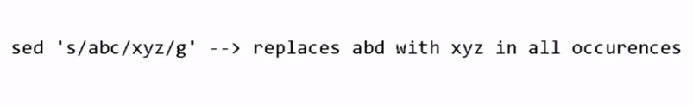

Changes done by sed will be temporary.

Sed 2d filename 🡪deletes the 2nd line temporary

Sed nth filename🡪deletes the nth line temporary

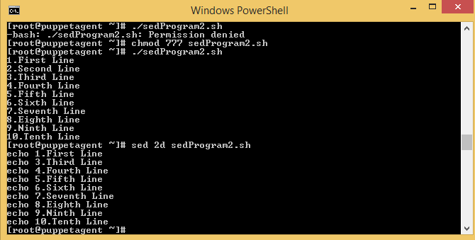

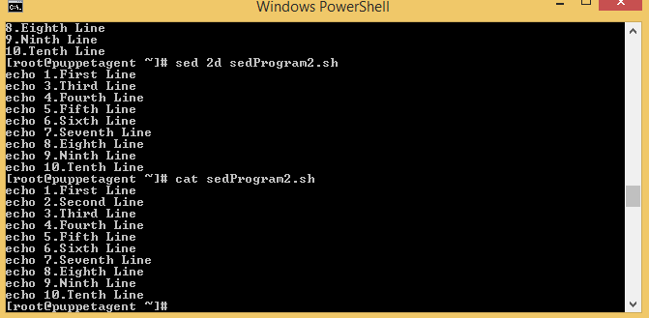

To make deletion permanent, use sed –I 1d filename

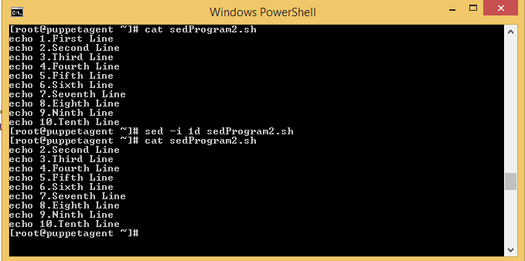

AWK:

It is used to extract rows and columns:

Ls –lrt | awk {‘print $9’}=> extract 9th column from ls –lrt output

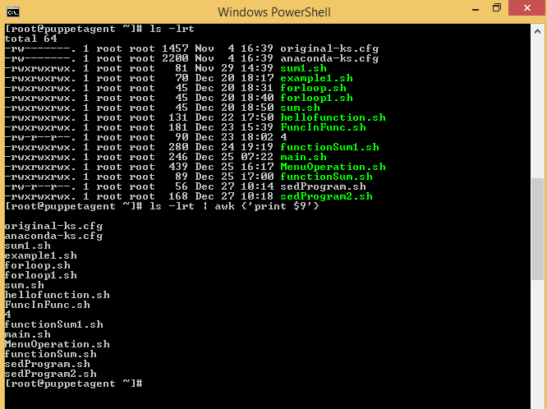

If we want to print size and file name from the list:ls –lrt

Use: ls –lrt | awk {‘print $5 $9’}

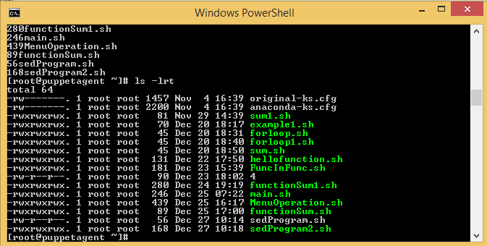

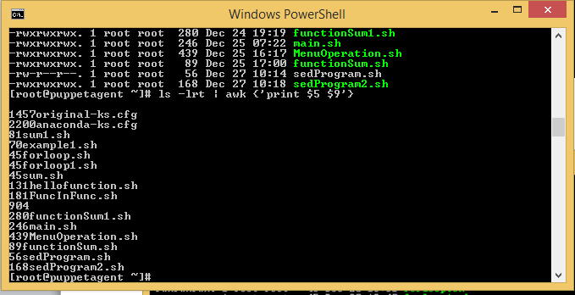

If you want separate size and filename with comma then following command will work:

Ls –lrt | awk {‘print $5 “,” $9}

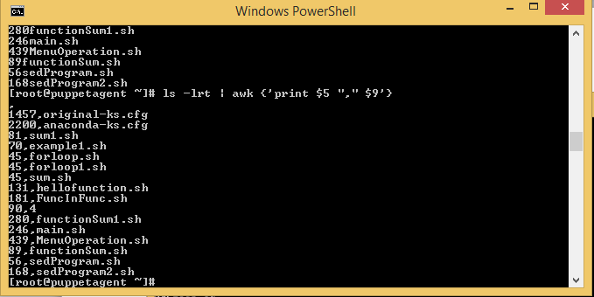

If you want separate size and filename by tab then following command will work:

Ls –lrt | awk {‘print $5 “\t” $9’}

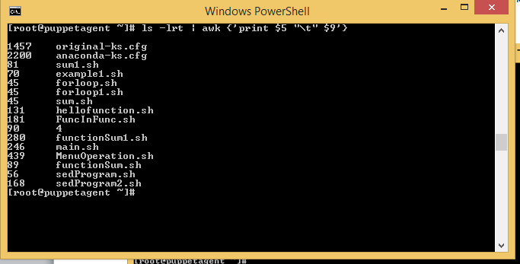

Different delimeters(---,###,\t) are used to separate the column name.

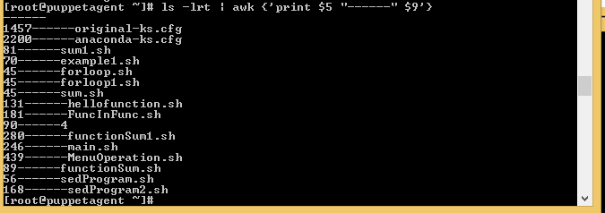 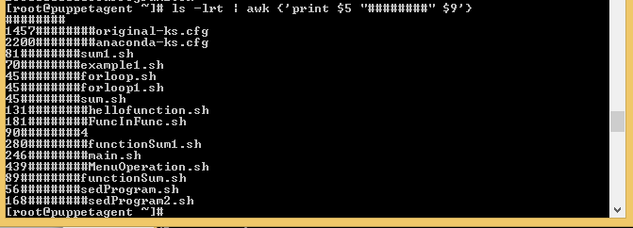

If we want to print sepecific row from the output of ls –lrt.

Ls –lrt | awk ‘FNR==9 {print}’

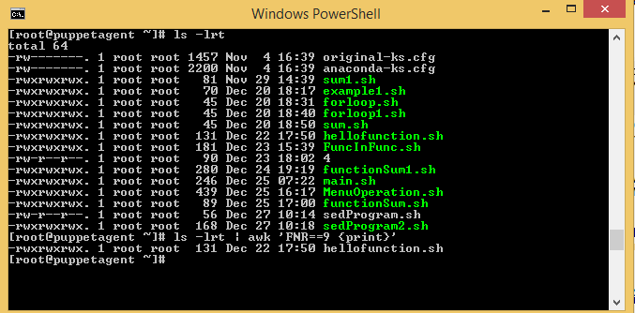

AWK can be used to extract particular row or column from command output or file output.

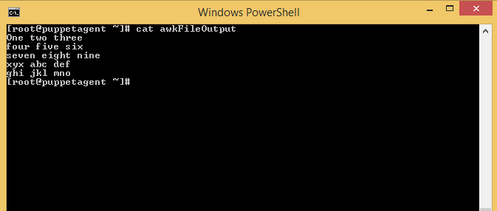

It will print 3rd Column from the output of file

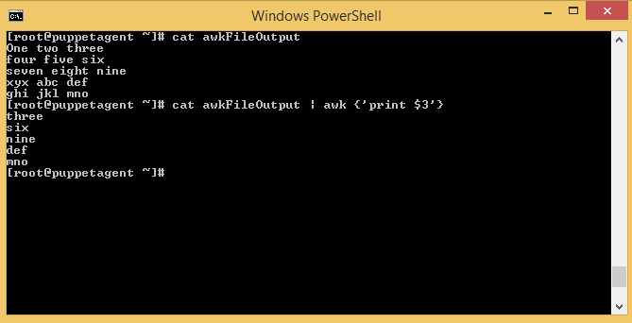

It will print the first row from the output of awkFileOutput file



Extracted result content can re-directed to file

Cat awkFileOutput | awk {‘print $3’} > /file

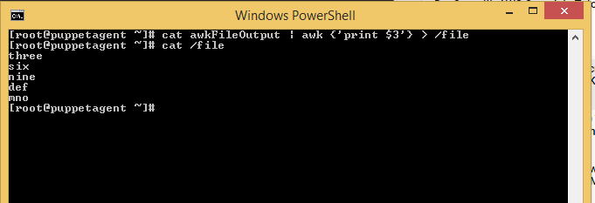

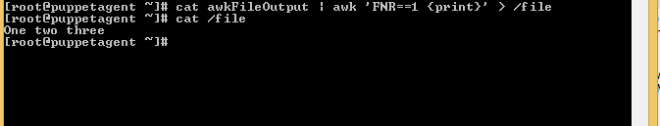

Store the command output into the variable.

‘ ‘ == It is back tick below under the Esc button on keyboard

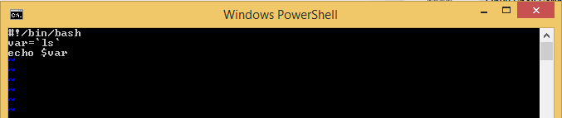

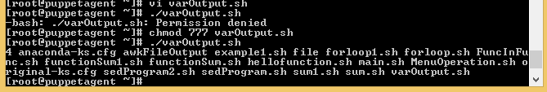

Regular Expression:

With wild characters/ meta characters eg._*

*-Match zero or more occurences

^-carrot /beginning of line

$-ending

?-single character

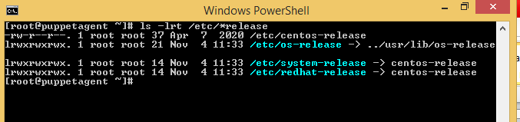

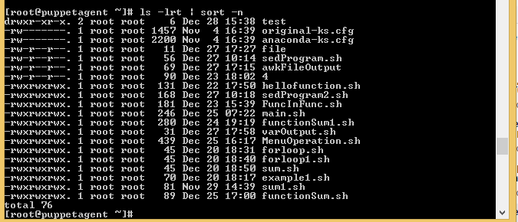

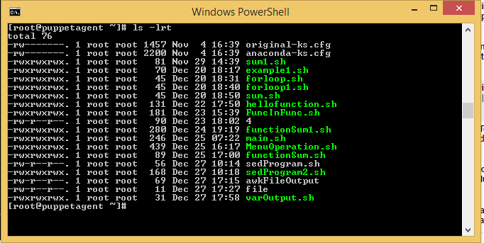

List out all the files list

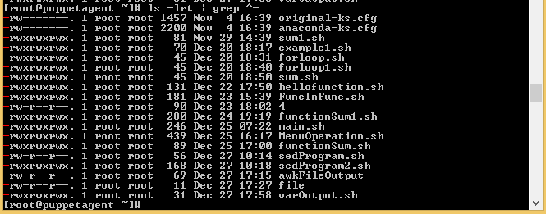

List out all the directory list

Ls –lrt | grep ^d

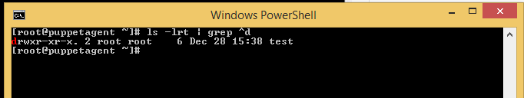

List of file ending with sh

Ls –lrt | grep sh$

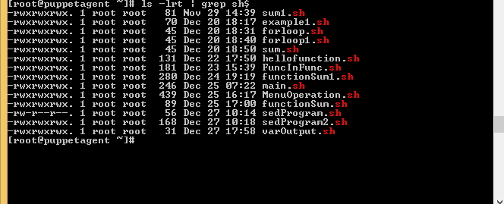

?-matches the single character:

Ls –lrt /etc/os?release

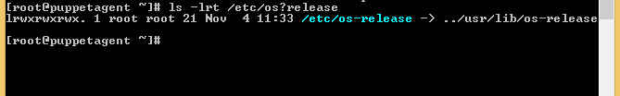

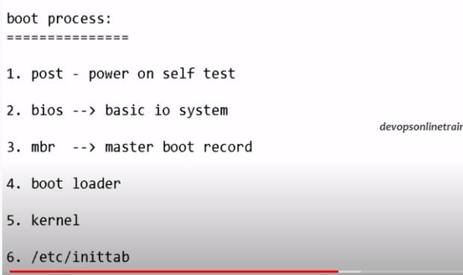

It provides the run-level

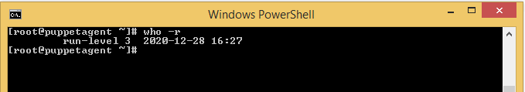

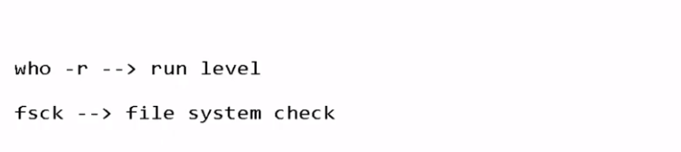

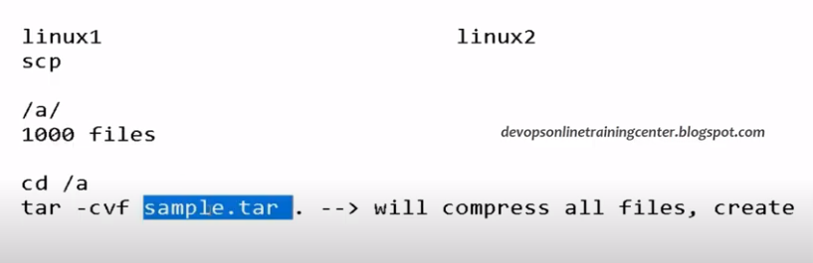

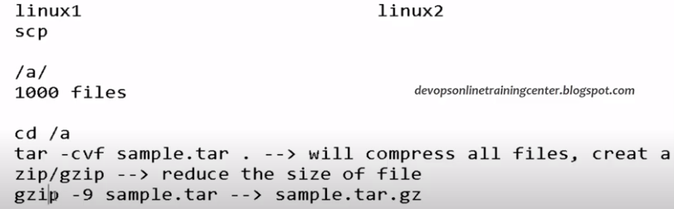

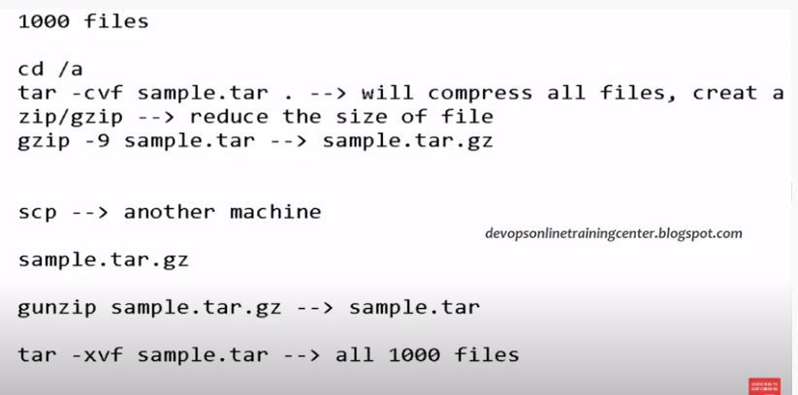

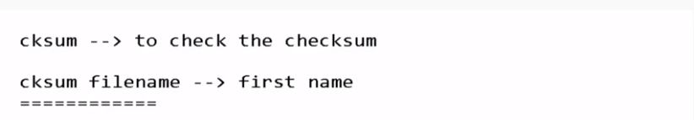

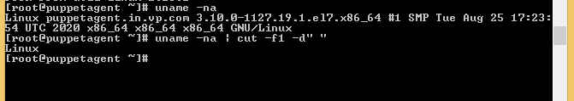

Cut it to used to cut substring from the string based on the delimiters provided.

Cut the string into pieces based on delimiters.

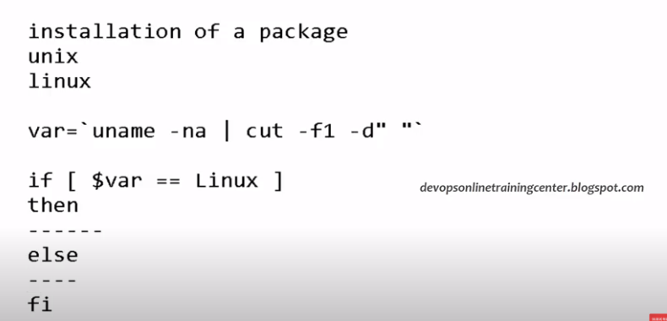



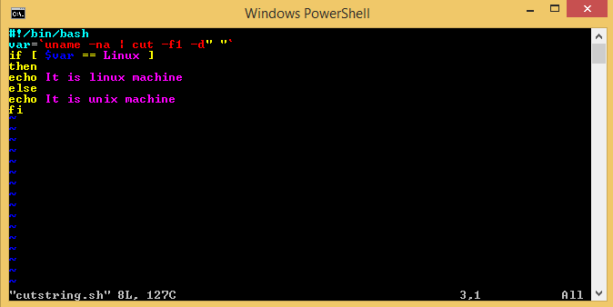

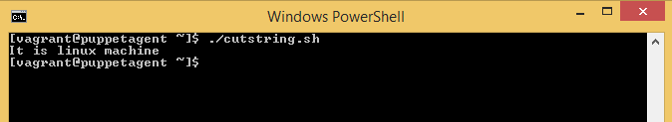

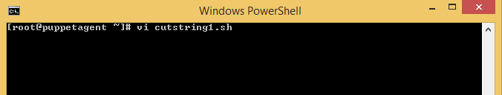

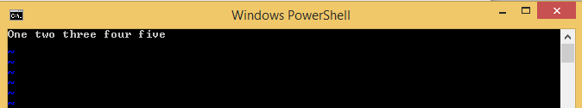

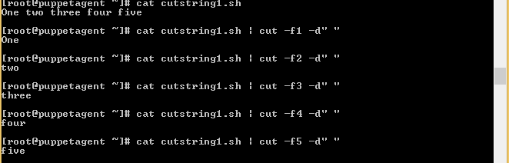

Show the output based on field. We can also cut the string based on character.

Linux#cat file2 | cut –c1-5

