https://www.youtube.com/watch?v=ilM8aRw2CBQ&list=PL5nViEmyYI0bmfcM_s4P-dfzKrOpcFWWK&index=13

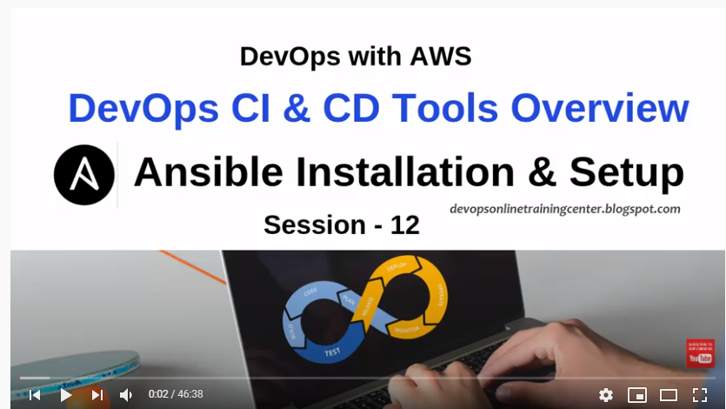

DEVOPS tool:

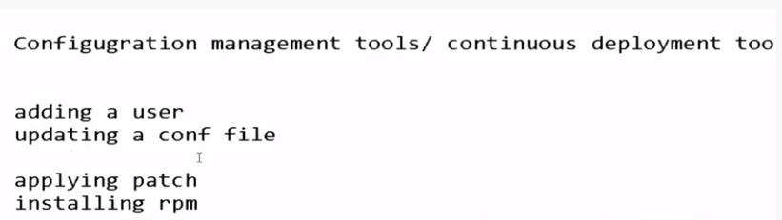

Configuration Tools:

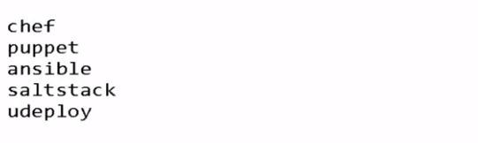

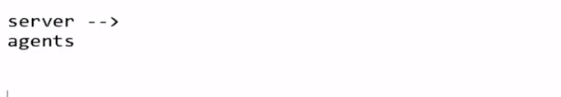

There is one server, where we can write script which can automate the functionality of configure several software on client/agents machine.

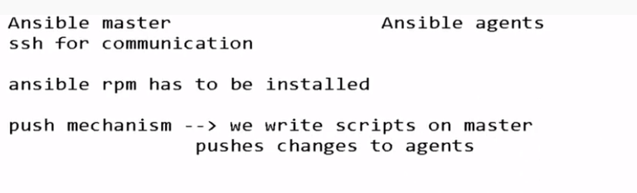



Ansible is of 2 types: Open source & Enter prise

Ansible is developed in python language



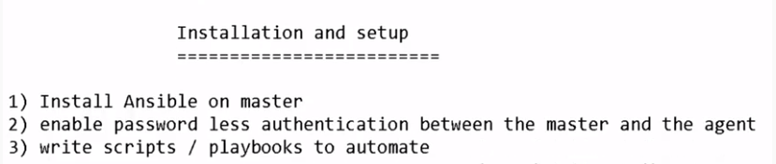

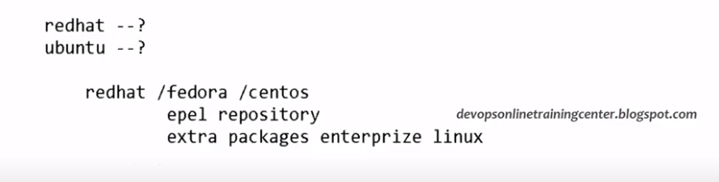

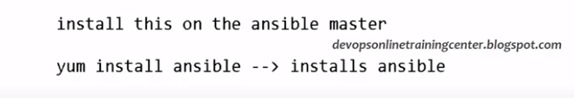

All ansible related documents found at below link:

<https://docs.ansible.com/ansible/latest/installation_guide/intro_installation.html>

ssh command from master machine to operate some operations on agent machine.

Login into the 2 macine

1. puppetagent machine as: ansible-master#

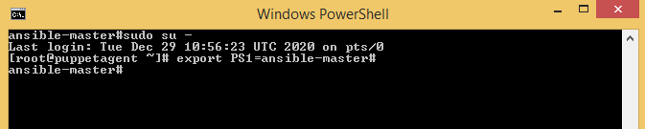

1. Ubuntu machine as:ansible-agent#

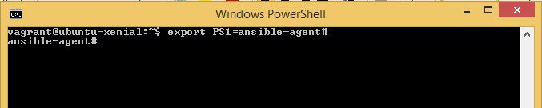

Switch the user from different mode:root to vagrant(normal mode)

Sudo vagrant make it to root.



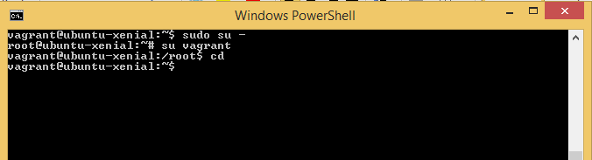

Ssh to client machine from master machine:

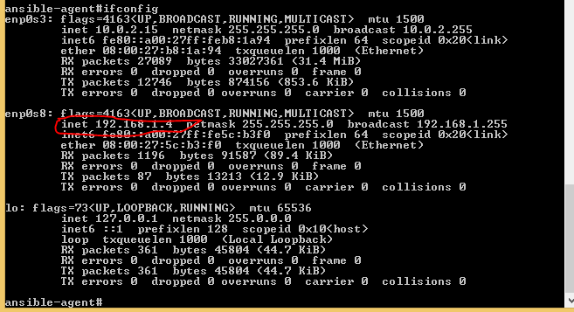

Ssh –l root 192.168.1.4

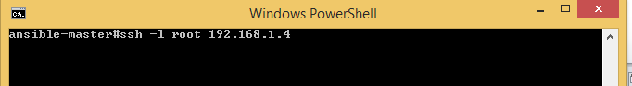

Enter password:vagrant

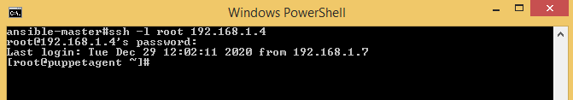

Now once login into the client machine from master machine, whatever floder or file created , it is created in client machine.

Create masterTestfile in ansible-master# login and create file masterTestfile by touch command.

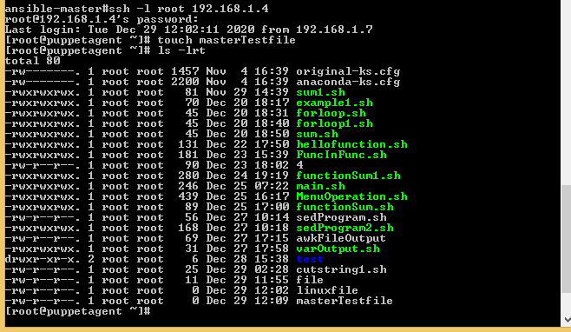

Now masterTestfile is also reflected in ansible-agent(client machine)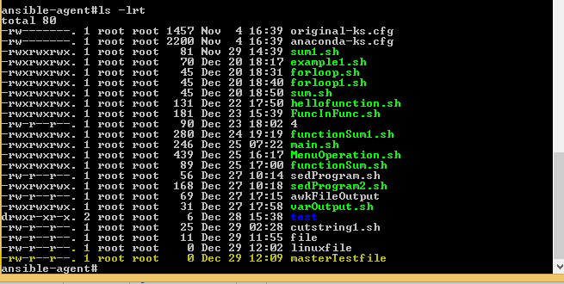

**Another Command**: ssh –l root 192.168.1.4 “ls”, it will login into the agent machine,

Show the output results of agent machine and prompt back to master machine.

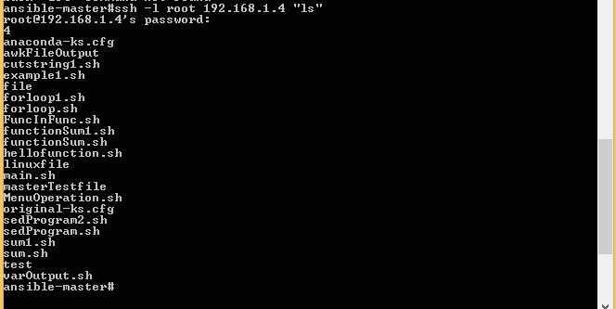

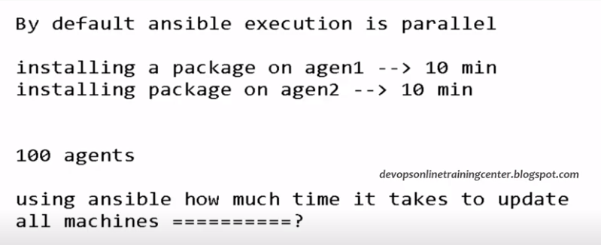

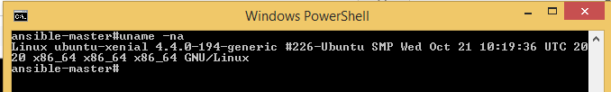

Based on verson of architecture, install the EPEL software

Copy the URL link and use weget URL, it will install the packages

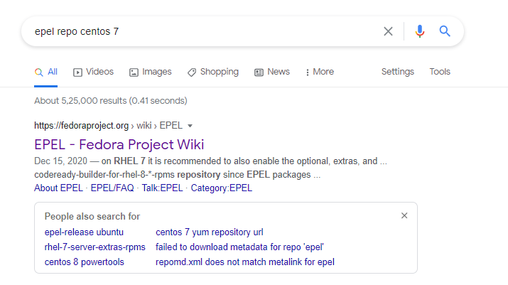

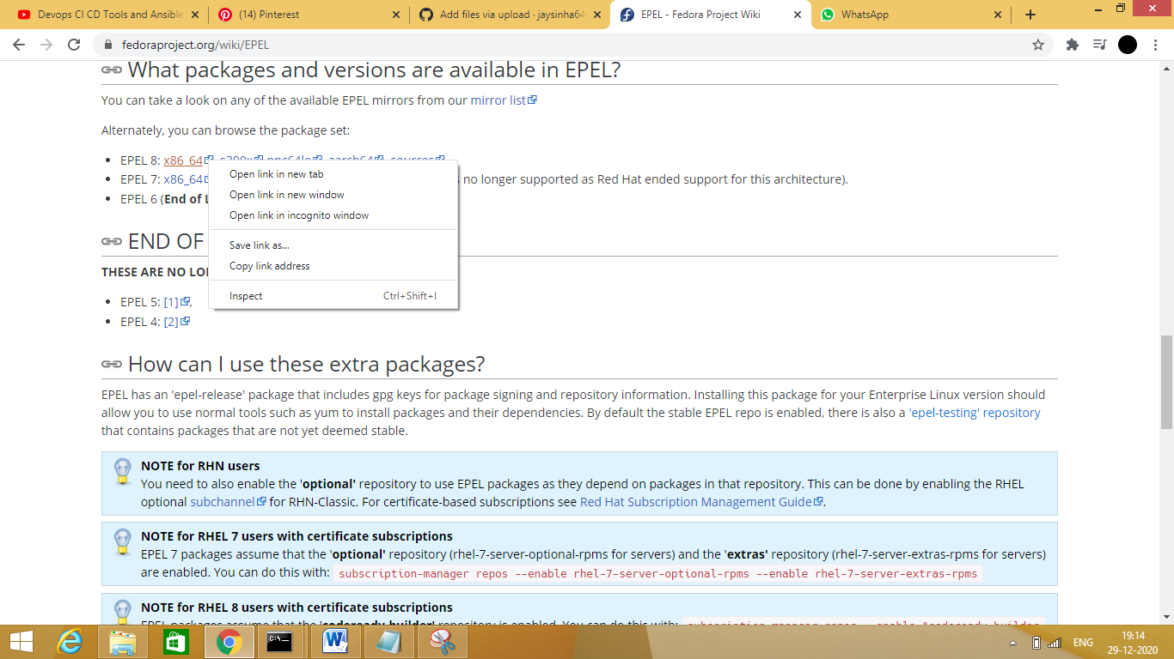

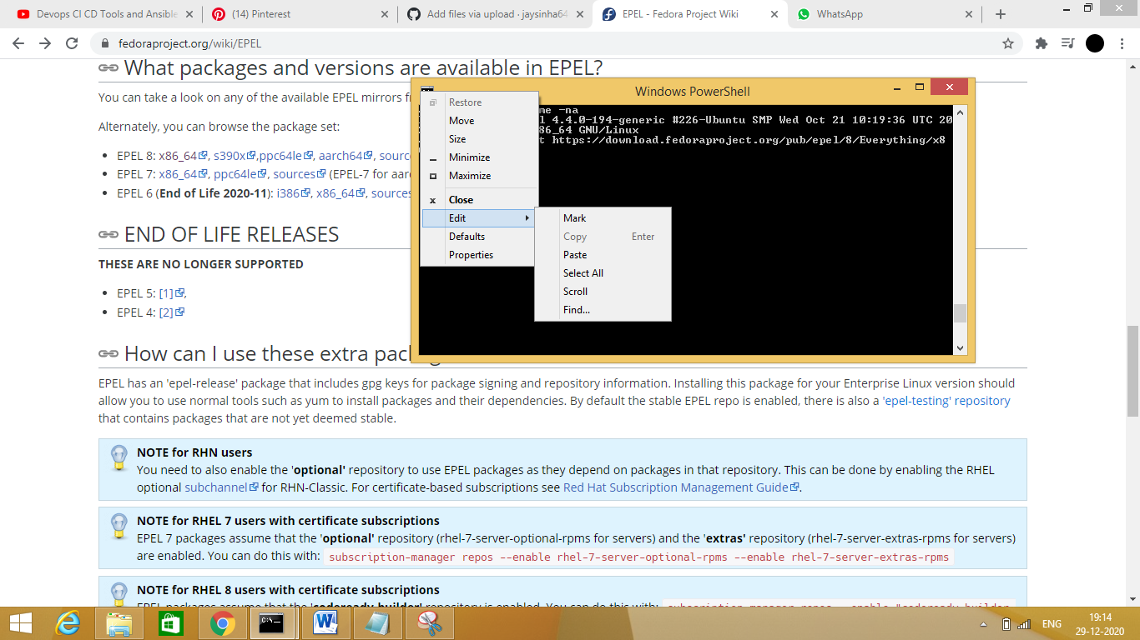

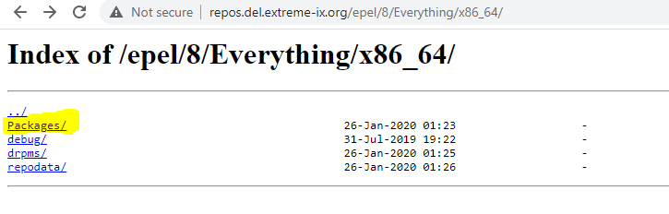

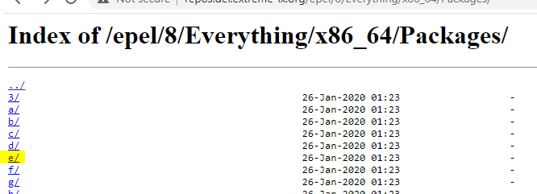

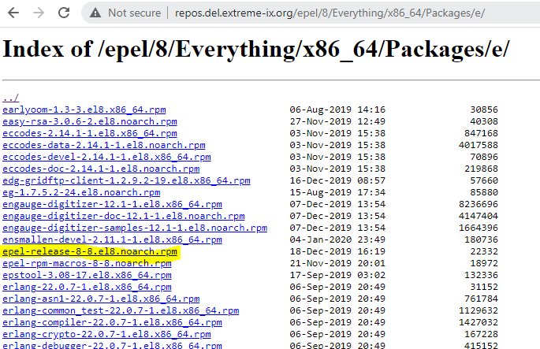

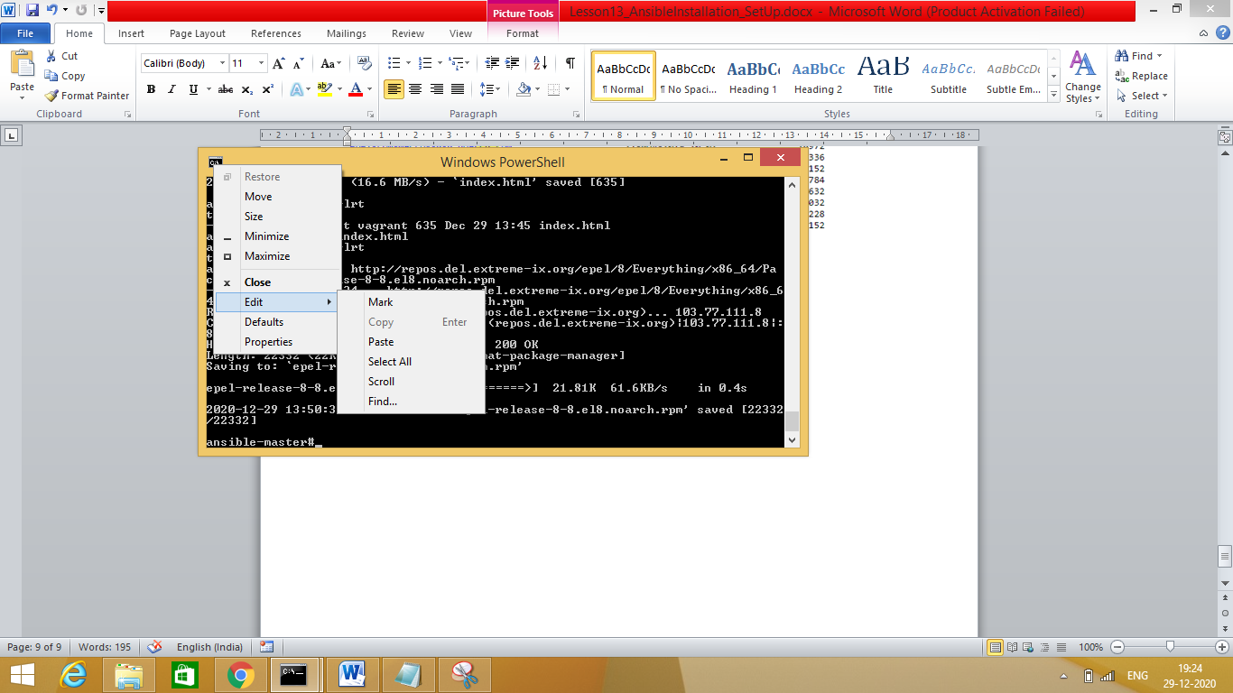

Wget then URL download the required packages in ansible-master# machine

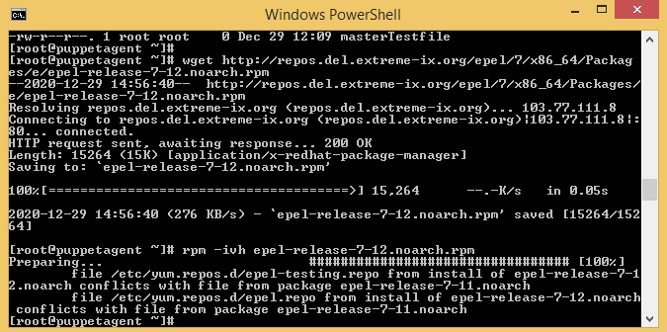

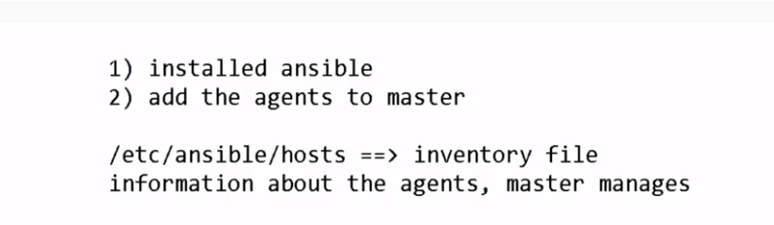

Change the IPaddress of 1 machine if same 2 instances are running on laptop.

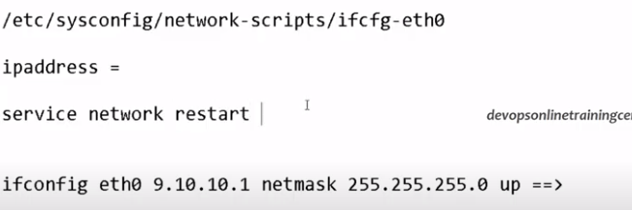

/etc/sysconfig/network-scripts/ifcfg-eth0

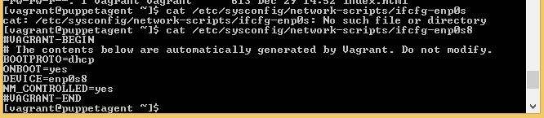

https://stackoverflow.com/questions/33129651/access-web-server-on-virtualbox-vagrant-machine-from-host-browser