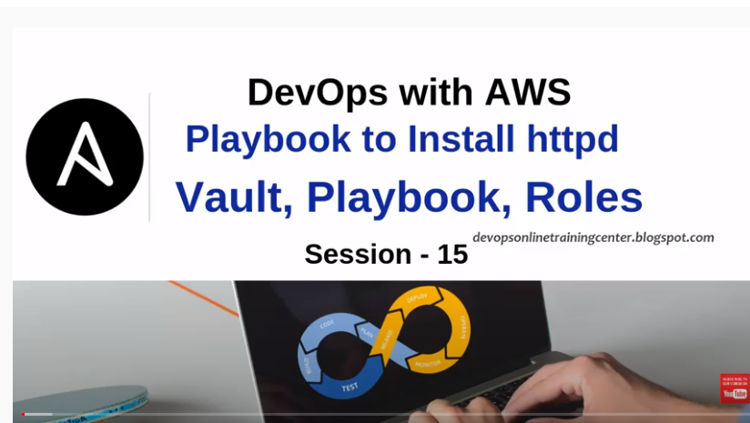

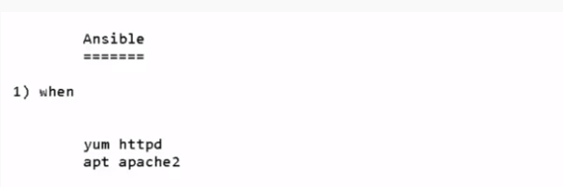

Yum httpd: For linux machine

Apt apache2: It is for Ubuntu/Debian machine

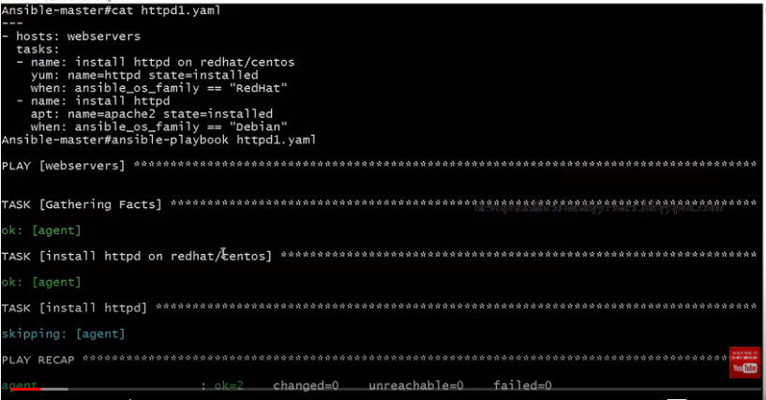

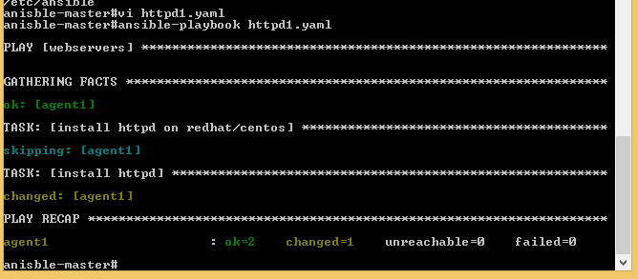

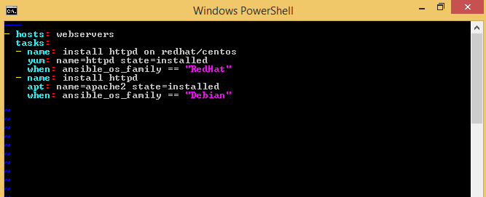

**Reusability:** Calling 1 playbook from inside playbook.

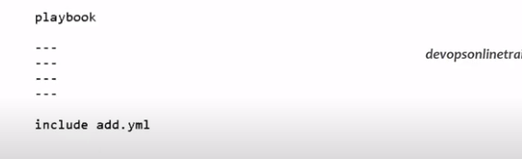

This will create file in agent/slave machine.

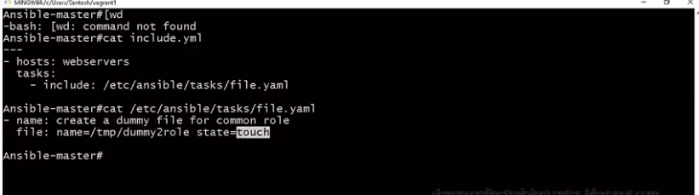

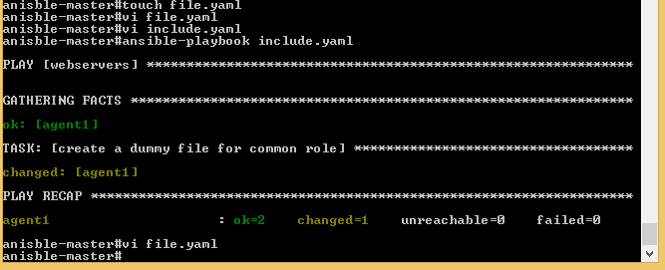

To create directory use below command:

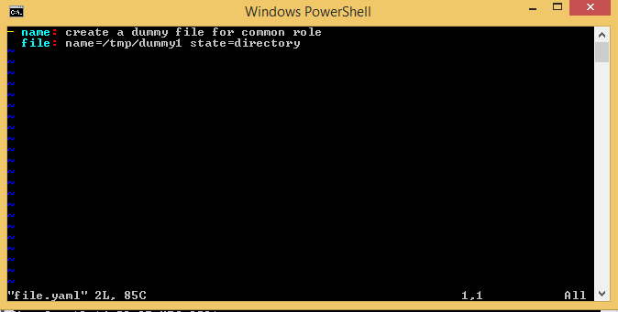

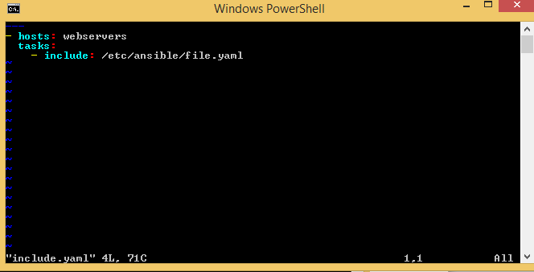

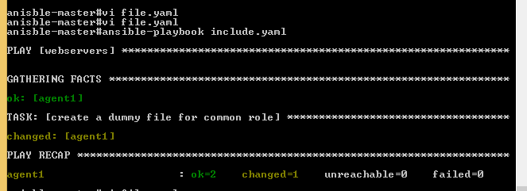

To list the directory in tmp floder:



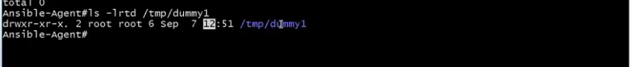

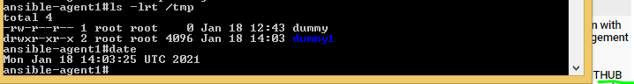

**Facts: It contains all the information about the agent machine:**

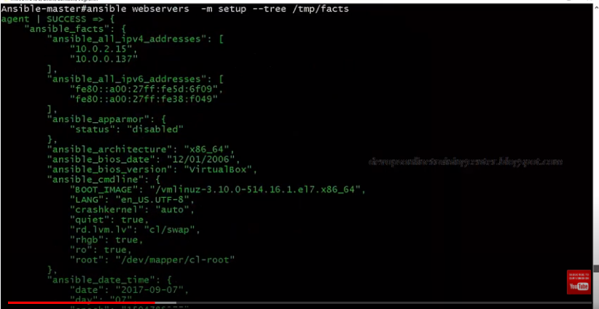



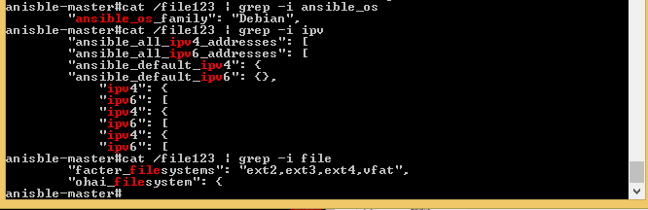

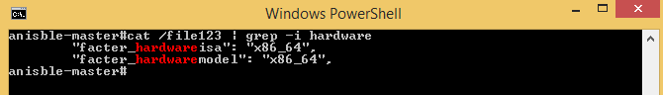

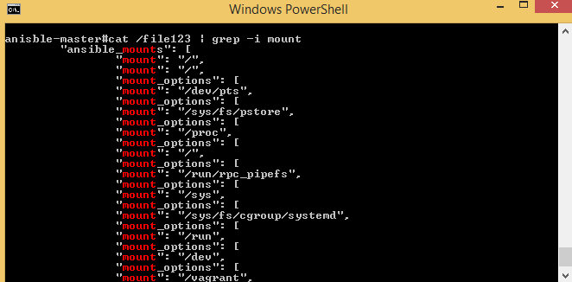

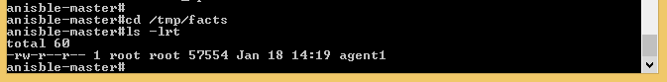

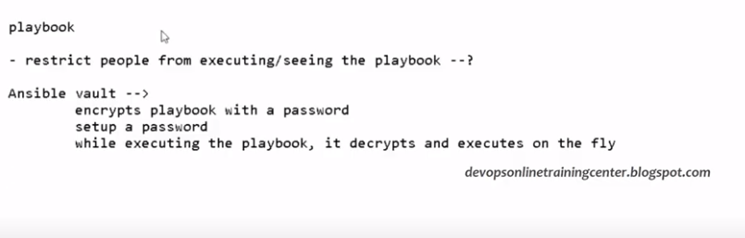

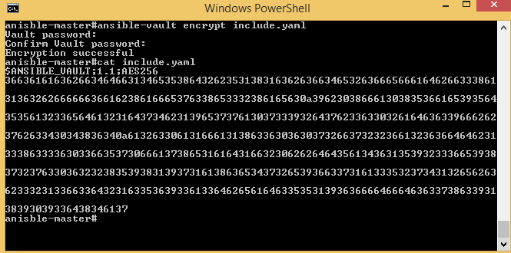

Ansible execute it in encrypt format, need below command:

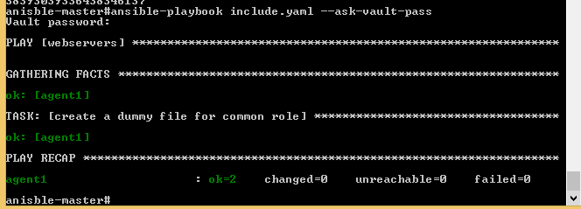

**How to decrypt the encrypt file:**

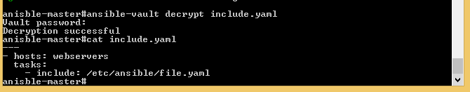

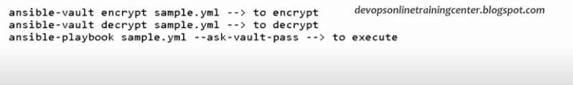

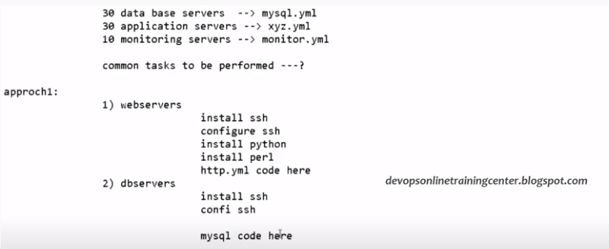

Second approach 2: It is better in compare to approach 1 because we are using reusability.

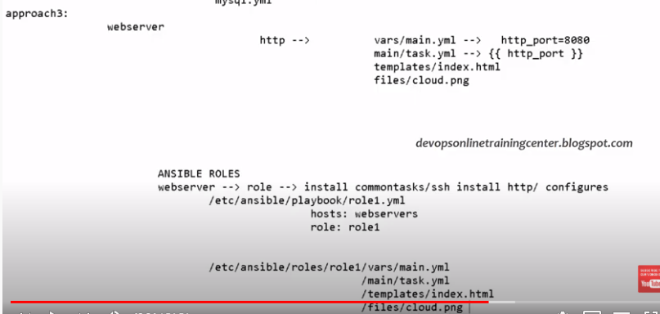

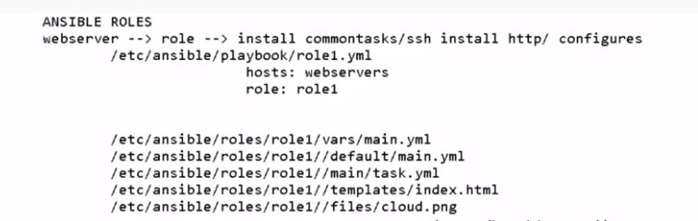

<https://www.youtube.com/watch?v=-h-7IdesQvs&list=PL5nViEmyYI0bmfcM_s4P-dfzKrOpcFWWK&index=17>

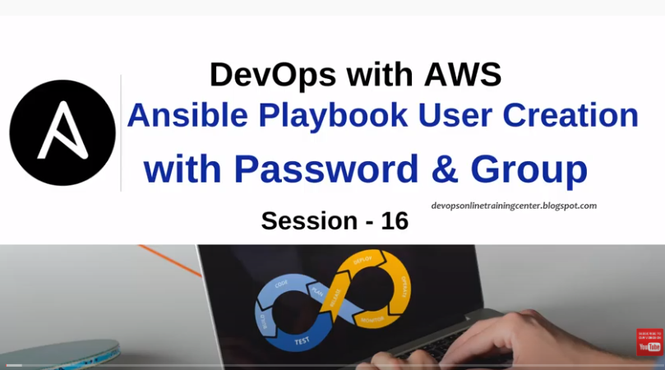

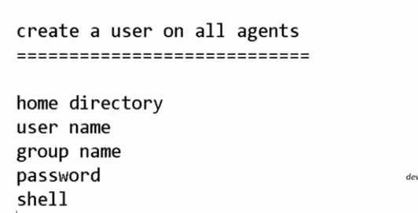

<https://docs.ansible.com/ansible/2.5/modules/user_module.html>

We can encrypt the password by openssl passwd command:

And use that encrypted password in user.yaml file

zkaE/AcD6nNzY

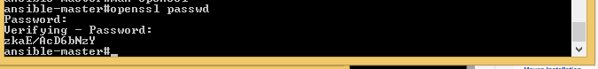

To see all the users which are created in agent/slave machine:



To see the list of groups, make sure the group is already created and use group name in yaml file which was already created.

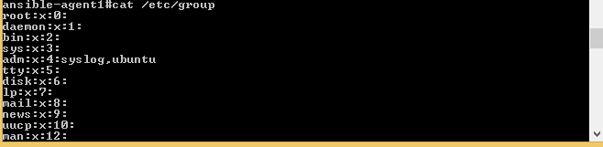

If groups are not created, we can create the groups:



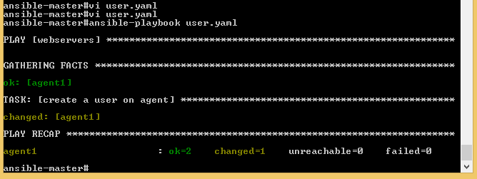

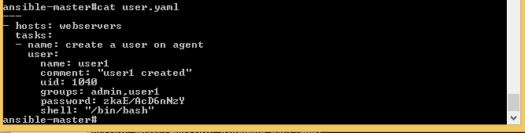

To check whether user1 is created on agent1 machine or not.





<https://www.theurbanpenguin.com/managing-users-in-ansible/>

To see the user1 is created in multiple groups:



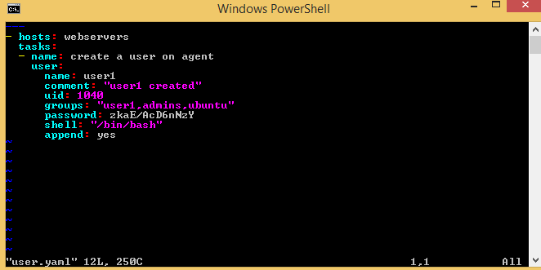

To check whether home directory is created for user or not, in agent/slave machine

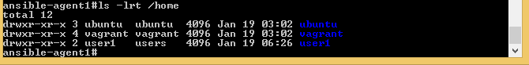

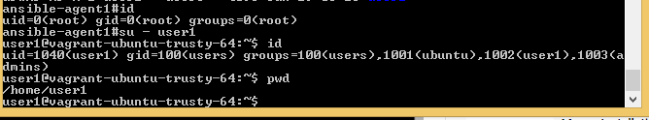

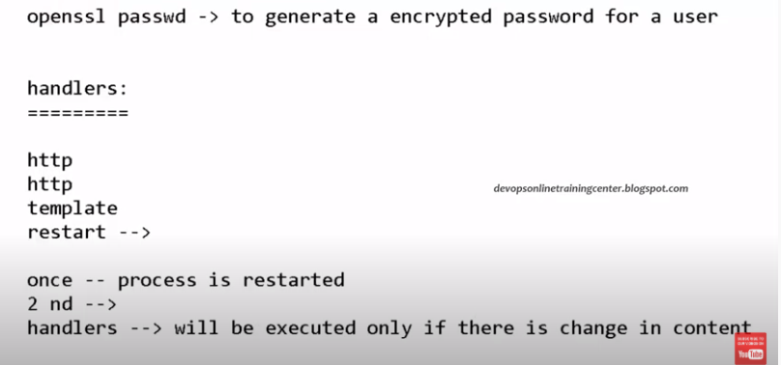

**Idempotent:**

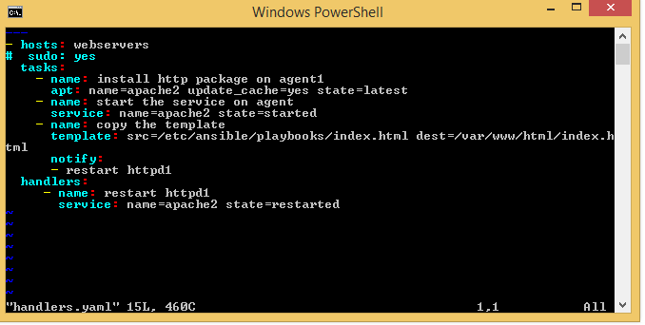

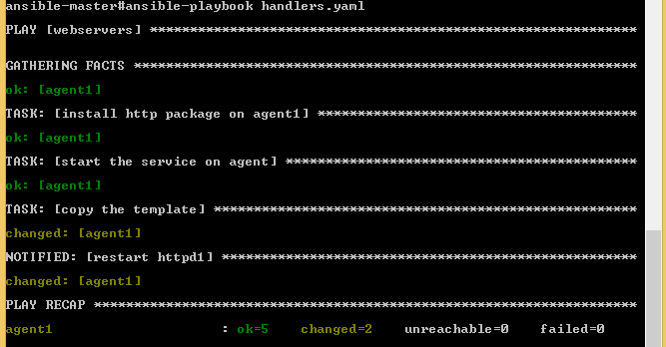

Now check on the Agent machine, after changing into the index.html, the new changes reflected or not on web browser.

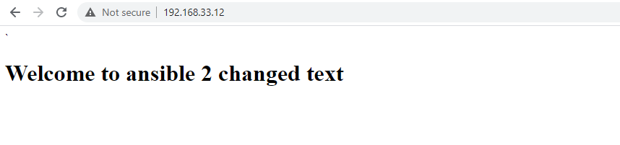

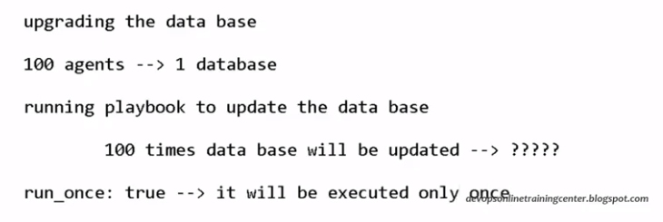

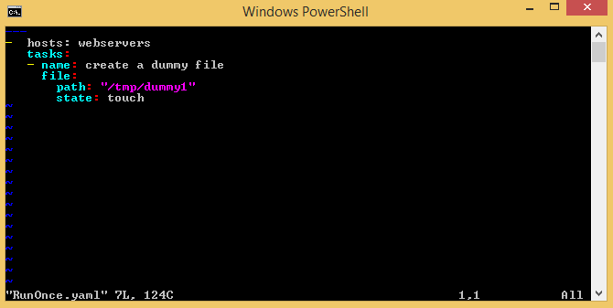

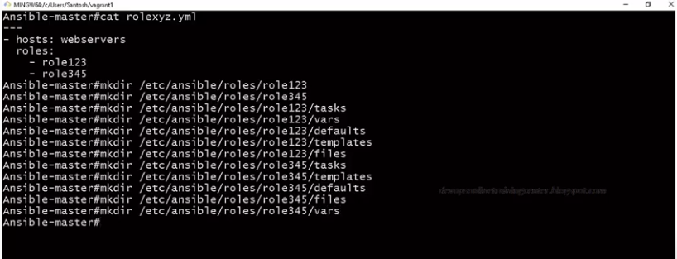

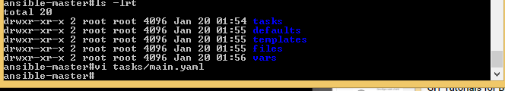

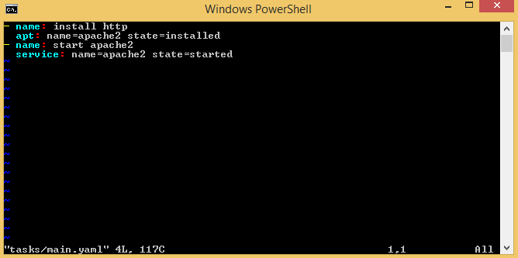



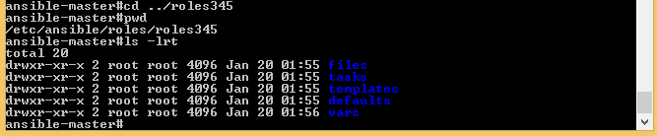

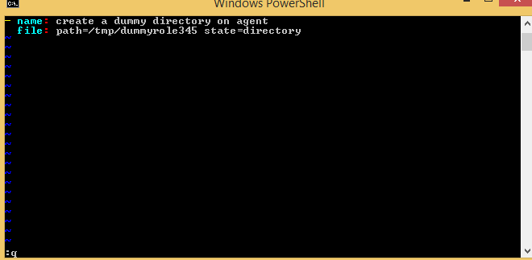

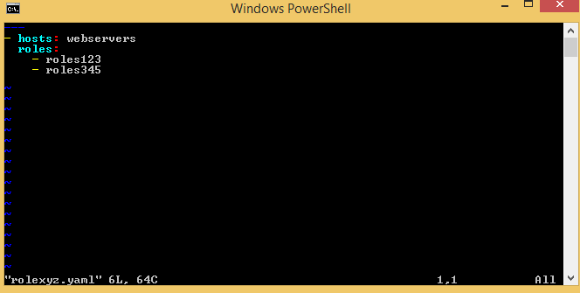

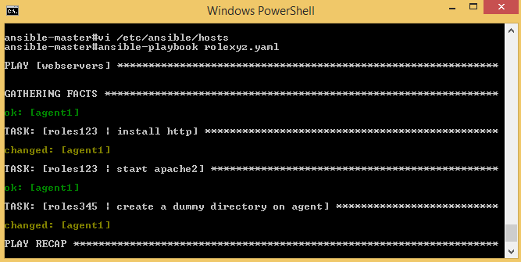

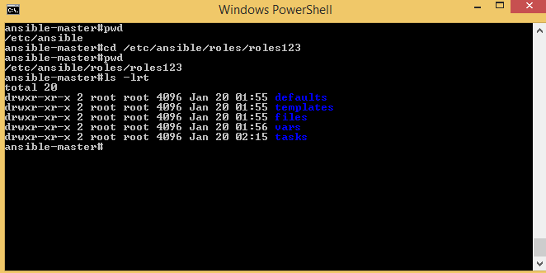

Create Index.html into templates floder:

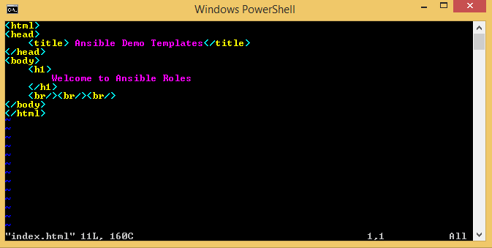

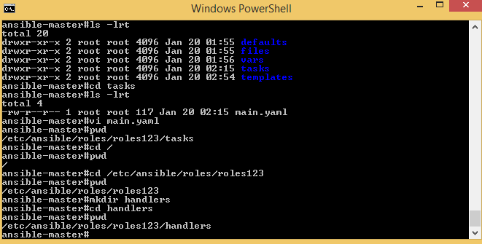

Etc/ansible/Roles/roles123/Tasks/main.yaml

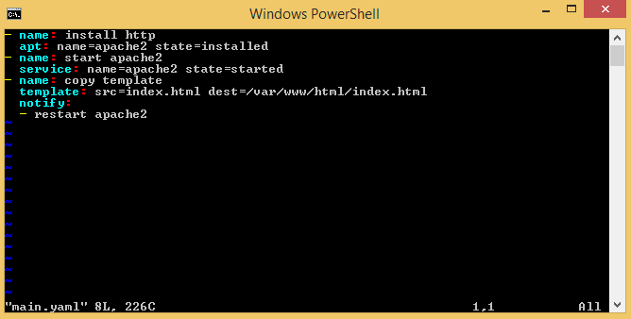

Etc/ansible/role/roles123/handlers/Handlers.yaml:

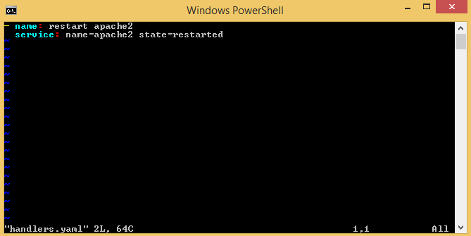

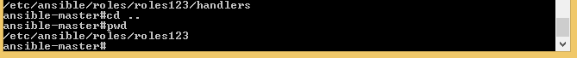

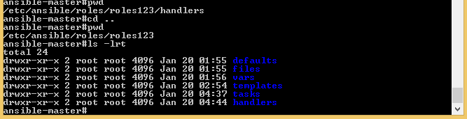

Go to templates floder and change the parameters:

================Roles=====================================



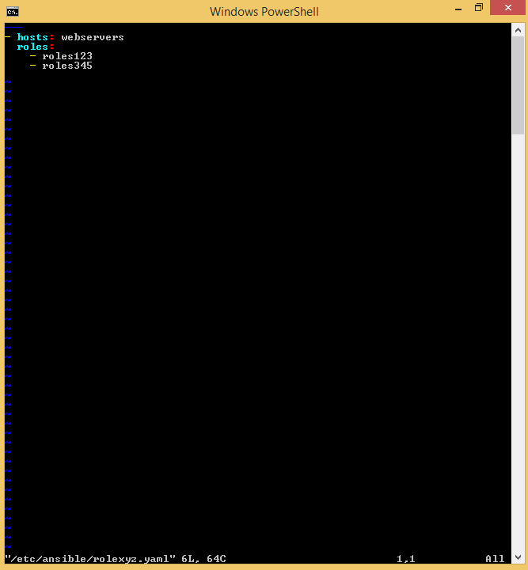

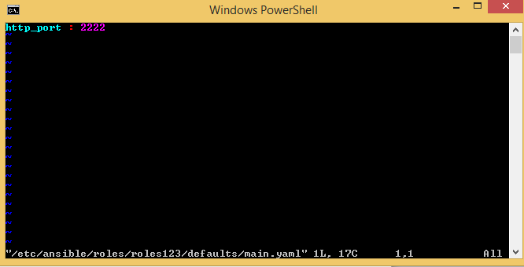

To make sure Handlers should work, change some value in INDEX.HTML file:

Below is out put after change:

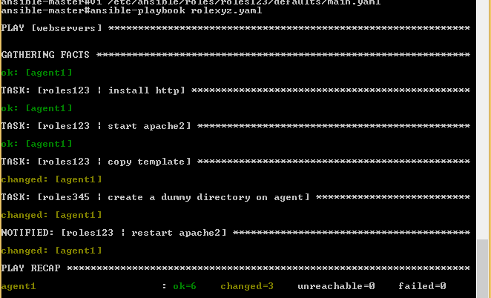

Passing parameters http_port in index.html file and passing parameters value in http_port:1111

In default floder main.yaml file.

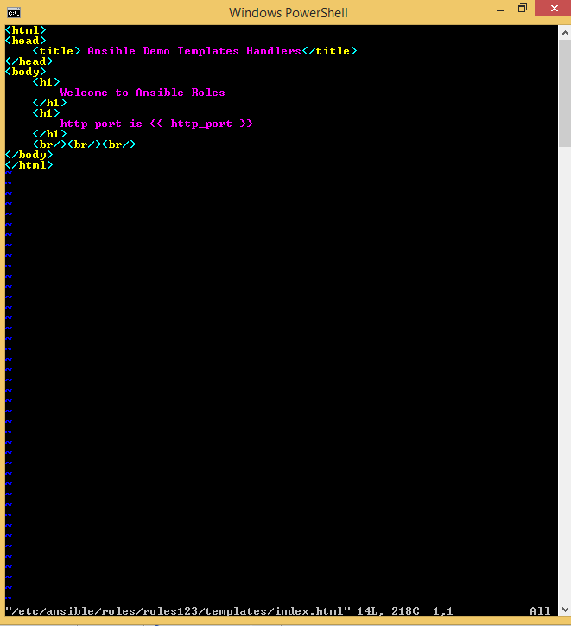

Tasks/main.yaml file:

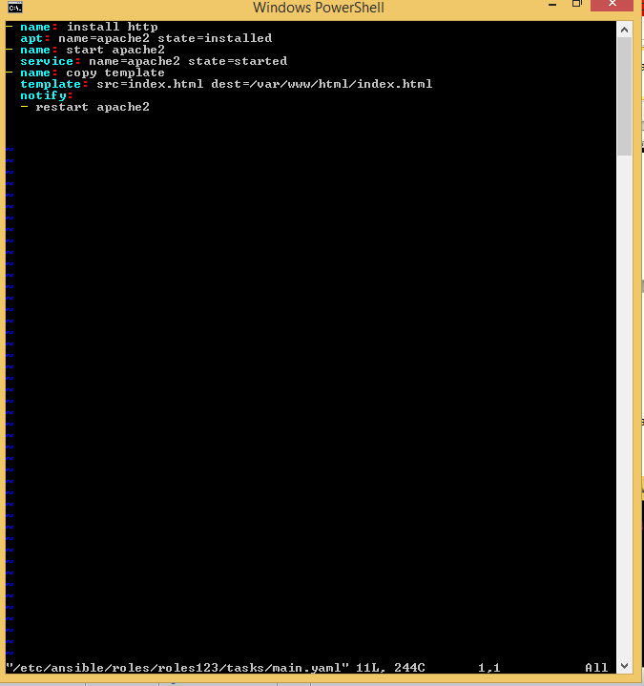

Handler file should be in different handlers directory as main.yaml

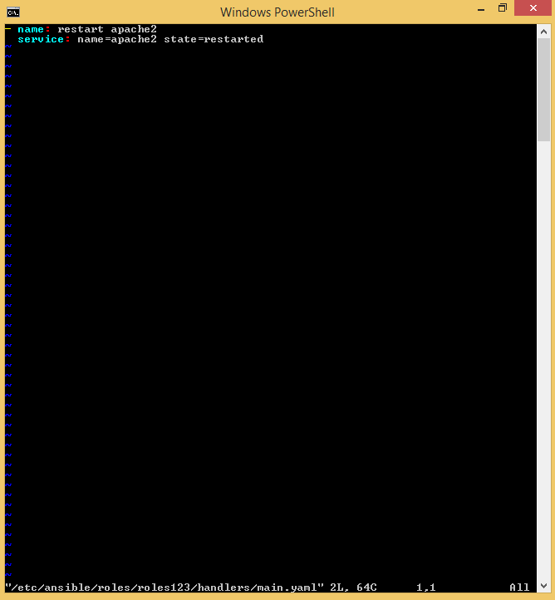

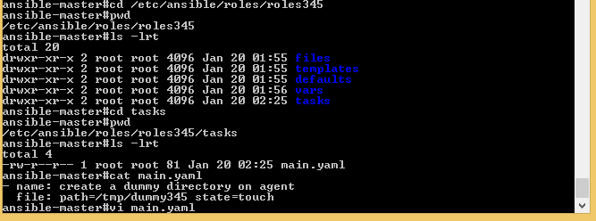

Below mail file is created in roles345/tasks/main.yaml floder. It is to create directory on agent/slave machine.

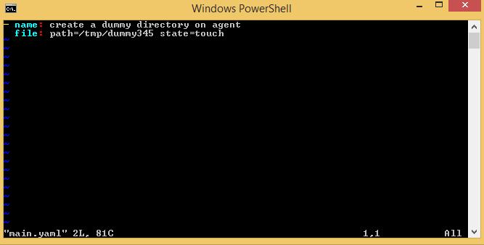

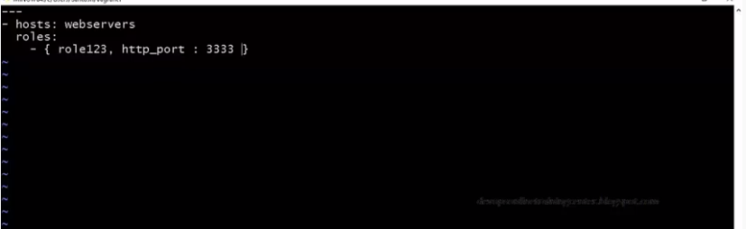

If parameter (http_port )value is define in 3 places: vars/main.yaml or defaults/main.yaml or rolexyz.yaml, then precedence will provide to rolexyz.yaml playbook file over others.

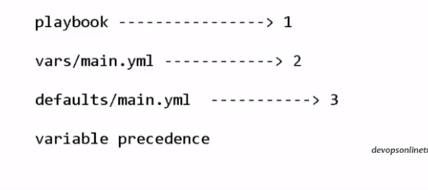

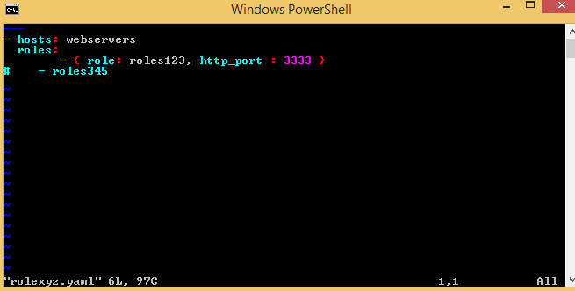

For displaying ansible_os_family, make changes in index.html file

Like that we can display any values from Facts like-hardware,OS,RAM etc.

