<https://www.youtube.com/watch?v=b17dt2p7t0s&list=PL5nViEmyYI0bmfcM_s4P-dfzKrOpcFWWK&index=18>

https://www.youtube.com/watch?v=fm91DI42684&list=PL5nViEmyYI0bmfcM_s4P-dfzKrOpcFWWK&index=19

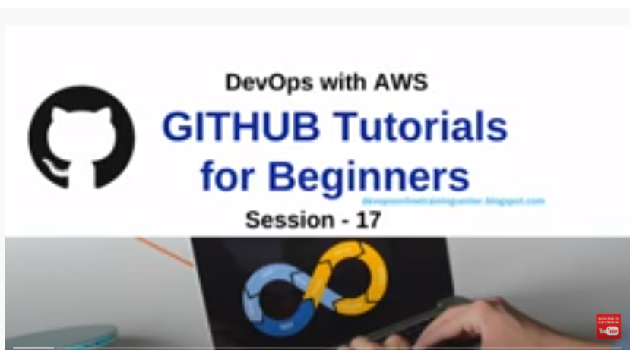

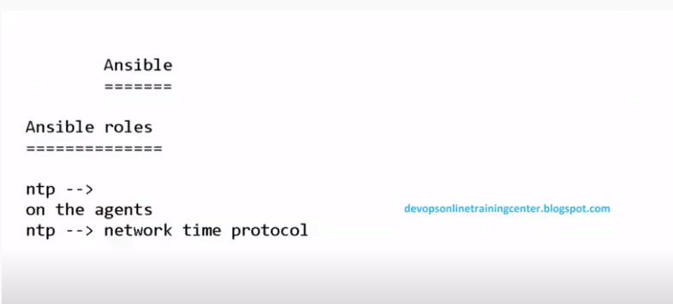

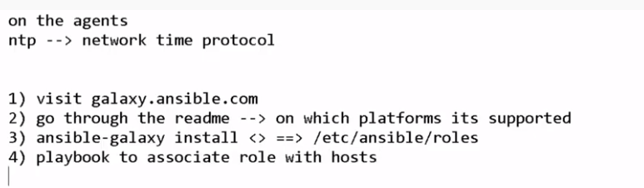

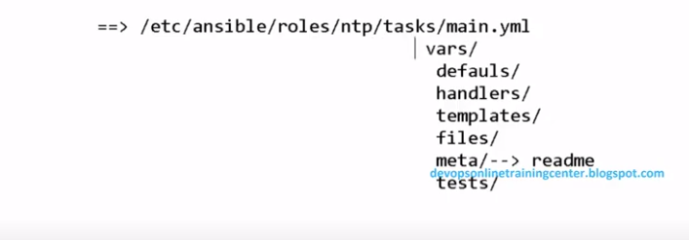

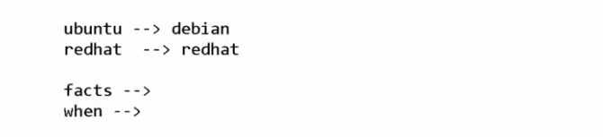

## [Installing Ansible on Debian](https://docs.ansible.com/ansible/latest/installation_guide/intro_installation.html#id16)-latest version install steps on Ubuntu:

Debian users may leverage the same source as the Ubuntu PPA.

Add the following line to /etc/apt/sources.list:

deb http://ppa.launchpad.net/ansible/ansible/ubuntu trusty main

Then run these commands:

$ sudo apt-key adv --keyserver keyserver.ubuntu.com --recv-keys 93C4A3FD7BB9C367

$ sudo apt update

$ sudo apt install ansible

## Uninstall ansible

To remove just ansible package itself from Ubuntu 16.04 (Xenial Xerus) execute on terminal:

sudo apt-get remove ansible

## Uninstall ansible and it's dependent packages

To remove the ansible package and any other dependant package which are no longer needed from Ubuntu Xenial.

sudo apt-get autoremove ansible

TO download the roles from ansible-galaxy and install ntp package on agent

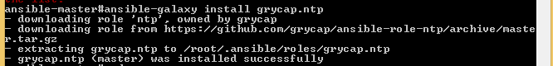

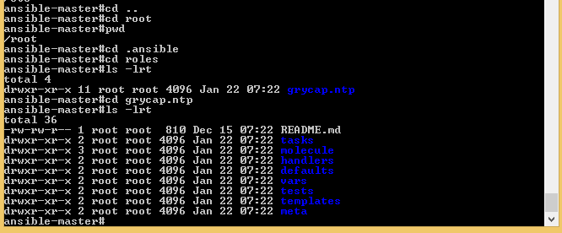

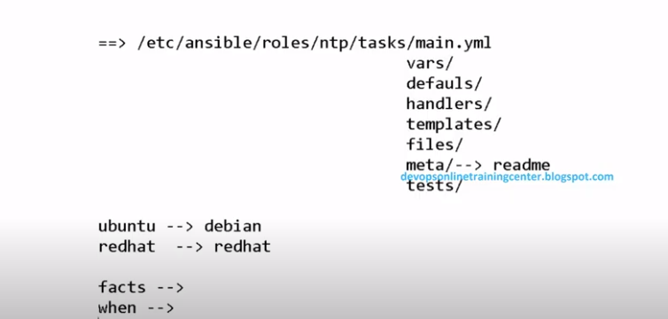

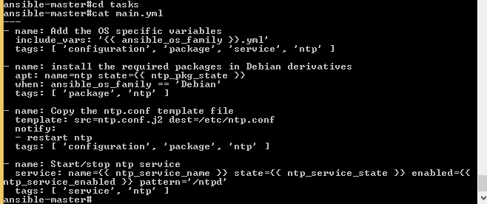

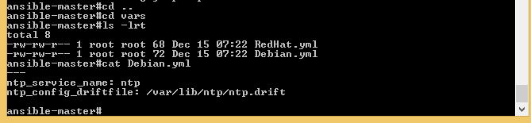

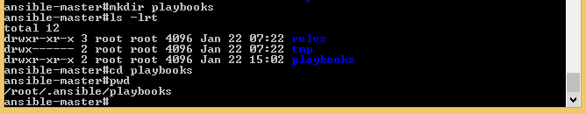

If you want see what are the softwares installing parallel pon agent/slave,we can use below command:

Ps –ef | grep apt

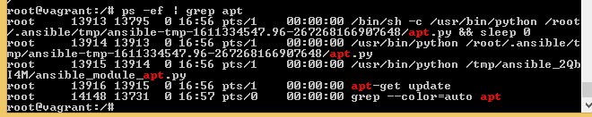

If we want to see the status of ntp service on agent machine, use the below command:

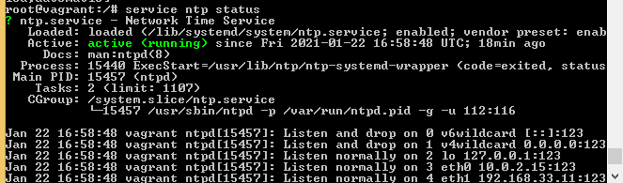

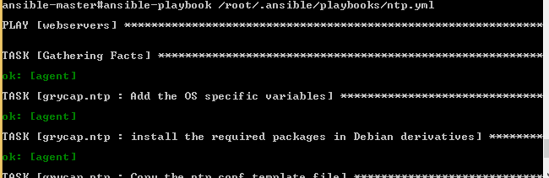

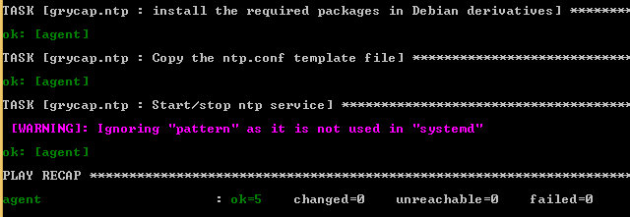

Playbook ntp.yml @root/.ansible/playbooks/ntp.yml

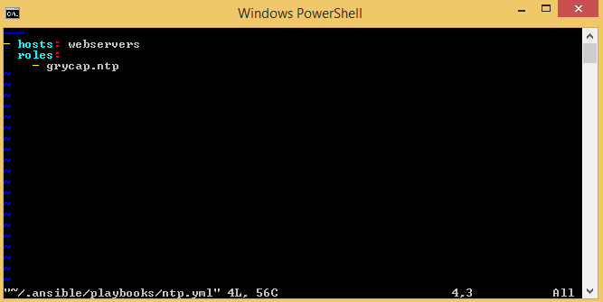

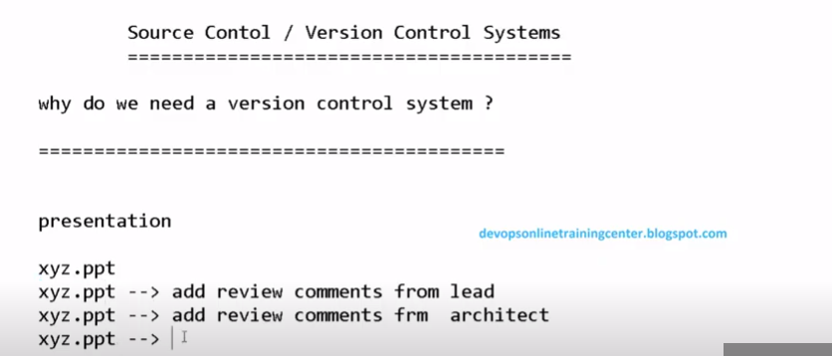

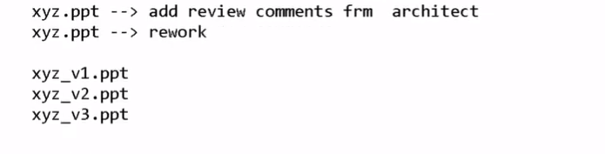

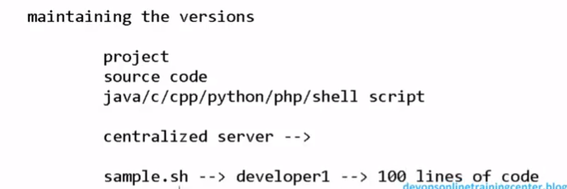

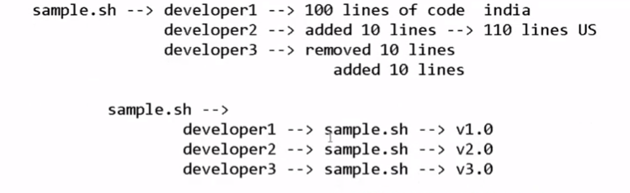

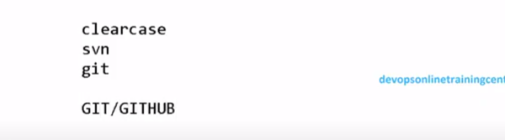

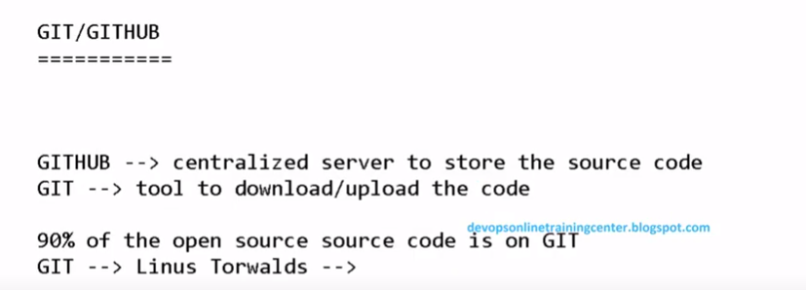

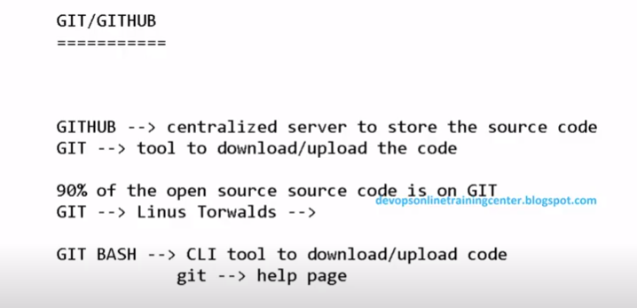

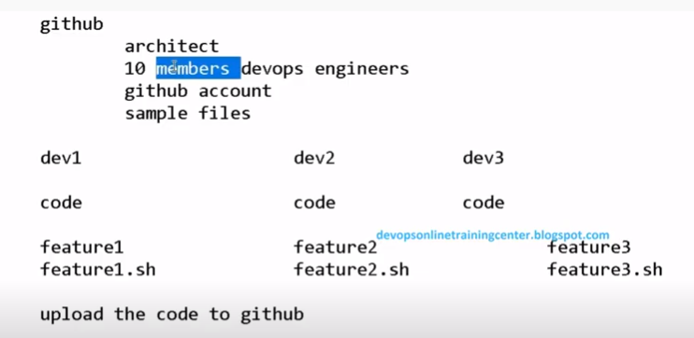

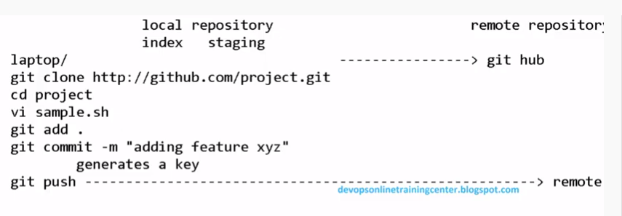

Login into the GITHUB and create respository:

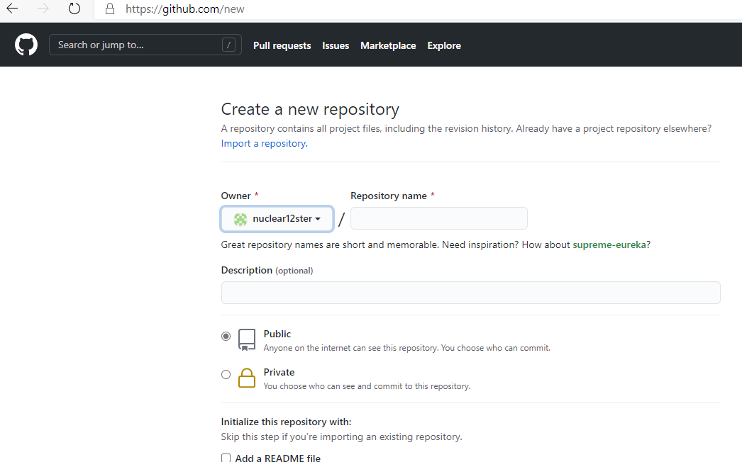

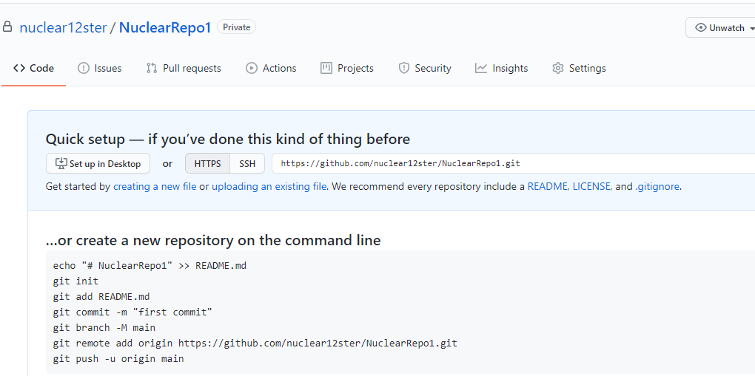

HTTPS link:

<https://github.com/nuclear12ster/NuclearRepo1.git>

ssh Link:

[git@github.com:nuclear12ster/NuclearRepo1.git](mailto:git@github.com:nuclear12ster/NuclearRepo1.git)

Click on Readme link under Code section. Type something and commnit the file.

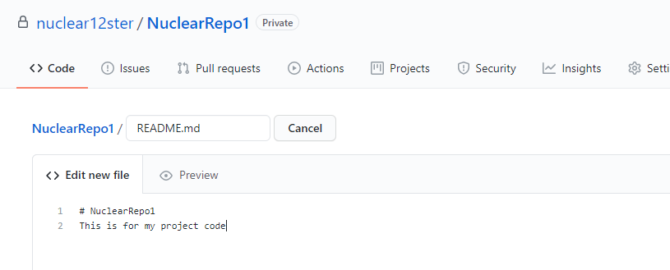

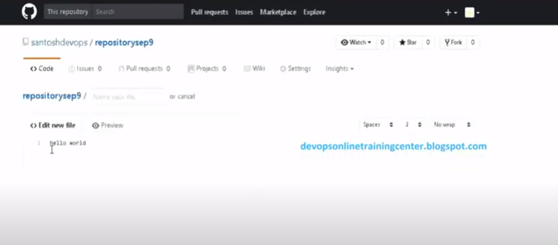

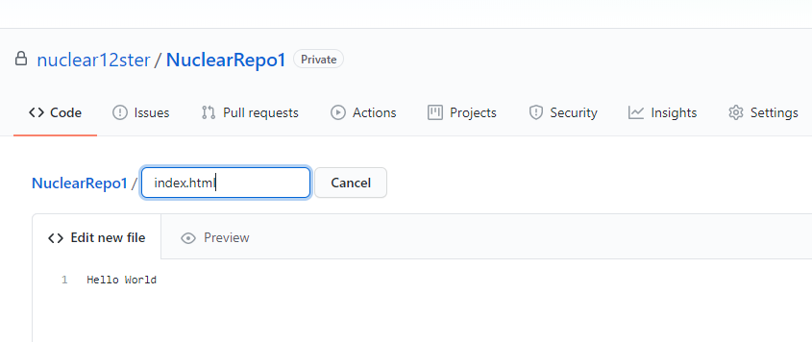

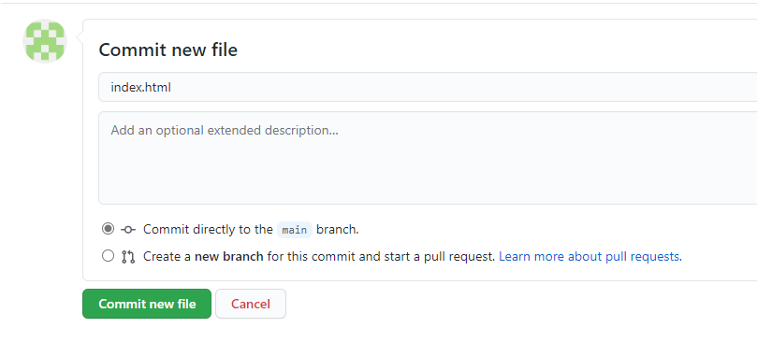

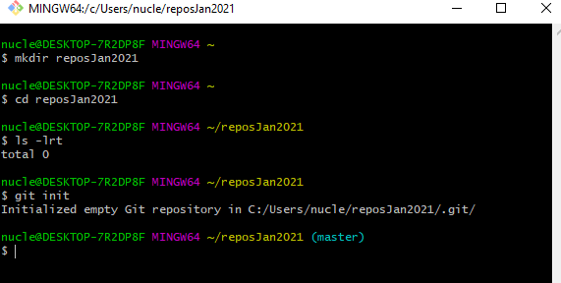

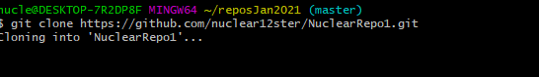

Create branch in repository:

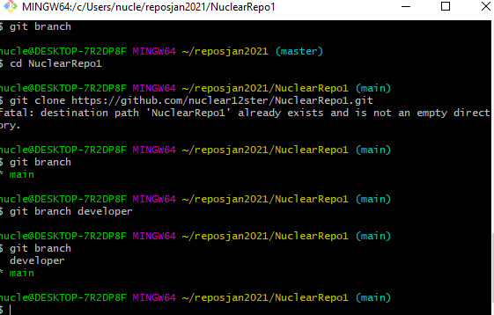

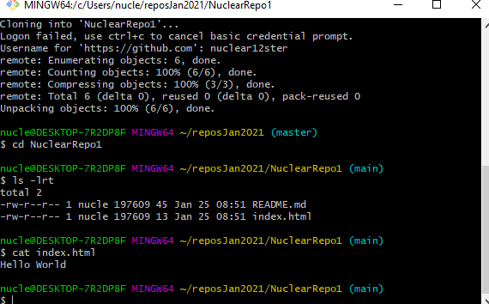

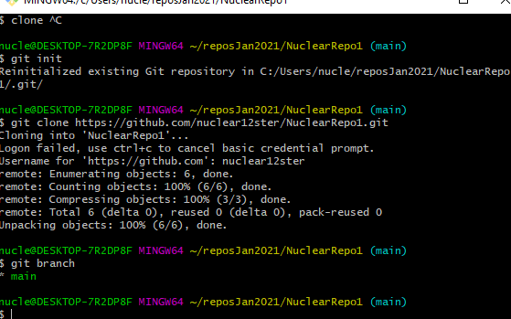

This change is for local machine, not for github server.

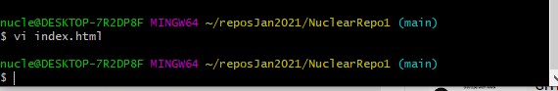

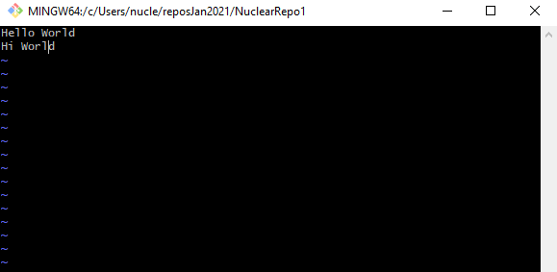

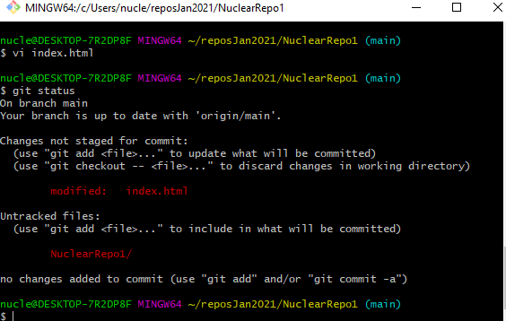

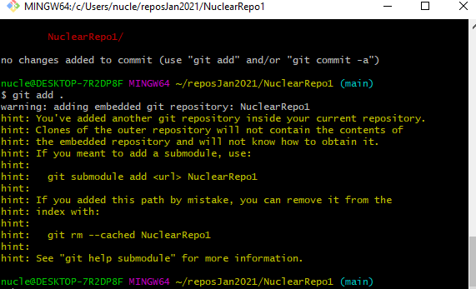

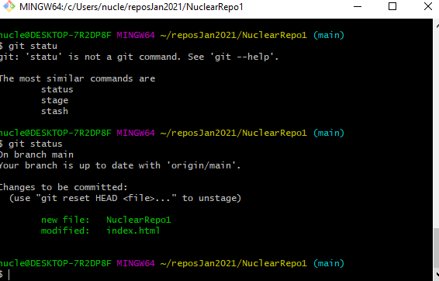

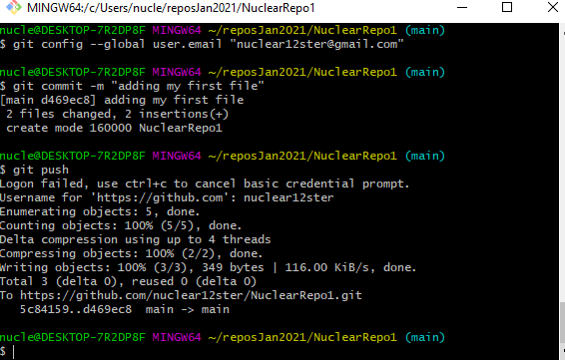

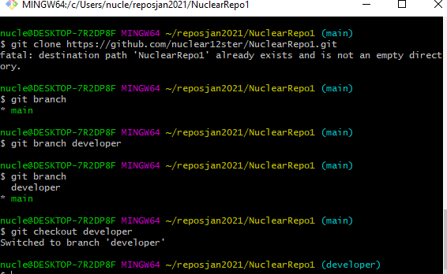

Now we are on branch node:

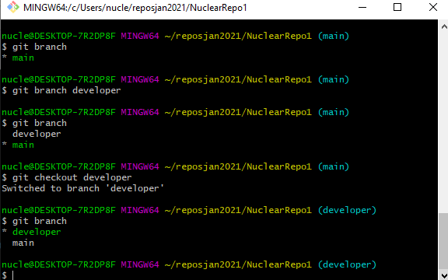

Files in Master are copied into branch mode:

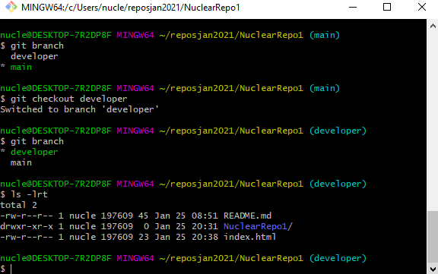

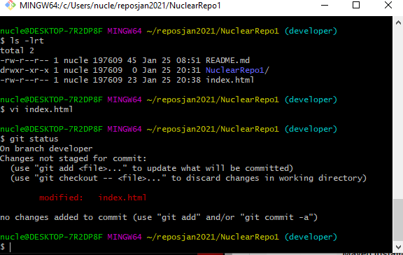

We can push all files,code from local developer branch to remote server branch

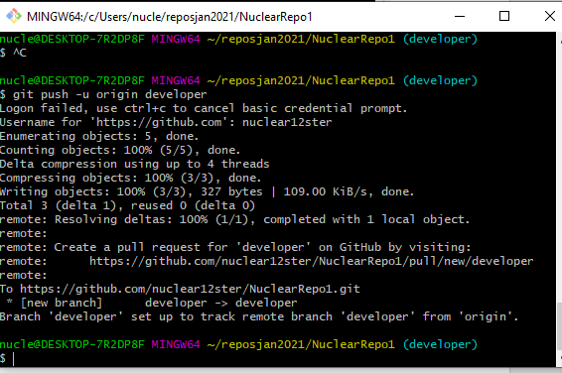

To merge into the master branch:

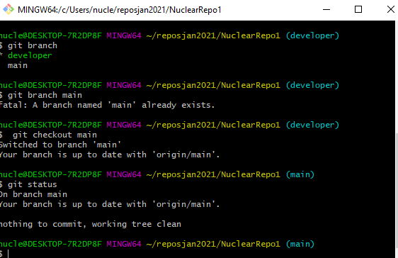

To push the changes into the master-index.html file.

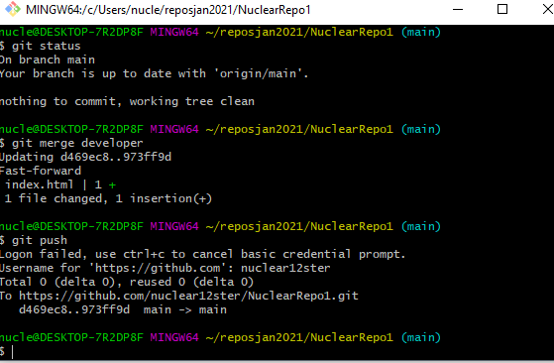

To delete the branch:

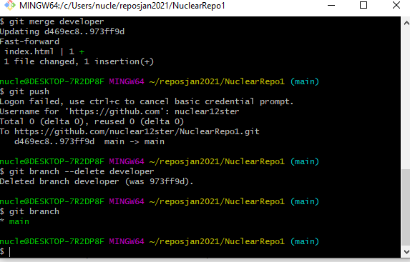

[GITHub Tutorials | Maven Installation Tutorials | Push and Pull Tutorial - YouTube](https://www.youtube.com/watch?v=fm91DI42684&list=PL5nViEmyYI0bmfcM_s4P-dfzKrOpcFWWK&index=19)

[GITHub Tutorials | Maven Installation Tutorials | Push and Pull Tutorial - YouTube](https://www.youtube.com/watch?v=fm91DI42684&list=PL5nViEmyYI0bmfcM_s4P-dfzKrOpcFWWK&index=19)

https://www.youtube.com/watch?v=fm91DI42684&list=PL5nViEmyYI0bmfcM_s4P-dfzKrOpcFWWK&index=19

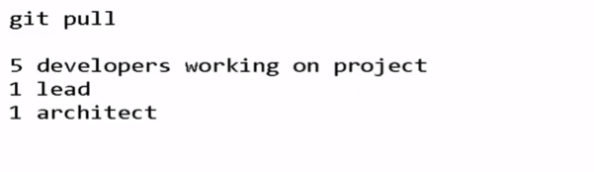

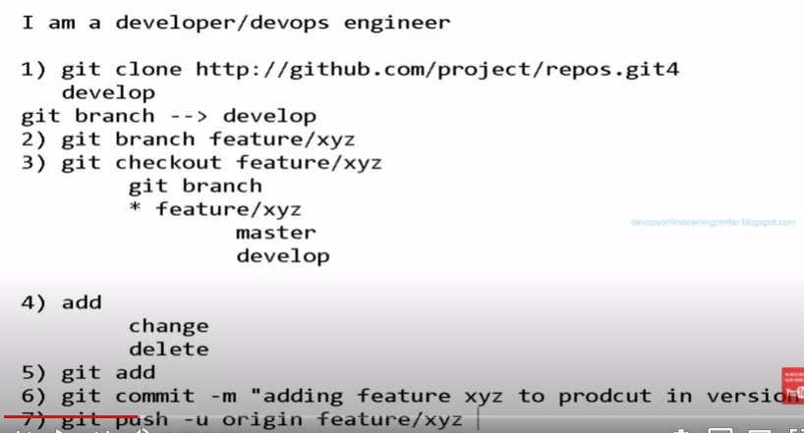

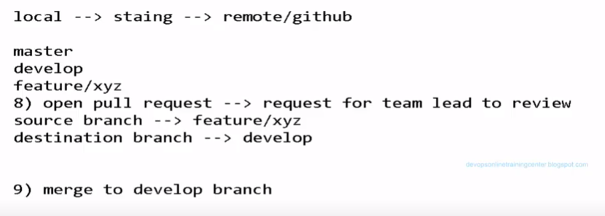

On Point 4: add . (ADD DOT) will add all the files of current directory and all files are push in the master

If you want to add only 1 file, then specified the filename which you want to push and commit.

**Git Add filename.**

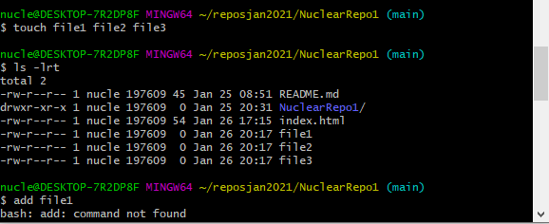

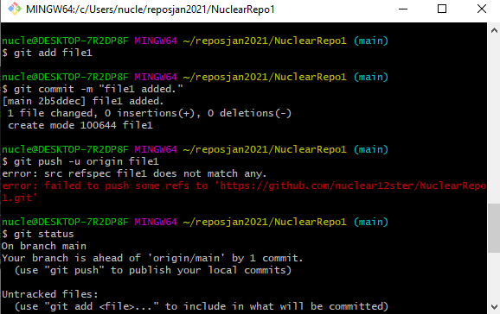

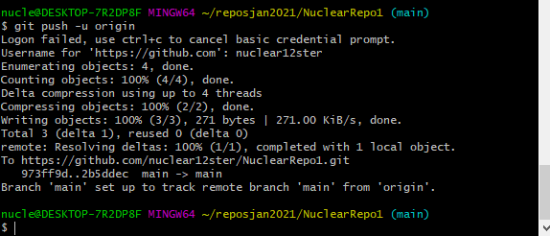

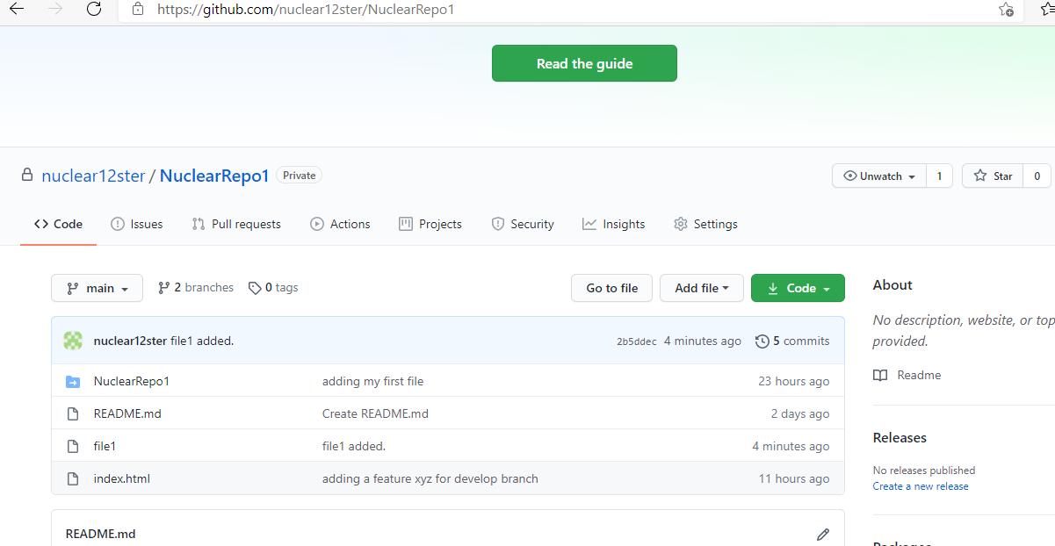

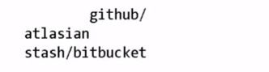

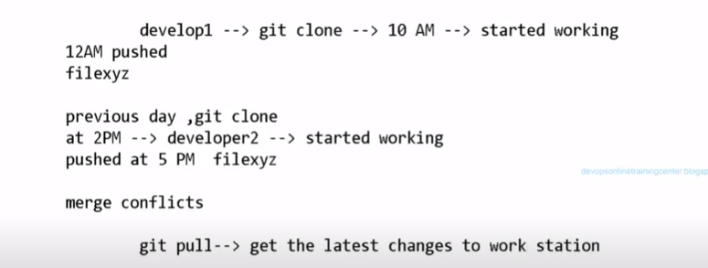

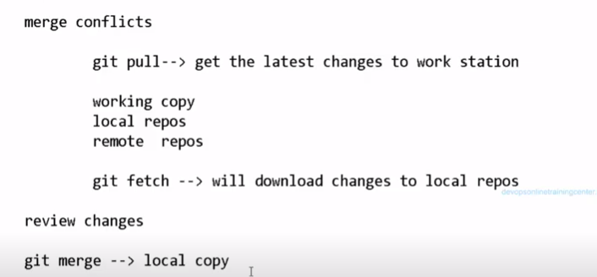

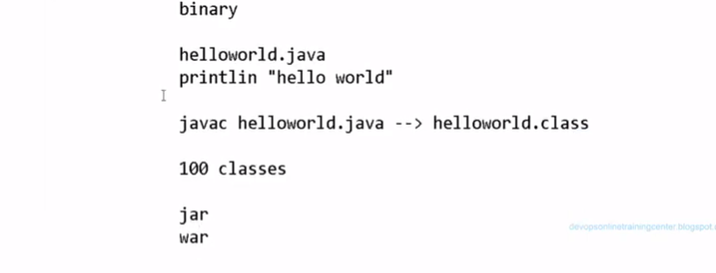

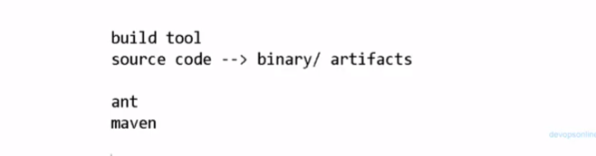

**Converting source files into jar file, we will do it by 2 tools:**

1. **Apache ANT --- Old now—build.xml**
2. **Apache Maven—POM.xml—Project Object Module**

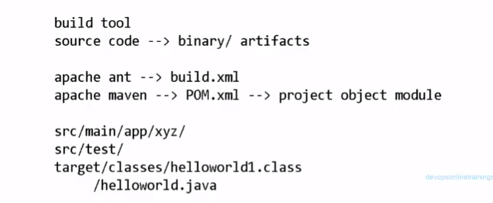

**Install maven:**

**Apt install –y maven**



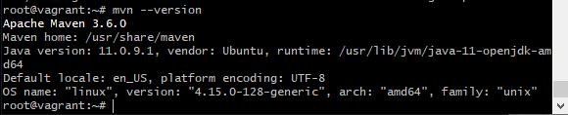

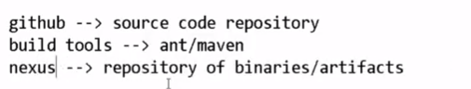

[Maven Installation Tutorials | Generate, Process, Validate, Compile, Test - YouTube](https://www.youtube.com/watch?v=nD0yyads-oo&list=PL5nViEmyYI0bmfcM_s4P-dfzKrOpcFWWK&index=20)

[**https://www.youtube.com/watch?v=nD0yyads-oo&list=PL5nViEmyYI0bmfcM_s4P-dfzKrOpcFWWK&index=20**](https://www.youtube.com/watch?v=nD0yyads-oo&list=PL5nViEmyYI0bmfcM_s4P-dfzKrOpcFWWK&index=20)

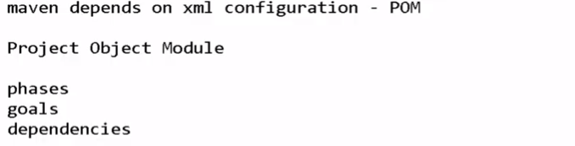

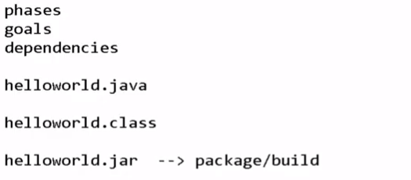

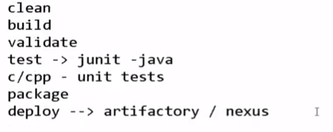

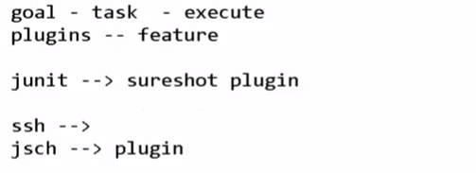

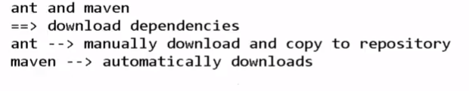

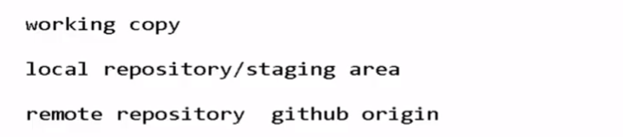

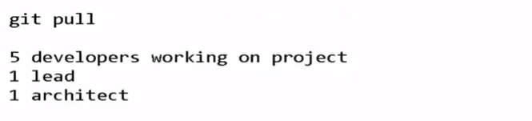

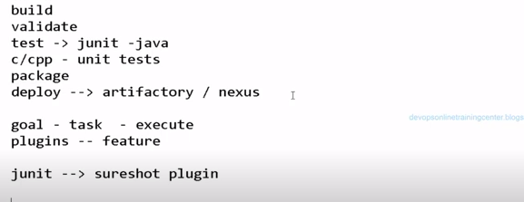

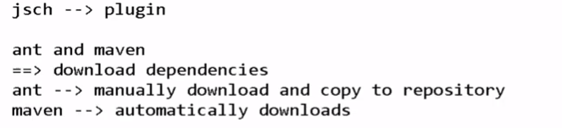

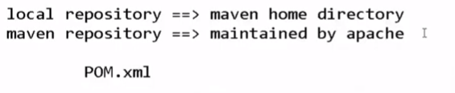

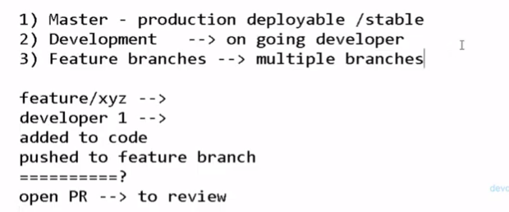

[Maven Archetype Plugin – Usage (apache.org)](https://maven.apache.org/archetype/maven-archetype-plugin/usage.html)

[**https://maven.apache.org/archetype/maven-archetype-plugin/usage.html**](https://maven.apache.org/archetype/maven-archetype-plugin/usage.html)

1. $ mvn archetype:generate

In the following example, we selected the quickstart archetype (default value, which is 15 here but may vary depending on the repository content) and set groupId to com.company, artifactId to project, version to 1.0 and package to com.company.project.

