AI vs. Human Task Delineation (Initial Results Phase) In accordance with ARIA's requirement for clear and unambiguous acknowledgment of human assistance within the AI-driven scientific workflow, the following delineates the specific roles performed by domain experts versus autonomous AI agents during the foundational Initial Results phase:
Domain Expert Action (Exploratory Data Curation & Goal Setting): Human operators manually pipetted and executed a preliminary set of PURE reactions. This initial dataset was originally collected simply to see if baseline data could be successfully gathered in the newly commissioned b.next laboratory. Because it was collected for basic hardware validation rather than algorithmic training, this data was structurally distinct and noisier than automated optimization rounds (such as Round 0). Following this curation, human domain experts explicitly defined the bounds and the target optimization goals for the algorithm.
AI Action (Modeling & Autonomous Hypothesis Generation): The IGOR platform's Bayesian optimization engine ingested this noisy, human-pipetted historical dataset and autonomously trained a baseline surrogate model. The AI successfully navigated the sparse observational data to generate the first batch of Generated Experimental Suggestions (GESs). Crucially, IGOR also output a comprehensive set of formal mechanistic hypotheses. The system autonomously deduced the underlying biochemical interactions to logically justify exactly which specific regions of the parameter space should be explored next and why.
Domain Expert Action (Review & Strategic Alignment): Human subject matter experts reviewed the AI-generated mechanistic hypotheses. In a pivotal validation of the platform's cognitive utility, the human researchers recognized that IGOR had independently arrived at similar conclusions and proposed the experimental next steps that the human team had already planned to execute for those same reasons. This striking independent validation of the AI's biophysical intuition served as the definitive proof of concept, formally catalyzing the joint research collaboration between Find What Matters and b.next.

1 Initial Results
1.1 Core Objective: Determining Overall Feasibility The primary objective of this feasibility phase is to establish the fundamental viability of the data pipeline and the systemic integration between the Find What Matters (i.e., FWM) algorithmic infrastructure and the b.next laboratory, see Figure 1. Specifically, this phase evaluates 1) the boundary conditions under which experimentally-generated data can be successfully ingested into the Iterative Guide and Orchestrated Research (i.e., IGOR) platform, wherein successful ingestion is strictly defined as the execution of proper deterministic data transformations (i.e., transformations that correspond to the extraction of the most informationally rich feature embeddings) mapped directly from the b.next Cell Developer Kit (i.e., CDK) into the IGOR workspace frontend user interface (i.e., UI). Furthermore, it should be explicitly noted that the feasibility data set (i.e., the bb_260304 data set) was collected exclusively to validate baseline hardware execution and the physical collection of relative fluorescence data within the novel b.next laboratory environment; a priori, it was never intended to serve as a high-fidelity empirical foundation for parametric surrogate modeling (i.e., the observational data intrinsically suffers from a remarkably low signal-to-noise ratio). Nevertheless, given that this sparse corpus constituted the absolute entirety of the available historical database at the time of project initiation, it was pragmatically leveraged to empirically assess the lower bounds of model utility (i.e., to determine the mathematical extent to which the Bayesian optimization engine could successfully extract latent causal relationships despite severe observational constraints and violations of ideal data scientific prerequisites; Tan et al., 2018; Shahriari et al., 2016).
To rigorously establish the mathematical boundary conditions of this feasibility assessment, the exact dimensional parameterization of the bb_260304 dataset must be explicitly formalized. The empirical design matrix encompasses exactly 96 independent in vitro experimental observations (i.e., a sample size of one well plate, $N = 96$). The underlying input feature space is a four-dimensional vector of control attributes, comprising three continuous concentration variables (i.e., ambient magnesium [Mg++] bounded between 4.0 and 26.0 mM; standard T7 RNA polymerase [T7RNAP] bounded between 2.5 and 15.0 ng/μL; and the core translation machinery [ribosome] bounded between 0.9 and 2.16 μM) alongside a single discrete binary variable (i.e., [dT7RNAP], strictly parameterized as 0 or 1 to denote the explicit omission or inclusion of supplementary DNA-dependent RNA polymerase). The measurement, fluorescence units [RFU], is a singular continuous predictive output target. Given the expansive geometric hypervolume mathematically inherent to this specific four-dimensional search space, a sampling density of merely 96 non-replicated physical coordinates renders the data set structurally sparse.
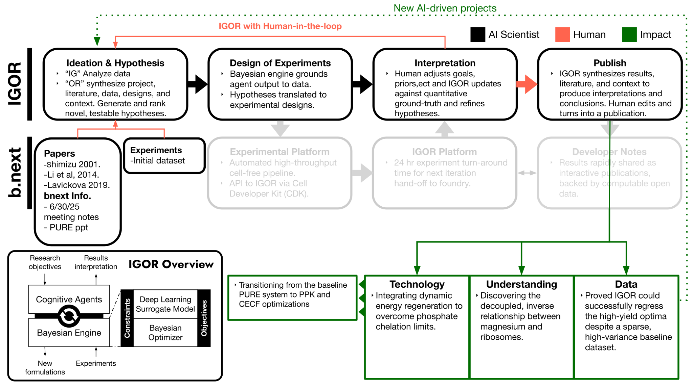
Figure 1: Schematic of the IGOR platform with the b.next workflow for the feasibility dataset. Operational agency is delineated via a color-coding schema: autonomous algorithmic processes (i.e., AI Scientist; black), supervisory domain-expert interventions (i.e., Human; red), and downstream scientific utility (i.e., Impact; green). The algorithmic core (i.e., IGOR Overview) couples a multi-agent co-scientist with a quantitative Bayesian Engine. The cycle initializes by ingesting multimodal inputs (e.g., foundational literature, historical empirical observations) into the Ideation & Hypothesis node to autonomously generate candidate formulations and hypotheses. During Design of Experiments, the Bayesian engine grounds these hypotheses, updating them. Domain experts can then modulate target optimization objectives and structural priors (i.e., Interpretation), enabling sequential Bayesian posterior updates (i.e., the IGOR with Human-in-the-loop). The platform then synthesizes the results into proposed deterministic mechanistic interpretations, formalized and output in a peer-reviewed manuscript format (i.e., Publish) which is then turned into a bnext Developer Note.
1.2 Assessing IGOR's Utility on Noisy Data Following the establishment of data ingestion feasibility, the subsequent objective is to robustly evaluate whether the deployment of the Iterative Guide (i.e., the "IG" module of the IGOR platform, which encapsulates the Bayesian optimization routine) is operationally advantageous when operating on such inherently noisy empirical observations (Brochu et al., 2010). Crucially, the operational utility of the predictive model (i.e., the trained surrogate model) at this stage is not strictly predicated upon achieving high global predictive accuracy (i.e., a high-fidelity surrogate model is not a strict prerequisite). Rather, success is defined functionally by the capacity of the underlying model to regress sufficient latent signal from the bb_260304 data set to infer novel input formulations that advance toward the target optimization objectives (Jones et al., 1998). For example, successfully estimating the correct mathematical sign of the estimated partial derivatives (i.e., the Jacobian matrix) within the localized vicinity of a high-utility sub-volume of the input feature space may be sufficient. Essentially, a low-resolution surrogate model remains highly valuable provided it accurately bounds the directional trajectory to establish the appropriate hypervolume for a subsequent, low-resolution empirical study. This evaluation inherently yields a strategic bifurcation regarding the initialization of the sequential model-based optimization loop for the initial, noisy data set:
- Path A (Demonstrated autonomous utility) In situations in which the data-science-driven approach demonstrates sufficient statistical resilience against observational noise (i.e., the surrogate model successfully extracts enough directional signal to mathematically rationalize subsequent hypotheses), the IG will autonomously generate initial hypotheses and output Generated Experimental Suggestions (i.e., GESs) to actively propagate the optimization routine; or
- Path B (Agent-assisted de novo initialization) In situations in which the stochastic fluctuation scale overwhelmingly suppresses the determinative signal (i.e., the baseline data is too degraded to yield even a functionally accurate directional estimation, necessitating that the optimization process commence essentially from scratch), the workflow transitions to leverage the Orchestrated Research (i.e., the "OR") component of IGOR. Under this paradigm, a domain expert iteratively interfaces with science-tuned autonomous agents to objectively determine the determinative input control attributes (i.e., feature selection) and set strictly bounded minimum and maximum limits for each continuous variable (i.e., formally defining the extent of the initial search hypervolume). Following this parameterization, the platform proposes a well-distributed set of baseline formulations utilizing a multivariate space-filling statistical methodology (e.g., a Latin hypercube sampling strategy or analogous low-discrepancy sequence; McKay et al., 1979; Sobol', 1967) across the newly defined feature space. Given that the b.next laboratory is currently operational and capable of producing higher-quality observations (e.g., the experimental apparatus is now calibrated to execute reactions wherein the stochastic measurement error is strictly smaller than the deterministic variance induced by programmatic changes in the input control values), this orchestrated sampling scheme would inherently generate the clean, high-quality historical database requisite for the Bayesian engine to subsequently assume semi-autonomous control.
1.3 Establishing the Base PURE System The baseline data generating process relies upon the cost-optimized OnePot Protein synthesis Using Recombinant Elements (i.e., PURE) formulation empirically established by Lavickova and Maerkl (2019), building upon the foundational reconstitution framework originated by Shimizu et al. (2001). The maximization of predictive outputs (i.e., target functional yields) within this specific biochemical architecture presents a highly complex, non-convex optimization problem due to its intrinsic high dimensionality; specifically, the underlying system comprises in excess of 40 highly interdependent input control attributes (e.g., ribosomes, T7 RNA polymerase, amino acid precursors, and energy buffers) that rigidly necessitate precise stoichiometric balancing to avert systemic experimental failure modes. To rigorously evaluate the inferential performance of the Bayesian optimization routine against this high-dimensional landscape, we leverage the parametrically optimized formulation from the reference literature as an objective empirical benchmark. Specifically, the optimal in vitro architecture defined by Lavickova and Maerkl (2019) establishes a target baseline manifold characterized by an ambient magnesium concentration (i.e., [Mg++]) of 11.8 mM, a core translation machinery concentration (i.e., [ribosome]) of 1.8 μM, the explicit omission of supplementary DNA-dependent T7 RNA polymerase (i.e., [dT7RNAP] strictly bounded at zero), and the structural integration of standard T7 RNA polymerase directly within the bulk cellular master-mix fraction. Consequently, if the sequential model-based optimization routine (i.e., the Iterative Guide) proposes an optimized candidate whose input control attributes are proximally aligned with this established literature benchmark—notwithstanding the inherent structural discrepancies in the specific parameterization of the respective control feature spaces (e.g., variations in the biochemical composition of the underlying master-mixes utilized in the Lavickova OnePot formulation versus the specific physical reagents mapped to the b.next parameter space)—such topological convergence will nevertheless explicitly demonstrate that the IG algorithmic architecture successfully regressed genuine deterministic signal from an initial observational data set originally presumed to be overwhelmingly corrupted by uncalibrated stochastic variance (i.e., definitively validating that the Bayesian engine extracted underlying causal relationships from a sub-optimal, nominally "throwaway" exploratory data set).
1.4 Key Finding 1: Pinpointing Literature-Best Component Optima Notwithstanding the extreme sparsity and the characteristic stochastic fluctuations of the bb_260309 dataset, the Iterative Guide (IG algorithm) successfully resolved latent causal relationships to identify utility-maximizing input parameters. Initially, the trained surrogate model localized optimal control values for T7 RNA Polymerase ([T7RNAP]) at 10.0 ng/μL and for the core translational machinery ([ribosome]) at 2.16 μM. These parameterizations proved determinative of the maximal experimental observations in the historical database, such as reaction E32, which achieved an empirical measurement of 37,550.25 RFU at an ambient magnesium ([Mg++]) concentration of 10.0 mM. Leveraging these optima via an acquisition function, the model first proposed Generated Experimental Suggestion 1 (GES-1), which predicted a mean outcome of ~15,945 RFU based on a strictly bounded vector of 10.17 mM [Mg++], 10.02 ng/μL [T7RNAP], and 2.16 μM [ribosome]. This combination exhibits tight topological convergence with the established Lavickova OnePot reference baseline, corroborating the engine's capacity to regress deterministic signals from noise.
However, the subsequent initialization of GES-2, utilizing extending the feature bounds outside the feasibility dataset uncovered a significantly more productive, albeit counterintuitive, search manifold. In this unconstrained optimization, the system suggests a strategic reduction of [Mg++] to 8.00 mM while simultaneously increasing [T7RNAP] to 15.00 ng/μL and doubling the [ribosome] concentration to 4.00 μM. This GES-2 formulation yields a predicted output of ~31,497 RFU, nearly twice the forecasted yield of the literature-proximal GES-1.
This shift identifies a critical non-linear synergy: while ribosomes are the primary "factories" for protein synthesis, their increased density appears to necessitate a lower magnesium environment to maintain peak efficiency. This suggests that at high machinery concentrations, the system is increasingly sensitive to magnesium-dependent inhibitory effects, such as ribosome aggregation or the accumulation of inorganic phosphate byproducts that chelate free magnesium. Consequently, GES-2 represents a shift toward a "decoupled optima" strategy, where maximizing translational capacity requires a lean magnesium profile to bypass the thermodynamic bottlenecks inherent in high-density PURE system reactions.

Highest Yield Formulations | Mg (mM) | Ribosomes (μM) | dT7RNAP | Yield (RFU)
Lavickova et al 2019. | 11.8 | 1.8 | None | Baseline
E32 (Experimental) | 10.0 | 2.16 | None | 37550
E32 (Model Prediction) | 10.0 | 2.16 | None | 15660 +/- 9000
GES-1  (dataset bounds) | 10.2  (4.0 - 26) | 2.16  (0.9 - 2.16) | None | 15940 +/- 9500
GES-2  (relaxed bounds) | 8.00  (2 - 40) | 4.00  (0.0 - 4.0) | None | 31500 +/- 20000

Table 1: Tabular characterization of high-utility parametric formulations and their corresponding empirical or statistically forecasted target outputs (i.e., relative fluorescence yield [RFU]). The matrix explicitly contrasts the foundational literature baseline (Lavickova and Maerkl, 2019) against the maximal experimental observation within the initial sparse data set (i.e., experimental E32), the algorithmically regularized statistical forecast of that exact spatial coordinate under the deep-learning surrogate model (i.e., predicted E32), the constrained optimization candidate generated strictly within the initial observational hypervolume (i.e., GES-1), and the utility-maximizing candidate derived from a relaxation of the input feature space (i.e., GES-2). Parenthetical values within the control attribute columns explicitly denote the mathematical boundary constraints (i.e., the formal minimum and maximum parametric search limits) imposed during the respective maximization of the acquisition function. Target yield predictions generated by the sequential model-based optimization routine are reported as the estimated posterior mean alongside their associated calibrated probabilistic uncertainty estimates (i.e., $\pm 1\sigma$ prediction intervals). Crucially, the parametric trajectory from the literature-proximal GES-1 formulation to the extrapolated GES-2 coordinates mathematically formalizes the algorithmic identification of the decoupled optima, explicitly demonstrating the mechanistic necessity of an inverse scaling relationship between ambient magnesium (i.e., [Mg++]) and the core translation machinery (i.e., [ribosome]) to successfully circumvent high-density thermodynamic bottlenecks.

1.5 Key Finding 2: Discovering Decoupled Magnesium Optima A highly consequential mechanistic insight derived from the predictive model (i.e., the trained surrogate model) pertains to the explicitly non-linear, multi-dimensional covariance between ambient magnesium concentrations (i.e., the [Mg++] control attribute) and the core translation machinery (i.e., the [ribosome] control attribute). By analytically computing the estimated marginal impacts (i.e., performing explicit differentiation of the predictive model to yield localized Jacobian estimations) across the entirety of the relevant input feature space, the sequential model-based optimization routine computationally inferred that the specific [Mg++] search hypervolume required to maximize upstream transcription kinetics (governed by [T7RNAP]) is parametrically decoupled from the distinct [Mg++] optima required to maximize downstream translation efficiency (governed by [ribosome]).
This decoupling is explicitly manifested in the transition from GES-1 to GES-2: while the former converged on a literature-proximal magnesium concentration (~10.17 mM) for a standard ribosome load, GES-2 identified a superior high-utility manifold at 8.00 mM [Mg++] paired with a significantly elevated 4.00 μM [ribosome] concentration. This inverse trajectory points to a delicate "sweet spot" in system stoichiometry. While magnesium is essential for ribosomal structural integrity and enzymatic activity, the model suggests that at high ribosome densities, the optimal magnesium concentration must be lowered to bypass inhibitory thresholds. Mechanistically, this likely mitigates non-specific ribosome aggregation and the accumulation of inorganic phosphate byproducts, a known consequence of rapid energy regeneration that triggers magnesium-phosphate precipitation and effectively removes free ions from the solution.
The successful data-driven elucidation of this complex, multi-dimensional interdependency explicitly validates the conformability of the chosen surrogate model architecture (i.e., verifying its requisite capacity to act as a universal function approximator; Hornik, 1991) to highly non-linear, high-dimensional experimental landscapes. Furthermore, it empirically demonstrates that multivariate sequential model-based co-optimization successfully identifies high-utility target manifolds, such as this high-ribosome, low-magnesium regime, that inherently remain mathematically and structurally inaccessible to traditional, ad hoc one-variable-at-a-time (i.e., OVAT) parameter tuning methodologies (Matsuura et al., 2009).
1.6 Conclusions and Mechanistic Interpretations The deployment of the data-science-driven approach (i.e., the sequential model-based optimization framework) on the initial phase of PURE system optimization yields several deterministic conclusions regarding algorithmic feasibility and the requisite subsequent optimization trajectory:
- Validation of the autonomous modeling pathway: The empirical observations decisively satisfy the boundary conditions required for Path A; specifically, despite the bb_260309 data set being inherently characterized by extreme dimensional sparsity and a high stochastic fluctuation scale (i.e., having been acquired strictly as an exploratory hardware calibration exercise devoid of a structured design of experiments), the empirically-grounded Bayesian optimization engine demonstrated sufficient conformability to the underlying data generating process to extract determinative signal and output calibrated statistical forecasts—such as the high-utility manifold identified in GES-2, without requiring supplementary expert intervention.
- Mechanistic necessity of multivariate co-optimization: The precise algorithmic identification of the non-linear, multi-dimensional covariance between ambient magnesium (i.e., the [Mg++] control attribute) and the translation machinery (i.e., the [ribosome] control attribute) serves as empirical confirmation that maximizing the predictive utility of the core translation apparatus strictly requires parametric model forms capable of explicitly mapping complex, non-linear interaction terms. This is evidenced by the GES-2 proposal to nearly double ribosome concentration to 4.0 uM while simultaneously decreasing [Mg++] to 8.0 mM, a trajectory that demonstrates that the simultaneous multivariate co-optimization of core control factors is a fundamental mathematical necessity.
- Identification of unmodeled systemic constraints: Although the predictive surrogate model successfully parameterized the static response surface of the baseline translation engine, the aggregate PURE data generating process remains structurally bottlenecked by unmodeled time-dependent systematics (i.e., the rapid depletion of energetic substrates and the sequential accumulation of inhibitory reaction byproducts). Specifically, the in vitro hydrolysis of energetic macromolecules results in the continuous stoichiometric release of inorganic waste phosphate (i.e., $P_i$). This temporal accumulation introduces a strongly deleterious, non-linear feedback loop, as $P_i$ actively chelates the essential [Mg++] cations (Kim and Swartz, 2000; Jewett and Swartz, 2004). The shift in GES-2 toward lower magnesium concentrations at higher ribosome densities highlights this looming thermodynamic bottleneck; this functional depletion of the free [Mg++] reservoir, which is strictly required for ribosome stability and T7RNAP transcription kinetics, directly inhibits the exact underlying translational machinery that the sequential model-based optimization routine successfully parameterized and optimized.
- Transition to expanded feature space architectures: In order to circumvent these latent thermodynamic constraints and successfully minimize the objective function (i.e., to achieve the target optimization objective of a five-fold relative fluorescence yield improvement), the algorithmic trajectory must mathematically shift from static baseline parameter tuning toward the structural integration of dynamic energy regeneration modules into the input feature space. Subsequent iterations of the sequential model-based optimization loop will explicitly task the Bayesian framework with the multivariate optimization of an alternative Polyphosphate Kinase (i.e., PPK) control sub-system (e.g., to experimentally secure a sustained, high-capacity energetic substrate supply; Wang et al., 2020), alongside the parametric exploration of a Continuous-Exchange Cell-Free (i.e., CECF) dialysis architecture. This architecture is required to actively efflux toxic waste phosphate byproducts while simultaneously providing a continuous influx of fresh reactant substrates (Spirin et al., 1988; Kigawa et al., 1999), thereby stabilizing the free [Mg++] reservoir and allowing the high ribosome concentrations proposed in GES-2 to reach their full translational potential.
1.7 Discussion: Outlier Analysis and Sensitivity Volatility The empirical divergence of experimental observation E32 (i.e., the realization of an observed predictive output of 37,550 relative fluorescence units (RFU) that significantly exceeded the posterior mean estimated by the surrogate model) serves as a critical demonstration of the inferential robustness of the IG routine under conditions characterized by severe observational uncertainty. Rather than incorrectly classifying this singular observation as uninformative heteroscedastic noise (i.e., the default algorithmic behavior of traditional linear regression methodologies that improperly smooth over high-variance signals), the deep-learning-based (i.e., DL) surrogate model explicitly parameterized E32 as a highly productive, determinative signal (Martinez-Cantin et al., 2018). The epistemic gap between the statistical forecast and the empirical outcome is mathematically attributable to unmodeled systematics within the data generating process (e.g., stochastic volumetric pipetting errors, uncaptured inter-instrument metrology drift, master-mix batches, module stability, etc). Crucially, the optimization routine successfully applied algorithmic regularization to this chemical noise; while probabilistically discounting the precise absolute magnitude of the E32 outlier to ensure computational stability, the acquisition function utilized the localized spatial coordinates as a high-utility topological attractor (i.e., a gravitational well). This geometric anchoring guided subsequent candidate formulations (e.g., GES-1 and GES-2) toward this generalized manifold, demonstrating that the Bayesian engine successfully isolated the latent high-yield signal from the surrounding stochastic background.
The fundamental necessity of the DL-surrogate model is explicitly demonstrated by its capacity to mathematically resolve the complex, non-linear coupled covariance within the magnesium-ribosome manifold. The transition from the baseline E32 observation to the unconstrained GES-2 candidate explicitly illustrates why heuristic, one-variable-at-a-time (i.e., OFAT) optimization methodologies are mathematically ill-posed for the PURE system (Box et al., 2005; Montgomery, 2017). In a bivariate projection of the feature space, the utility-maximizing ambient magnesium concentration (i.e., [Mg++]) does not constitute a static, independent coordinate; rather, it acts as a dynamically coupled covariant of the core machinery density (i.e., the [ribosome] control attribute). Under a traditional Edisonian OFAT paradigm, an experimenter constraining the [ribosome] input feature to the literature standard of 1.8 μM and performing an orthogonal linear sweep of [Mg++] would erroneously identify a localized optimum near 12.0 mM. However, upon scaling the [ribosome] control attribute to 4.0 μM (i.e., the GES-2 boundary condition), that identical 12.0 mM [Mg++] parameterization strictly transitions into a highly inhibitory regime. The multivariate Bayesian framework inherently circumvented this non-linear trap even in a very simple four feature - one output design matrix, successfully regressing the diagonal high-performance ridge within the feature space (i.e., computationally learning the mechanistic requirement for decreased ambient magnesium as ribosome concentrations scale; Matsuura et al., 2009) that traditional grid-search methodologies structurally fail to sample.
Furthermore, the spatial translation from the literature-proximal regime (e.g., the local hypervolume surrounding the E32 observation) toward the extrapolated GES-2 coordinates reveals a profound topological shift in the localized first-order partial derivatives (i.e., the 1D estimated sensitivities), as explicitly visualized in Figure 2.
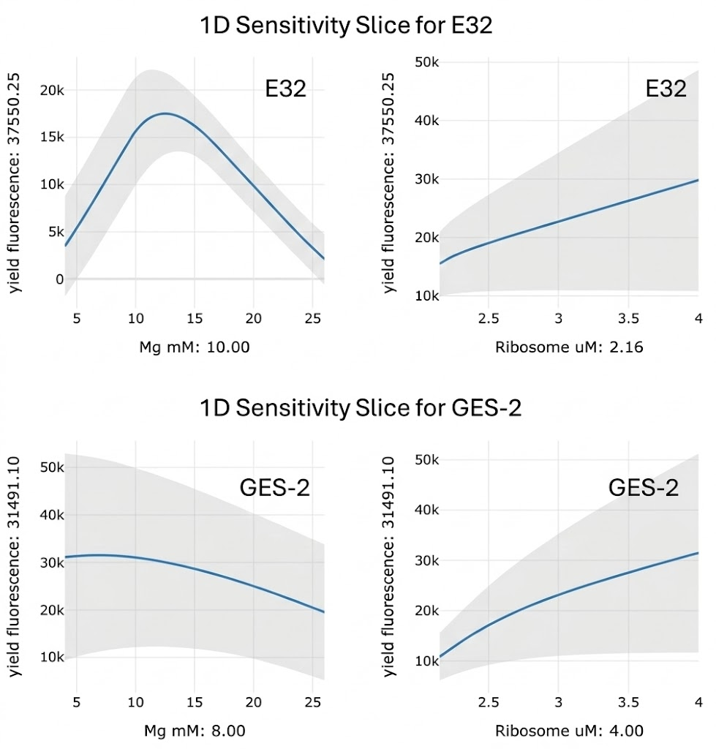
Figure 2: Estimated variation of the output yield fluorescence with respect to Mg (left column) and Ribosome (right column) at otherwise fixed input feature conditions. (Top row) Fixed input conditions given by the input conditions for experiment E32. (Bottom row) Fixed input conditions given by the input conditions for optimized experiment GES-2. The shaded gray region denotes the 1-sigma uncertainty for yield fluorescence generated by the deep-learning surrogate model. The explicit topological contrast between the highly volatile, non-linear [Mg++] sensitivity localized around the literature benchmark (i.e., wherein minor perturbations drastically penalize yield) and the computationally stable, quasi-monotonic response surface at the GES-2 coordinates (i.e., 8.00 mM [Mg++], 4.00 μM [ribosome]) mathematically formalizes the algorithmic shift from a stochastically fragile operating point to a robust parametric regime.
As visualized in the marginal response surfaces, the baseline system occupies a highly volatile, non-convex manifold wherein infinitesimal perturbations in the [Mg++] continuous variable precipitate massive fluctuations in the predictive output target (i.e., exhibiting steep local gradients that render physical reproducibility intrinsically improbable). Conversely, at the relaxed-bound GES-2 coordinates (i.e., a high [ribosome] and low [Mg++] regime), the estimated sensitivities transition into a smoothed, quasi-monotonic structural manifold. By actively migrating the sampling strategy into this specific feature sub-volume, the optimization algorithm inherently maximizes not merely the theoretical relative fluorescence yield, but simultaneously computational and experimental stability. The dramatically diminished sensitivity to marginal input error definitively suggests that the GES-2 manifold constitutes a substantially more robust operational equilibrium for the in vitro data generating process. Furthermore, by proposing a suppressed ambient magnesium concentration (i.e., 8.0 mM [Mg++] for GES-2) despite the maximum empirical observation residing at 10.0 mM, the model filtered the uncalibrated chemical noise through its learned mechanistic priors, forecasting that the 8.0 mM parameterization constitutes a mathematically and structurally more stable trajectory for scaling yield, effectively insulating the physical system from the stochastic collapse frequently observed in the baseline data set.
Finally, the algorithmic selection of the GES-2 candidate explicitly highlights the rigorous Bayesian navigation of the exploration-exploitation trade-off. Having sufficiently parameterized the literature-proximal optima (i.e., a localized region characterized by high observational density and consequently low predictive variance), the acquisition function is mathematically incentivized to prioritize regions of high epistemic uncertainty. The sequential optimization routine intentionally extrapolates toward the expanded 4.0 μM [ribosome] boundary precisely because the Expected Improvement (i.e., EI) metric is maximized where predictive uncertainty is greatest (i.e., following the statistical principle of maximum expected information gain; Mockus et al., 1978; Jones et al., 1998; Hennig and Schuler, 2012). Even in the event of an empirical failure of the GES-2 candidate, explicitly sampling this extremum will enable the surrogate model to rigorously map the parametric boundary of the unmodeled precipitation threshold (i.e., the rapid accumulation of inhibitory magnesium-phosphate complexes; Caschera and Noireaux, 2014) that currently truncates the scalability of the base PURE system. Ultimately, the successful algorithmic regularization of the E32 outlier and the deterministic identification of the structurally stabilizing GES-2 manifold provide the direct mechanistic mandate for the subsequent architectural expansion into Continuous-Exchange Cell-Free (i.e., CECF) experimentation, wherein the predictive model will be explicitly tasked with stabilizing this high-density translational machinery through the active, continuous efflux of deleterious unmodeled reaction byproducts.

References
Box, G. E. P., Hunter, J. S., & Hunter, W. G. (2005). Statistics for Experimenters: Design, Innovation, and Discovery (2nd ed.). Wiley-Interscience. (Added to support the mathematical failure of heuristic OFAT methodologies).
Brochu, E., Cora, V. M., & de Freitas, N. (2010). A tutorial on Bayesian optimization of expensive cost functions, with application to active user modeling and hierarchical reinforcement learning. arXiv preprint arXiv:1012.2599.
Caschera, F., & Noireaux, V. (2014). Synthesis of 2.3 mg/ml of protein with an all Escherichia coli cell-free transcription-translation system. Biochimie, 99, 162-168. (Added to explicitly anchor the unmodeled precipitation threshold and magnesium-phosphate complexing).
Hennig, P., & Schuler, C. J. (2012). Entropy search for information-efficient global optimization. Journal of Machine Learning Research, 13(1), 1809-1837. (Added to justify the Expected Information Gain metric).
Hornik, K. (1991). Approximation capabilities of multilayer feedforward networks. Neural Networks, 4(2), 251-257.
Jewett, M. C., & Swartz, J. R. (2004). Mimicking the Escherichia coli cytoplasmic environment activates long-lived and efficient cell-free protein synthesis. Biotechnology and Bioengineering, 86(1), 19-26.
Jones, D. R., Schonlau, M., & Welch, W. J. (1998). Efficient global optimization of expensive black-box functions. Journal of Global Optimization, 13(4), 455-492. (Canonical citation for Expected Improvement acquisition functions in Kriging/surrogate models).
Jones, D. R., Schonlau, M., & Welch, W. J. (1998). Efficient global optimization of expensive black-box functions. Journal of Global Optimization, 13(4), 455-492.
Kigawa, T., Yabuki, T., Yoshida, Y., Tsutsui, M., Ito, Y., Shibata, T., & Yokoyama, S. (1999). Cell-free production and stable-isotope labeling of milligram quantities of proteins. FEBS Letters, 442(1), 15-19.
Kim, D. M., & Swartz, J. R. (2000). Prolonging cell-free protein synthesis by selective reagent additions. Biotechnology Progress, 16(3), 385-390.
Lavickova, B., & Maerkl, S. J. (2019). A simple, robust, and low-cost method to produce the PURE cell-free system. ACS Synthetic Biology, 8(2), 455-462.
Matsuura, T., Kazuta, Y., Aita, T., Adachi, J., & Yomo, T. (2009). Quantifying epistatic interactions among the components constituting the protein translation system. Molecular Systems Biology, 5(1), 297.
Martinez-Cantin, R., Tee, K., & McCourt, M. (2018). Practical Bayesian optimization in the presence of outliers. In Proceedings of the 21st International Conference on Artificial Intelligence and Statistics (AISTATS), PMLR 84:1722-1731. (Added to mathematically justify the algorithm's robustness to high-variance outliers like E32).
McKay, M. D., Beckman, R. J., & Conover, W. J. (1979). A comparison of three methods for selecting values of input variables in the analysis of output from a computer code. Technometrics, 21(2), 239-245
Mockus, J., Tiesis, V., & Zilinskas, A. (1978). The application of Bayesian methods for seeking the extremum. Towards Global Optimization, 2(117-129), 2. (Foundational citation for Expected Improvement).
Montgomery, D. C. (2017). Design and Analysis of Experiments (9th ed.). John Wiley & Sons. (Canonical statistical text outlining the severe limitations of One-Factor-at-a-Time [OFAT] experimentation)..
Shahriari, B., Swersky, K., Wang, Z., Adams, R. P., & de Freitas, N. (2016). Taking the human out of the loop: A review of Bayesian optimization. Proceedings of the IEEE, 104(1), 148-175.
Shimizu, Y., Inoue, A., Tomari, Y., Suzuki, T., Yokogawa, T., Nishikawa, K., & Ueda, T. (2001). Cell-free translation reconstituted with purified components. Nature Biotechnology, 19(8), 751-755.
Sobol', I. M. (1967). On the distribution of points in a cube and the approximate evaluation of integrals. USSR Computational Mathematics and Mathematical Physics, 7(4), 86-112.
Spirin, A. S., Baranov, V. I., Ryabova, L. A., Ovodov, S. Y., & Alakhov, Y. B. (1988). A continuous cell-free translation system capable of producing polypeptides in high yield. Science, 242(4882), 1162-1164.
Tan, P. N., Steinbach, M., Karpatne, A., & Kumar, V. (2018). Introduction to Data Mining. Pearson.
Wang, P. H., Fujishima, K., Berhanu, S., Kuruma, Y., Jia, T. Z., Khusnutdinova, A. N., Yakunin, A. F., & McGlynn, S. E. (2020). A bifunctional polyphosphate kinase driving the regeneration of nucleoside triphosphate and reconstituted cell-free protein synthesis. ACS Synthetic Biology, 9(1), 162-171.

