1 AI vs. Human Task Delineation (Round 0 Iteration)
In accordance with ARIA's requirement for clear and unambiguous acknowledgment of human assistance within the AI-driven scientific workflow, the following delineates the specific roles performed by domain experts versus autonomous AI agents during the Round 0 closed-loop iteration:
- Domain Expert Action (Data Ingestion & Goal Parameterization): Domain experts curated the foundational historical data (20260305-round-0-igor.csv) and formatted it for ingestion. To guide the optimization, the human operators established the specific multi-objective targets (e.g., maximizing steady-state yield and exponential synthesis rate) and defined the initial mathematical bounds for the search hypervolume
- AI Action (Modeling & Experimental Design): The IGOR platform’s Bayesian optimization engine autonomously trained a neural network surrogate model on the historical data. Utilizing a hit-probability acquisition function, the AI navigated the high-dimensional design space to generate a targeted batch of novel Generated Experimental Suggestions (GESs).
- Domain Expert Action (Workflow Translation & Execution): As is standard when commissioning novel hardware for an autonomous 'self-driving' laboratory, human operators bridged the digital-to-physical gap during this early phase by mapping the AI-generated GESs to the specific operational parameters of the newly integrated LabCraft liquid handler The human then oversaw the physical execution of these recipes in the laboratory.
- Domain Expert Action (Metrology & Data Formatting): Following the physical reactions, a human operator collected the raw time-series fluorescence measurements. The human fit this data to extract the targeted kinetic parameters (e.g., steady-state yield and reaction rate), curated the results, and appended the empirical ground-truth observations to the dataset for the AI's subsequent learning cycle
- AI Action (Scientific Reporting): A specialized AI science writer agent (a prototype of the Meta-Analysis agent, operating externally to the core IGOR Bayesian loop for this round) ingested the curated experimental outcomes. The AI synthesized these empirical results to autonomously generate the first draft of the written report

2 Round-0 Iterative Optimization and Algorithmic Resilience
To properly contextualize the operational constraints of the Round-0 experimental campaign, it must be explicitly noted that this initial phase relied exclusively upon the quantitative Bayesian optimization routine (i.e., the Iterative Guide [IG] situated on the platform's front end). The multi-agent Orchestrated Research (i.e., OR) module remained entirely dormant during this epoch, as the designated b.next experimenter had not yet received the requisite pedagogical training to interface with the semantic cognitive agents. Consequently, the sequential model-based optimization routine operated completely "blind" to any qualitative literature priors, mechanistic hypotheses, or advanced contextual reasoning, strictly regressing deterministic signal from the raw empirical variance.
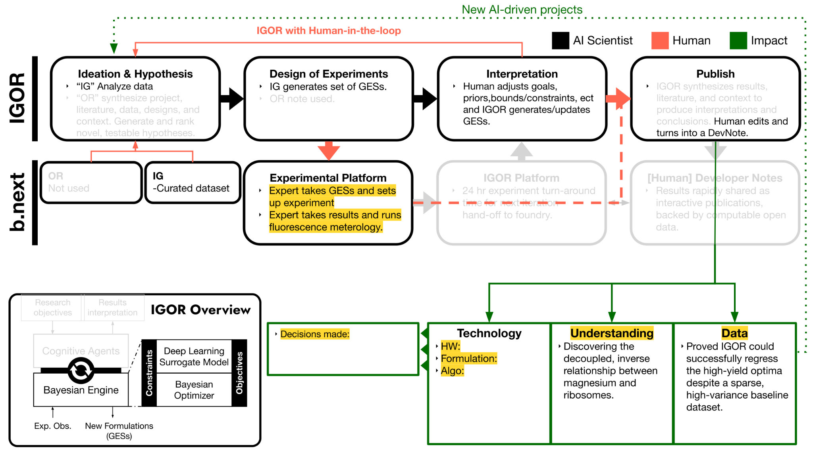

2.1 Expansion of the Design Matrix and Multi-Objective Parameterization
To formally initialize the Round-0 sequential model-based optimization trajectory, the underlying surrogate model systematically ingested an expanded historical design matrix (i.e., the 20260305-round-0-igor.csv dataset). This foundational training corpus aggregated a diverse array of explicitly parameterized combinatorial regimes to maximize the structural variance available for training; the dataset comprehensively encompassed baseline commercially available protein mixes (e.g., PMix-AR-898), orthogonal ionic boundary screens executed at reduced reaction volumes (e.g., Mg_K_screen), and the targeted integration of alternative dynamic energy regeneration modules (e.g., Polyphosphate Kinase [PPK] architectures operating in the explicit absence of baseline creatine phosphate).
Crucially, to rigorously capture the non-linear kinetic dynamics of the in vitro data generating process, the predictive output target was mathematically transitioned from a singular static yield measurement into a highly constrained multi-objective parameterization. Empirical fluorescent reporter data (i.e., plamGFP and deGFP) were transformed into absolute protein concentrations via standardized calibration curves and subsequently fit to a continuous sigmoidal functional form: $f(t) = C + \exp[-k(t - t_0)]$. Consequently, the Bayesian optimization engine was explicitly tasked with the simultaneous co-optimization of three distinct regressors: the maximization of the asymptotic steady-state yield (i.e., sigmoid_steady_state $[C]$, nominally targeted at an aggressive 500 ng/$\mu$L from a baseline of 120 ng/$\mu$L); the maximization of the exponential synthesis rate (i.e., sigmoid_rate $[k]$, strictly targeted at 10 $\text{h}^{-1}$ from a baseline of ~1.37 $\text{h}^{-1}$); and the minimization of the temporal activation delay (i.e., sigmoid_time_offset $[t_0]$, strictly targeted at 0 h).
2.2 Target Calibration and the Hit-Probability Acquisition Function
The algorithmic navigation of this high-dimensional, multi-objective search space was governed by a hit-probability acquisition function (i.e., strictly formalized as an indicator objective function mathematically combined with an expected-value acquisition metric). This specific algorithmic architecture has several advantages in iterative optimization for material synthesis. Notably, under hit probability, exploration versus exploitation is deterministically controlled by the calculated likelihood of achieving the target goals under typical predictive distributions accessible to the optimizer. Concretely, if the predictive mean is closer than approximately one predictive standard deviation (i.e., $<1\sigma$) to the near side of the goal interval, the optimization routine will mathematically prefer to shrink localized variance and move the mean toward the goal; this is exploitation. In the opposite case, when the target goals are structurally far away, the optimization will preferentially increase variance; the mathematical preference to improve the mean is also much weaker in this exploration regime.
This latter behavior often surprises experimenters, though it has proven very effective in in silico optimization loop convergence tests. During the initialization of Round-0, the untrained domain experts arbitrarily parameterized the multi-objective targets at extrema situated radically outside the bounds of the historical baseline (e.g., demanding a steady-state target of $C \to 500$ ng/$\mu$L). If the goals are several standard deviations away, the algorithmic exploration may be drastic—this is mathematically intended—but subject matter experts should strictly reject physically unreasonable suggestions, or temporarily utilize nearer goals if such a rejection rate is experimentally impractical. Consequently, Find What Matters (i.e., FWM) personnel formally intervened to execute targeted pedagogical training, instructing the b.next domain experts on the rigorous mathematical calibration of multi-objective targets to ensure that subsequent human-in-the-loop goal-setting would utilize nearer, statistically accessible intervals to safely and predictably govern the algorithmic exploration.
2.3 Human-in-the-Loop Regularization of the Spatial Hypervolume
The initial programmatic generation of candidate formulations (i.e., Generated Experimental Suggestions 1 through 5; GES-1 to GES-5) was strictly localized to an interpolative search space. Within this constrained hypervolume, specific input features were rigidly bounded by unmodeled hardware systematics (e.g., explicitly constraining supplementary [PEG4K] to 0%, [RNAse Inhibitor] to 2000 U/mL, and [ribosome] to 1.8 $\mu$M to accommodate the mechanical limitations of the automated liquid handling hardware at the time, whilst temporarily zeroing [PPK] and [PolyP] pending the resolution of an unmodeled biochemical debugging systematic).
Because the hit-probability acquisition function mathematically identified that the target 500 ng/$\mu$L steady-state yield could not be achieved within these restricted initial bounds, the Iterative Guide naturally incentivized the relaxation of the feature space. Exercising their supervisory human-in-the-loop mandate, domain experts iteratively expanded the parametric search limits into physiologically plausible but highly extrapolated regimes (e.g., scaling the continuous maximum allowable bounds for [Magnesium acetate] to 25.0 mM, [Potassium glutamate] to 200.0 mM, and [Creatine phosphate] to 100.0 mM), thereby granting the Bayesian engine the requisite mathematical freedom to execute extrapolative exploration in pursuit of the user-defined objective limits.
2.4 Algorithmic Resilience: Hardware Systematics and Outlier Regularization
The physical execution of these extrapolated Round-0 formulations introduced severe unmodeled systematics, explicitly testing the inferential robustness of the IG algorithm operating independently of any semantic guidance. First, during the automated synthesis phase, the experimenter actively identified a structural communication fault within the robotic application programming interface (i.e., the hardware API). Consequently, the actual liquid-handling execution physically compounded experimental coordinates that deviated structurally from the intended algorithmic targets (i.e., precipitating a programmatic divergence between the intended ges-to-run.csv design matrix and the physically executed ges-obs.csv matrix). Because the experimenter identified this systemic fault during execution, the algorithmic pipeline bypassed the theoretical targets and seamlessly ingested the strictly as-run empirical coordinates, mathematically regularizing the hardware execution error without requiring a foundational model reset.
Second, the resultant dataset necessitated rigorous outlier detection. For typical material optimization problems, experiments are expensive and few, while all manner of process and measurement faults can lead to erroneous data that escape detection. The heuristic inclusion of such corrupted points greatly reduces the statistical power of any model trained on them through the overestimation of the noise level and thus the underestimation of the determinative signal (or possibly by requiring the use of more-kurtotic predictive distributions).
The traditional alternative is to "model" only the points with identical experimental conditions for comparison to the candidate outlier; the "model" is often a normal distribution fit to perhaps two other points. Experimentation must be arranged to allow for such an analysis, often by working in triplicate at potentially triple the cost. Even if replicates have a low marginal cost, their power when used alone in outlier detection is fundamentally limited by low statistics and correlated localized noise.
Conversely, the algorithmic identification of such outliers, especially those not obvious to the experimenter, is achieved continuously by comparison to other datapoints across the feature space; the mathematically relevant quantity is the candidate outlier’s probabilistic likelihood evaluated strictly under a surrogate model trained on the so-called $n-minus-1$ dataset (i.e., a rigorous leave-one-out cross-validation methodology). Simply using the same model type intended to be fit after outlier removal (i.e., a capacious but well-regularized deep-learning surrogate possessing calibrated uncertainty and appropriate extrapolative behavior) has proven highly optimal in in silico optimization loop convergence tests. Intuitively, this superior inferential performance is due to the model’s learned smoothness priors allowing the simultaneous unraveling of global deterministic trends and localized noise levels, systematically isolating non-physical execution errors strictly from the variance topology.
2.5 Epistemic Uncertainty and the Magnesium Anomaly
By leveraging these smoothness priors, the sequential optimization loop successfully regressed a highly productive, anomalous manifold within the expanded feature bounds. Upon algorithmic analysis of the empirical outcomes, the surrogate model determined that the maximum observed asymptotic steady-state yields occurred strictly within search sub-volumes characterized by unexpectedly high ambient magnesium concentrations (e.g., candidate GES-8, which achieved an extraordinary empirical sigmoid_steady_state output of 161.25 ng/$\mu$L strictly conditioned upon an anomalously elevated [Magnesium acetate] concentration of 23.74 mM).
However, this profound divergence introduces a critical vector of epistemic uncertainty into the optimization trajectory. Further root-cause investigation by domain experts revealed the physical probability that the magnesium acetate master-stock utilized during the robotic synthesis was systematically miscalibrated by the operator. Because the Bayesian engine deterministically regresses signal based strictly upon the provided empirical ground-truth, it cannot a priori differentiate a genuine, novel high-concentration biochemical optimum from a catastrophic human metrology error. Consequently, the surrogate model formally classified this specific vector as a locus of high epistemic uncertainty, generating the mathematically rigorous mandate to either physically recalibrate the master-mix metrology or systematically explore this specific high-concentration manifold in subsequent optimization loops.
2.6 The Standalone Utility of the Iterative Guide and Preparation for Round-1
Crucially, every algorithmic milestone achieved during Round-0—including the multi-objective sigmoidal parameterization, the systematic bound expansion via the hit-probability acquisition function, the regularization of the robotic API faults, and the $n-minus-1$ regression of the magnesium anomaly—was executed exclusively by the quantitative Iterative Guide (i.e., the IG module) operating in a state of absolute semantic blindness. Because the experimenter had not yet received formal training on the deployment of the semantic Orchestrated Research (i.e., OR) module, it remained functionally bypassed during this phase. Consequently, the predictive model received strictly zero a priori semantic priors, reference literature, or structural heuristics regarding the biophysical mechanisms of the PURE system.
The capacity of the IG module to successfully navigate this high-dimensional, noise-corrupted parameter space strictly via the mathematical regression of empirical variance definitively proves the standalone utility of the Bayesian architecture. However, to circumvent the remaining epistemic uncertainties (e.g., the magnesium anomaly) and fully optimize the expanded energy regeneration modules, semantic priors must be integrated into the algorithmic trajectory. Following the conclusion of Round-0, FWM personnel executed targeted pedagogical interventions to train the b.next experimenters on the deployment of the OR module. This operational upgrade ensures that for the subsequent Round-1 campaign, the system will successfully couple the IG module's quantitative rigor with the OR module's autonomous semantic synthesis, formally equipping the platform to explicitly deduce and target non-linear interaction terms (e.g., stoichiometric thermodynamic ratios and Pareto frontiers) via mathematically rigorous multivariate Design of Experiments (i.e., DOE).

Figure 3: The Multi-Objective Sigmoidal Parameterization
- What it should visually show: A time-series plot (X-axis: Time [h], Y-axis: Absolute Protein Concentration [ng/$\mu$L]). Show the raw, noisy empirical data points of a representative PURE reaction (e.g., a high-performing PMix-AR-898 run) overlaid with the fitted continuous sigmoidal curve.
- Key Annotations: Explicitly label the three mathematical regressors on the curve: the horizontal asymptote ($C$; sigmoid_steady_state), the maximum exponential slope ($k$; sigmoid_rate), and the temporal x-intercept/delay ($t_0$; sigmoid_time_offset).
- Placement: Directly after Section 2.1 (Expansion of the Design Matrix and Multi-Objective Parameterization).
Max-Style Caption:
Figure 3: Mathematical transformation of the empirical data generating process from a singular static yield observation into a continuous multi-objective parameterization. Raw time-series relative fluorescence data (i.e., absolute protein concentration derived via standardized plamGFP/deGFP calibration curves; represented as discrete markers) are computationally fit to a sigmoidal functional form, $f(t) = C + \exp[-k(t - t_0)]$ (i.e., the solid trendline). This rigorous kinetic parameterization explicitly transitions the Bayesian optimization target from a singular scalar into a highly constrained three-dimensional objective space, tasking the sequential model-based optimization routine with the simultaneous maximization of the asymptotic steady-state yield (i.e., $C$), the maximization of the exponential synthesis rate (i.e., $k$), and the minimization of the temporal activation delay (i.e., $t_0$).

