The dataset in 20260305-round-0-igor.csv was built by combining the following experimental conditions:
- PPK_20250611 — PURE run with commercially available NEB PURExpress protein mix (Pmix), but with custom energy mix (small molecule solution; Smix), varying the concentration of magnesium acetate added. Fluorophore was plamGFP.
- PPK_20250612 — same as above, but in the presence of PPK, and without creatine phosphate. A standard reaction is included as a control.
- PPK_20250613 — further magnesium sweep in the presence of PPK and without creatine phosphate.
- PPK_20250616 — comparing the combination of the PPK and creatine kinase modules to PURE with those alone.
- PMix-AR-898 — standard PURE experiments using Nucleus Cytosol and using plamGFP as a reporter. Some experiments run with higher concentration of Pmix and Ribosomes (from different batches).
- PMix_(AR-931)_QC_PURE_Timecourse — additional experiments with varying ribosome concentrations.
- PMix-MFG-128-PURE-Activity-QC — experiments using two different Pmix stocks and using deGFP as a fluorescent reporter
- Mg_K_screen-20251105_090558 — PURE using Nucleus Cytosol but at 5 uL reaction sizes (compared to 10 uL standard) and plamGFP as a reporter, but varying magnesium acetate and potassium glutamate concentrations.

Regressor values are sigmoidal fits to fluorescence data that has been converted to absolute concentration numbers using standards curves for GFP.

The data were fit to the functional form:
$\frac{C}{1+exp[-k(t-t_{0})]}$
where regressor values are `sigmoid_steady_state` = C, `sigmoid_rate` = k and `sigmoid_time_offset` = t_0.

`ges-igor-output.csv` was the set of GES’s generated by IGOR; some of these had 0 magnesium acetate concentration, for which we have a strong prior that the experiment will not run, so they were excluded from the actual experiment. `ges-to-run.csv` contains the experimental conditions that were intended to be run, but due to an issue with the API for the robot that prepared the experiments, these were not the actual experimental conditions run. Instead, those are found in `ges-obs.csv`, along with sigmoidal fit parameters to the concentration values.

Goals:

sigmoid_steady_state  (ng/uL) | sigmoid_rate (1/h) | sigmoid_time_offset (h)
120 | 1.36752134 | 0
500 | 10 | 3

First 5 GES’s were generated within the bounds of the initial hypervolume, but where we set PEG4K to 0, RNAse Inhibitor to 2000, and Ribosome to 1.8 uM as this could not be easily pipetted by the robot at the time. PPK and PolyP were excluded because there is currently an issue that is being debugged.

GES reaction volume was chosen to be 10 uL.

Expanded Bounds:

 | DNA (nM) | PEG4K 40% | RNAse inhibitor (U/mL) | Pmix (mg/mL) | Ribosome (uM) | Magnesium acetate (mM) | Creatine phosphate (mM) | Potassium glutamate (mM) | PPK | PolyP
min | 1 | 0 | 2000 | 1.53 | 1.8 | 0 | 0 | 60 | 0 | 0
max | 20 | 0 | 2000 | 2.2425 | 1.8 | 25 | 100 | 200 | 0 | 0

Upon analysis, we found that the highest steady state values were found for magnesium concentrations that were much higher than expected. Further investigation revealed that it is possible that the magnesium acetate stock used to run the GES’s was reported at the wrong concentration when made, but we are not sure—it is possible that in the regimes of parameter space explored, this is a real effect.

Experimental setup and Analysis Found on Notion -- main points summarized here

Experimental Setup:
- Made all samples in triplicate.
- Pipetted DNA and Pmix manually
- Mg, CP, K w/ labcraft
- Base master mix assembled mostly by hand.
- Assembly order of base master mix likely not most ideal (Pmix, DNA, Ribos should be last). Will update in future rounds
- Mismatch of platemap between manual and automated titration methods – so we ended up with a GES* instead of GES.
- Base mix samples were sitting at RT on the 384 well plate for a few hours as I debugged the labcraft. Expected lower yield and higher variability

Analysis:
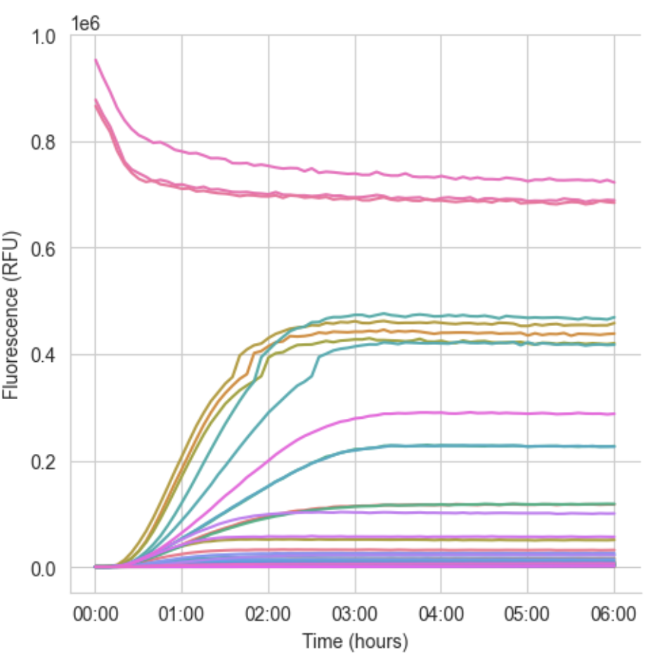
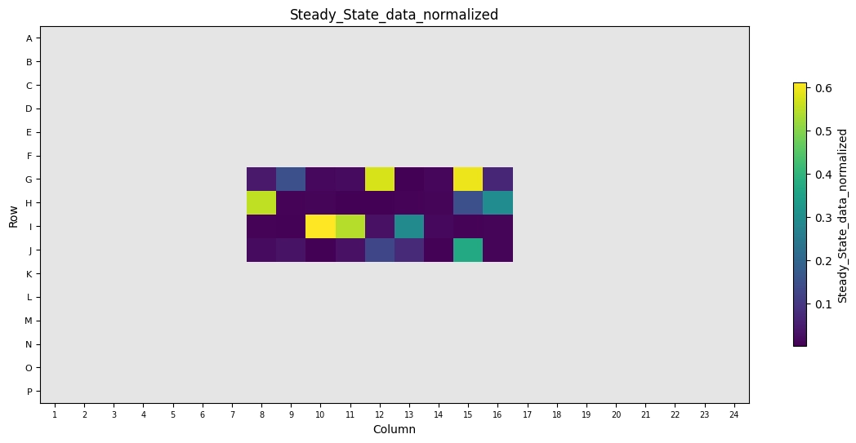
Platemap of steady states: No clear relationship of error with dispensing on a platemap. So we can move forward with analysis trusting that hte dispensing was done.

Marginal Effects:
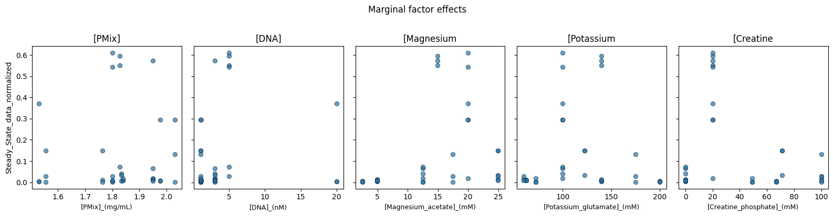
Spaces explored across the samples:

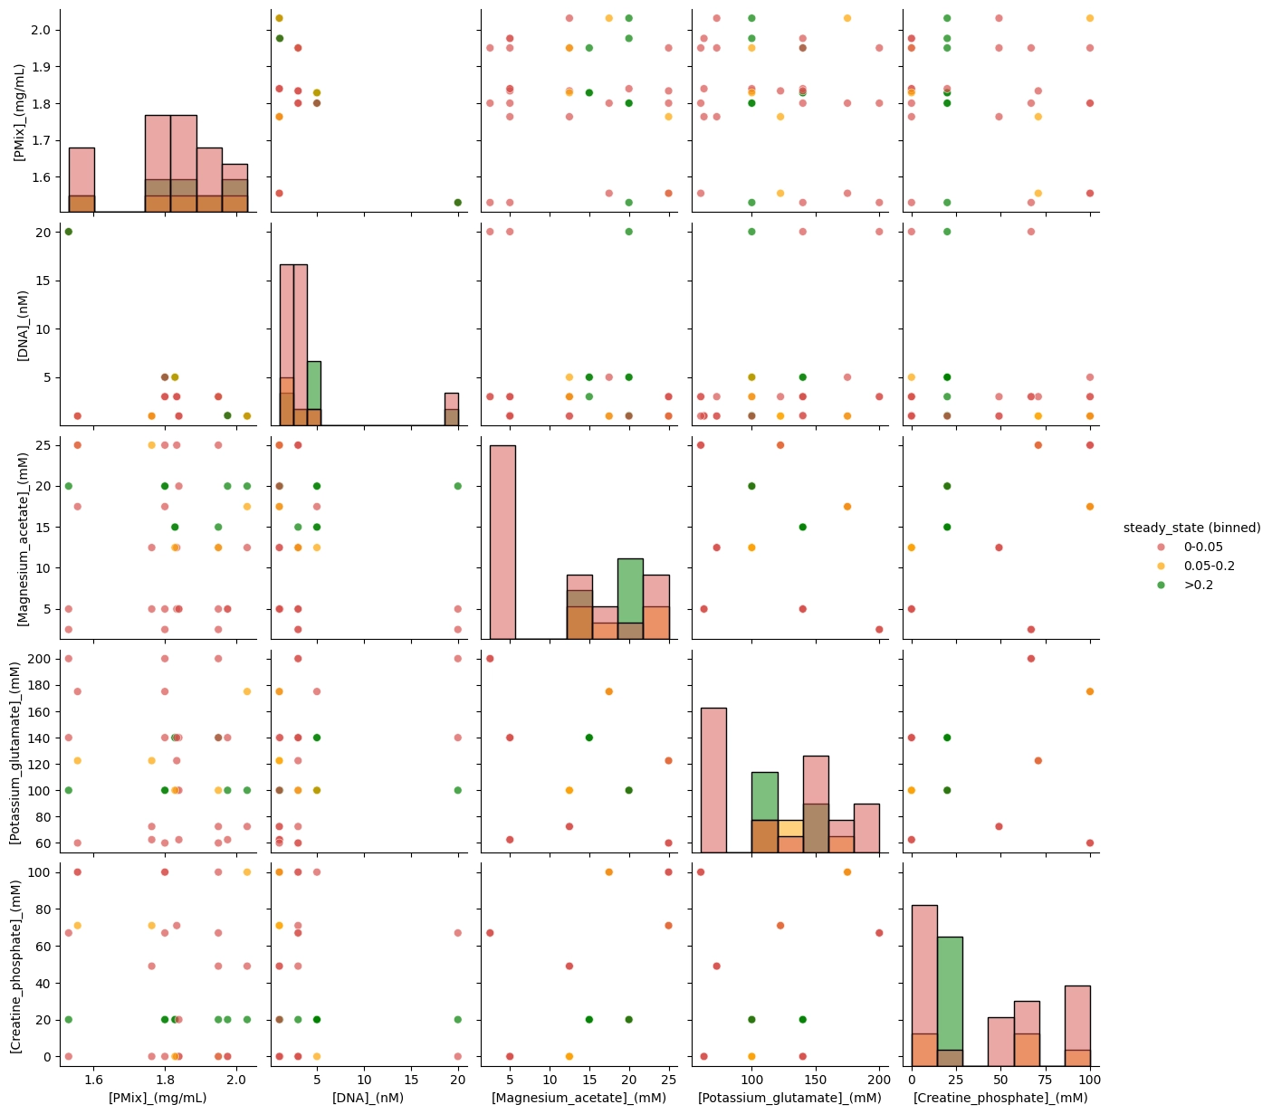

Best variants:
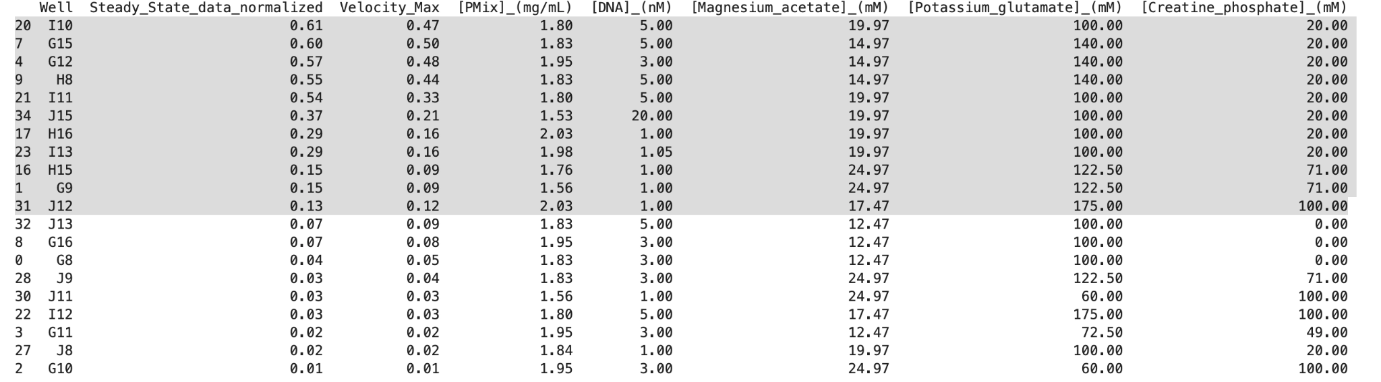
Those are pretty similar to what we normally do aside from the super high Mg!

Adjusting for incorrect Mg concentrations
After discussion (as noted above), we thought that perhaps mg was accidentally made at a higher concentration than expected. When we adjust for the wrong stock Mg concentration, we see:
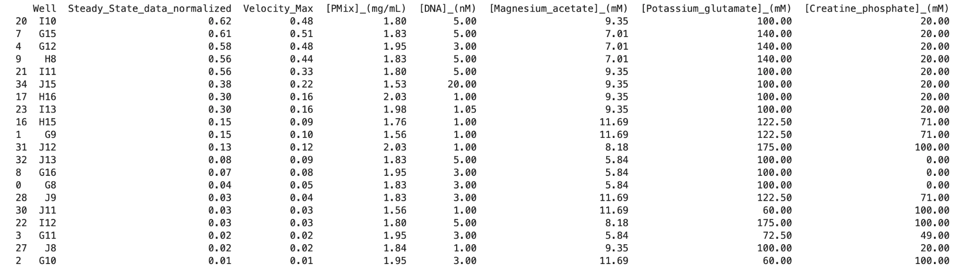
Which is more along the same space of our typical Mg concentrations that do well.
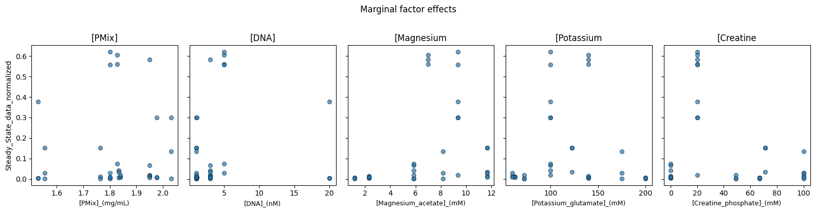
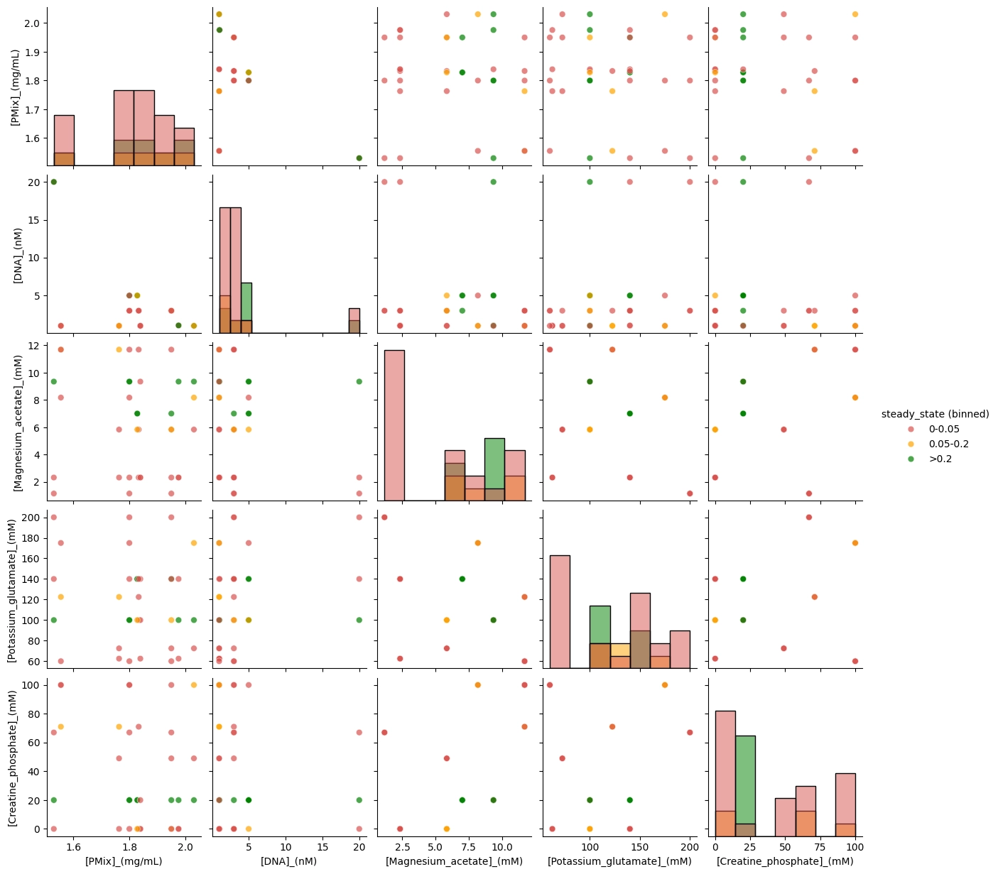
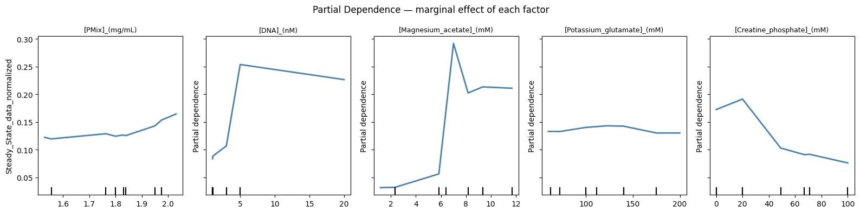

## Data and sensitivity analysis (foudn on Notion - again, only some results copied here)
General results:
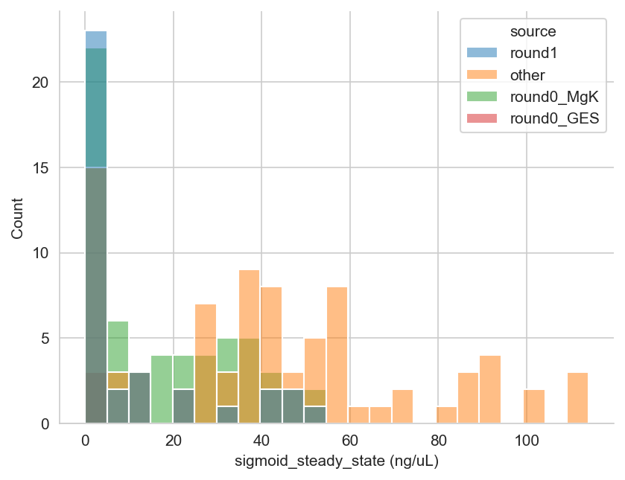
- Mis label here – “round 1” is actually the GES* generated for this round.

PCA comparing our different data sources:

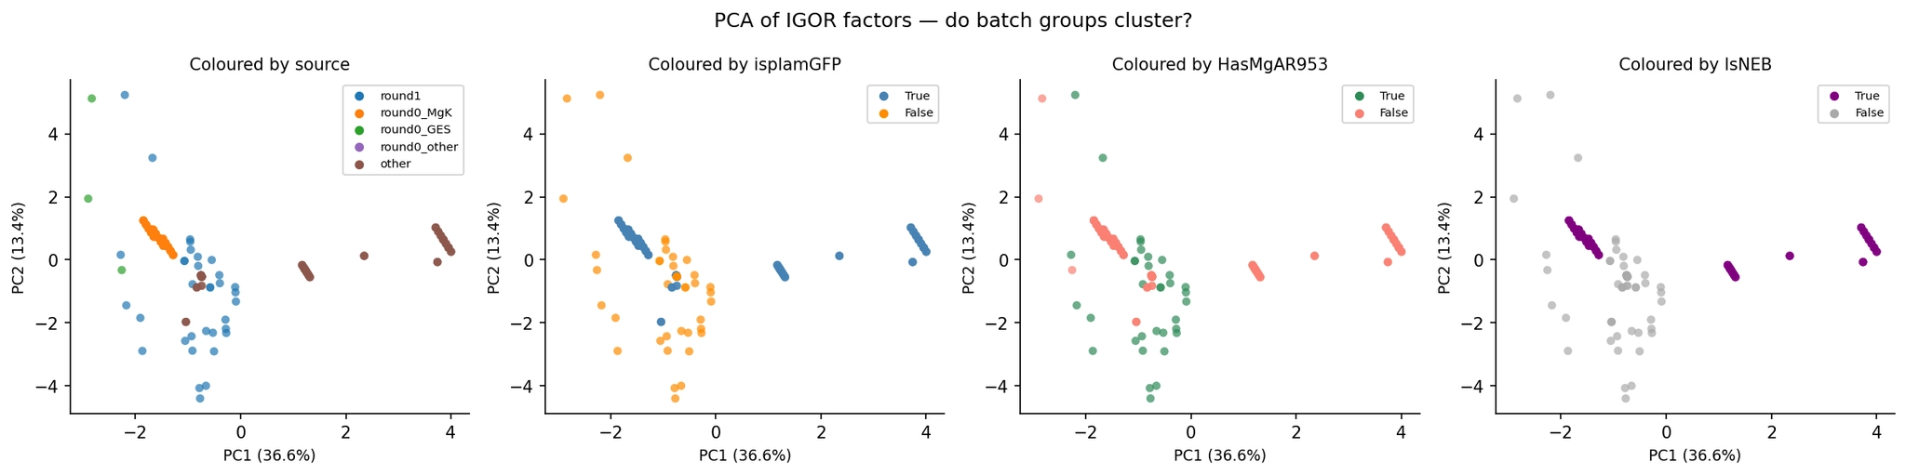

Shows that R1 does indeed explore a different parameter space.

We see
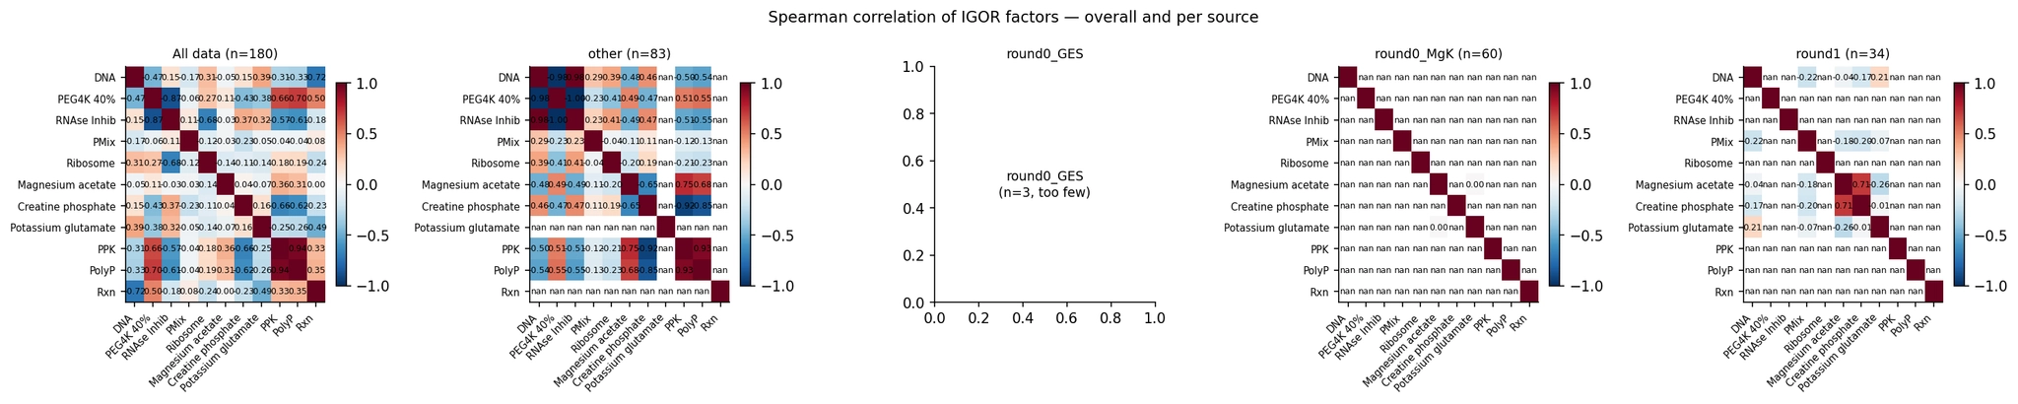
Validating our understanding of input data:
- other: we see high correlation with:
  - PEGx DNA
  - RNAse Inh x PEG
  - PPK xMg
  - PPK xCP
  - Poly P x PPK
  - ^ expected from SYs experiments
- round 0: Mg K:
  - low off diagnoal within source correlations. makes sense since this round sweeps of both
- round 1: IGOR GES 1
  - high correlation with CP and Mg. ← this isnt great that IGOR suggested this combination because then the individual effects of these cant be dientangled within this round alone.
I was curious about what systematic biases, I made a RF surrogate w/ and w/o batch variables (more description in Notion)
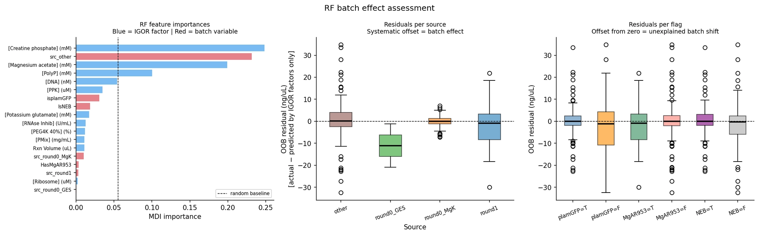
This showed that with a basic RF, batch effect isnt much of a problem.

– Example of what we can do –

- Log transform of response. Response right skewed. Do log1p = log(1+x) to better balance the input data
- 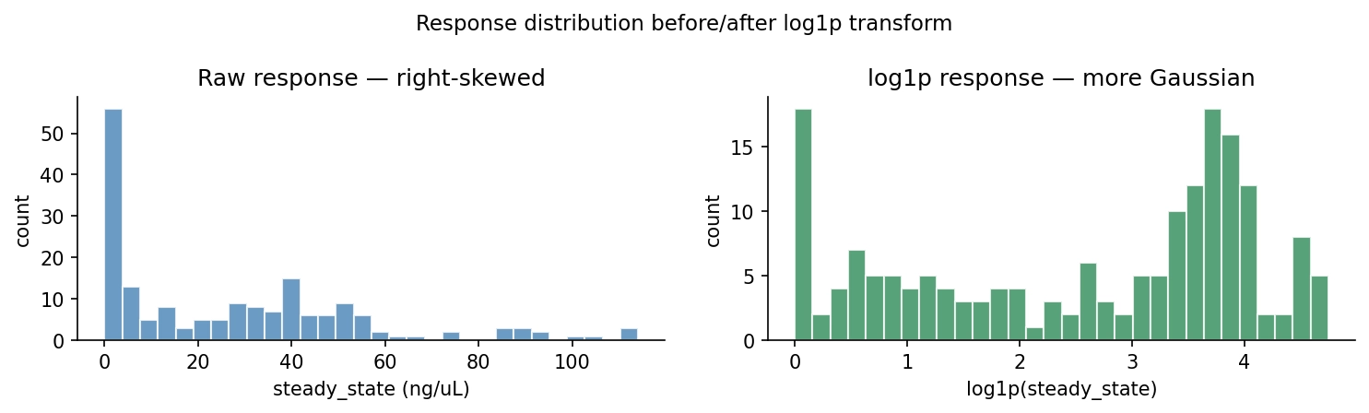
Current mechanistic state (from SNs own surrogate to show what we should try to start generating w/ IGOR)
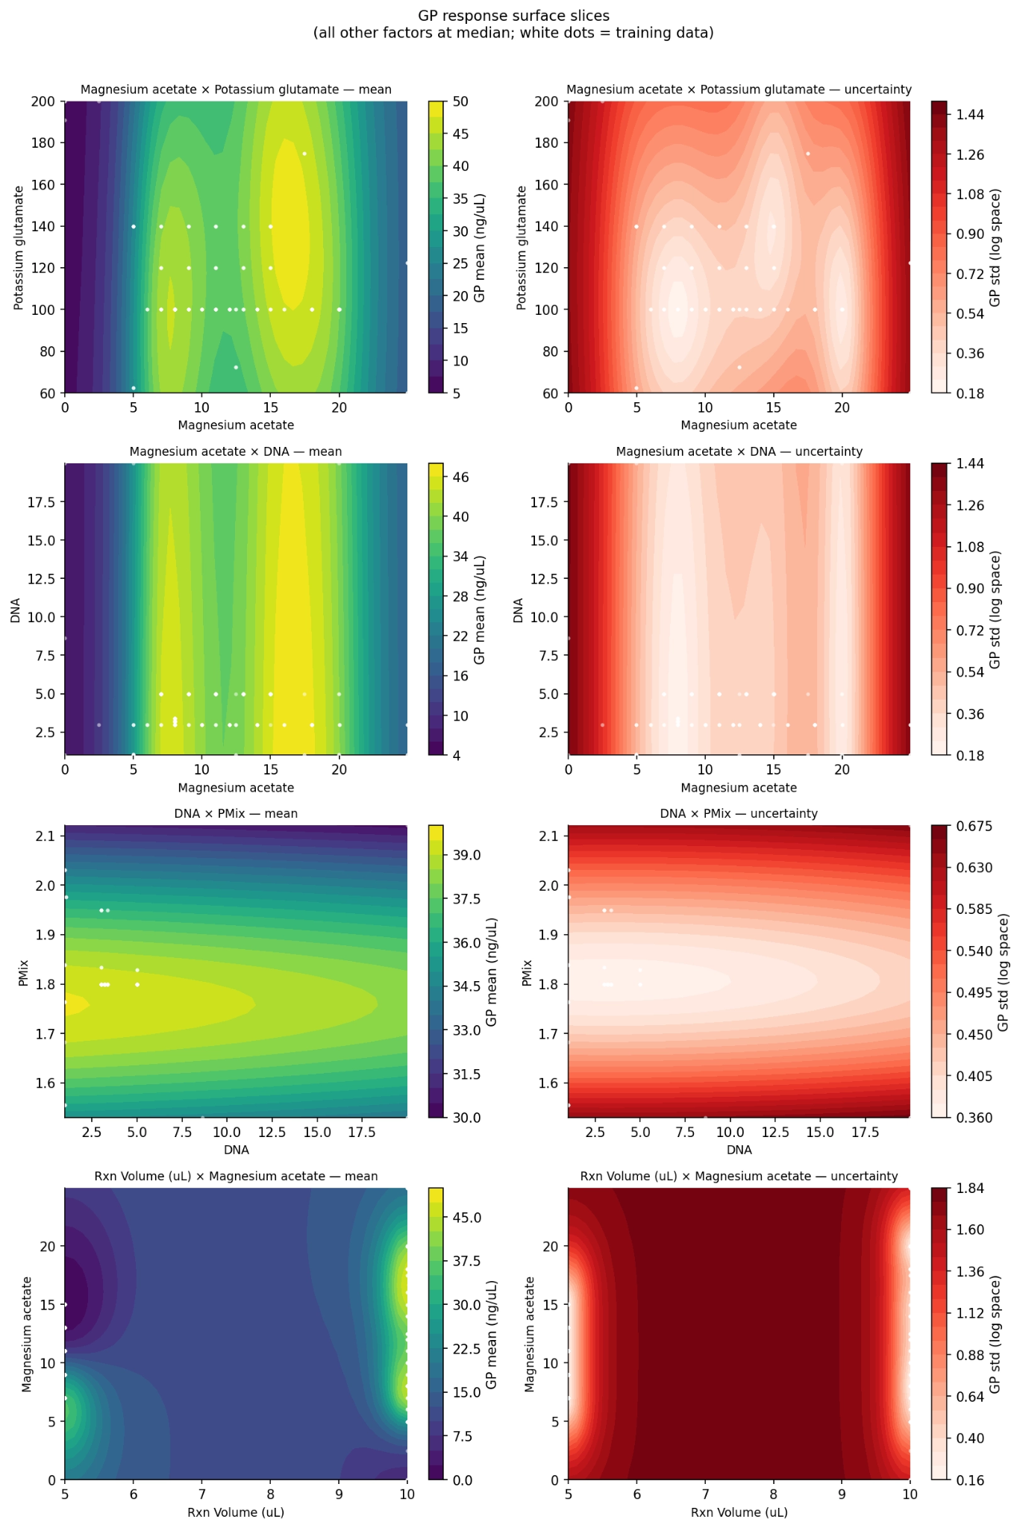
If we can make this with IGOR, we could better determine what mechansitically IGOR is learning, and plot the GES’s in this landscape to showcase some aspect of the acquisition function, as well as show how how learning shifts with each round.
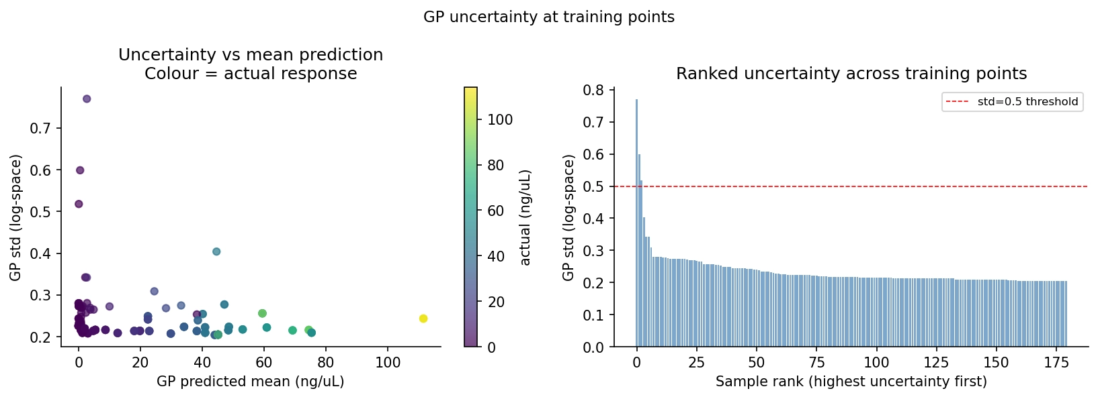
Draw a Saltelli sample of 16k points (normalized factor space). Eval GP mean and analyse w/ SALib
S1 = main effecct, ST = total effect If ST>>S1 factor effect mostly through itneractiosn w/ other factors
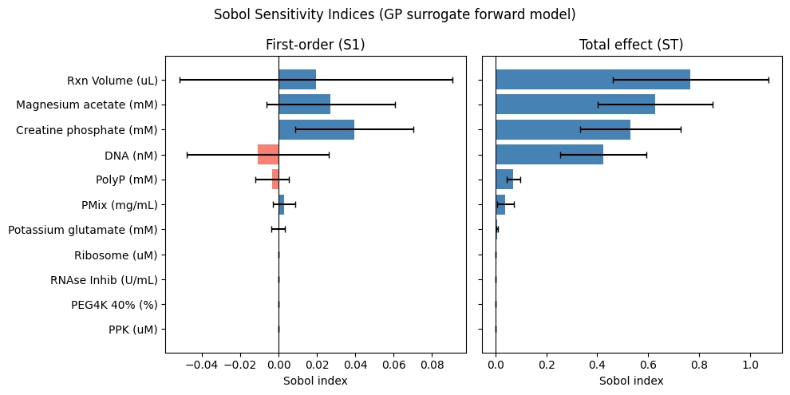

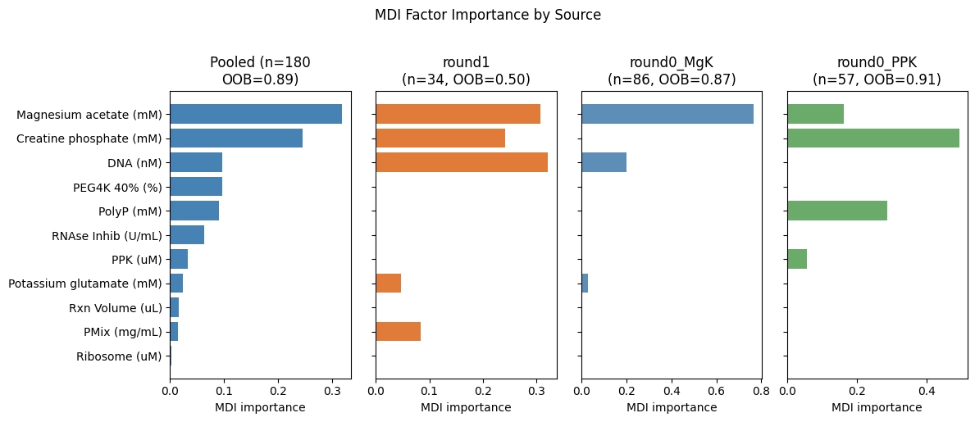
–

Ideally we calculate error for pred. vs actual of GES*...

CORE Learnings:
- We still do not understand why IGOR is picking specific samples, especially repeatedly proposing seemingly unproductive regions like 0 Mg. We (b.next) was motivated to build enough visibility to debug and to better guide future data collection, so we did some exploratory data analysis, built a surrogate, and ran some sensitivity analysis to learn what we’d ideally have IGOR also do/learn/summarize.
- R0 GES coverage expands the factor space, relative to older “other” data, and the PCA showed that a lot of variance is driven by systematic experimental structure (which matches expectations from how some experiments were run).
- Pooling the data across rounds looks “mostly OK” for a first pass, at least for additive batch effects, based on the RF comparison where adding batch indicators did not improve OOB R² (ΔR² ≈ -0.003). This suggests the batch labels we tried are not adding predictive power beyond the factors.
- A big risk is confounding from correlated factors, which makes any “importance” interpretation (SHAP, PDP) fragile. In the compiled dataset, we explicitly called out strong correlations (notably among PPK, PolyP, PEG) and flagged that this can cause misleading attributions.
- We need FWM folks to get us GES's without more dev and descriptions on their end.
  - Going off of the output R0 draft from IGOR (?), I see that we had potentially set the yield goal too high. so thats why we were getting more exploration and unproductive samples (like 0 Mg) samples. In the future, we should set the goal to be something a few stds closer to the actual data.
  - I also learned that here there was some focus of learning on the lag time…which isnt great since theres a lot of batch-to-batch variability depending on the operator, and isnt something that were explicitly trying to optimize.
Learnings from the “quick-and-dirty surrogate” work :
- A GP surrogate is useful mainly as a language + visualization tool right now, not as a final predictive model. We’re using it to learn what sensitivity/uncertainty plots we want from IGOR/FWM.
- High-residual points are valuable targets for investigation, both for debugging (data quality, regime changes, missing factors) and for guiding what to sample next (hopefully what IGOR does)
- Binary-ish inputs (PPK, PolyP, PEG) and sparse sampling in 11D are likely major drivers of uncertainty and instability in GP behavior, and they point to a need for more deliberate sampling across those axes. Do these learnings translate to IGOR?

What we learned to take into next discussions and rounds with FWM/IGOR:
- We need uncertainty and interpretability hooks to make IGOR’s proposals legible and debuggable, not just point predictions.
- “Where the surrogate is poor” is actionable: it can indicate missing covariates, confounding, or where new data would most improve the model (and our mechanistic understanding).
- A key open question is how this maps onto IGOR internally: What assumptions it makes since that determines what kinds of diagnostics are realistic.

