IG:

Generated GESs with bounds

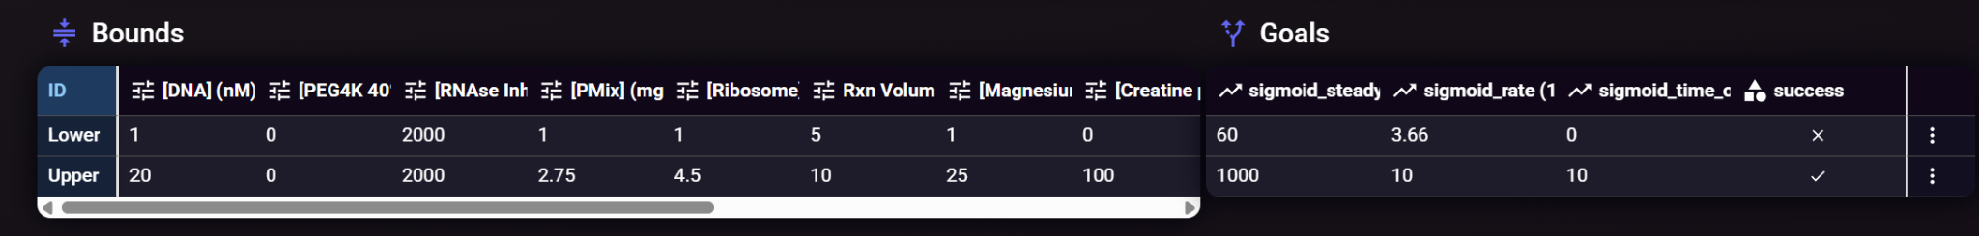

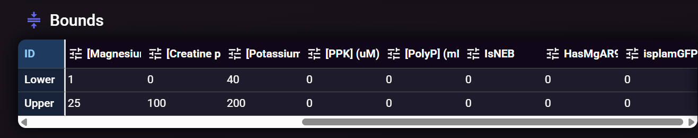

Then added the new features (ATP, GTP, Amino Acid Mix, tRNA) to the GES columns, and normally sampled them about their min/max mean.

OR
Then asked IGOR
- Review these files: new-features-for-pure-yield.pdf, 20260309-round-1-bounds.csv, Copy of Shimizu et al. - 2001 - Cell-free translation reconstituted with purified .pdf, Copy of PURE overview.pdf, Copy of Li Improved Cell-Free RNA and Protein Synthesis System.pdf, Copy of 20250630 FWMai__benxt Meeting Notes.pdf, Copy of lavickova-maerkl-2019-a-simple-robust-and-low-cost-method-to-produce-the-pure-cell-free-system-2.pdf
- We want to increase PURE yield and rate as high as we can, given the features and bounds in the master table. We will use the GESs generated and add the new features (ATP, GTP, Amino Acid Mix, tRNA) normally sampled at the mean of the min max bound. Does that make sense?

IGOR then generated a final OFAT report, we asked IGOR:
While your previous report was insightful, the proposed experimental plan relies on a One-Factor-At-A-Time (OFAT) approach. OFAT is fundamentally flawed for optimizing a highly coupled biochemical network like the PURE system because it fails to capture non-linear dynamics and synergistic cross-correlations between components.

The core advantage of AI and Bayesian Optimization is the ability to efficiently navigate high-dimensional design spaces by varying multiple parameters simultaneously. Please generate a revised final report and experimental plan. This new plan must abandon OFAT and propose a multivariate combinatorial strategy. Formulate new hypotheses focused on the interaction effects between the master table features and your proposed new features. The experimental plan should design a batch of experiments where multiple variables are adjusted simultaneously to maximize PURE yield and effectively map the complex interaction landscape.

IGOR then generated a new multivariate Final Report.

