Dataset:
The dataset in XX.csv was built by combining
- The dataset from 20260305-round-0-igor.csv
- The results from round-0 GES (Mg-adjusted concs)

Converting the ng/ul of GFP. Then fit the sigmoid as previously described.

GES Generation
We pushed to test more factors. Since IG cant determine factors to explore without it having been explored before, we decided to explore: {GTP, ATP, AAs, tRNAs} in addition to previously explored factors: {Mg, K, CP}*. Run GESs still differ significantly from IG-GESs.
To help facilitate new features being explored we are incorporating a FWM domain expert to work with b.next domain expert.

Currently GES are only being run that are generated from IG, we should also include GES from OR as well.

*This is true for Bayesian Optimization without defining a prior on a column with zero variance. No method can determine what to do without information. For example a sampling choice has to be made, or encoded.

For zero-variance columns, FWM utilizes an initial sampling strategy centered on the baseline point. Samples are drawn from a probability distribution that decays with distance from this center; this process is then iteratively updated via Bayesian optimization, using a surrogate model to guide subsequent recommendations. This is currently done by hand and not automated.

Bounds were set as:

GES’s were generated by:
<Scott TODO>
LHC or Sobol of unexplored factors? Neither, unexplored factors were chosen and normally distributed about baseline value with a domain expert informed choice for the standard deviation value.

Experimental Setup
- Did not run replicates as per discussion
  - For typical material optimization problems, experiments are expensive and few while all manner of process and measurement faults can lead to erroneous data that escape detection. Inclusion of such points greatly reduces the statistical power of any model trained on them through overestimation of noise level and thus underestimation of signal (or possibly by requiring the use of more-kurtotic predictive distributions).
Identification of such outliers, especially those not obvious to the experimenter, is achieved by comparison to other datapoints; the relevant quantity is the candidate outlier’s likelihood under a model trained on the so-called n-minus-one dataset. Simply using the same model type intended to be fit after outlier removal (a capacious but well-regularized model with calibrated uncertainty and appropriate extrapolative behavior) has proven sufficient or even optimal in in silico optimization loop convergence tests.
Intuitively, this performance is due to the model’s smoothness priors allowing the simultaneous unravelling of trends and noise level. In a sense, though only replicates (as discussed below) have perfect signal overlap, enough of the dataset has moderate overlap with the candidate point that in combination they provide a useful predictive distribution.
The traditional alternative is to “model” only the points with identical experimental conditions for comparison to the candidate outlier; the “model” is often a normal distribution fit to perhaps two other points. Experimentation must be arranged to allow for such an analysis, often by working in triplicate at potentially triple the cost. Even if replicates have a low marginal cost, their power when used alone in outlier detection is limited by low statistics and correlated noise.

- Overriding: DNA = 5, Pmix = 1.8, Ribos=1.8 constant for all GES’s. We currently do not have capability to titrate these reagents in an automated fashion.
- Wanted to run 5ul reactions, but with this many factors that were varying, there wasn't enough dead volume, so had to use 10ul reactions.
- Had to crop Creatine Phosphate to the upper end of 60mM and AAs to 0.4 to be able to physically fit the variety of concentrations in each experiment given the upper concentrations of all the stock concentrations. This required some time to determine
  - Saved to ges-round-1-mod-cp6-aa04.csv
- Base master mix made by hand (we’re running low on cytosol so I didnt want to risk OT combination which also requires a higher volume)
- All final factors were titrated by labcraft (Milestone! This was the highest throughput run we’ve run in terms of SEVEN factors being titrated!!)
- Used a newly created stock of Mg with confirmed concentrations (concerns from last round as noted there)
- Once above were fixed, the conditions ran through the pipeline with labcraft for once fairly seamlessly!
- Final actual titrated concentrations w/ the data is found: ges-round-1-results-normalized-fluorescence.csv
- Converted to ng/ul is here:

Results
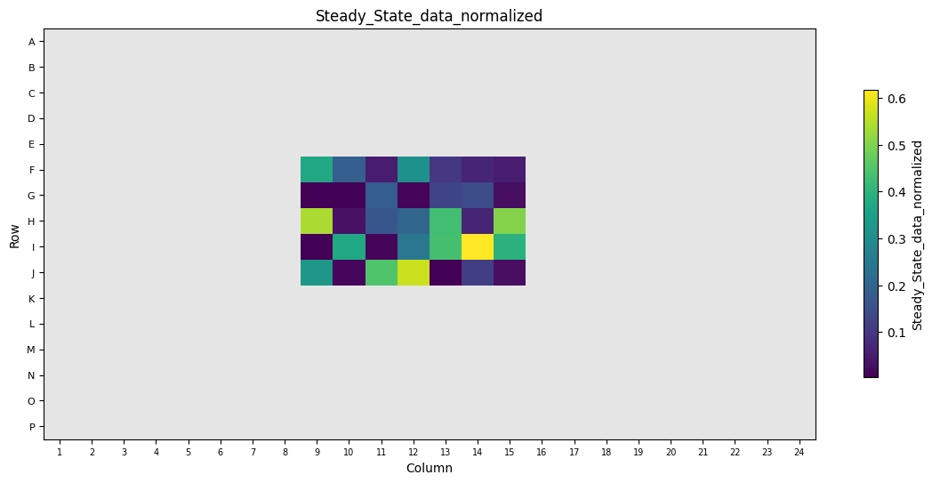
Platemap of yield looks solid. No noticeable biases from distribution.
Notably, CP has a bimodal distribution, which lines up well with Mg. High CP w/ High Mg results in one high yield region. Med CP w/ med Mg also high yield. Points in between not good (see respective subplot below)
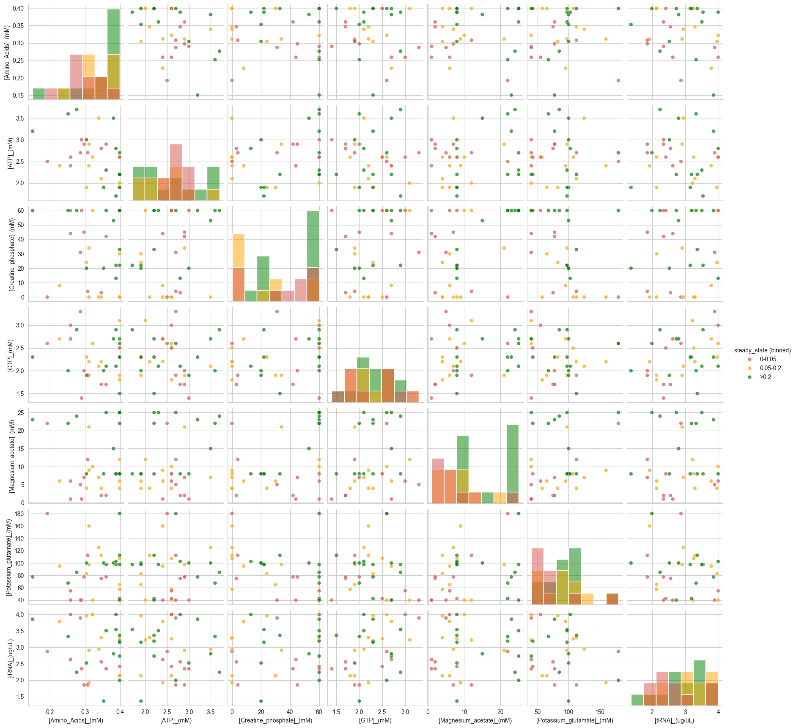

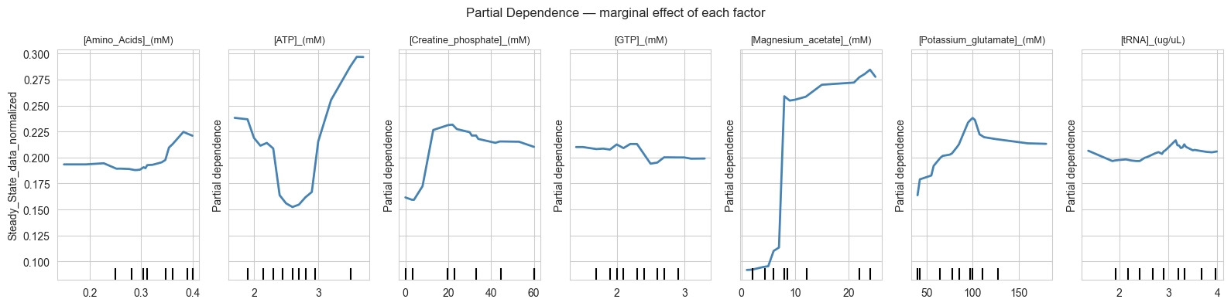
- Samples look pretty good!
- Notably, the concentration of Mg is also suggesting a range of higher Mg samples that we also saw in Round 0 prior to our adjustment of Mg concentration. This suggests that our Mg stock concentration from R0 was probably actually correct and we shouldn't have adjusted the concentration post-hoc. Moving forward, we should update that.

Further analysis to compare results would ideally first have this dataset converted to ng/ul.

