Product Specifications Extraction
From Raw Data
Leveraging Generative AI and Large Language Models

Author: Kulbir Singh
Organization: Walmart Global Tech
Date: October 2025
Version: 1.0

Table of Contents

Table of Contents 2
Executive Summary 3
Background / Problem Context 3
Importance of Product Content Quality 4
Role of AI and LLMs 4
Technical Approach / Methodology 5
Why V2 design was finalized 5
Architecture Overview 5
System Overview 5
Key Workflow Steps (V2 - DAG Orchestration) 5
Tech Stack 6
LLM Selection 6
Architecture Diagram 7
Evaluation Metrics & Verification Methodology 8
Key Results or Business Impact 8
Challenges & Learnings 9
Future Roadmap 9
Conclusion 9
References & Acknowledgements 10

Executive Summary
In the rapidly evolving digital commerce ecosystem, product content quality plays a pivotal role in driving discoverability, customer trust, and conversion. Yet, sellers and marketplace operators continue to face operational challenges in maintaining accurate and complete product specifications. Manual data entry, inconsistent templates, and evolving attribute standards often result in suboptimal listings that negatively affect the overall customer experience.
This whitepaper presents Walmart Global Tech’s AI-driven “Spec-Free Item Ingestion” system, designed to automate the extraction and structuring of product specifications directly from unstructured inputs such as text, images, and PDFs. Leveraging large language models (LLMs), machine learning (ML), and workflow orchestration using Apache Airflow DAGs, this initiative represents a transformative step toward achieving faster, more accurate, and scalable product onboarding.
By adopting this AI-enabled design, the marketplace ecosystem can achieve 40–50% faster product onboarding, 25–30% improvement in listing completeness, and $600M–$1.5B annualized cost savings through reduced manual labour and improved automation efficiency. The architecture also lays the foundation for future integration with multimodal AI, reinforcement learning, and agentic autonomous systems, ensuring adaptability to dynamic business needs.

Background / Problem Context
Marketplace platforms rely on sellers to upload product information across millions of SKUs. Each product requires detailed specifications—dimensions, materials, compatibility, and other attributes—to comply with marketplace standards and enhance customer search experience.
However, this process is manual, time-consuming, and error prone. Sellers often skip optional fields or provide incomplete data, leading to poor product discoverability and lower buyer confidence. Frequent changes in category templates further exacerbate the challenge, as sellers must repeatedly update their listings.
The result is a high degree of content inconsistency, increased rejections in listing validation, and significant onboarding delays. These inefficiencies directly impact the marketplace flywheel—fewer listings, reduced assortment, and slower growth in buyer-seller engagement.

Importance of Product Content Quality
Accurate and comprehensive product attributes are the foundation of modern e-commerce operations. High-quality structured content directly improves:
- Search Ranking and Discoverability: Algorithms depend on complete and accurate metadata to match products with relevant customer searches.
- Conversion and Buyer Confidence: Detailed specifications increase transparency and reduce return rates.
- Operational Efficiency: Structured content simplifies inventory management, categorization, and data analytics.
- Compliance and Governance: Properly structured specifications ensure adherence to category standards and regional compliance rules.
A system that can autonomously extract and validate these specifications from unstructured sources—without human intervention—significantly boosts marketplace agility and scalability.

Role of AI and LLMs
The evolution of large language models (LLMs) has unlocked new possibilities in structured data extraction from unstructured sources. LLMs can now interpret product descriptions, correlate text across formats, and infer missing attributes based on contextual understanding.
In the “Spec-Free Item Ingestion” system, LLMs serve as the core intelligence engine, capable of performing:
- Product Type Classification: Identifying the correct product category based on textual or visual cues.
- Attribute Extraction: Parsing natural language or visual information to populate structured fields.
- Prompt-Based Reasoning: Adapting prompts dynamically based on feedback loops, data confidence scores, and contextual patterns.
- Adaptive Learning: Improving prediction accuracy by retraining on historical product data and validation feedback.
This combination of language intelligence, ML pipelines, and workflow automation drives a self-improving system that minimizes manual effort while enhancing data completeness.

Technical Approach / Methodology
The system design evolved through three major versions, culminating in the finalized Version 2 (V2) — a modular, DAG-orchestrated architecture optimized for reliability, scalability, and observability.
Version | Design Type | Characteristics | Limitations
V1 | Service-Oriented Monolithic Design | Tightly coupled logic, static workflows | Difficult to scale and maintain
V2 | DAG-Orchestrated Modular Design | Airflow-based orchestration with independent flows for classification, prompt generation, and attribute extraction | Chosen as the final production-ready model
V3 | Agentic AI Design | Self-directed LangGraph-based autonomous agent reasoning and planning | Deferred for future phases due to high complexity and governance constraints

Why V2 design was finalized
Version 2 offered the right balance between governance, modularity, and scalability. It allowed:
- Parallel execution of ML tasks through Apache Airflow DAGs.
- Improved error handling and retry mechanisms.
- Clear traceability and audit control required for enterprise-grade compliance.
- Easier debugging and visibility through defined workflow boundaries.

Architecture Overview

System Overview
The Autospec Service(Product Spec Extraction Service), serves as the orchestration and API backbone of the system. It interfaces with the Intake System, Akodo (Spec Management System), and Kafka for event-driven data ingestion and processing.

Key Workflow Steps (V2 - DAG Orchestration)
- Feed Intake: Unstructured data (text, PDFs, or images) is received from sellers via Intake.
- Feed Acknowledgement: Autospec Service validates and stores data in MongoDB.
- DAG Trigger: Airflow DAG triggers tasks for classification and extraction.
- Product Type Classification: LLM determines the most suitable product type using trained prompts.
- Attribute Template Fetch: Akodo APIs supply relevant attribute templates for the identified type.
- Attribute Extraction: LLM extracts attribute values and maps them to schema fields.
- Feed Status Update: Workflow updates status in MongoDB and sends acknowledgment.
- Final Output: Structured data is returned in marketplace-compliant JSON format.

Tech Stack
- Languages/Frameworks: Java, Spring Boot
- Databases: MongoDB
- Workflow Orchestration: Apache Airflow
- LLM’s : Google Gema, Grok AI
- Messaging: Kafka
- Integration APIs: Akodo Specification Service
This design enables modularity, observability, and continuous improvement without disrupting existing marketplace systems.

LLM Selection
To enable accurate and scalable extraction of product specifications from unstructured data, two complementary large language models (LLMs) were selected after multiple rounds of benchmarking — google/gemma-3-4b-it for text-based extraction and x-ai/grok-4-fast for image-driven attribute understanding.
These models were chosen to balance accuracy, speed, and multimodal adaptability while maintaining compatibility with Walmart’s AI governance and MLOps framework.
Gemma-3-4b-it demonstrated superior performance in text reasoning and schema-aligned extraction tasks, whereas Grok-4-fast delivered strong results in visual comprehension and multimodal alignment for image-based attributes such as color, packaging, and dimensions.

LLM Model | Primary Use Case | Rationale for Selection
google/gemma-3-4b-it | Text-based Product Type Classification and Attribute Extraction | Selected for its efficiency in handling high-volume textual data, ability to infer missing attributes, and ease of deployment within Airflow DAG tasks.
x-ai/grok-4-fast | Image-based Attribute Extraction (Visual Specifications) | Chosen to complement Gemma by covering image-centric attributes, ensuring holistic extraction from both text and visual feeds.

Architecture Diagram
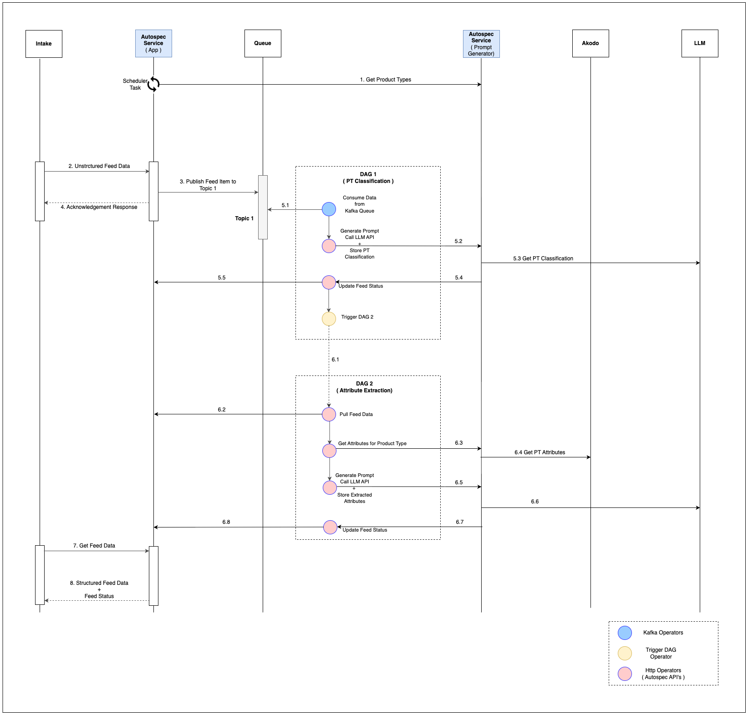

Evaluation Metrics & Verification Methodology
To ensure robustness and measurable improvement, the system was evaluated against well-defined KPIs and success criteria:
Metric | Definition | Target
Accuracy | Percentage of correctly extracted attributes | ≥ 90%
Completeness | Ratio of populated fields to total required fields | ≥ 95%
LLM Confidence Score | Model’s self-assessed confidence in predictions | ≥ 0.85
Manual Review Reduction | Reduction in human verification effort | ≥ 60%
Processing Latency | End-to-end extraction time per SKU | ≤ 10 seconds
Listing Rejection Rate | Reduction in rejected listings due to missing data | ≥ 30%
Evaluation involved validation across multiple product categories with manual benchmarking and automated accuracy scoring using labelled datasets from the Akodo specification system.

Key Results or Business Impact
Based on pilot evaluations and marketplace projections:
- Efficiency Gain: 40–50% reduction in product onboarding cycle time.
- Quality Improvement: 25–30% increase in attribute completeness and accuracy.
- Scalability: System designed to handle 420M SKUs with ~150M new SKUs annually.
- Cost Impact: $600M–$1.5B annual savings based on labor hour reduction.
- ROI: Payback achieved within 12 months of go-live.
- Seller Adoption: Improved satisfaction due to reduced manual intervention and faster onboarding.
These results demonstrate tangible business value through measurable improvement in speed, accuracy, and content quality.

Challenges & Learnings
While the AI-driven approach offers substantial benefits, it introduces new complexities that must be managed carefully:
- LLM Hallucination:
Occasionally, models infer incorrect attributes. This is mitigated via prompt engineering, fallback models, and confidence thresholds.
- Prompt Drift:
Over time, model responses may vary with context changes. Continuous retraining and version control of prompts are crucial.
- Cost Optimization:
API calls to large models can be expensive. DAG-level orchestration introduces dynamic model selection (e.g., GPT-4 for high accuracy, GPT-3.5 for cost efficiency).
- Integration Complexity:
Seamless interfacing with legacy intake systems and Akodo schema updates required extensive API standardization.
- Cross-Category Generalization:
Training models to handle diverse product categories demands extensive data normalization and feedback cycles.

Future Roadmap
The roadmap focuses on extending the current architecture into a self-adaptive, multimodal, and agentic AI ecosystem:
- Multimodal Inputs: Incorporate image-based feature extraction (e.g., packaging, color, shape) using Vision Transformers (ViT) and OCR pipelines.
- Reinforcement Learning: Introduce feedback loops for self-improving models through reinforcement signals from human-in-the-loop validations.
- Agentic AI Layer: Transition to Version 3 (LangGraph-based design) enabling autonomous goal-directed agents capable of optimizing workflow dynamically.
- Scalability Enhancements: Expand to international marketplaces (e.g., FCC, Massmart).
- Continuous Monitoring: Integrate observability dashboards to track data quality, latency, and drift metrics.
These initiatives will further Walmart’s strategic goal of autonomous digital transformation across global marketplaces.

Conclusion
The “Spec-Free Item Ingestion” initiative represents a significant leap in Walmart’s journey toward intelligent, data-driven automation. By combining LLMs, ML models, and modular orchestration, the system transforms product onboarding from a manual, error-prone process into a scalable, adaptive, and high-precision operation.
The project demonstrates the convergence of AI, automation, and enterprise-scale design thinking — ensuring better data quality, faster time-to-market, and substantial cost savings. It also establishes a scalable foundation for future innovations involving Agentic AI and multimodal learning, reinforcing Walmart’s position at the forefront of digital transformation in retail technology.

References & Acknowledgements
- Project Repository: nucleus-hub/autospec-service
- Internal Design References: Walmart Confluence (API Design, Kafka Design, Database Schema)
- LLM Frameworks: LangChain, OpenAI GPT Series, Hugging Face Transformers
- Workflow Tools: Apache Airflow, LangGraph
- Authors & Contributors: Kulbir Singh, Walmart Global Tech

(End of Whitepaper)

