Fibonacci and The Golden Ratio

People rarely speak of Mathematics and Fun in the same sentence. The first three suggestions when searching ‘why is maths’ on Google are: ‘so boring’, ‘so difficult’ and ‘important’. But Maths can be fun, right? In this article we’ll be going through one of the more popular as well as enthralling concepts from the world of numbers: Fibonacci Numbers.

Any person who has ever studied maths will be acquainted with the Fibonacci numbers or the Fibonacci sequence, introduced by Leonardo of Pisa in his 1202 book Liber Abaci. Well, to sum up, the Fibonacci sequence is made of numbers where each number is a sum of two preceding numbers in the sequence, beginning from 0 and 1. Thus, the first fifteen numbers in the sequence are:

0, 1, 1, 2, 3, 5, 8, 13, 21, 34, 55, 89, 144, 233, 377…. and so on.

Here, the 6th term, 5 is a sum of 2 and 3, 89 results from the addition of 34 and 55, and 233 from 89 and 144. The sequence obviously stretches to infinity. However, an interesting observation arises from the Fibonacci sequence, when we divide any number in the series from the previous number, we increasingly tend towards the ratio 1.618, as seen in the image below. This is the Golden Ratio, also known as Phi.

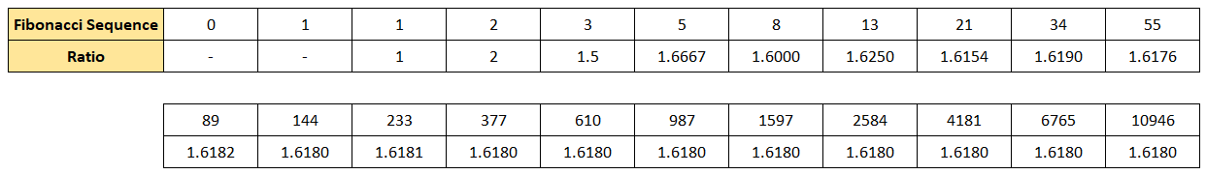

The Golden Ratio also manifests in the following spiral:

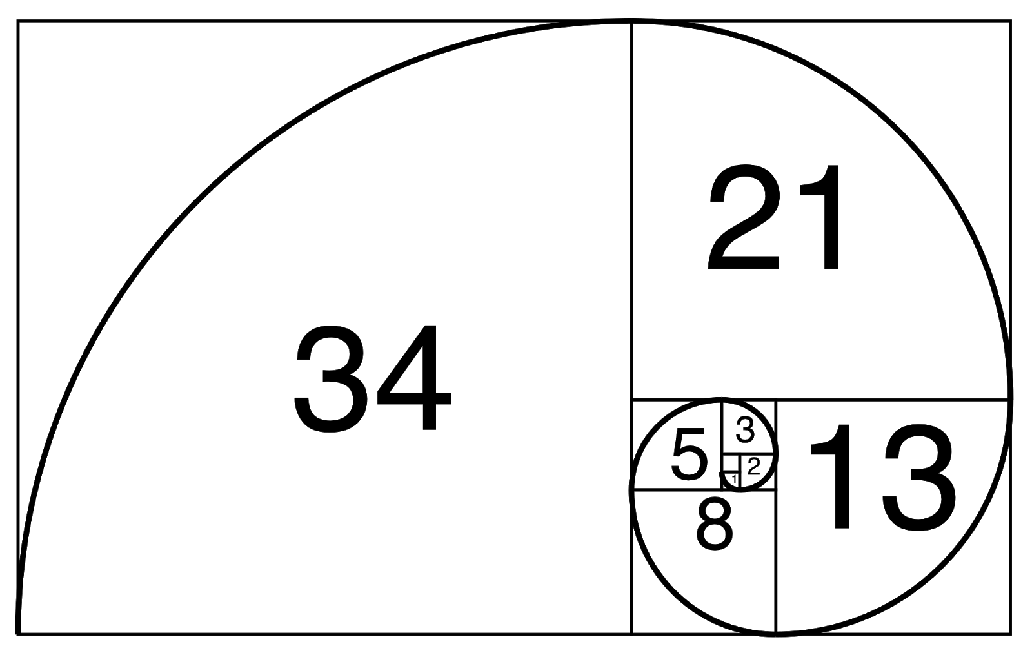

Image Credit: theincredibletruths.com

The appearance and applications of Fibonacci numbers and the Golden Ratio are plenty and baffling, ranging from nature and biology to algorithms and even the stock market. Here, we’ll discuss some of these intriguing aspects of the two.

# Fibonacci in Nature, Space and Biology

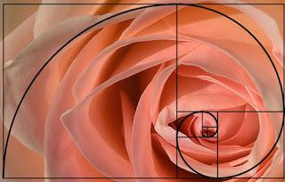

As evident from the above image, petals of many flowers like roses, sunflowers, and lilies follow a pattern very similar to the one formed by the Golden Ratio. This phenomenon is also found in biology, especially human anatomy.

There are many instances of the Golden Ratio in the human body, and many people even estimate the number to be as high as 300! Like, the length of your palm to your arm is approximately 1.618. The spiral also appears quite frequently in many works of art, particularly in those of Leonardo Da Vinci.

Outer space also encompasses the Golden Ratio in many forms and methods, like the spiral of a galaxy. Or that the ratio of diameter of Saturn’s rings to the diameter of the planet itself is very close to the Golden Ratio.

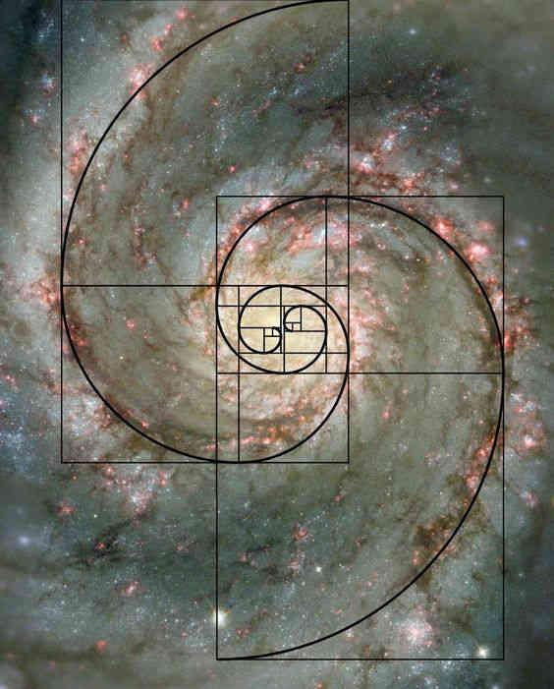

Image Credit: unimelb.edu.au

A more acute example of the Golden Ratio in space would be found in our Solar System itself. The period it takes for many planets to revolve around the sun on their elliptical paths corresponds very closely to the Golden Ratio (and the use of exponents).

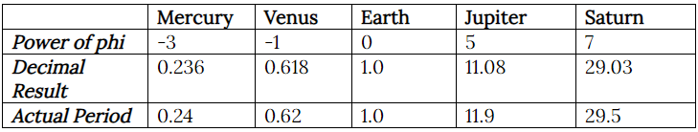

# Fibonacci Retracements

One application of the Fibonacci series appears in the stock market, specifically in technical analysis of securities. Consistency is a prominent feature of the series, and it is also visible when we divide one term with its succeeding numbers in the series.

For example,

Dividing one number by the following number, 13/21 = 0.618

If we skip over one number in the series, we get 13/34 = 0.382

Skipping over two numbers gets us 13/55 = 0.236

This holds true for all numbers in the series, and when expressed as percentages they are 61.8%, 38.2% and 23.6% which form the levels of Fibonacci Retracements. But what exactly is Fibonacci analysis or retracement? Whenever a stock moves in any direction, upwards or downwards, usually it tends to retract before its next movement. For example, if the price of a security moves from Rs 100 to Rs 150, it's expected that the price will retrace to Rs 120 before moving upwards again to a higher level. The Fibonacci Ratios, i.e 61.8%, 38.2% and 23.6% helps traders determine the level of retracement, and also serve as indicators to enter a new position or exit a loss-making one.

Let’s understand Fibonacci Retracement through the help of the TCS share price over the last 6 months.

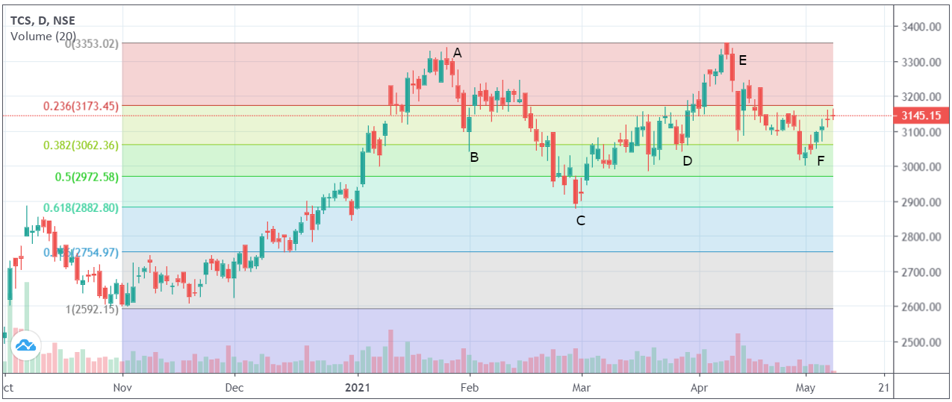

Image Credit: moneycontrol.com

We can calculate the retracement levels manually, but most technical analysis tools enable us to draw Fibonacci levels automatically. Fibonacci levels are drawn when the stock is in an uptrend or downtrend, between a trough and a peak. Here, the price on 2nd Nov, i.e, Rs 2592 has been taken as the trough, and point A (Rs 3353) is the peak. Notice how the stock movements correspond with the Fibonacci levels before it reaches the peak. From there, the price retreats to point B, which is 38.2% below the peak, then rises and again retraces to C 61.8% reduction. It moves onto D the 38.2% and then moves towards the peak E. From there it retraces to F and this cycle continues.

So, what does it mean for the trader? How do the retracement levels affect the trading strategies? This chart has multiple implications:

1. If a trader has a significant position at point A and sees that the stock price is falling, they can place the stop-loss at point B because the stock can fall further if it crosses that level, and it did. This function serves to cut down his losses.
2. At point C when the stock starts rallying and a trader misses this opportunity, they can enter into the market at point D, because the stock crosses the retracement line and the price is expected to rise further.

Thus, the retracement levels enable us to determine targets and stop-loss for our trades and contribute to the construction of support and resistance lines, one of the fundamental concepts of technical analysis. However, Fibonacci Retracement shouldn’t be the only factor in determining trades, but it acts as an indicator to support trading strategies and should be taken with a grain of salt.

# Conclusion

The Fibonacci number has vast applications, in many many fields. Some of the are:

1. It is used in the algorithm for a polyphase merge sort, which divides the list in the proportion of the Golden Ratio. It is also used for one-dimensional searching algorithms.
2. Random number generators also use a form of the Fibonacci sequence.
3. Used in Planning Poker, a game used to estimate the duration of software development.
4. Fibonacci series plays a key role in the formation of the Brock-Mirman economic growth model.
5. Mario Merz, a 20th-century artist, used the Golden Circle in his artworks in the 1970s.
6. Fibonacci sequence features prominently in musical composition, popularised by Joseph Schillinger.

The purpose of the article was to establish the fact that Fibonacci sequence isn’t some trivial mathematical concept spoken of casually; but that its applications are everywhere, not always prominent but subtle in nature.

# Caption