OPERATOR GUIDE
Lalikul Cut Prep
User manual for the local SVG cut preparation demo
Windows | Epilog Fusion Maker 36 | Demo version
From a laser bed image to motif centres and physical cut shapes.
Edition: August 2026

1. What this application does
Lalikul Cut Prep is a local demo that converts an image of a laser cutter bed into a collection of motif centres and physical rectangles or squares. It detects visual motifs, supports manual corrections, checks conflicts, and exports only valid geometry as SVG.
Scope: The demo does not control the laser cutter, start jobs, or configure power, speed, or material. Review the SVG in the production software before cutting.

Recommended workflow
- Prepare. Select the machine and confirm the physical bed size and working units.
- Load. Paste the image from Epilog Dashboard or open an image from Windows.
- Position. Lock or unlock the image to position it without distortion.
- Detect. Run Detect and review every visual centre and cut shape.
- Correct. Move, add, delete, or disable detections. Use Fix Overlaps or arrange orange cuts manually.
- Verify. Run Verify Export to check the round-trip transformation.
- Export. Save the SVG in the required unit and confirm its dimensions in the receiving software.

2. Installation and startup on Windows
- Install Python. Use Python 3.10 or later and enable Add python.exe to PATH during installation.
- Run setup.bat. The setup creates a local .venv and installs PySide6, OpenCV, and NumPy. It rebuilds the environment if the existing one is broken.
- Open Lalikul Cut Prep.lnk. The shortcut created by setup.bat launches the app through pythonw.exe, with the Lalikul icon and no visible terminal. Use run_console.bat only for diagnostics.
Privacy: All processing runs locally. The demo does not need to upload the image to a web service.

3. Interface overview
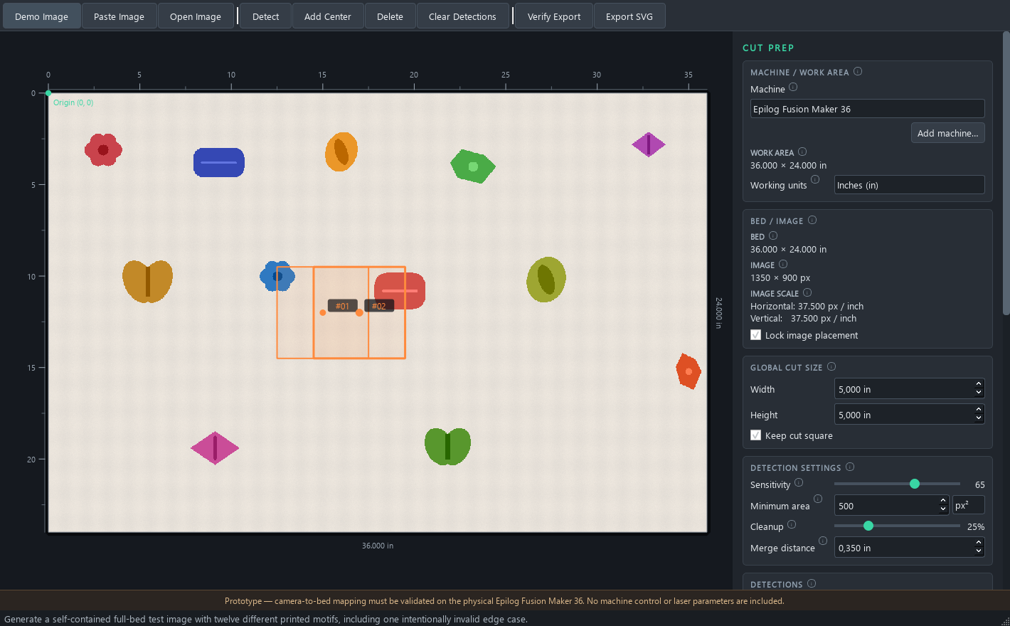
Figure 1. Full interface with two colliding cuts shown in orange.

Top toolbar
Demo Image: generates a self-contained test image.
Paste Image: pastes the current clipboard image.
Open Image: opens a PNG, JPG, JPEG, or BMP file.
Detect: runs the detector again using the current settings.
Add Center: enables manual centre creation.
Delete: deletes the selected detection.
Clear Detections: removes every detection.
Verify Export: reconstructs exportable geometry and measures the round-trip error.
Export SVG: saves enabled, valid cuts.
Fix Overlaps: appears only when cuts collide. It separates them automatically while keeping every cut as close as possible to its visual centre. Manual editing remains available.
Help: Keep the pointer still over a top-toolbar button for about 1.3 seconds. Small circular information icons open explanations in English. Navigation help opens only when you select Navigation controls.

4. Machine, bed, and units
- Machine selects the bed profile. The manufacturer states a maximum engraving area of 36 x 24 in for the Epilog Fusion Maker 36 (approximately 915 x 610 mm).
- Add machine... saves custom profiles with a name, width, height, and unit.
- Working units changes all visible measurements between in, cm, and mm.
- The origin is at the top-left corner; X increases to the right and Y increases downwards.
- IMAGE SCALE shows how many image pixels represent one physical unit horizontally and vertically.
Important: If horizontal and vertical scales differ, the app calculates them independently from image resolution and physical image placement.

5. Getting an image from Epilog Dashboard
The proposed workflow is consistent with Epilog's official documentation. Copy Background Image uses the IRIS camera system to capture the bed. Epilog states that the copied image can then be pasted into a design application; in this demo it is pasted directly from the Windows clipboard.
This is not a camera connection: Lalikul Cut Prep does not access the cameras, firmware, or an Epilog API. It only receives the image that Epilog Dashboard places on the clipboard.

Copy Background Image workflow
- Epilog Dashboard. Place the material on the bed and check the IRIS camera view.
- Copy Background Image. Select the background-image copy command in Dashboard.
- Clipboard. Windows temporarily stores the copied capture.
- Lalikul Cut Prep. Activate the app and press Ctrl+V or Paste Image.
- Detection. Select Detect, review the visual centres, and resolve any collisions.
- SVG. Verify and export the valid cut shapes.
Summary: Epilog Dashboard > Copy Background Image > clipboard > Ctrl+V > detection > cut shapes > SVG.
Official sources: Epilog - How and When To Use Copy Background Image; Epilog - Precisely place artwork using the IRIS Camera
Preflight check: The selected machine and app bed size must match the Dashboard job. Incorrect scale or image placement shifts the physical cuts.

6. Positioning and locking the image
- Unlock. Clear Lock image placement.
- Move. Drag from inside the image.
- Scale. Drag any of the four corner handles. The aspect ratio is preserved automatically.
- Lock. Enable Lock image placement again before editing centres and cut shapes.
- The image loads centred and contained within the bed without distortion.
- Detections remain anchored to image pixels when the image is moved or scaled. Automatic detections use the geometric centre of the complete visual extent, so dense lower areas in ships, violins, or machines do not pull the centre away from the artwork's middle.

Navigation controls
The compact panel floats over the bottom-left of the canvas. Opening or closing it never moves or resizes the bed.
- Pan: Space + drag, H + drag, or middle-button drag.
- Zoom: Z + click, Alt + click to zoom out, or Ctrl + mouse wheel.
- Fit the complete bed: Ctrl + 0.
- Return to normal editing: V or Esc.

7. Configuring detection
Change a setting and select Detect again. Double-click any Detection Settings control to restore its default value.
Setting | Default | Purpose | Risk when increased
Sensitivity | 65 | Detects differences from the background. | May include noise.
Minimum area | 500 px² | Rejects groups that are too small. | May discard small motifs.
Cleanup | 25% | Removes noise and closes small gaps. | May join nearby shapes.
Merge distance | 0.35 in | Groups fragments of one motif. | May join separate motifs.

Minimum area: This can be expressed in px² or in the squared global physical unit. Conversion to pixels is automatic and uses the current image scale.

8. Reviewing detections and collisions
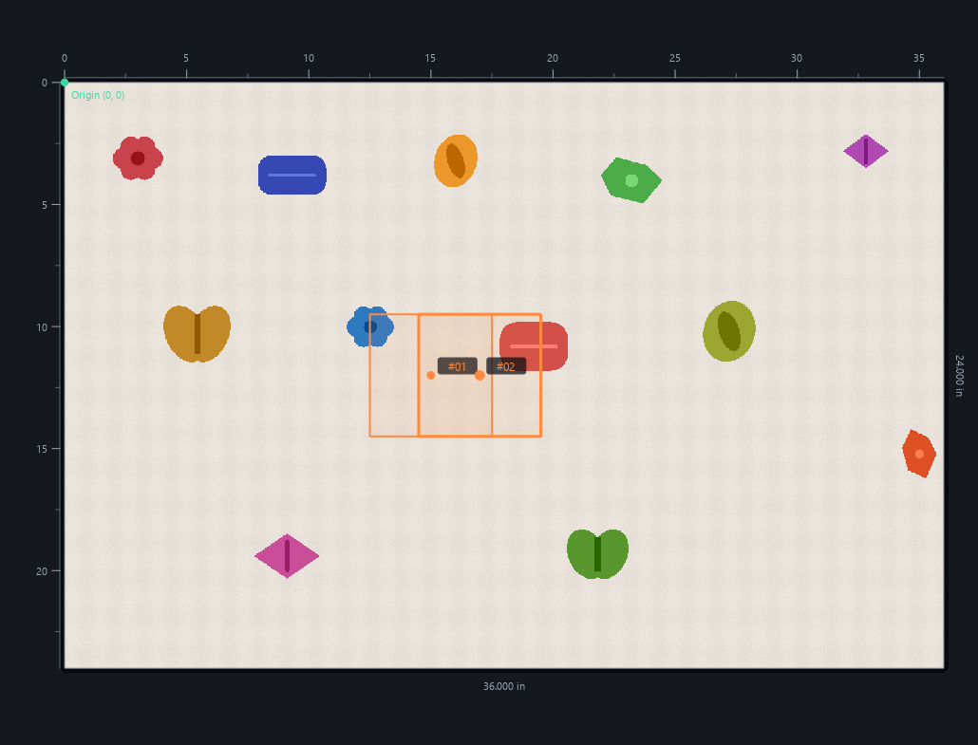
Figure 2. Two enabled overlapping cut shapes are shown in orange.
Colour | Meaning | Action
Green | Valid | Ready for export.
Yellow | Selected | Edit or inspect this centre.
Orange | Collision | Use Fix Overlaps, separate manually, or disable one.
Red | Outside bed | Move the centre or reduce the cut size.
Grey | Disabled | Enable it if it should be exported.

Collision rule: If two enabled cuts overlap or their edges touch exactly, both change to COLLISION. They count as invalid and are excluded from the SVG. Fix Overlaps keeps visual centres as anchors and shares the minimum required movement between colliding cuts; manual arrangement remains available. A disabled cut does not create a conflict.

9. Manual editing and cut size

Moving and managing centres
- Select a centre or its cut shape and drag it to move it.
- Enable Add Center and click on the bed to create a manual centre.
- Press Delete to remove the selection or Clear Detections to empty the list.
- Include in export enables or disables a cut without deleting it.

Global Cut Size
- The initial value is 5 x 5 in.
- With Keep cut square enabled, edit either Width or Height; the other dimension updates automatically.
- Disable Keep cut square to create freely sized rectangles.
- Use the up and down arrows or type a value directly.
Global effect: The configured size applies to every detection and can create or resolve collisions and out-of-bed cuts.

10. Verifying and exporting SVG
- Review. Confirm there are no red or orange cuts and that all required cuts are enabled.
- Verify Export. The app converts geometry to the export unit and reconstructs it in pixels. The purple outline and maximum error verify the round trip.
- Export units. Keep Same as working units whenever possible.
- Export SVG. Choose the destination and confirm any unit-change warning.
- The SVG contains only enabled cuts that are inside the bed and collision-free.
- The image, centres, labels, and bounding boxes are not exported.
- Write debug JSON beside SVG creates a diagnostic file containing scales, states, and coordinates.
Warning: If Export units differs from Working units, verify the total bed size and cut positions in the receiving software before production.

11. Troubleshooting
The shortcut reports a missing environment: Run setup.bat. If Python was removed, reinstall it and repeat setup.
Ctrl+V does not load an image: Return to Epilog Dashboard, select Copy Background Image, and paste immediately. Also confirm the clipboard contains an image.
The image looks distorted: Reload it. The app preserves aspect ratio; use only the corner handles to scale it.
Detect finds internal parts: Increase Merge distance or Cleanup cautiously, then run detection again.
Two cuts are orange: Select Fix Overlaps to minimise displacement from the visual centres, or drag the cuts manually until they are separated. You can also disable one.
A cut is red: Its outline extends outside the bed. Move the centre or reduce Global Cut Size.
The imported SVG has the wrong size: Match Export units to Working units and verify the page size during import.

12. Current demo limitations
- There is no direct connection to cameras, Dashboard, PrintAPI, or the laser cutter.
- Detection uses OpenCV, not YOLO or a trained model.
- The app does not configure power, speed, frequency, focus, or material.
- Mapping is linear and does not correct perspective or homography.
- Physically validate the origin, scale, and SVG on the Epilog Fusion Maker 36 before production.

Default values
Setting | Initial value
Machine | Epilog Fusion Maker 36 - 36 x 24 in
Working units | Inches (in)
Global Cut Size | 5 x 5 in
Sensitivity | 65
Minimum area | 500 px²
Cleanup | 25%
Merge distance | 0.35 in
Image placement | Locked
Export units | Same as working units

