Here you are able to upload information in two tables with xml file.

GitHub - https://github.com/nudl3s/wwiis.git

1. 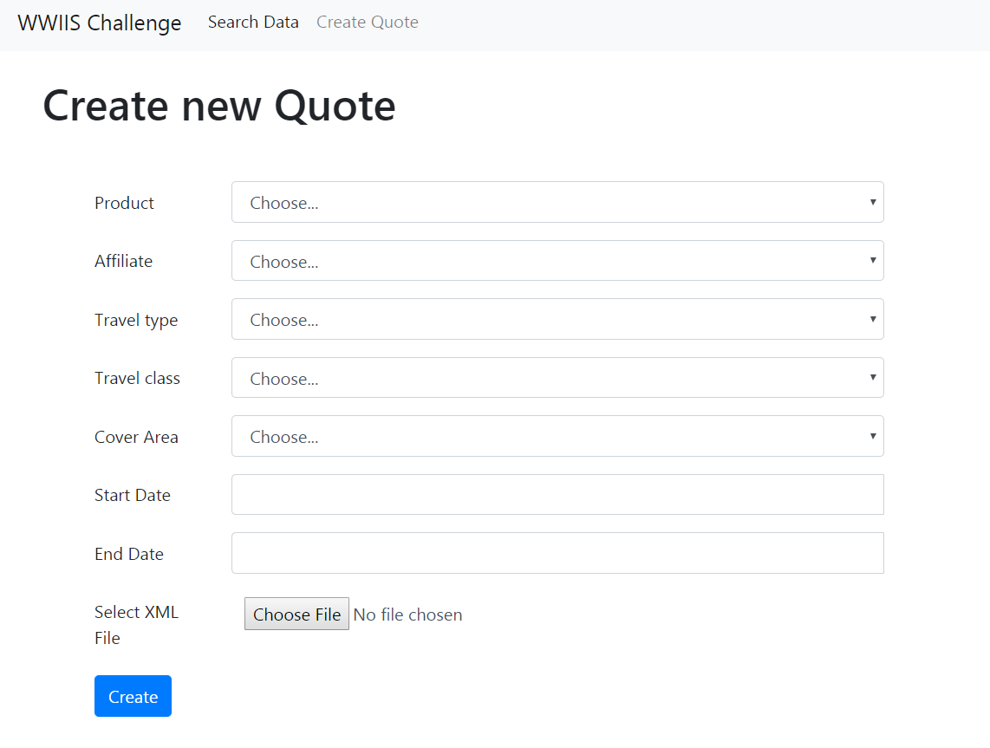Create page – Form allow us to choose some data and send it via ajax request to our function for insert into database..
2. 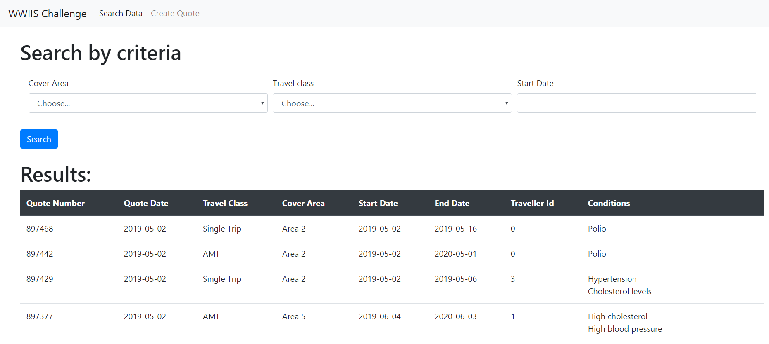Search Page – searching by some criteria and with Join getting the conditions that are saved in text field as xml.