Work-case 2
Made by БІКС-13 students: Ihor Kohut, Artem Bereza, Sofiia Lapchyk
Made by Sofiia Lapchyk:
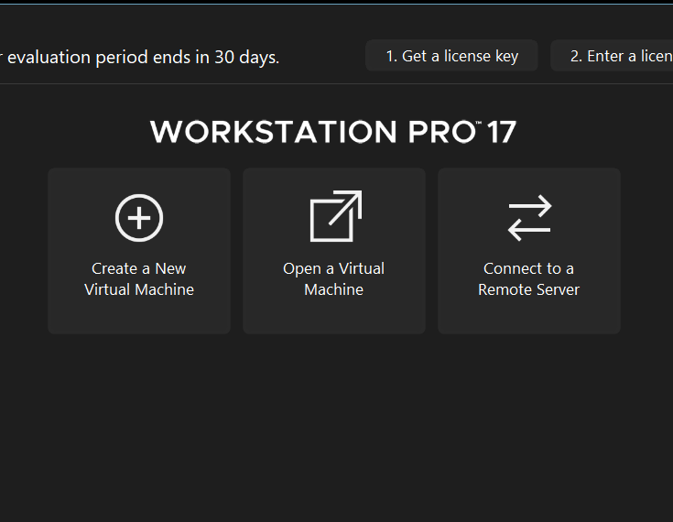
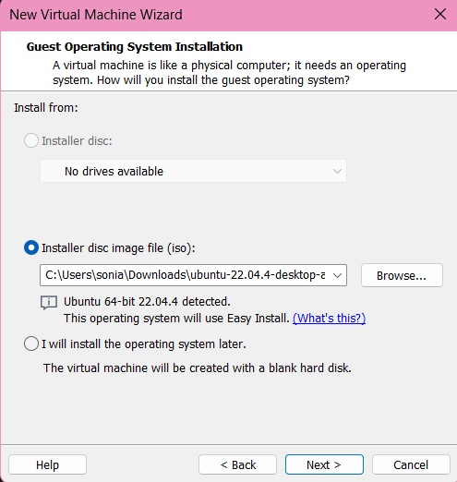
2. Describe a set of basic actions in the hypervisor you installed:
- Creating a new virtual machine:
As soon as you have downloaded hypervisor you should to download ISO image. Open hypervisor and fill in some appropriate details: ISO image, machine folder, name, user profile. Define the virtual machine’s resources: how much of our host machine’s memory and processors the virtual machine can use.
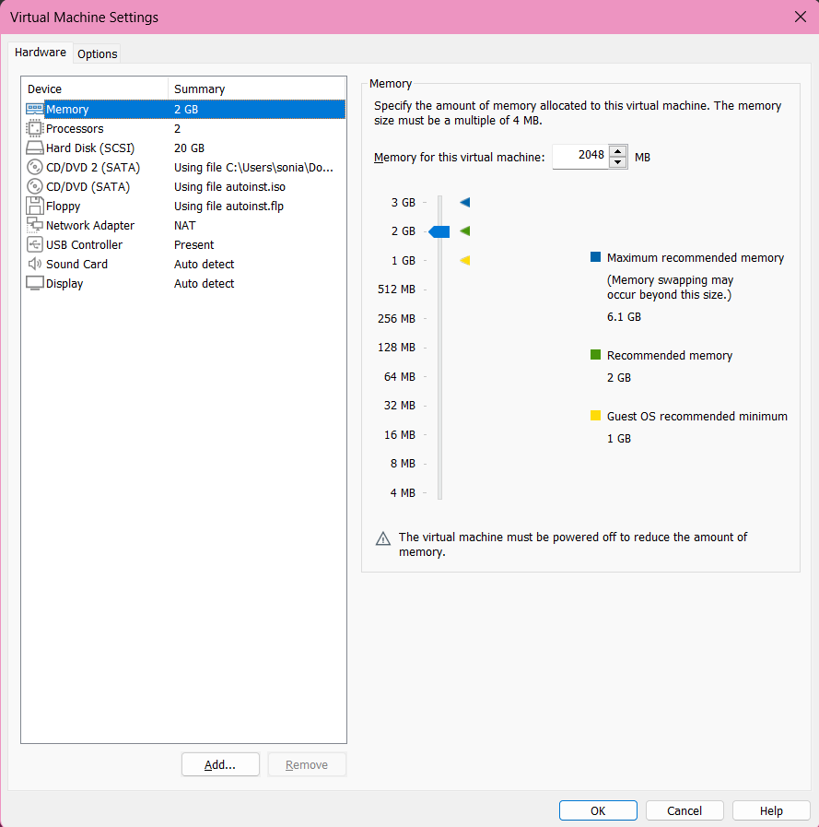
- Selecting/adding equipment available for the virtual machine:
Click “VM” in the top panel, “Settings”, in the hardware tab you can add new devices such as network adapters, additional disks, USB devices.

- Setting up the network and connecting to Wi-Fi points:
Add or configure a network adapter for the virtual machine in the same hardware tab, choose the type of network: standard network or Wi-Fi network.
- Ability to work with external storage (flash memory):
In the hardware tab you can add a new USB controller or USB device by this option. Connecting the external storage is made by selecting it from the list of USB devices.

