Work-case 2
Made by БІКС-13 students: Ihor Kohut, Artem Bereza, Sofiia Lapchyk
Made by Ihor Kohut:
3. Install the GNU/Linux CentOS operating system (or other convenient distribution for you) in your hypervisor in a basic configuration with a graphical program.
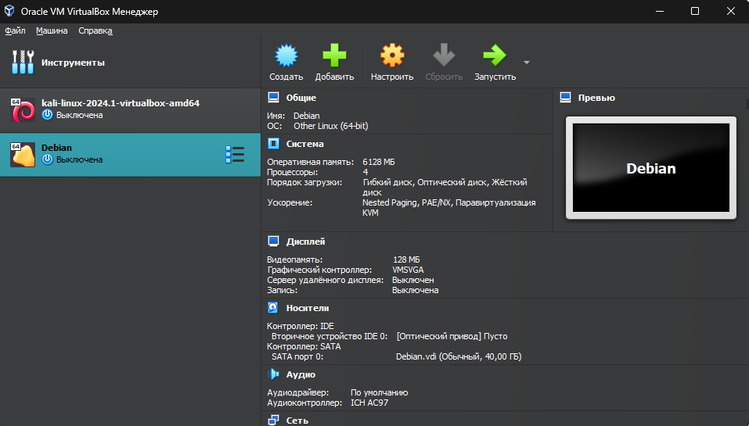
To create an operating system in the hypervisor, you need to click the “Create” button, then set the name of the new system, select the system you need from the list of systems and load the system ISO file. It’s also worth setting up memory, RAM and how many processor cores the system will use, I configured all this in the window before the first launch (installation) of the system.
Then press run.
Selecting the Graphical install
Selecting English language
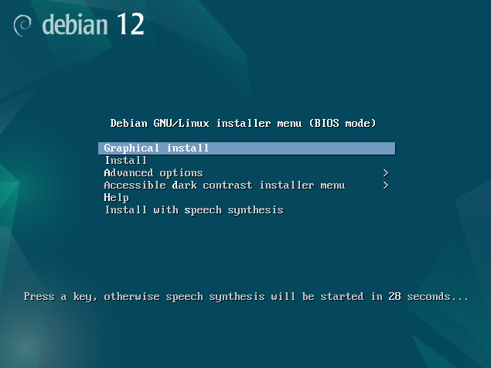
Next step: select country – Ukraine, and select the keyboard layout
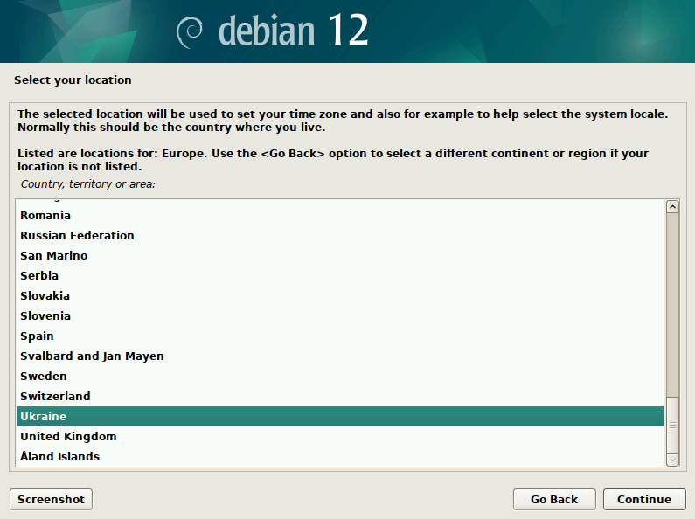
Installation begins. Then we set the root and user passwords. Next is a window with disk selection, select the first item and select our disk.
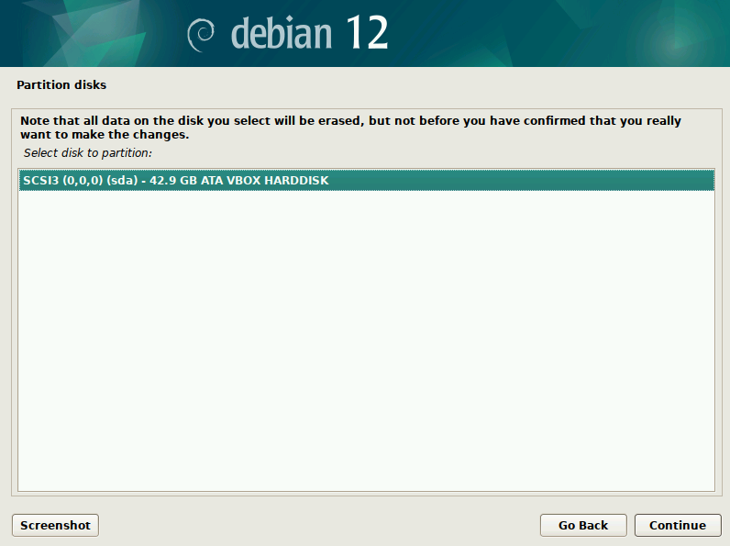
Press “Yes”.
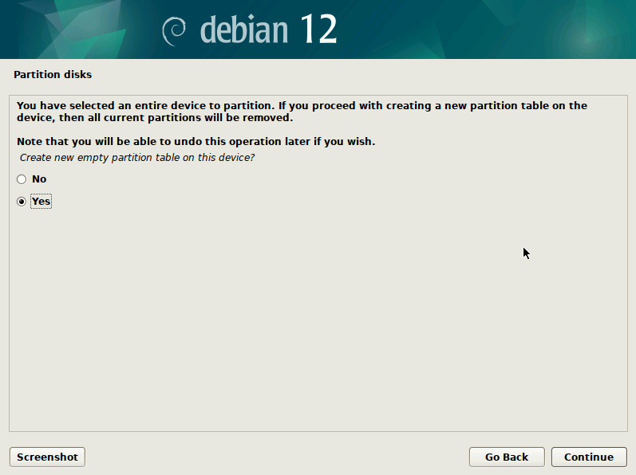
Installing…
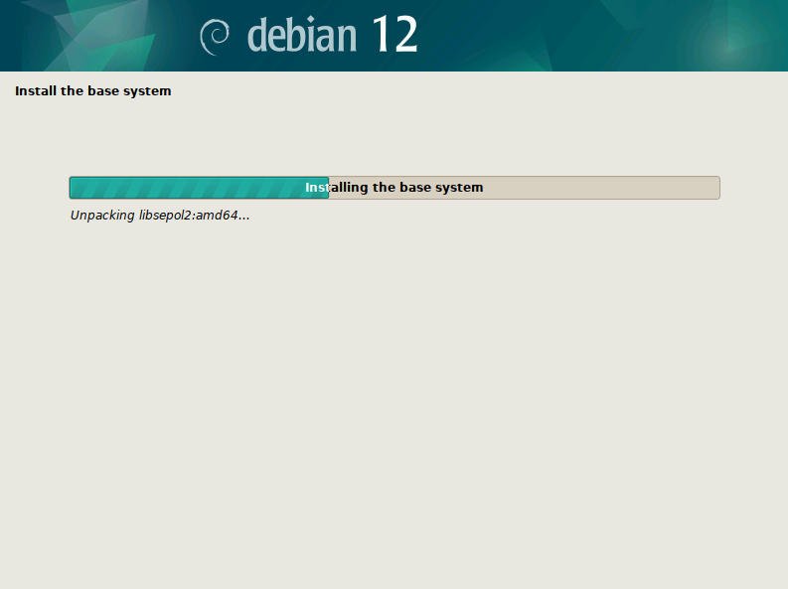
Set the region to Ukraine so that it is correctly connected to the mirror and set deb.debian.org
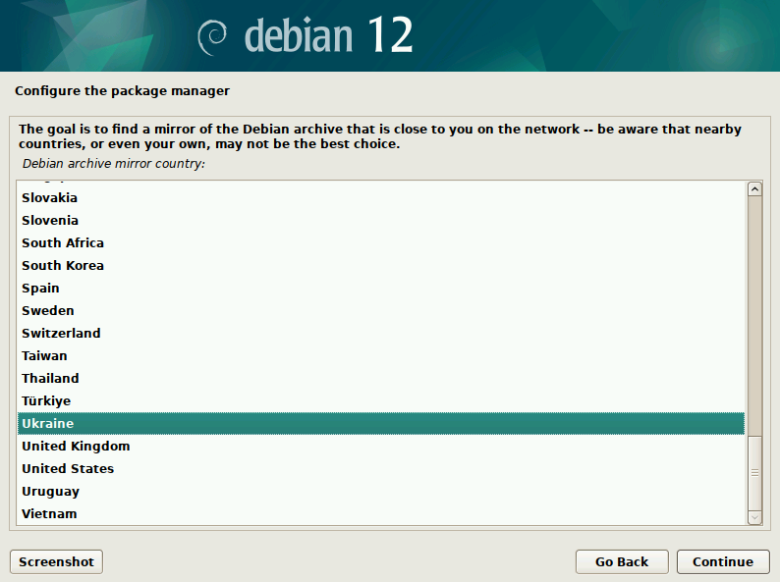
Select desktop environment – GNOME
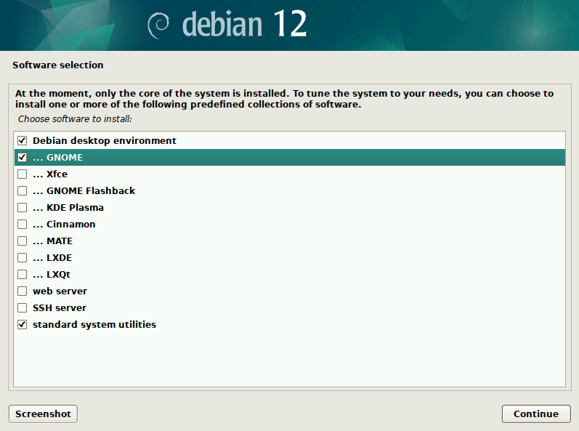
Installing…
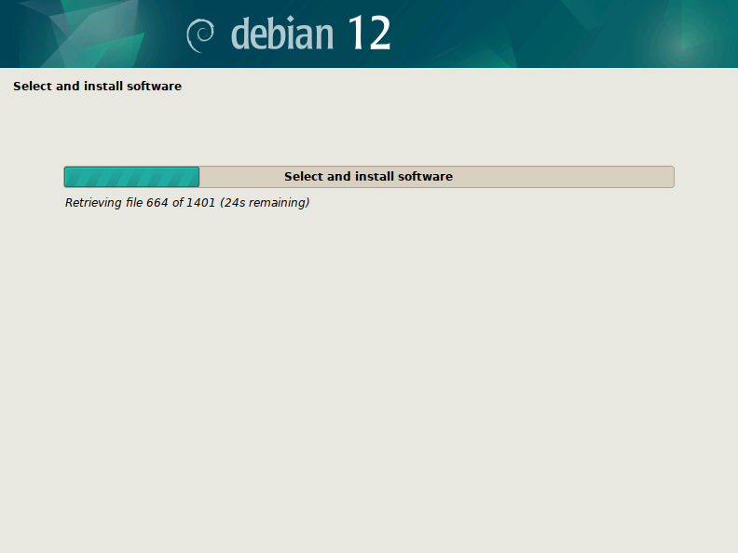
Installation is complete. Click continue.
