FREELANCE THE WORK SPACE WEBSITE INFORMATION

Company Information
- Company Registration number 060
- Trading address: 49 Addington Way, Luton, Bedfordshire LU4 9FP
- Domain name: www.FreelanceTheWorkSpace.com
- Email address: Bookings@freelancetheworkspace.com
Selina@freelancetheworkspace.com
Eugene@freelancetheworkspace.com
- Contact number: TBC

WEBSITES THAT WE LIKE:
http://www.kimblehaircare.com/
http://www.cloutieragency.com/Cloutier.html
http://www.crystalagency.com/makeupandhair
http://www.thelightrooms.com

PAGE 1: Home Page

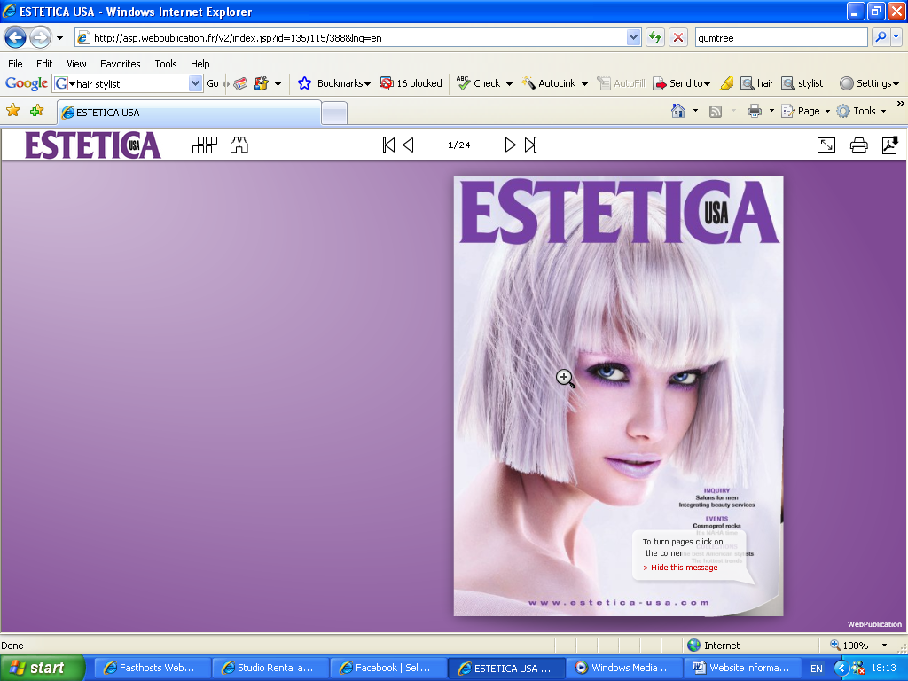
Aims of this page: To come across professional and sharp as well as approachable and fresh
- Colour Scheme: Black, Grey (Silver) and Lime
- Magazine style website like this website http://asp.webpublication.fr/v2/index.jsp?id=135/115/388&lng=en
- Menu will be on the front of this page
- Company logo on the front page
- Company logo needed if possible

PAGE 2: About Us Information.

Aims of this page: Introduce clients and those that want to be represented by us for work. We are a unique proposition in that we are focused on representing those of ethnic origin.

Wording for this page so far

Welcome to Freelance The Work Space Ltd, we are a specialist Afro Caribbean and Asian agency providing you with talented creative Hair Stylist, Make up Artists and Photographers. We seek to provide you with professionals to compliment you commercial, TV, print, music and film projects.

We aim to offer/provide you with specialist Afro Caribbean and Asian creative professional’s right for your work at the right levels of standards.

Our mission is to showcase Afro Caribbean and Asian creative professionals within the industry for there quality, skills and individual successes. Freelance The Work Space is just that, we are an agency for Freelancers to build their careers within a diverse array of projects and industries.

As one of the founders of this company Eugene (Rowan) Davis has over 20 years worth of industry experience and training both in the USA and UK. Having worked within the Music and Television industry, he has had his work showcased in Editorials, Music videos and Album covers. Eugene has worked with the legendary Ether Kitt, Mary J Blige, BBC’s Angelica Bell, Recording Artist Lil Kim, Chanta Moore and much much more. Please see his bio for further information and bookings.
- On this page to have an image on the side of the above wording.

PAGE 3: ARTISTS AND GALLERY

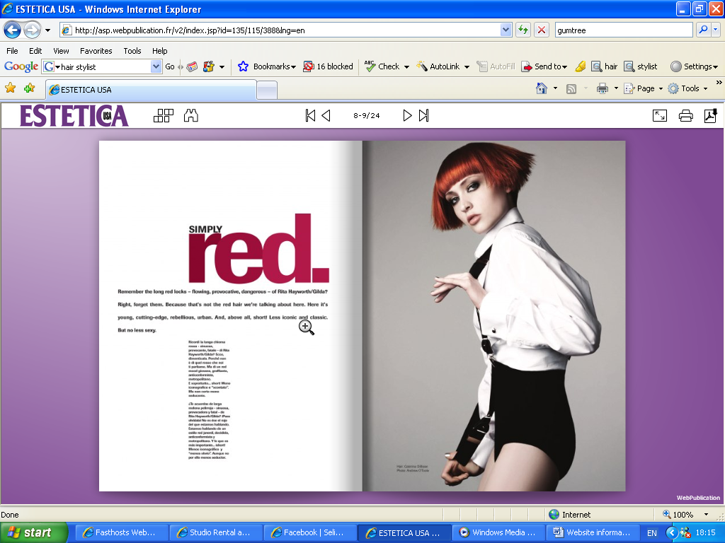

- On this page, we would like a panel that will display the different artists that we have i.e. Hair Stylists – Eugene Davis and Paula Henry, Make Up Artist – TBC and Photographer Karl
- Three sections
  - Hair Stylist
  - Make Up Artist
  - Photographer

See below for example
http://www.cloutieragency.com/Cloutier.html - Follow the link and go to the section where it says Portfolios at the top and then click by category. Select Hair and the top up is an example of how I want this page to look. I.e. the slideshow of the pictures, biography, resume and name of the artist.

I would like to be able to upload pictures onto this page as and when we get new ones etc. Also the ability to either at film reels for example, Eugene has worked on a lot of music videos and we want to display some of the video clips.

http://www.crystalagency.com/makeupandhair

PAGE 4: Representation process for Freelance The Work Space Ltd

Wording for this page so far

Thank you for your interest in being represented by www.Freelancetheworkspace.com.
While we cannot represent everyone who contacts us, we also don’t want to be the last one to know about the next great talent, so we encourage you to review this website and submit yourself according to the criteria and instructions included here.
Each submission should be addressed to bookings@freelancetheworkspace.com.
It must be accompanied by:
- Letter of intent
- 5-4X5’s of your best images at 72 or 96dpi.
- Complete contact information
- (First and last name, professional title, current home address, email address, home and/or mobile phone number.
- Resume/CV in MS Word
- City where you currently reside
- URL (other than MySpace.com)
The agency gets a 20% commission on ALL of your bookings. There is no such thing as a house account (an account that you bring to the agency that is not commissionable to the agency). Everyone here plays by the same rules.
If you submit your work to the agency and don’t get signed, don’t get discouraged. You can always resubmit in a few months should you wish to show us new work and want to try again. We will do our best to give feedback, as long as you follow the instructions that we have included here for submitting your work and images.
When submitting your images to us, pick carefully. We are looking for range and not extremes.
We would like to thank you for considering Freelance The Work Space and hope that you will continue to strive for success.

PAGE 5: CONTACT US PAGE
- Enquiry form for them to fill out and to be directed to main email address

Business needs:
- Company Website with logo – currently being completed by Withmore
- CD Business Cards – Short presentation of pictures, company info and web link
I.e. www.wizbit.net
- Letter heads for contracts etc
- Company phone (mobile or 0845 number)
- Business cards – front print the same as the CD Business cards
- Photo test shots for pictures on the Website

Clients

- Fashion Shows
- Award shows
- Magazines
- Music
- TV Companies
- Modelling agencies
- Recording companies
- Private clients

Bookers
Hair Stylist
- Eugene Davis
- Paula Henry
Photographer
- Karl
Make Up

Future plans
- Freelance The Work Space will be expanding to include a multi use Warehouse space freelancers to use. I.e. Studio space like http://www.thelightrooms.com and http://www.thewhitewomb.com/facilities.html

