

Fakulta riadenia a informatiky

**Semestrálna práca S2**

Diskrétna simulácia

Bc. Pavol Motýľ

5ZIS12

2024/2025

# Udalostný diagram

# Testovanie generátorov

Otestovanie generátorov bolo realizované pomocou nástroja Arena Input Analyzer.

## Rovnomerné diskrétne rozdelenie

## Rovnomerné spojité rozdelenie

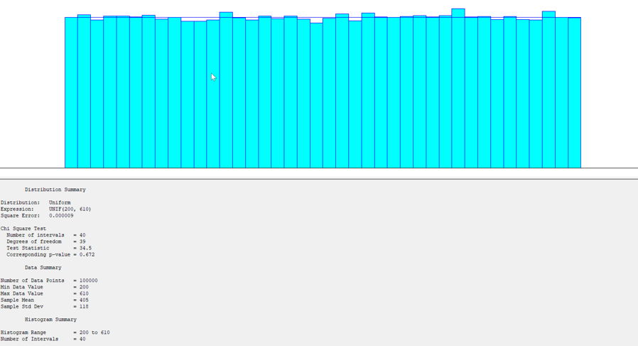

## Trojuholníkové rozdelenie

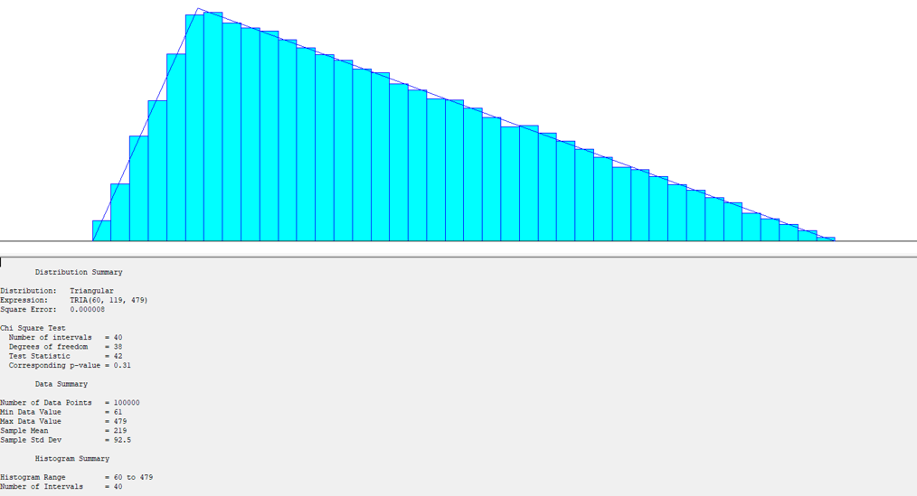

## Exponenciálne rozdelenie

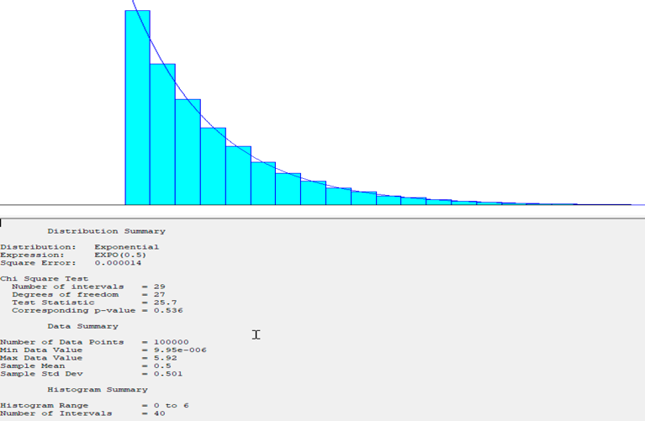

## Empirické diskrétne rozdelenie

## Empirické spojité rozdelenie

