RISE@WORK

Client Documentation, DALHOUSIE WINTER 16

Overview

This document has compiled guidelines and important information on the usability and functionality of the Rise@Work application.

CONTENTS

**ADMIN PANEL** 2

**SPREADSHEETS** 3

**MAPS** 5

**SURVEYS** 13

**USER LOGIN AND REGISTRATION** 18

**MANAGING EMAILS & STRATEGIES** 20

## **ADMIN PANEL**

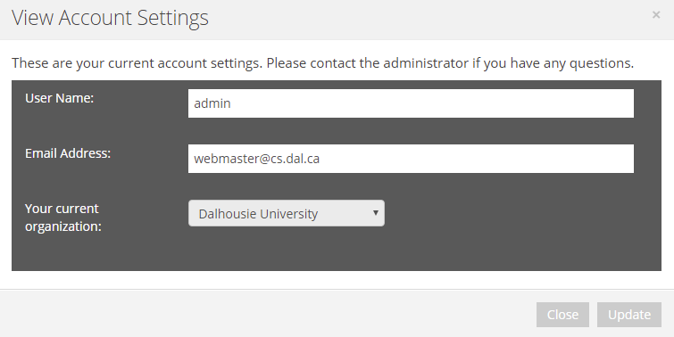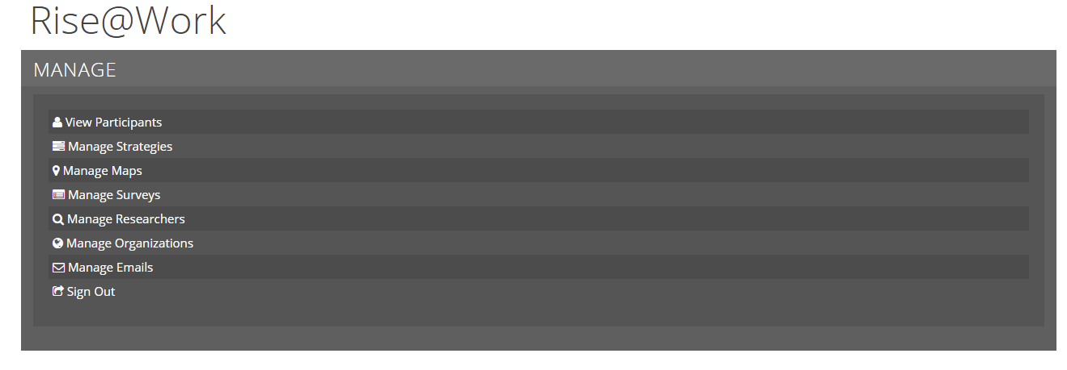The first tool the client may notice upon successful login in with an admin account is the **admin panel**:

Figure 1: Admin Panel & Account Settings

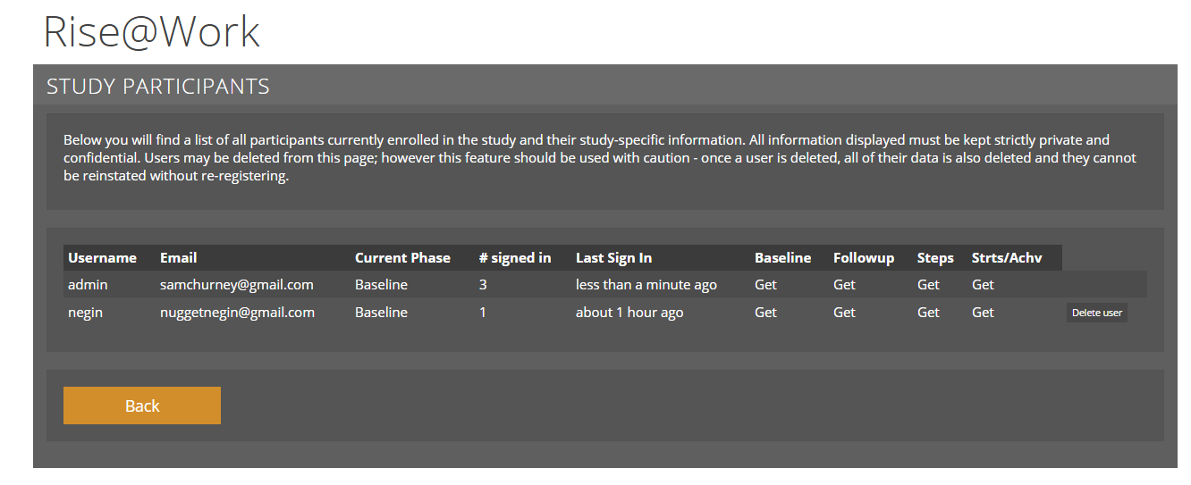The admin panel is a repository of settings and management tools which only the admin account can have access to. The first panel is the view participants panel*.*

Figure 2: Study Participants

This panel allows the admin to manage and retrieve excel spreadsheets such as the surveys and steps from the study participants currently enrolled in the specified organization. As well, it shows which users are in which phase of the study, the number of times signed and their last sign in. Lastly, it is possible to delete a participant from the organization through the **Delete User** command which will initialize a prompt confirming the deletion.

## **SPREADSHEETS**

As mentioned, Figure 2 allows for the admin to retrieve excel spreadsheets which will begin a download once initialized. There are 8 worksheets which contain all the dates and steps from Baseline, Phase 1 through 5, participant name, starting date, and steps taken in each phase.

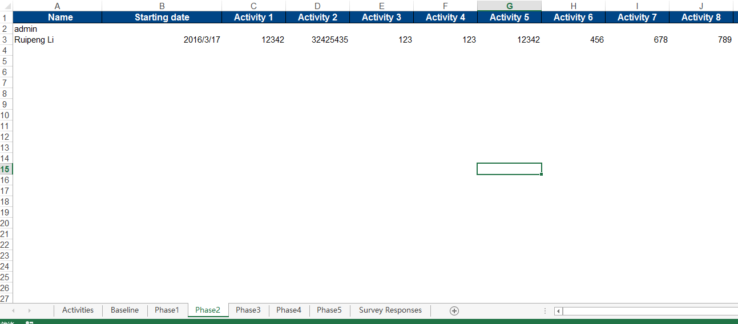

Figure 3: Example of Phase 2 Steps, Start Date, and Participant Name

The survey responses are also stored into the excel spreadsheet with all the applicable response information under the **Survey Responses** tab.

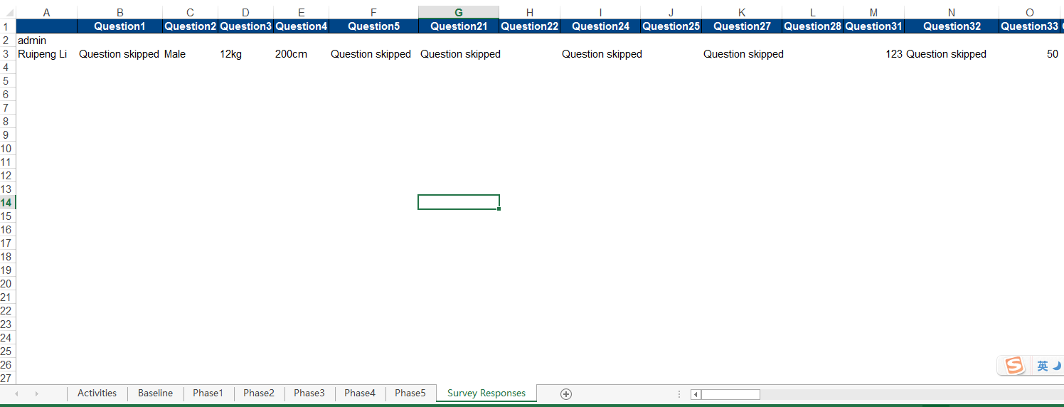

Figure 4: Survey Response section of Excel Spreadsheet

## **MAPS**

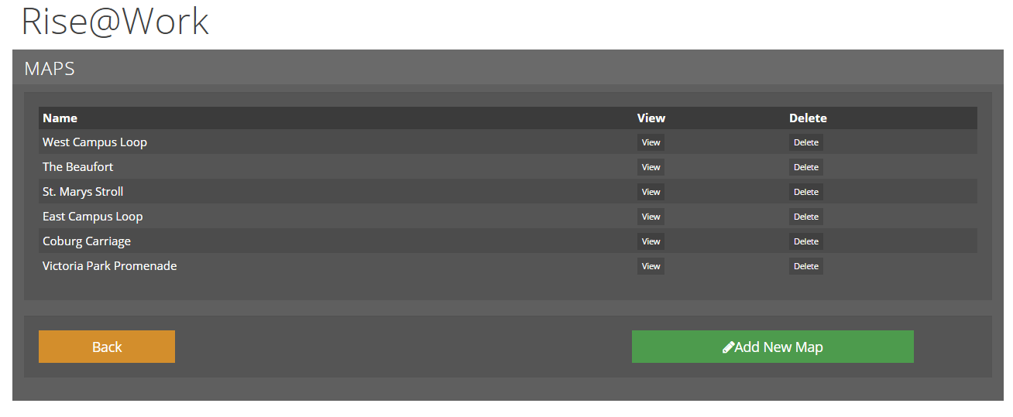Maps may be implemented through either the **Map Bank** or through the form field. Both methods will be covered in this section.

Figure 5: Maps

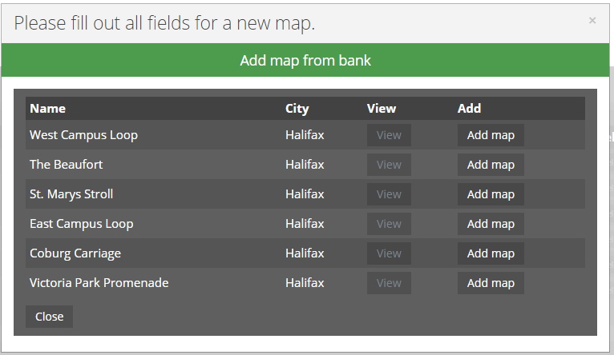To create a new map, the admin must select **Add New Map**. From there, the admin can select a premade map from the **Map Bank** or create one from scratch using the form and **Google My Maps** map and routing creation feature. The Map Bank is a repository of previously created maps. To add a map from the Map Bank simply selecting **Add map** of the selected map to be usedwill process the command.

Figure 6: Map Bank

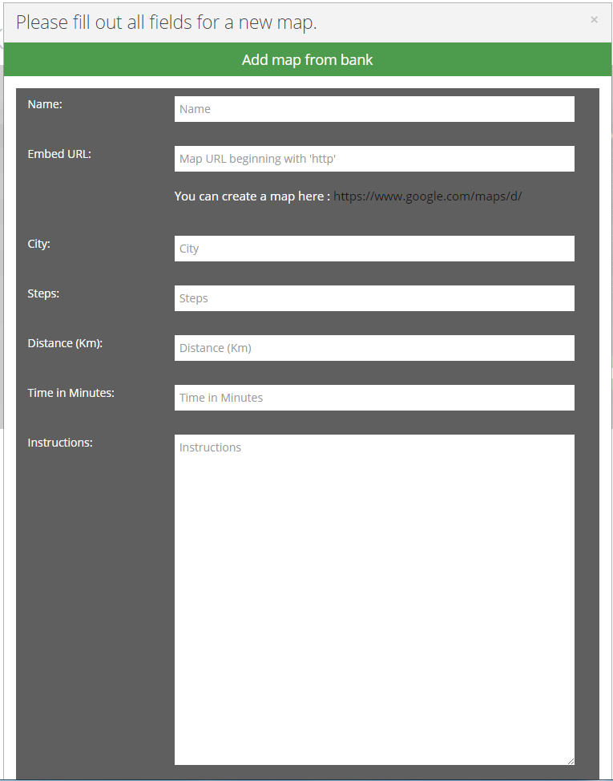

Figure 6: New Maps Form

The forms are quite straightforward and self-explanatory. However, creating an embed URL requires a bit of work. To create a new route/map select the link provided under the **Ember URL** section. This will bring the admin to a new page.

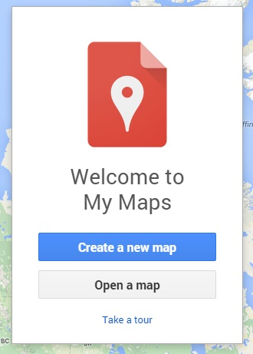

Figure 7: My Maps

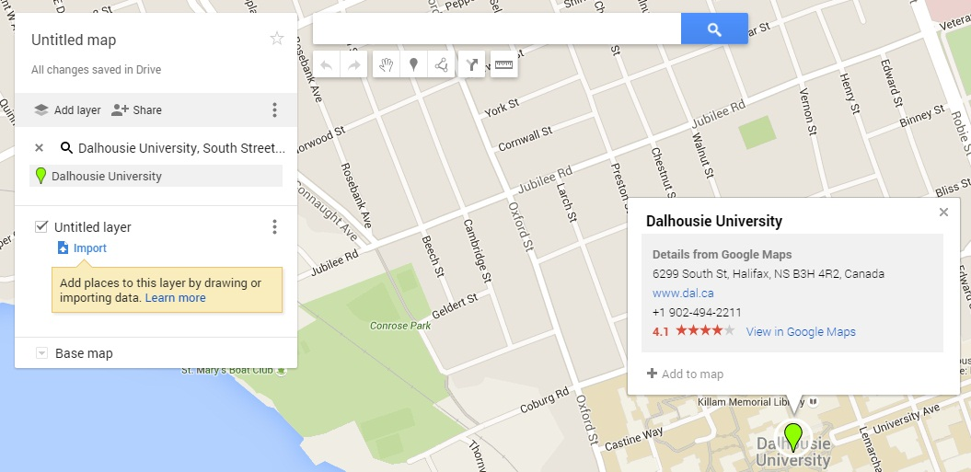

Figure 8: My Maps – Tutorial 1

To create a route, the admin may type into the search box an address or locate the area on the map. In this example, I am constructing a route from Dalhousie University to Coburg Place. To select a walking route, enter another (i.e. Coburg Place) address and select the **2 arrow icon** under the search bar (6th icon from the left.) The map should have two balloons at this point pinpointing the two locations.

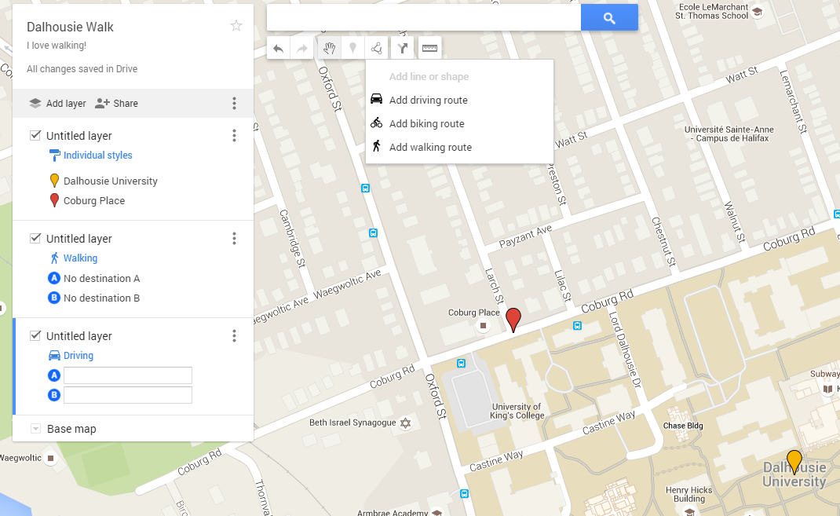

Figure 9: My Maps – Tutorial 2

Each section can be given a name and a description as seen in my example of **Dalhousie Walk** with the description **I love walking!** However, these descriptions will not be imported into the Map Bank and must be manually filled in the above form as seen in Figure 6.

After which, the admin should select **add walking route**. This will begin drawing a route from the starting location to the destination location. The admin can guide the line however they like on available roads from the starting location to the destination.

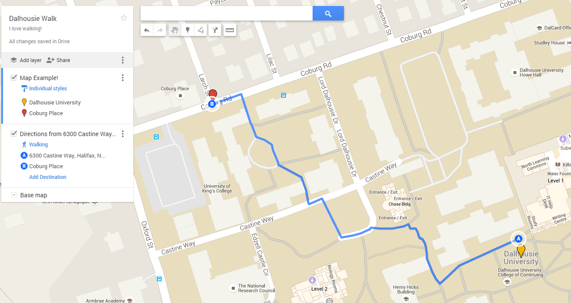

Figure 10: My Maps – Tutorial 3

Directions are then provided with the total time and distance which can be inputted into the form field in Figure 6. Again, these will not be manually imported into the form field.

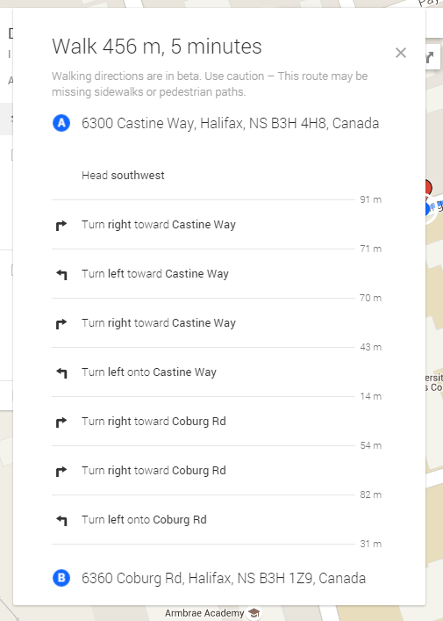

Figure 11: My Maps – Directions

The last step is to retrieve an embed link to paste into the form field of Figure 6 into **Embed URL**. This can be found by click on the **3 dots** on the right hand side of the menu and then clicking on **Embed on my site.**

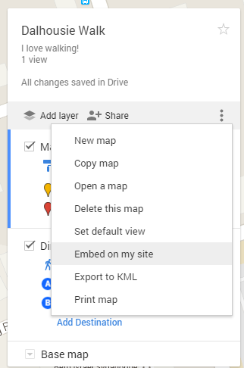

Figure 12: My Maps – Embedding

The user must ensure that the map is public or else an error will pop up stating that the map is not public and sharable. Maps are created on private by default.

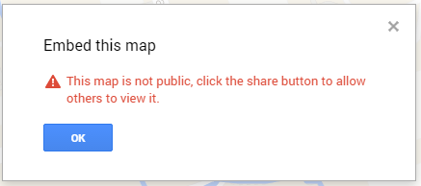

Figure 13: My Maps – Private Error

This can be achieved by changing the **Sharing Settings** one the user selects **Embed on my site** and selecting **Change…** under **Who has Access**. The sharing link here is not the correct link for the **Embed URL** field, the embed link will soon be retrieved.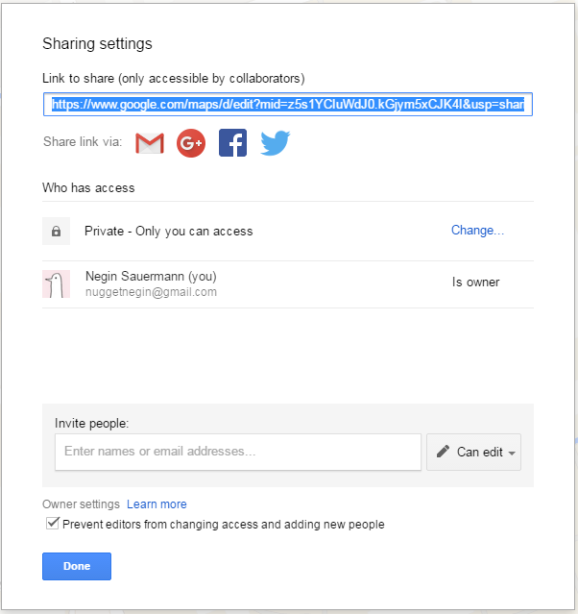

Figure 14: My Maps – Sharing Settings

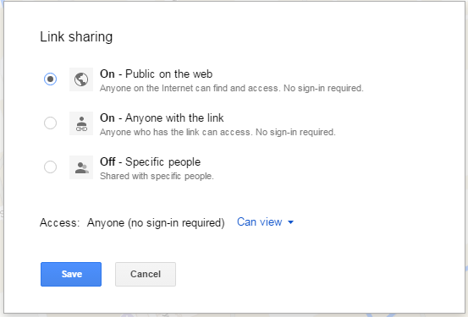

Figure 15: My Maps – Sharing Settings Continued

After these steps the new map embed link is all ready to be pasted into the **Embed URL** section of the form from Section 6. The admin must manually fill in all other applicable sections of the form field such as the number of steps, minutes, instructions and kilometres which can be retrieved from the directions portion of the My Maps. That completes the map section!

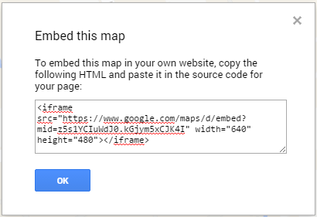

Figure 16: My Maps – Embed Link

## **SURVEYS**

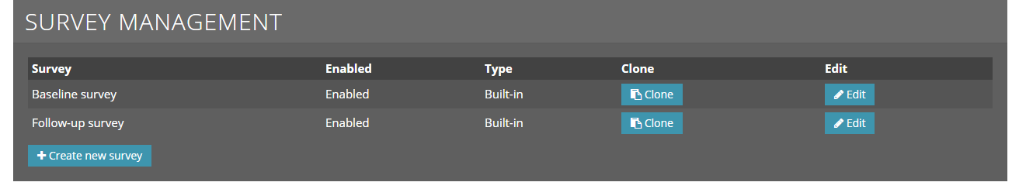Surveys can be accessed and managed completely through the **Admin Panel** as seen in Figure 1. They do not file require upload or styling.

Figure 17: Survey Management

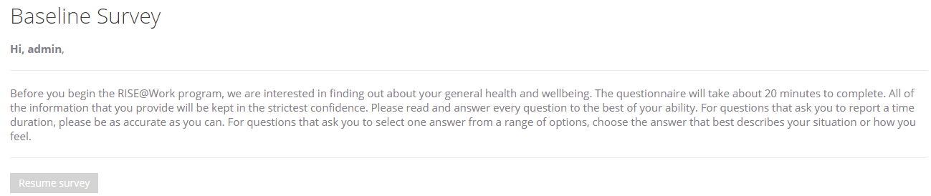The site is deployed with two surveys a **baseline** and **follow-up** survey. The **baseline survey** is prompted when the user first creates an account and successfully logs in.

Figure 18: Survey Introduction

As well, there is a survey message upon login if the user has not yet completed the survey which will allow the user to resume the survey. As such, the user will not have access to the features of the Rise@Work application until they have completed the survey.

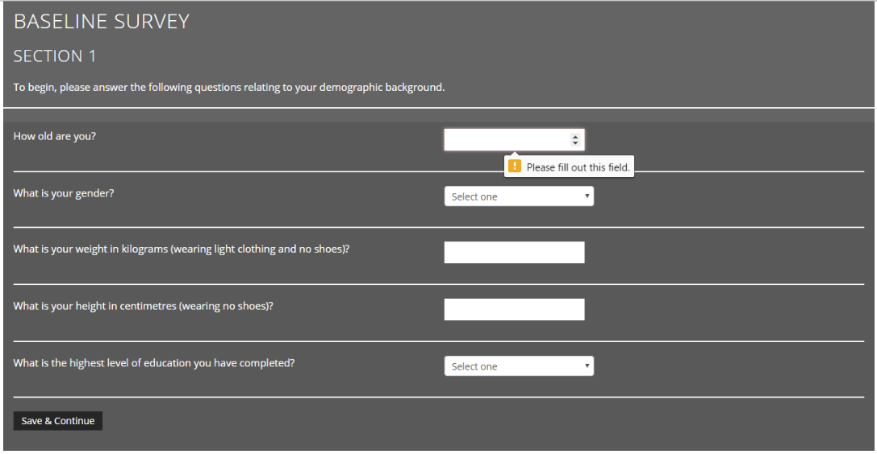Furthermore, the survey is divide into 6 sections so that the user does not have to constantly click the next button for each question. There are effective error handling checks such as a prompt stating **Please fill out this field** if the user attempts to **Save and Continue** without filling out a section. Select boxes are surrounded in red if the user does not select an option from the box.

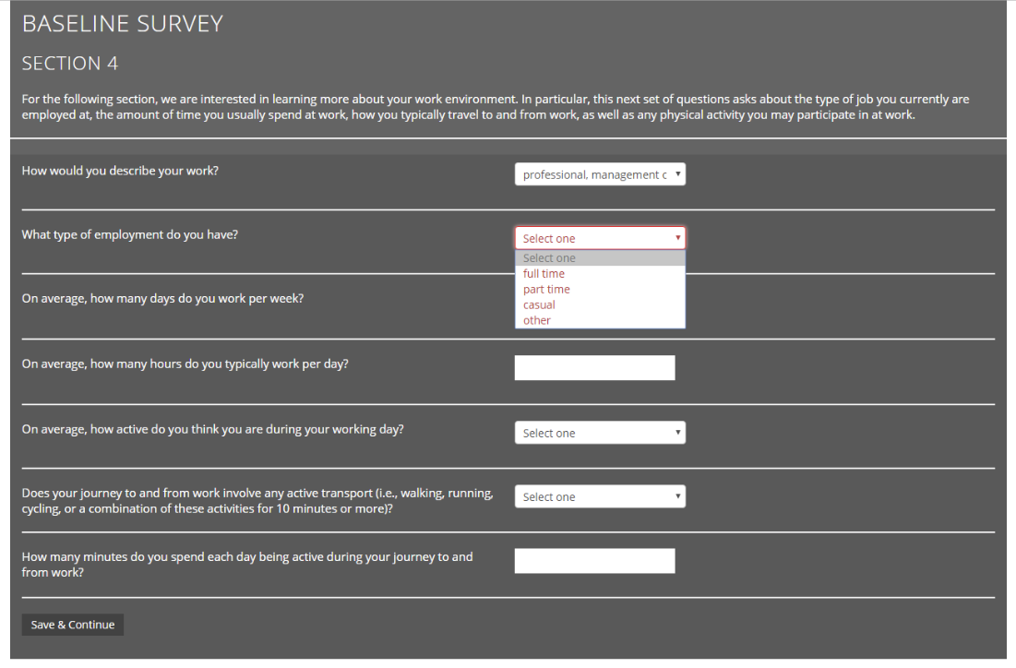Figure 19: Baseline Survey – Textbox Error & Select Box Error

Once the user completes the survey, they are thanked for completing the survey and provided with a link to the dashboard/homepage. To customize a survey, the admin may select the **edit** field in Figure 17. However, built-in surveys cannot be modified. They must be first **cloned** which is also an option in the Survey Management section.

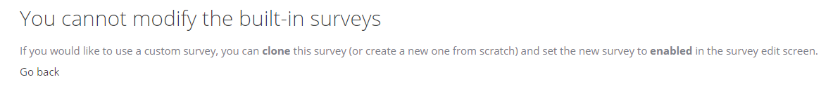Figure 20: Survey Modification Error

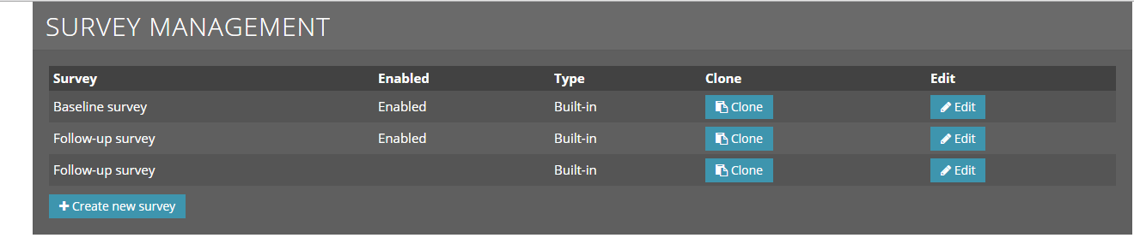

Figure 21: Survey Clone Example – 2 Follow-Up surveys created through Clone feature

Another option is to create a survey from scratch and ensure that the survey is set to **enabled**. As seen in Figure 22. When editing, each section and description can be edited and sections can also be implemented through the **+ Add Section to** survey field at the bottom of the page. Surveys can also be deleted but this cannot be undone so ensure that the correct survey is being deleted.

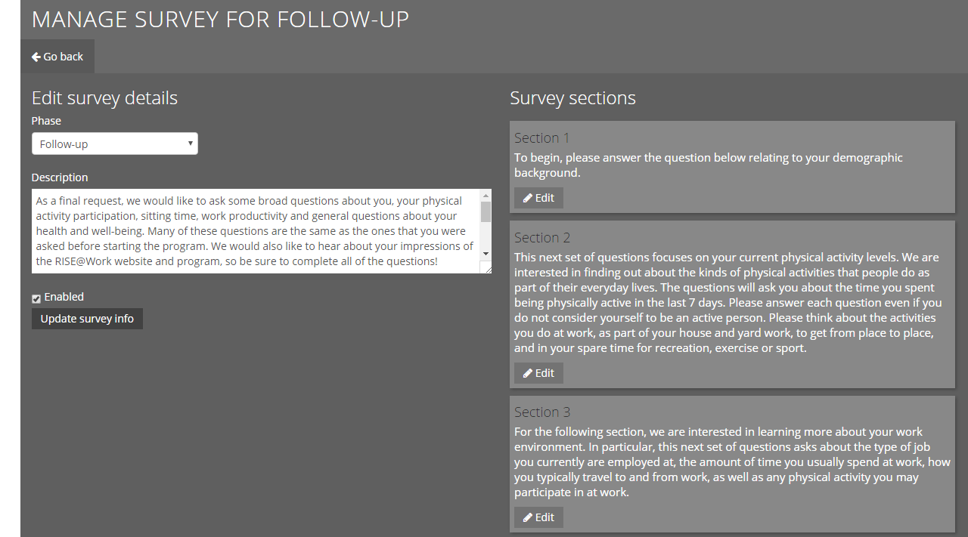

Figure 22: Edit Survey

MANAGE ORGANIZATIONS

Organizations can be managed and created through the **admin panel**.

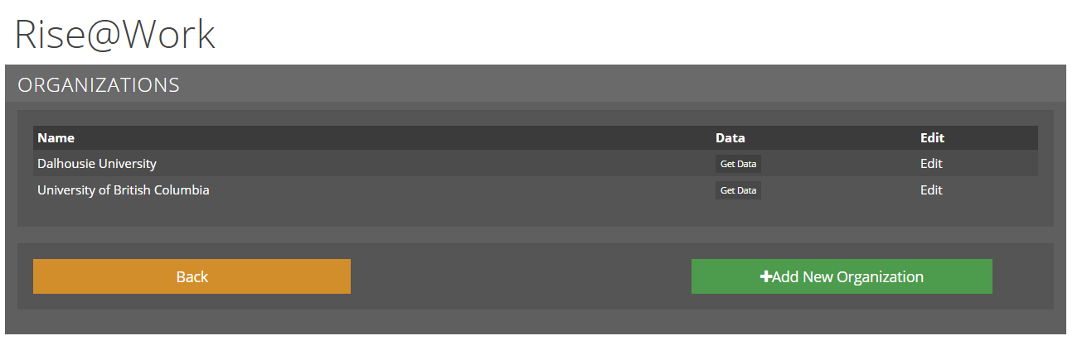

Figure 23: Organizations View

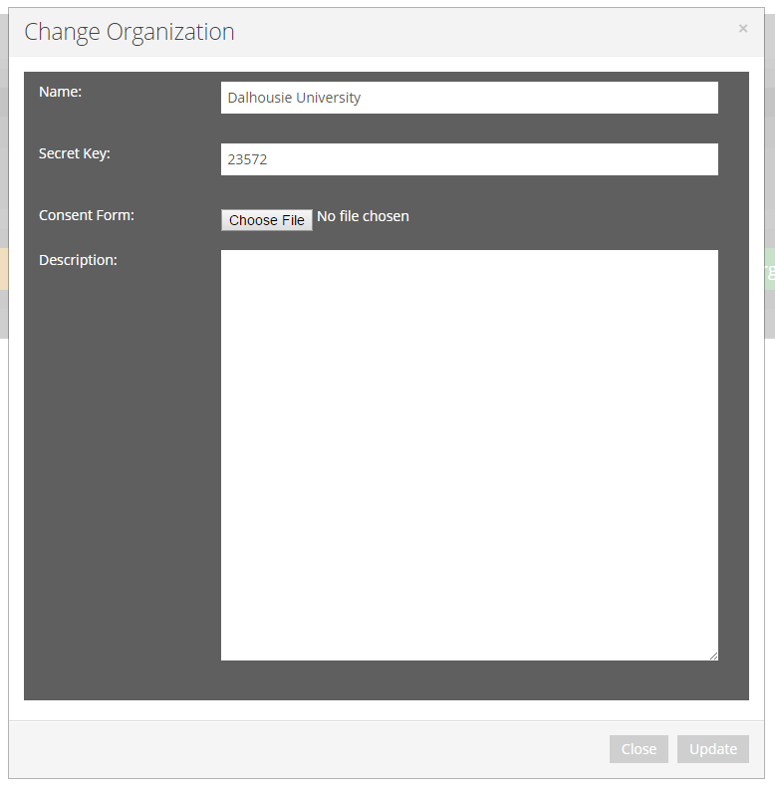It is also possible to edit the organization’s information and retrieve its data through this menu a seen in Figure 24. The secret key is the unique ID the user must enter upon registration to join an organization.

Figure 24: Organizations Update

The create an organization form field is quite self explanatory. The consent form can be uploaded and will be displayed when a user is registering for Rise@Work and selects the applicable organization (i.e. Dalhousie University). The consent form *must* be in **PDF format** to be able to be uploaded and displayed.

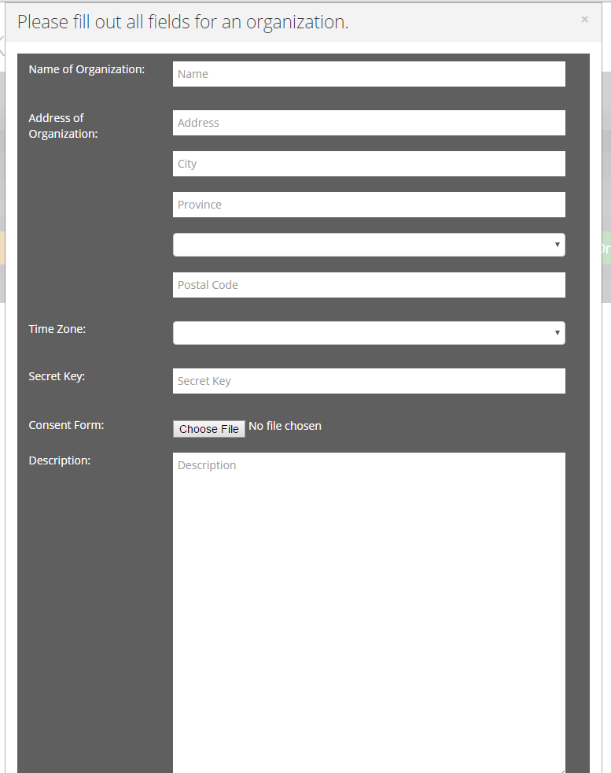

Figure 25: Organizations Creation

## **USER LOGIN AND REGISTRATION**

On the front page, there is a **Sign Up** feature that will display a pop up when selected. As seen in Figure 26.

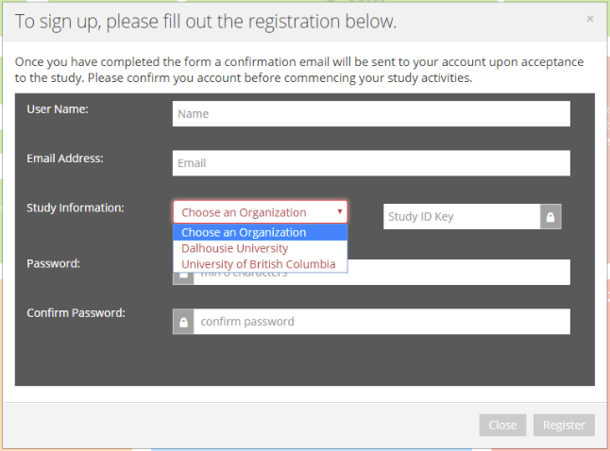

Figure 26: Sign Up

The user must select an organization from the drop-down menu and enter the appropriate Study ID key in order to be able to register an account.

When those conditions are met, the consent form is displayed in the same page as well as the checkbox **I agree to take part in this study**. The user is able to zoom in and out of the consent form and scroll through it. The user cannot register unless they check off the consent form checkbox and will be prompted with an error as seen in Figure 27. Once the user is registered, they are able to sign in and are prompted to complete the survey. After which, they are capable of using Rise@Work and log their steps. Users do not have access to the **Admin Panel**.

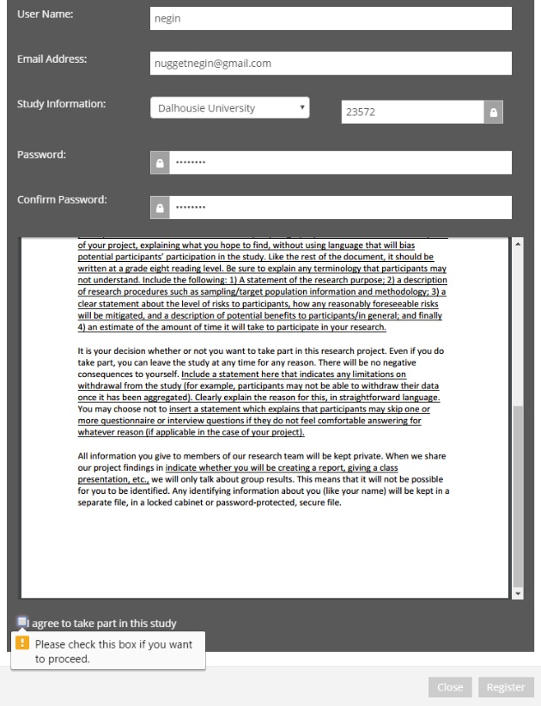

Figure 27: Sign Up Consent Form

## **MANAGING EMAILS & STRATEGIES**

Emails and strategies can be edited through the **admin panel** and the functionality is similar to the surveys where they can be edited in the window and do not require uploading from the admin.

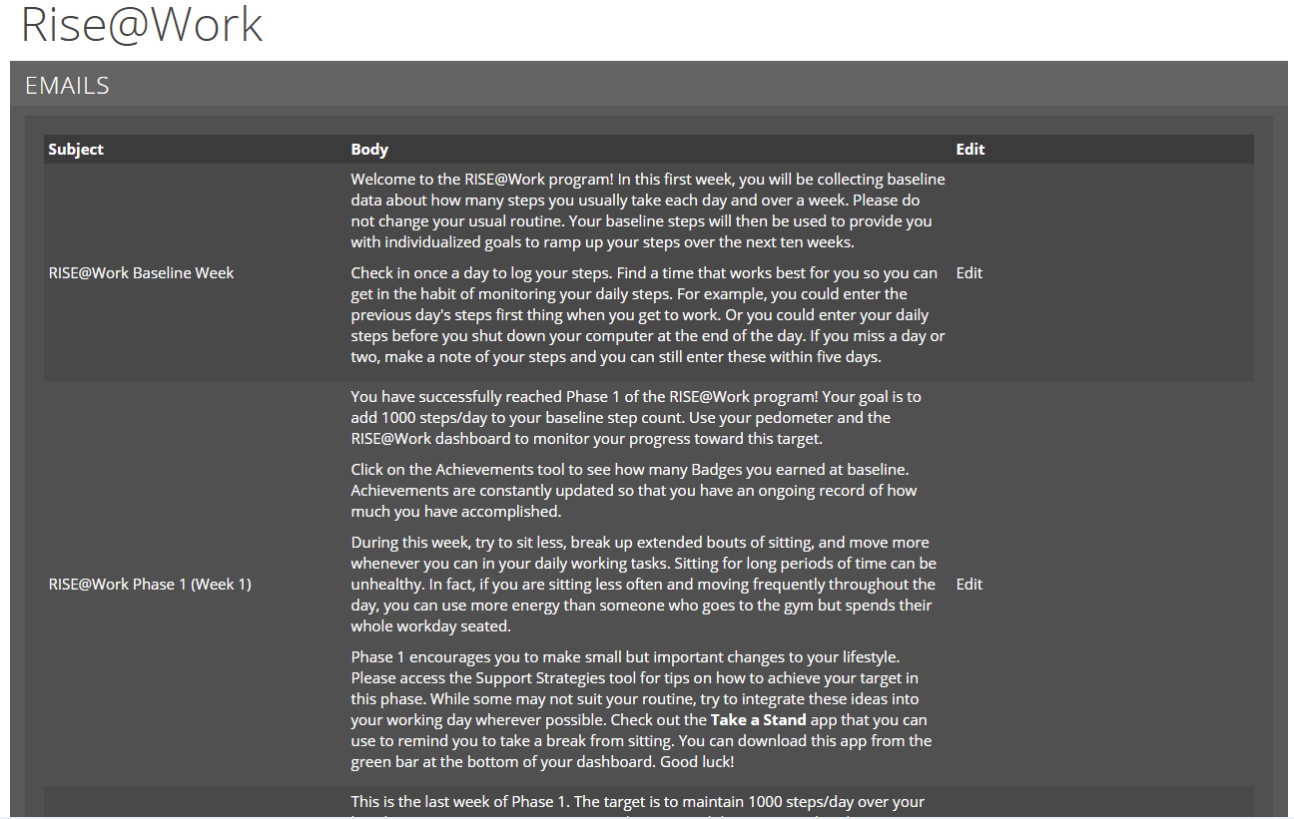

Figure 28 & 29: Emails and Emails Editing

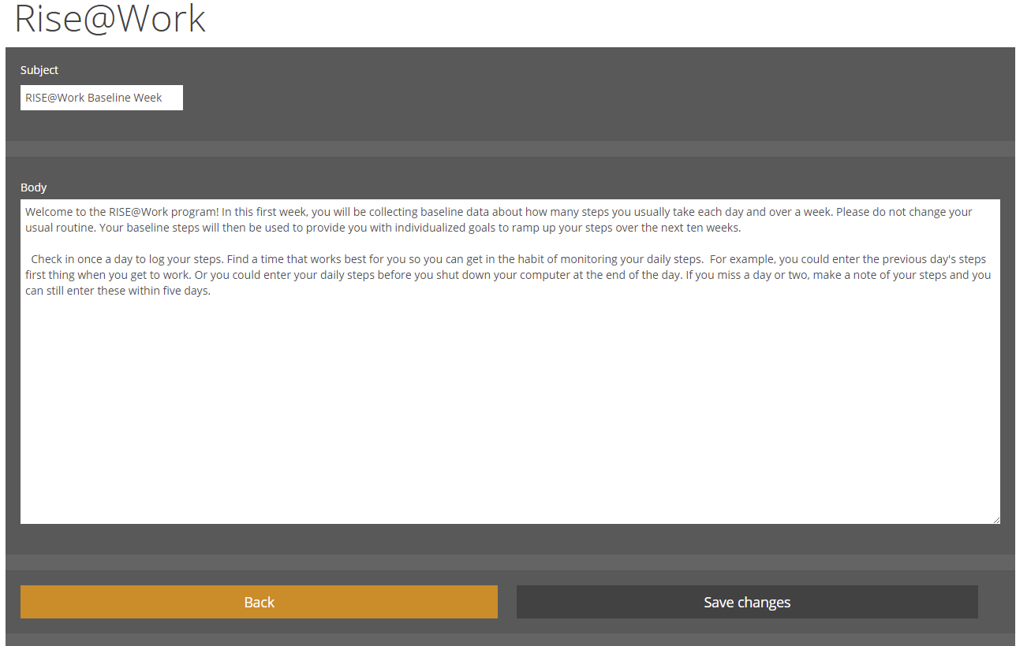

To implement a new strategy, the admin may select Add New Strategy/Route which will open a form field to create the new strategy.

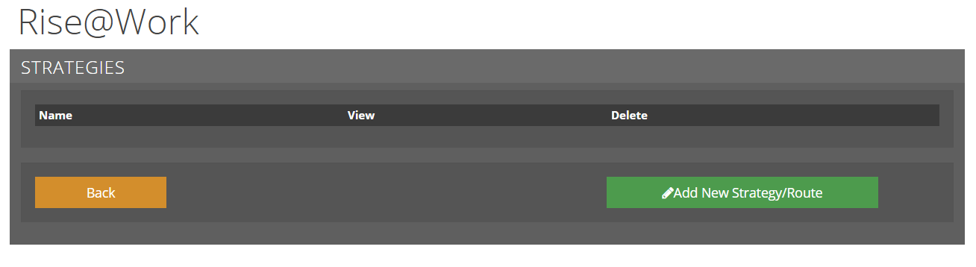

Figure 30: Strategies & Strategy Creation

