**50.012 Networks (2021 Term 6)**

**Homework 4**

Hand-out: 30 Nov

Due: 9 Dec 23:59

Name: Victoria Yong Student ID: 1004455

**1.** (textbook chapter 5, adapted from problem P14 and P15): Consider the network shown below. Suppose all the four ASes are running OSPF for their intra-AS routing protocol and assume the cost for every link in the graph is 1. Suppose eBGP and iBGP are used for the inter-AS routing protocol. Initially suppose there is no physical link between AS2 and AS4.

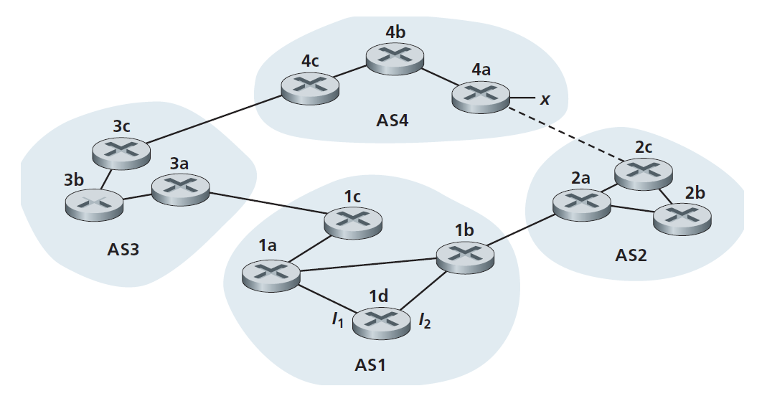

1. Router 3c learns about prefix x from which routing protocol: OSPF, eBGP, or iBGP?

Router 3c learns about prefix x from router 4c via eBGP protocol.

1. Router 3a learns about x from which routing protocol?

Router 3a learns about x from router 3c via iBGP protocol.

1. Router 1c learns about x from which routing protocol?

Router 1c learns about x from router 3a via eBGP protocol.

1. Router 1d learns about x from which routing protocol?

Router 1d learns about x from router 1c via iBGP protocol.

1. Once router 1d learns about x it will put an entry (x, I) in its forwarding table. Will I be equal to I1 or I2 for this entry? Explain why in one sentence.

I will be equal to I1 since by OSPF, the shortest known path for the packet at 1d to reach x will be via 1a to 1c.

1. Now suppose that there is a physical link between AS2 and AS4, shown by the dotted line. Suppose router 1d learns that x is accessible via AS2 as well as via AS3. Will I be set to I1 or I2? Explain why in one sentence.

I will be set to I2. Since we assume every path has link cost of 1, and since both routes have the same AS-PATH length, the route through I2 will have the least intra domain cost, making it the closest next-hop router (hot potato routing). Thus, I will be set to I2.

1. Now suppose there is another AS, called AS5, which lies on the path between AS2 and AS4 (not shown in diagram). Suppose router 1d learns that x is accessible via AS2 AS5 AS4 as well as via AS3 AS4. Will I be set to I1 or I2? Explain why in one sentence.

I will be set to I1 since the route through AS2 will no longer provide the shortest AS-PATH, and the shortest AS-PATH will be through AS3.

**2.** (textbook chapter 6, adapted from problem P15): Consider the following network:

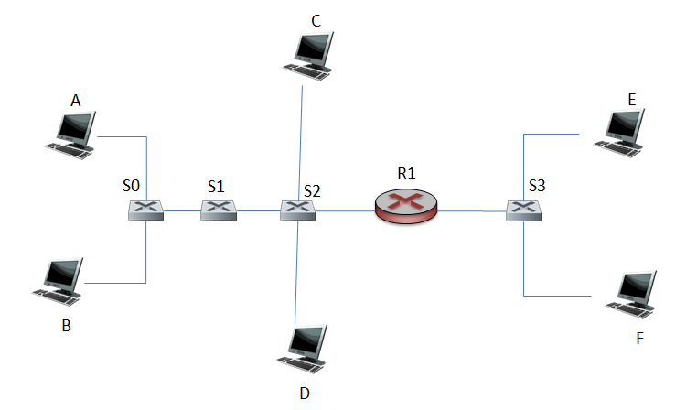

Where S0, S1, S2, and S3 are switches and R1 is a router. Note that the hosts at different side of R1 belong to different subnets.

1. Consider sending an IP datagram from Host E to Host F. Will Host E ask router R1 to help forward the datagram? Why? In the Ethernet frame containing the IP datagram, what are the source and destination IP and MAC addresses?

No. E and F are in the same subnet. By checking the subnet prefix of Host F, Host E will know that they are in the same LAN and will not send the packet to R1.

Source IP: Host E IP Address

Destination IP: Host F IP Address

MAC Address Source: Host E MAC Address

MAC Address Destination: Host F MAC Address

1. Suppose host E would like to send an IP datagram to host B, and assume that E’s ARP cache does not contain B’s MAC address. Will E perform an ARP query to find B’s MAC address? Why? In the Ethernet frame (containing the IP datagram destined to B) that is delivered to router R1, what are the source and destination IP and MAC addresses?

Host E will not perform ARP to find the MAC address of B since they are not in the same subnet, which Host E can learn by checking the IP address prefix of B. However, Host E will perform an ARP query to find the IP and Mac addresses of the first-hop router, R1.

Source IP: Host E IP Address

Destination IP: Host B IP Address

MAC Address Source: Host E MAC Address

MAC Address Destination: Router R1 MAC Address

1. Suppose Host A would like to send an IP datagram to Host B, and neither A’s ARP cache contains B’s MAC address nor does B’s ARP cache contain A’s MAC address. Further suppose that the switch S1’s forwarding table contains entries for Host B and router R1 only. Thus, A will broadcast an ARP request message. What actions will switch S1 perform once it receives the ARP request message?

Switch S1 will record the incoming MAC address of Host A in its forwarding table. Since Host A does not know the MAC address of B, the destination MAC address in the packet will be FF-FF-FF-FF-FF-FF. S1 indexes the switch table using this MAC address but will not find any entries for this address in its table. S1 will flood, and forward the packet on all interfaces except the link interface from Host A.

1. Will router R1 also receive this ARP request message? If so, will R1 forward the message? Once Host B receives this ARP request message, it will send back to Host A an ARP response message. But will it send an ARP query message to ask for A’s MAC address? Why? Will switch S1 receive the ARP response message from Host B?

Router R1 will receive the ARP request but will not forward it.

Host B will not respond with an ARP query since it obtains Host A’s MAC Address from the ARP query request sent by A. Host B will sent an ARP reply via unicast to A’s MAC address.

Switch S1 will not receive the ARP response since B replies to A via unicast message, and S0 already has A’s MAC address in its forwarding table. The ARP response will be forwarded through S0 to Host A and will not be sent to S1.

3. Consider the Cyclic Redundancy Check (CRC) algorithm. Suppose that the 4-bit generator (G) is 1001, that the data payload (D) is 10011001 and that r = 3. What are the CRC bits (R) associated with the data payload D? Please include in your answer the process you calculate the CRC.

