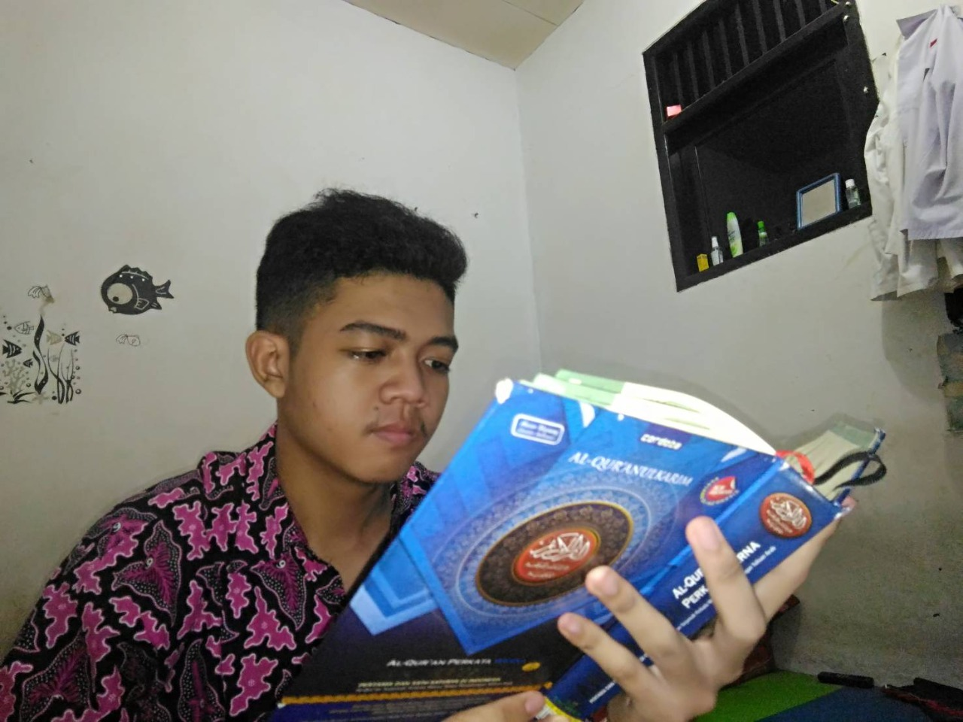

Reciting the Quran is one of the routine activities before studying. During the pandemic I realize many people are losing their hope for living. But whenever I recite the Quran I understand that life sometimes can be hard, it’s not because Allah doesn't love us. When our life is hard it's a sign from Allah to get closer to Allah. All the help we need in life is in the Quran, it’s our guide in living this life. So my friends, let’s recite the Quran together to obtain a sense of peace in life.