MF Analytics Platform
End-to-End Mutual Fund Analytics Platform
Bluestock Fintech Capstone Project
Submitted by: Nuha Pathan
Submission: 10 July 2026

Executive Summary

The MF Analytics Platform was developed as an end-to-end data analytics solution during the Bluestock Fintech Data Analyst Internship to analyze Indian mutual fund data using modern data engineering and business intelligence techniques. The project involved building a complete analytics pipeline, beginning with data extraction and preprocessing, followed by database design, exploratory analysis, financial performance evaluation, and interactive dashboard development.
Multiple datasets, including mutual fund schemes, historical NAV, Assets Under Management (AUM), investor transactions, SIP inflows, portfolio holdings, and benchmark indices, were cleaned and integrated into a centralized SQLite database using a reusable Python-based ETL pipeline. Exploratory data analysis was performed to identify trends in fund performance, investor behaviour, and industry growth, while financial metrics such as Historical Value at Risk (VaR), Conditional Value at Risk (CVaR), and Rolling Sharpe Ratio were computed to evaluate risk-adjusted fund performance.
An interactive four-page Power BI dashboard was developed to visualize key performance indicators, NAV trends, fund performance, and SIP analytics through dynamic filters, drill-through navigation, and interactive charts. Advanced analytics, including investor cohort analysis, SIP continuity analysis, a rule-based fund recommender, and sector concentration analysis using the Herfindahl–Hirschman Index (HHI), further enhanced the analytical capabilities of the platform.
Overall, the project demonstrates the complete lifecycle of a data analytics solution by integrating data engineering, financial analytics, SQL, and business intelligence to transform raw mutual fund data into actionable insights for informed decision-making.

1. Introduction

The Indian mutual fund industry has experienced significant growth over the past decade due to increasing investor participation, systematic investment plans (SIPs), and the rapid adoption of digital investment platforms. As financial datasets continue to grow in size and complexity, organizations increasingly rely on data analytics to evaluate fund performance, monitor investor behaviour, identify market trends, and support informed investment decisions.

The MF Analytics Platform was developed as an end-to-end data analytics solution during the Bluestock Fintech Data Analyst Internship. The primary objective of the project was to transform raw mutual fund datasets into meaningful business insights by implementing a complete analytics pipeline covering data ingestion, preprocessing, storage, analysis, visualization, and reporting.

The project integrates multiple technologies including Python, Pandas, SQLite, SQLAlchemy, SQL, Power BI, Git, and GitHub to build a scalable analytics workflow. Data from multiple sources, including mutual fund schemes, historical NAV values, Assets Under Management (AUM), investor transactions, portfolio holdings, SIP inflows, and benchmark indices, were cleaned, validated, and integrated into a centralized relational database.

The processed data was further analysed using exploratory data analysis techniques and financial performance metrics to evaluate fund performance and investor behaviour. An interactive Power BI dashboard was developed to provide business users with dynamic visualizations, KPIs, drill-through functionality, and trend analysis. In addition, advanced analytics techniques such as Historical Value at Risk (VaR), Conditional Value at Risk (CVaR), Rolling Sharpe Ratio, Investor Cohort Analysis, SIP Continuity Analysis, a Rule-Based Fund Recommender, and Sector Concentration Analysis using the Herfindahl–Hirschman Index (HHI) were implemented.

Overall, this project demonstrates the complete lifecycle of a data analytics solution, beginning with raw data acquisition and ending with interactive business intelligence and actionable financial insights.

2. Project Objectives

The primary objectives of the MF Analytics Platform are:
- Develop an automated ETL pipeline to ingest, clean, validate, and preprocess mutual fund datasets.
- Build a centralized SQLite database using a star schema to support analytical queries.
- Perform exploratory data analysis to identify trends in fund performance, investor behaviour, portfolio allocation, and industry growth.
- Calculate financial performance metrics such as Sharpe Ratio, Value at Risk (VaR), Conditional Value at Risk (CVaR), and Rolling Sharpe Ratio.
- Design and develop an interactive multi-page Power BI dashboard with KPIs, slicers, drill-through navigation, and business visualizations.
- Implement advanced analytical techniques including investor cohort analysis, SIP continuity analysis, fund recommendation, and sector concentration analysis.
- Generate actionable business insights that support investment analysis and decision-making.

3. Project Overview

The MF Analytics Platform was developed following a structured end-to-end analytics workflow that transforms raw financial datasets into meaningful business insights. The project combines data engineering, database management, statistical analysis, and business intelligence into a single analytical solution.
The workflow begins with collecting multiple mutual fund datasets containing fund information, historical NAV values, investor transactions, AUM statistics, SIP inflows, benchmark indices, and portfolio holdings. These datasets undergo preprocessing through a Python-based ETL pipeline where missing values are handled, duplicate records are identified, data types are standardized, dates are converted into a consistent format, and AMFI codes are validated across datasets.
Following preprocessing, the cleaned datasets are loaded into a SQLite relational database designed using a star schema. SQL queries and Python-based analytics are then used to calculate key financial metrics and generate analytical reports. Finally, the processed data is visualized using an interactive Power BI dashboard that provides users with intuitive access to industry trends, fund performance, investor analytics, and market insights.
The overall project workflow is illustrated below.
SQLite Data Warehouse
Cleaned & Processed Data
ETL Pipeline (Python)
Raw Mutual Fund Datasets

Interactive Power BI Dashboard
Performance Metrics & Advanced Analytics
SQL Analytics & Python Analysis

Business Insights & Reporting

4. Database Design

To support efficient data storage, querying, and reporting, a SQLite relational database was designed and implemented for the MF Analytics Platform. The database serves as the central repository for all cleaned and processed datasets generated through the ETL pipeline, enabling seamless integration between Python-based analytics and the Power BI dashboard.
A star schema architecture was adopted to organize the data into dimension and fact tables. This design minimizes redundancy, improves query performance, and simplifies analytical operations by separating descriptive information from transactional data. The centralized database also ensured consistency across different stages of the project, allowing multiple analyses to be performed using a common data source.
The database was developed using SQLite and populated using SQLAlchemy, enabling automated data loading directly from the processed datasets. Before insertion, all datasets underwent validation to ensure data quality and maintain referential consistency.

4.1. Database Schema
The database consists of 2 dimension tables, 5 fact tables, and 5 supporting analytical tables, providing a centralized repository for all processed mutual fund data used throughout the project.
Dimension Tables:
Table | Description
dim_fund | Stores descriptive information for each mutual fund scheme, including scheme name, fund house, category, and risk grade.
dim_date | Stores calendar attributes used for time-based analysis and reporting.

Fact Tables:
Table | Description
fact_nav | Historical Net Asset Value (NAV) records for mutual fund schemes.
fact_aum | Assets Under Management (AUM) information for fund houses.
fact_performance | Performance-related metrics for mutual fund schemes.
fact_transactions | Investor transaction records including SIPs, purchases, and redemptions.
fact_sip_industry | Stores monthly industry-level SIP statistics, including SIP inflows, active SIP accounts, new SIP registrations, total SIP AUM, and year-over-year growth.

Additional Analytical Tables:
To support specialized analyses and dashboard visualizations, additional tables were included in the database.
Table | Description
monthly_sip_inflows | Stores monthly SIP contribution data for industry trend analysis.
category_inflows | Records category-wise mutual fund inflows.
industry_folio_count | Contains industry-wide folio statistics over time.
portfolio_holdings | Stores sector-wise portfolio allocation for individual schemes.
benchmark_indices | Contains benchmark index values used for comparative analysis.

4.2. Database Loading Process
After the ETL pipeline completed data cleaning and preprocessing, each processed dataset was loaded into the SQLite database using SQLAlchemy. During the loading process:
- Missing values were handled during preprocessing.
- Data types were standardized before insertion.
- Date fields were converted into a consistent format.
- AMFI codes were validated across related datasets.
- Row count verification was performed after loading each table to ensure successful data insertion.
This automated workflow ensured that the database remained accurate, consistent, and ready for downstream analytics and visualization.
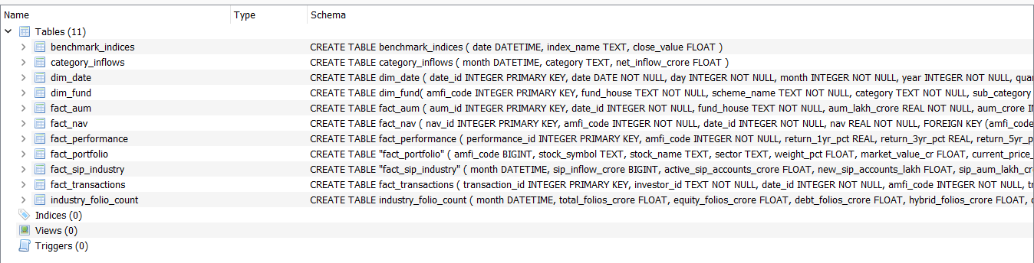
Fig 1. SQLite database containing dimension, fact, and analytical tables.

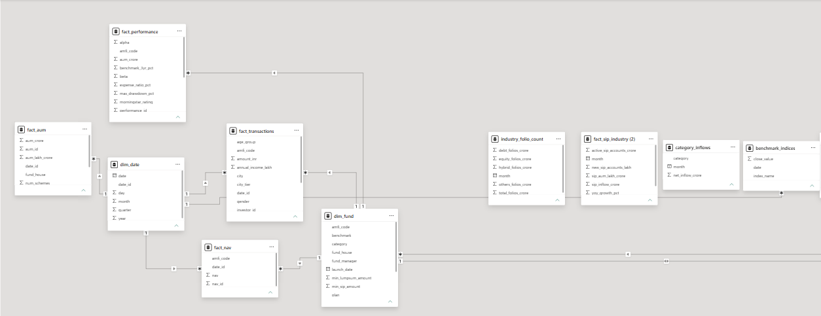

5. ETL Pipeline & Data Preprocessing

The Extract, Transform, and Load (ETL) pipeline forms the backbone of the MF Analytics Platform. It was developed using Python to automate the process of collecting, cleaning, validating, transforming, and loading mutual fund datasets into a centralized SQLite database. Automating these processes ensured data consistency, minimized manual intervention, and prepared high-quality datasets for analysis and visualization.

The pipeline was implemented using Pandas, NumPy, SQLAlchemy, and SQLite, with reusable scripts designed to handle multiple datasets efficiently.

5.1. Extract
During the extraction stage, mutual fund datasets were collected from publicly available sources, including historical NAV data, fund master information, Assets Under Management (AUM), investor transactions, SIP statistics, benchmark indices, portfolio holdings, and other supporting datasets. Live NAV information was also retrieved using the mfapi.in API.
The extracted datasets were organized into the project's raw data directory before preprocessing.

5.2. Transform
The transformation stage focused on improving data quality and ensuring consistency across all datasets. Several preprocessing operations were performed, including:
- Removal of duplicate records.
- Handling of missing values.
- Standardization of date formats.
- Validation of AMFI codes across related datasets.
- Data type conversion for numerical and categorical fields.
- Verification of NAV values, transaction amounts, and performance metrics.
- Generation of cleaned datasets for downstream analysis.
The processed datasets were saved separately to preserve the integrity of the original raw files.

5.3. Load
After preprocessing, the cleaned datasets were loaded into a SQLite database using SQLAlchemy. A structured relational schema was implemented, consisting of dimension tables, fact tables, and supporting analytical tables. Row count verification was performed after loading each dataset to confirm successful data insertion.
The centralized database served as the primary data source for SQL queries, Python analytics, and the Power BI dashboard.

6. Exploratory Data Analysis (EDA)

Exploratory Data Analysis (EDA) was performed to examine the characteristics of the processed mutual fund datasets and uncover meaningful trends related to fund performance, investor behaviour, industry growth, and portfolio composition. Python libraries including Pandas, Matplotlib, Seaborn, and Plotly were used to clean, summarize, and visualize the data.
A total of 16 visualizations were created to analyze different aspects of the mutual fund ecosystem, ranging from historical NAV trends and AUM distribution to investor demographics, SIP behaviour, sector allocation, and benchmark comparisons.
The analysis provided valuable insights that served as the foundation for the performance analytics, dashboard development, and advanced analytical tasks completed in the later stages of the project.

6.1. Key Visualizations
The following visualizations were developed during the exploratory data analysis phase:
No. | Visualization | Purpose
1 | NAV Trend Analysis | Analyze historical NAV movement of selected schemes
2 | AUM by Fund House | Compare Assets Under Management across AMCs
3 | Monthly SIP Inflow Trend | Study monthly SIP investment patterns
4 | Category-wise Inflow Heatmap | Visualize inflows across fund categories
5 | Investor Age Distribution | Analyze investor demographics
6 | SIP Distribution by Age Group | Compare SIP investments across age groups
7 | Gender Distribution | Examine gender-wise participation
8 | Geographic Distribution | Analyze investments across Indian states
9 | T30 vs B30 Distribution | Compare metro and non-metro investments
10 | Industry Folio Growth | Study industry participation trends
11 | NAV Correlation Heatmap | Compare fund movement correlations
12 | Sector Allocation | Analyze portfolio diversification
13 | Payment Mode Distribution | Study preferred payment methods
14 | KYC Status Distribution | Analyze investor compliance
15 | Transaction Type Distribution | Compare SIP, Lumpsum, and Redemption transactions
16 | Annual Income Analysis | Examine investment behaviour by income group
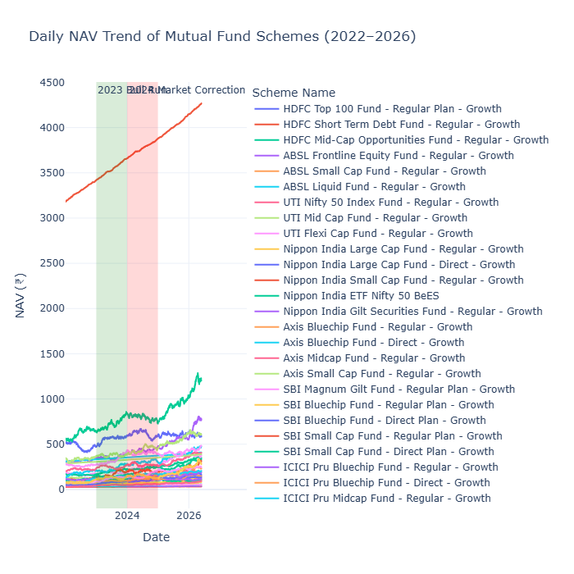
Fig 2. NAV Trend

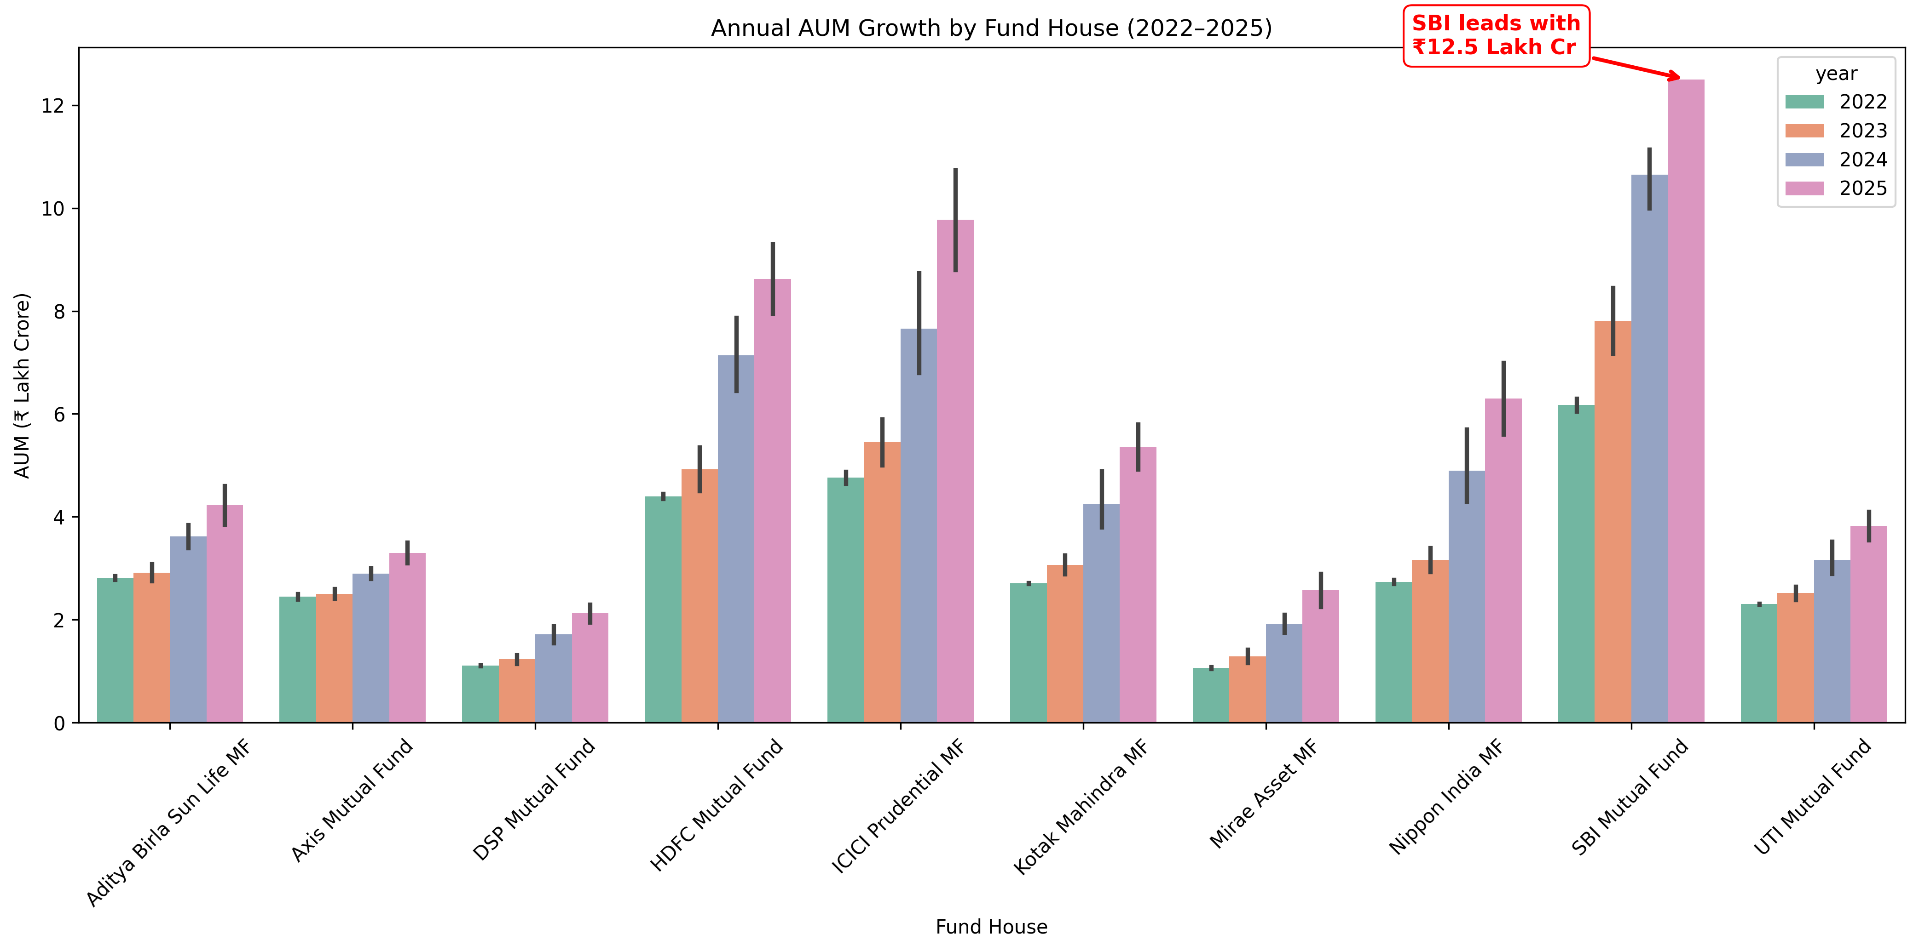
Fig 3. AUM by Fund House

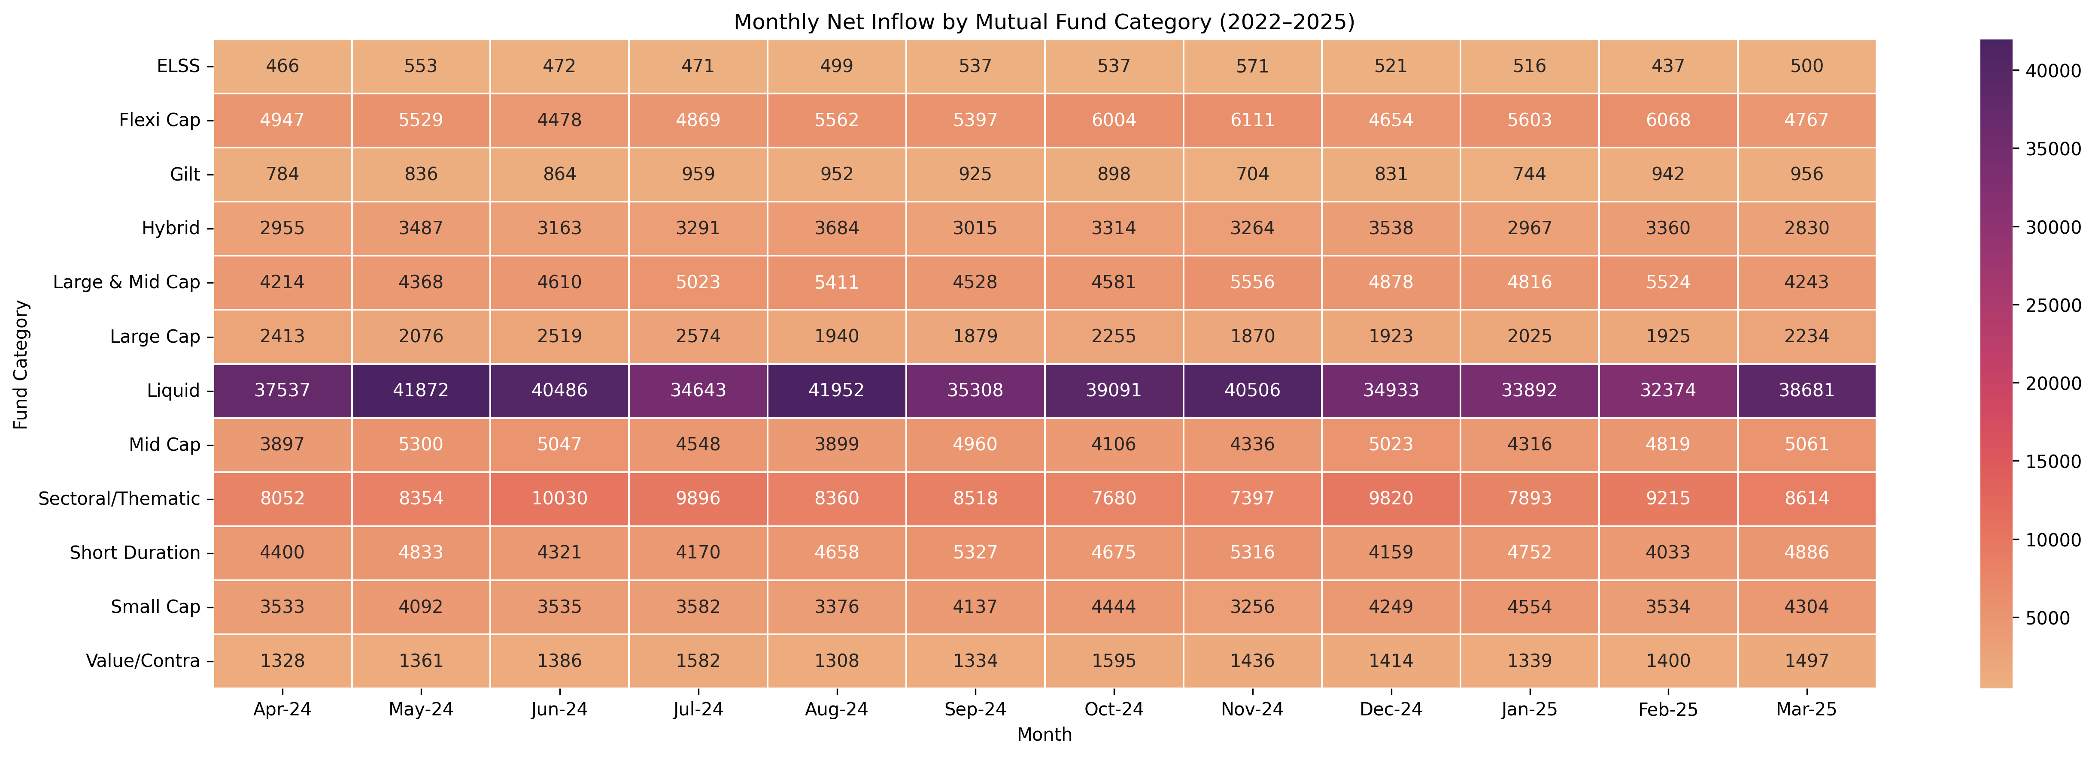
Fig 4. Category-wise Inflows Heatmap
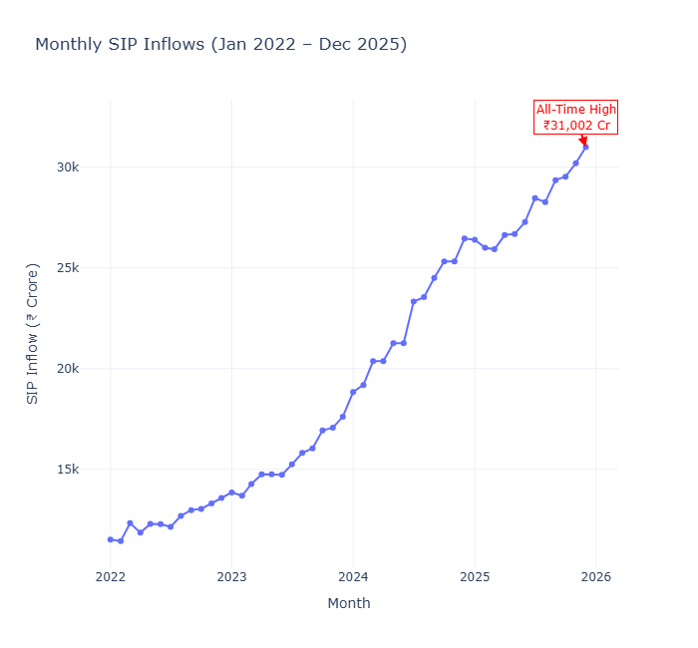
Fig 5. Monthly SIP Trend
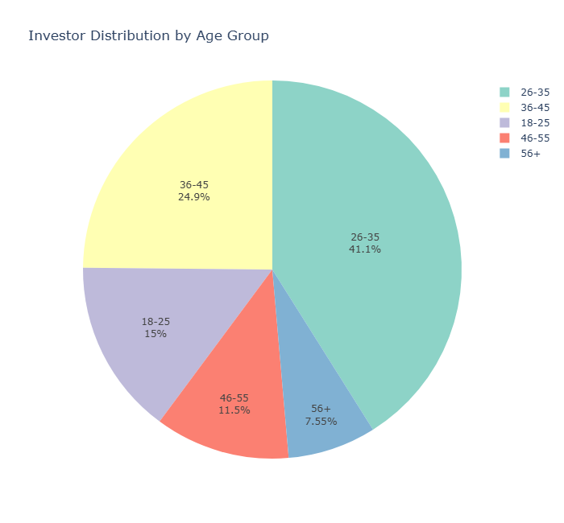
Fig 6. Investor Age Distribution

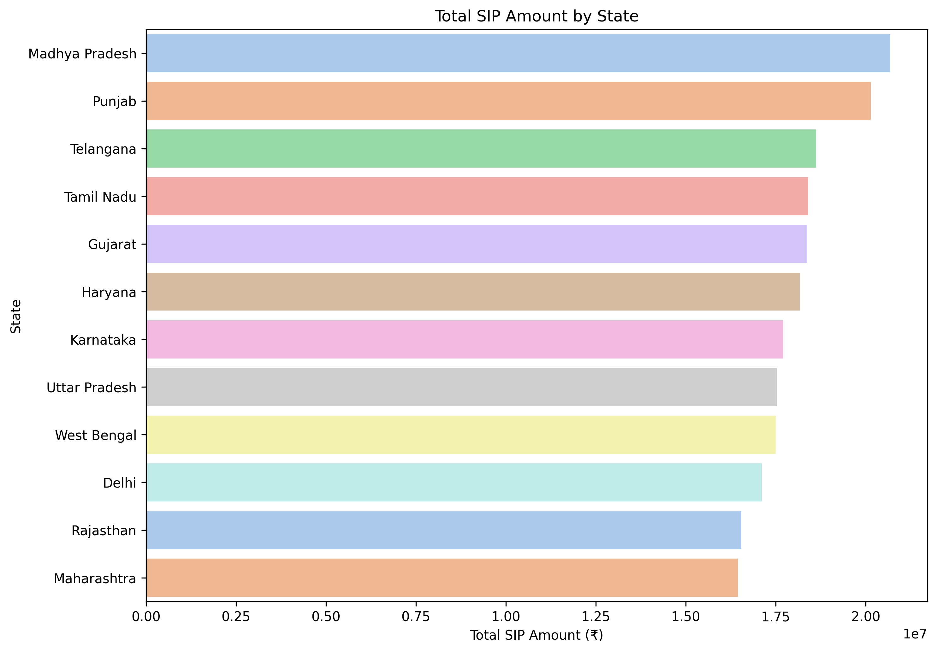

Fig 7. Geographic Distribution by State

6.2. Summary of Key Findings
The exploratory analysis highlighted several important trends across the mutual fund datasets. Historical NAV data demonstrated varying performance among schemes, while AUM analysis identified the dominant fund houses in terms of assets under management. Investor demographic analysis revealed differences in participation across age groups, gender, income categories, and geographic regions. Sector allocation and correlation analyses provided additional insights into portfolio diversification and fund relationships. Overall, the EDA phase established a strong analytical foundation for the subsequent performance metrics, dashboard development, and advanced analytics.

7. Performance Analytics

The Performance Analytics module was developed to evaluate the risk and return characteristics of mutual fund schemes using historical NAV data. Historical NAV records were processed to calculate daily returns, which served as the basis for computing various financial performance and risk metrics.
The analysis included the calculation of Sharpe Ratio, Beta, Alpha, Maximum Drawdown, Value at Risk (VaR), Conditional Value at Risk (CVaR), and Rolling Sharpe Ratio. These metrics provide a comprehensive assessment of each scheme's historical performance, volatility, downside risk, and market sensitivity.
The computed metrics were consolidated into structured CSV reports for further analysis and visualization. These outputs were also utilized during the advanced analytics stage to support fund comparison and recommendation.
Key Performance Metrics
- Calculated daily returns from historical NAV data.
- Computed Sharpe Ratio for risk-adjusted performance evaluation.
- Estimated Beta to measure market sensitivity.
- Calculated Alpha to evaluate excess returns over the benchmark.
- Determined Maximum Drawdown to identify the largest historical decline.
- Estimated Value at Risk (VaR) at a 95% confidence level.
- Calculated Conditional Value at Risk (CVaR) to assess expected losses beyond the VaR threshold.
- Computed Rolling Sharpe Ratio to analyze changes in risk-adjusted performance over time.
- Exported the calculated metrics as CSV files for reporting and dashboard integration.
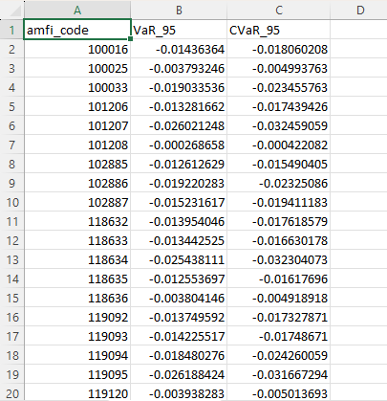 | 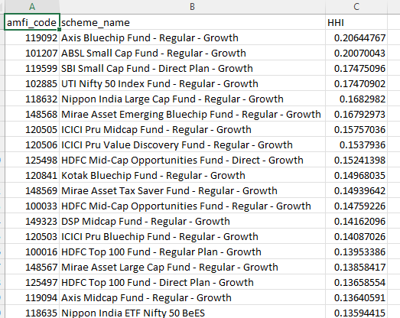
VaR CvaR Report | HHI Report

8. Interactive Dashboard

An interactive Power BI dashboard was developed to transform the analytical outputs into an intuitive and user-friendly reporting solution. The dashboard is connected to the SQLite data warehouse and enables users to explore mutual fund performance, industry trends, investor insights, and SIP analytics through interactive visualizations and filters.
The dashboard consists of five pages, including a dedicated drill-through page for detailed NAV analysis.
Dashboard Pages
Page 1 – Industry Overview
This page provides a high-level overview of the Indian mutual fund industry.
Visualizations
- KPI Cards (Total AUM, Monthly SIP Inflows, Total Folios, Total Mutual Fund Schemes)
- Industry AUM Trend (2022–2025)
- AUM by Fund House
- Year and Fund House slicers
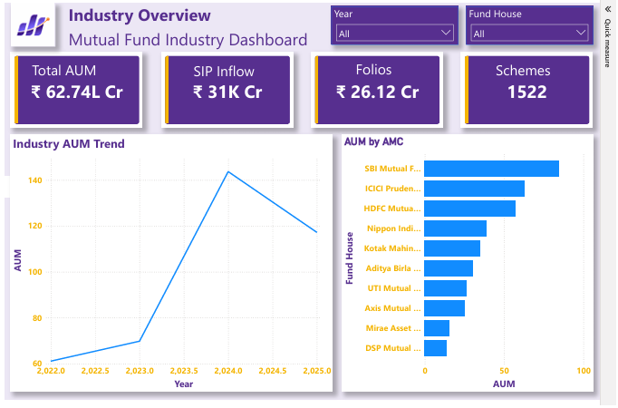
Page 2 – Fund Performance Analysis
This page focuses on evaluating mutual fund performance and comparing schemes based on risk and return.
Visualizations
- Risk vs Return Scatter Plot
- NAV vs Benchmark Trend Comparison
- Top 10 Funds by Fund Score
- Category and Fund House filters
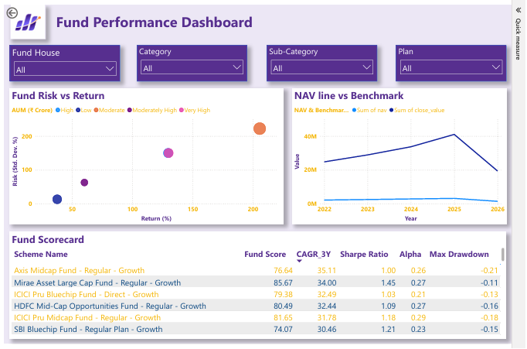
Page 3 – NAV Detail (Drill-through)
This page is a drill-through report that provides detailed information for an individual mutual fund selected from the Fund Performance page.
Visualizations
- Historical NAV Trend
- Scheme Information Cards
  - Current NAV
  - Fund Score
  - Launch Date
- Interactive drill-through navigation
- Custom tooltips
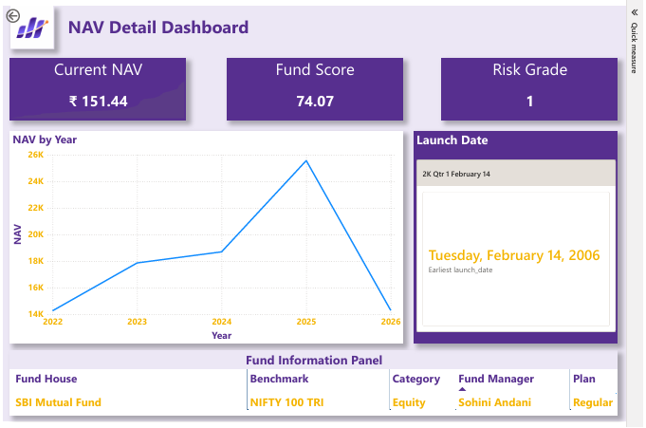
Page 4 – SIP & Market Trends
This page analyzes SIP growth and market performance over time.
Visualizations
- Monthly SIP Inflow Trend
- SIP Inflow vs Benchmark Index Comparison
- Year slicer
- Interactive tooltips
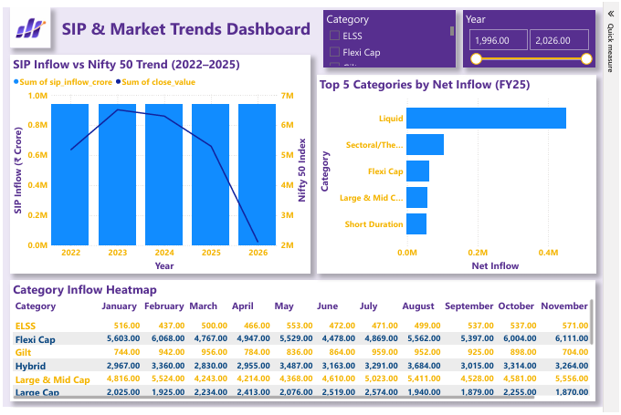
Page 5 – Investor Demographics
This page presents insights into investor behaviour and demographic distribution.
Visualizations
- Age Group Distribution
- State-wise Investor Distribution
- Annual Income Group Distribution
- Transaction Type Distribution
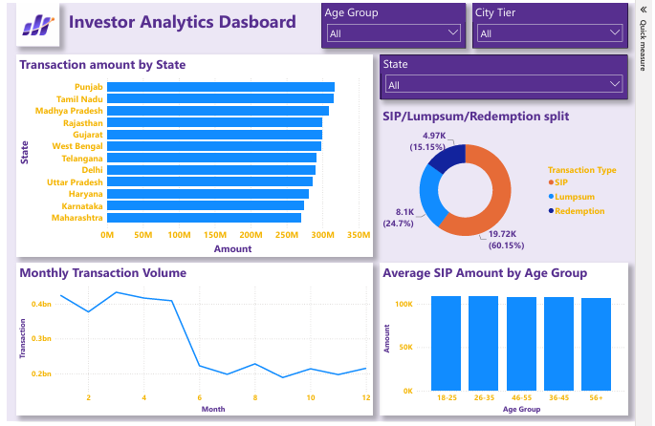

9. Advanced Analytics

The Advanced Analytics module extends the project beyond descriptive analysis by applying risk assessment techniques, investor behaviour analysis, and fund recommendation methods. These analyses provide deeper insights into mutual fund performance and support data-driven investment decisions.
The notebook includes statistical risk measurements, investor cohort analysis, market concentration analysis, and a rule-based mutual fund recommendation system.
Advanced Analytics Performed
Value at Risk (VaR) and Conditional Value at Risk (CVaR)
Calculated VaR and CVaR at a 95% confidence level using historical daily returns to estimate potential losses under normal and adverse market conditions.
Cohort Analysis
Performed cohort analysis using SIP investment data to group investors based on their first investment year. The analysis compares average SIP investment across different investor cohorts to understand long-term investment behaviour.
Herfindahl–Hirschman Index (HHI)
Calculated the Herfindahl–Hirschman Index (HHI) to measure market concentration among fund houses based on Assets Under Management (AUM). This analysis helps identify whether the industry is highly concentrated or broadly diversified.
Risk Category Analysis
Analyzed the distribution of mutual fund schemes across different risk categories and compared their corresponding fund scores to understand the relationship between investment risk and overall performance.
Rule-Based Mutual Fund Recommendation System
Developed a recommendation system that suggests suitable mutual fund schemes based on selected criteria such as risk category, fund score, and historical performance metrics. This provides users with a simple and interpretable approach for identifying potential investment options.

10. Key Findings

The Mutual Fund Analytics Platform successfully transformed raw mutual fund datasets into a structured analytical solution through data engineering, financial analysis, and interactive visualization. The following key findings were obtained during the project:
- The ETL pipeline successfully standardized and validated multiple mutual fund datasets, ensuring high data quality for downstream analysis.
- The SQLite star schema enabled efficient storage, querying, and integration of multiple financial datasets.
- Exploratory Data Analysis identified historical NAV trends, AUM growth patterns, investor demographics, SIP investment behaviour, and sector allocation across mutual fund schemes.
- Financial performance metrics such as Sharpe Ratio, Alpha, Beta, Maximum Drawdown, VaR, and CVaR provided valuable insights into fund risk and return characteristics.
- Cohort Analysis highlighted variations in investor SIP behaviour across different investment cohorts.
- The Herfindahl–Hirschman Index (HHI) provided an overview of market concentration among major fund houses.
- The rule-based recommendation system demonstrated how historical performance and risk characteristics can be used to identify suitable mutual fund schemes.
- The interactive Power BI dashboard enabled intuitive exploration of industry trends, fund performance, investor analytics, and SIP trends through dynamic filtering and drill-through analysis.

11. Conclusion

The Mutual Fund Analytics Platform successfully demonstrates the complete lifecycle of a real-world data analytics project, beginning with data ingestion and preprocessing and progressing through database design, exploratory analysis, financial performance evaluation, advanced analytics, and interactive business intelligence reporting.
By integrating Python, SQL, SQLite, and Power BI, the project provides a scalable and reusable analytical framework for evaluating mutual fund performance and investor behaviour. The implementation of financial risk metrics, cohort analysis, market concentration analysis, and a recommendation system further enhances the platform's analytical capabilities.
Overall, the project showcases practical skills in data engineering, data analysis, database management, financial analytics, and dashboard development while delivering meaningful insights that can support informed investment decisions.

