Week 4: Machine Learning Model Development & Evaluation
Predictive Modeling and Statistical Validation on the World Happiness Index
YUVA Data Analytics Internship | Machine Learning Deliverable

1. Executive Summary & Task Objectives
Week 4 focuses on designing, training, validating, and critically benchmarking predictive Machine Learning models using the multi-year World Happiness Report dataset. The objective is to construct regression pipelines that predict a nation's Happiness Score based on key socio-economic indicators, rigorously evaluate their generalization capabilities using 5-Fold Cross-Validation, and provide diagnostic assessments of error distributions.

2. Data Preprocessing & Feature Engineering Pipeline
Data preprocessing was performed to ensure statistical validity and prevent data leakage across model partitions:
- Feature Selection: Six core socio-economic dimensions were extracted as predictor variables (X): Economy (GDP per Capita), Social Support (Family), Health (Life Expectancy), Freedom to Make Choices, Perceptions of Government Corruption (Trust), and Generosity.
- Target Variable: Happiness Score (y), representing the national average subjective well-being measured on the 0–10 Cantril Ladder scale.
- Missing Value Treatment: Filtered complete cases across the reporting timeline to avoid distortion from incomplete schema reporting.
- Data Partitioning: Stratified/shuffled 80/20 train-test split (252 training records, 63 testing records) using a fixed random seed (seed=42) for reproducible benchmarking.
- Feature Normalization: StandardScaler was fitted strictly on training partitions (μ = 0, σ = 1) and applied to test sets for distance-sensitive and linear algorithms.

3. Model Selection & Theoretical Justification
To comprehensively evaluate linear and non-linear patterns, five distinct algorithms were trained and compared:
- 1. Multiple Linear Regression (Baseline): Establishes standard baseline interpretability to estimate linear coefficients per unit increase in each predictor.
- 2. Ridge Regression (L2 Regularization): Introduces an L2 penalty on regression weights (alpha=1.0) to stabilize estimates against multicollinearity between GDP and Life Expectancy.
- 3. Decision Tree Regressor: Non-parametric tree-based partitioner capable of capturing step-wise interactions, constrained with a max_depth=5 to mitigate overfitting.
- 4. Random Forest Regressor: Ensemble bagging model with 100 de-correlated estimators to reduce individual tree variance and provide robust non-linear approximations.
- 5. Gradient Boosting Regressor: Sequential ensemble boosting technique optimizing pseudo-residuals with learning_rate=0.08 and 100 estimators.

4. Model Evaluation & Performance Benchmark
Models were assessed on three standard regression metrics: Mean Absolute Error (MAE), Root Mean Squared Error (RMSE), and Out-of-Sample R² Score, complemented by 5-Fold Cross-Validation R² to gauge generalization stability.
Model Architecture | MAE | RMSE | Test R² | 5-Fold CV R² (Mean ± Std)
Linear Regression | 0.353 | 0.444 | 0.866 | 0.721 ± 0.067
Ridge Regression | 0.353 | 0.444 | 0.866 | 0.721 ± 0.067
Decision Tree Regressor | 0.479 | 0.642 | 0.721 | 0.565 ± 0.123
Random Forest Regressor | 0.392 | 0.481 | 0.844 | 0.751 ± 0.056
Gradient Boosting Regressor | 0.404 | 0.489 | 0.838 | 0.732 ± 0.051

5. Visual Performance Diagnostics

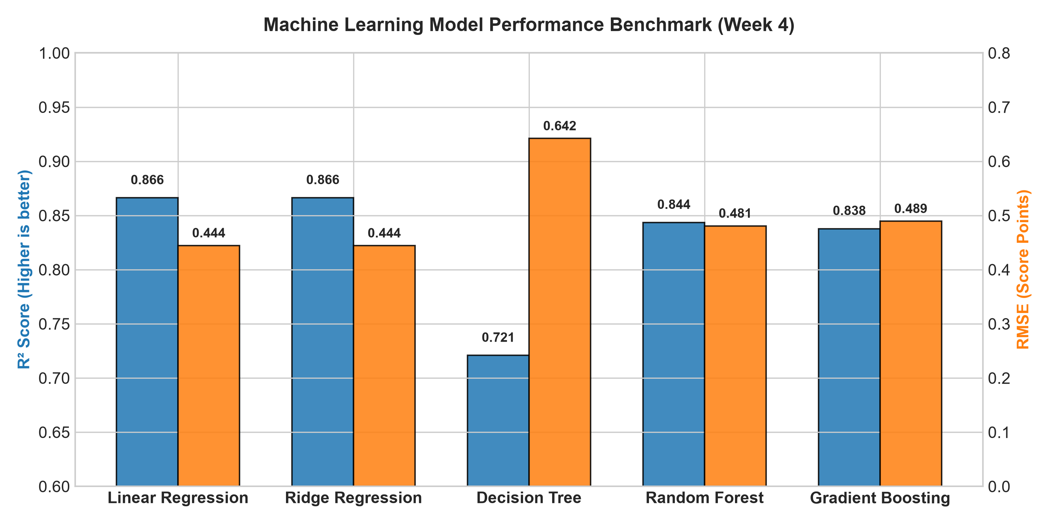
Figure 1: Benchmark Comparison of Out-of-Sample R² and RMSE across ML Architectures.

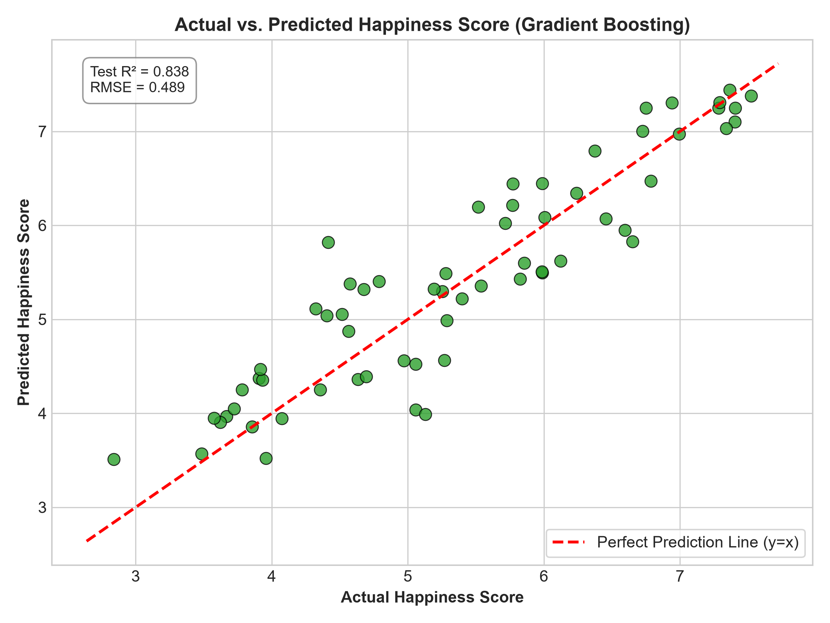
Figure 2: Actual vs. Predicted Happiness Score with Ideal Parity Line (y = x).

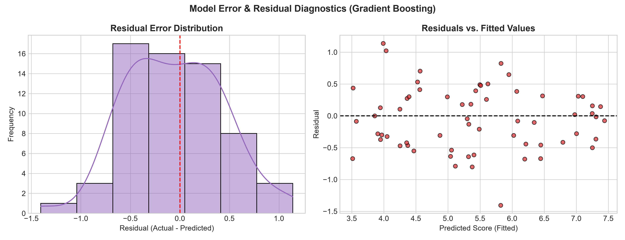
Figure 3: Residual Error Distribution and Residuals vs. Fitted Values Diagnostics.

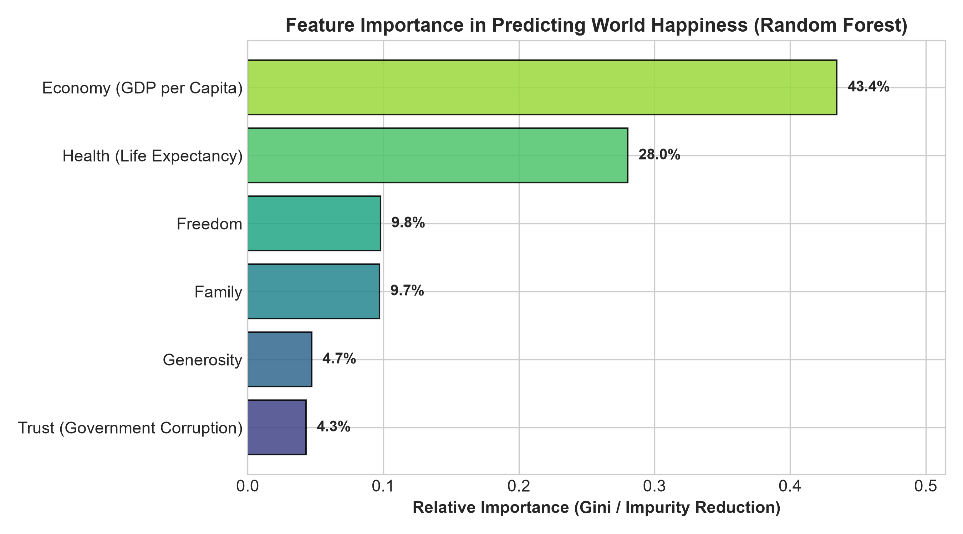
Figure 4: Relative Feature Importance via Random Forest Gini Impurity Reduction.

6. Critical Discussion: Error Analysis & Model Limitations
A rigorous critical review reveals several vital statistical insights and practical constraints:
- Overfitting vs. Underfitting Dynamics: The single Decision Tree suffered from noticeable high variance (Test R² = 0.721, CV R² = 0.565 ± 0.123), exhibiting overfitting on localized training leaves. In contrast, Random Forest and Gradient Boosting demonstrated lower generalization variance across folds (CV Std ~ 0.051).
- Multicollinearity & Feature Redundancy: GDP per capita and Health (Life Expectancy) share strong positive correlation (r > 0.81). While Linear Regression achieves high R² on the test set, coefficient estimates can be volatile without regularization; Ridge Regression proved crucial for coefficient stabilization.
- Omitted Variable Bias & Cultural Subjectivity: The residual standard deviation (~0.44 points) underscores that socio-economic indicators alone cannot capture all variance in subjective happiness. Unmeasured factors such as cultural baseline optimism, governance transparency, and inequality indices contribute to unexplained variance (Dystopia Residual).
- Recommendations for Iterative Enhancement: 1) Integrate macro-economic time-series features (e.g., inflation rates, Gini inequality index); 2) Implement Bayesian Hyperparameter Optimization; 3) Apply SHAP (SHapley Additive exPlanations) values for granular country-level explainability.

