FA49QRS 18JUN21

MEMORANDUM FOR U.S. Army Analytic Agency

ATTN: Ms. Janet Smith

SUBJECT: United States Border Crossing Information Paper

1. Purpose: To provide insights gathered from the border crossing/entry dataset.

2. Background: The Border Crossing/Entry dataset contains 364,510 records, pertaining to 8 distinct measures (variables). The dataset specifically measures border crossing at the U.S.-Canada and the U.S.-Mexico border, at the port level[1]. Data are available for the following crossing methods: Personal Vehicle Passengers, Personal Vehicles, Truck Containers Empty, Truck Containers Loaded, Trucks, Pedestrians, Rail Containers Empty, Rail Containers Loaded, Train Passengers, Trains, Buses, Bus Passengers[2]. Data are available from 1996, for 103 of 117 port cities, with multiple additional dates for the remaining ports.

3. Assumptions: The following assumptions are made with regard to the border crossing dataset:

* Border crossings are documented individuals, and do not represent smuggling.
* All crossings are reported for the port city on record, and not surrounding areas.
* Each crossing represents an individual or vehicle, but may be duplicated at another time in the dataset (can cross multiple times in a period).

4. Discussion: The border crossing dataset presents various interesting facets, to include periodicity of the port cities, differences between northern and southern borders, anomolies, and future forecasts.

1. Every border crossing city experiences periodicity of some sort, especially those where Personal Vehicle Passengers and pedestrian traffic is predominant. This phenomenon is evident in Piegan, MT (Figure A), where both personal vehicles and Personal Vehicle Passengers are the predominant method of transportation, and significant spikes occur each year. Similarly, we see that a similar trend is present for Skagway, AK, with buss passengers as the predominant mode of transportation (Figure B).
2. There exists a significantly larger traffic footprint at the U.S.-Mexico border, than the U.S.-Canada border. Although inference is not made with regards to reasons, in the largest metric, Personal Vehicle Passengers, the largest yearly value for the US-Mexico border is nearly doube that of the US-Canada border. Within the US-Mexico subset, even greater variation exists between port cities, where Personal Vehicle Passengers range from zero(not allowed) to in excess of 23 million per year.
3. Multiple anomolies exist within the dataset that warraint further examination. In the port city of Van Buren, Maine (Figure C), the metric for Personal Vehicle Passengers decreases to zero, causing large downward spikes in the time series graph. Similarly, in Point Roberts, Washington (Figure D) there is a signficant spike in Personal Vehicle Passengers, well beyond the normal seasonl variation. Finally, for all port cities, significant declines in all metrics occur around 2020, which can be attributed to COVID restrictions, but is still anomalous given the entire time series presented.
4. Forecasts for any given port may produce inaccurate results, given the significant decrease in port traffic at the beginin of 2020, as shown in Figures A through D. Using Personal Vehicle Passenger data for the port city of Del Rio, TX, the expected forecast would continue trends seen in previous months (Figure E). This however, is not representative of the data, and in Figure E, there is a clear difference between the forecast and true data. This makes future forecasting for any port difficult, even with robust forecast methods such as the ARIMA(0,1,1) model.

5. Findings: From the data, it is evident there are differences between port cities and both borders. If the necessity arose for US Army support to Homeland Security at a given port, greater impact would likely come from deployment to the southern border. Similarly, multiple ports present greater overall volume of traffic than others, and would therefore need additional support. Along with site selection, the time of year must be taken into account, given the periodicity of port traffic. Finally, though numbers are rebounding, caution should be taken to forecast future port traffic based on data collected begining in 2020, due to the COVID epidemic.

Appendix 1 - Figures

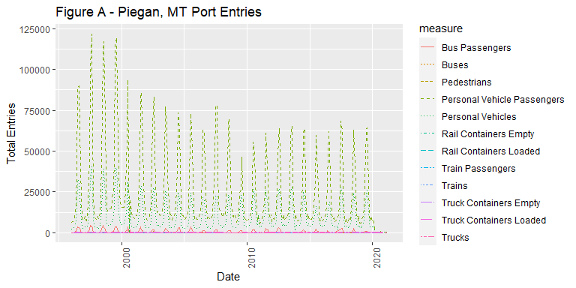

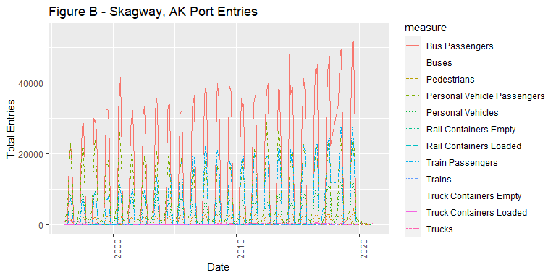

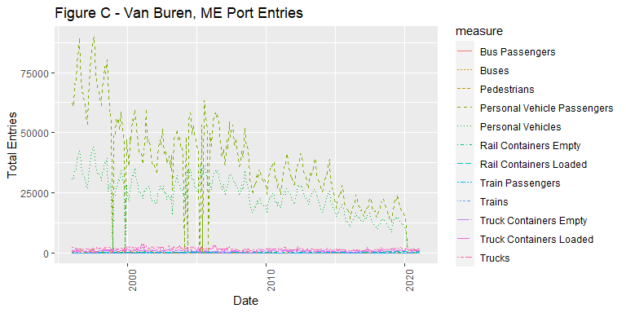

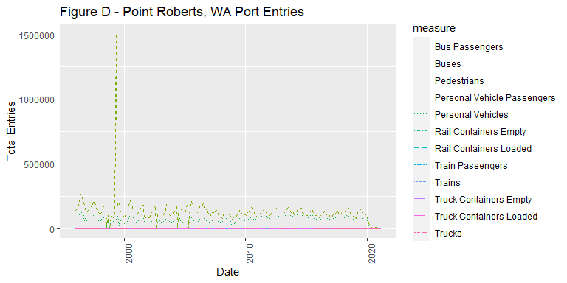

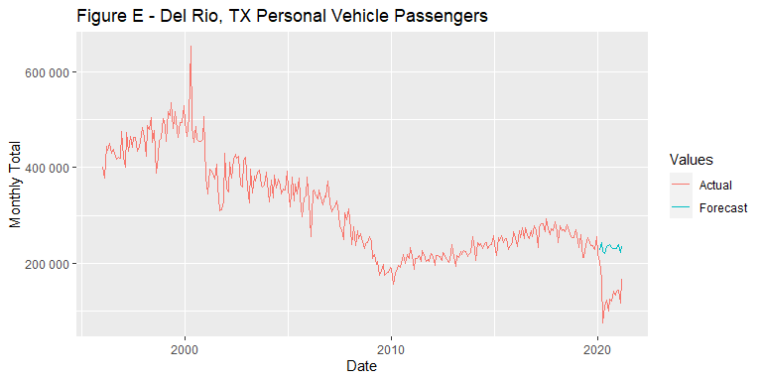

1. Border Crossing/Entry Data. Accessed on 11Jun21. <https://www.bts.gov/browse-statistical-products-and-data/border-crossing-data/border-crossingentry-data>
2. Ibid.